Literature review: Robust parenting programmes

August 2020

| Contents
1 Introduction & Objectives 2
2 Search Strategy 3
3 Parenting Programmes 4
3.1 What Works 4
3.2 What Works: Strength of Evidence for 75 parent-child interventions 5
The Healthy Child Programme 0–5 8
Triple P (positive parenting programme) 11
Delivering parenting programmes online 12
4 Conclusions 15
5 Appendix A 16
6 Appendix B 19

|

Introduction & Objectives
Early intervention programmes and strategies are designed to prevent poor outcomes later in life; they may be implemented at any time from conception to the onset of adulthood. This evidence review focuses on parenting programmes aimed at 0-5-year olds and their parents and looks at what parenting programmes are available and what makes them robust. A robust parenting programme is measured by the evidence base for the programme, whilst cost is also considered.
Covid-19 has had an impact on how parenting programmes can be delivered. This review will look at the evidence base for the success of parenting programmes being delivered digitally.

Search Strategy
Research Question: What are the different parenting programmes which are available to support families of children aged 0-5 years.
- What different programmes are available?
- Which programmes are shown to be robust?
Key words: parenting programmes, early years intervention
Databases searched: Pubmed, Emcare, CINAHL, TRIP
Other places searched: NICE Evidence, EBSCO Discovery, Early Intervention Foundation
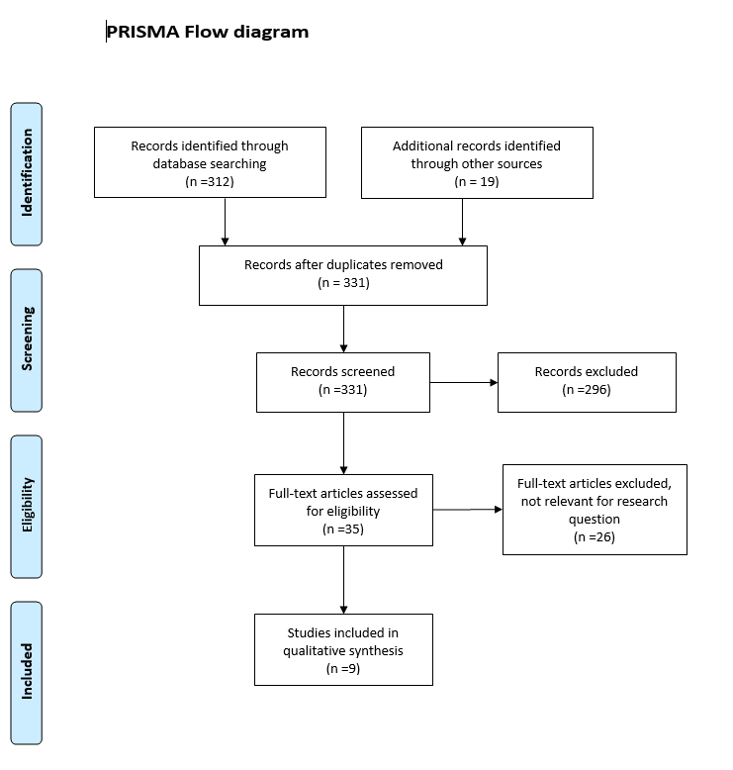
|

Parenting Programmes

What Works
In a 2016 Early Intervention Foundation report on ‘What works to support parent and child interaction in the early years’, the significance of the first five years of a child’s life were outlined: “During this time, the infant grows into an individual who can walk, talk and express an opinion. This dramatic transformation is facilitated by a highly malleable brain that rapidly matures as a result of neurological processes triggered in large part by the child’s environment. Young children thrive in environments that are predictable and responsive to their needs. Children struggle, however, in environments that are neglectful, unpredictable or overwhelming.”
The Local Government Association (2018) that a more holistic approach to parenting programmes has been developed by local authorities since they took on the responsibility for children’s public health in 2015. More targeted approaches have also been developed to support families with complex needs.2 Public Health England (PHE) has developed six early years high impact areas to support the transition of commissioning for 0-5 to local authorities.
The six areas are:
• transition to parenthood and the early weeks
• maternal mental health
• breastfeeding (initiation and duration)
• healthy weight, healthy nutrition (to include physical activity)
• managing minor illnesses and reducing hospital attendance/admissions
• health, wellbeing and development of the child aged two: Two year-old review (integrated review) and support to be ‘ready for school’
Parenting programmes can be delivered in universal and targeted setting. Some are used in both, and some are developed for one setting particularly. A common approach to describing the levels of need and intervention that may be required by children, young people and their families are outlined below:
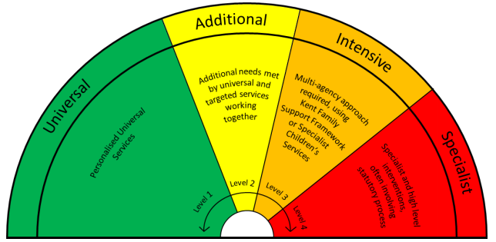
A list of indicators are used to determine which tier level is appropriate to respond to the family’s needs.

What Works: Strength of Evidence for 75 parent-child interventions
In 2016, Early Intervention Foundation conduced a study to determine the strength of evidence and the cost of 75 interventions which aim to support children’s development though parent-child interaction in at least one of three domains: attachment security, behavioural self-regulations and early language and cognitive development. The purpose of this report was the assess quality of evidence against cost of intervention to identify a set of robust programmes to support positive child outcomes.
Please see Appendix A for the table of interventions with evidence and cost rating.
Please see Appendix B for how the cost rating is assessed.
The strength of evidence rating is “primarily based on the intervention’s most robust evidence. This means that findings from a good QED or RCT will override a different finding from a pre/post study with no comparison group in determining a programme’s strength of evidence rating.”1
The review found that the majority of programmes are delivered in a group setting (47%), followed by individual settings (21%), home visiting (16%) and promotion (9%).
Only 4% of the programmes met the level four evidence threshold, meaning that they have evidence from at least two rigorously conducted studies. 19% have initial evidence, 24% have preliminary evidence and 46% did not meet the EIF level 2 threshold.
Below are the interventions which were shown to be robust:
Interventions that support attachment relationship (28 programmes assessed)
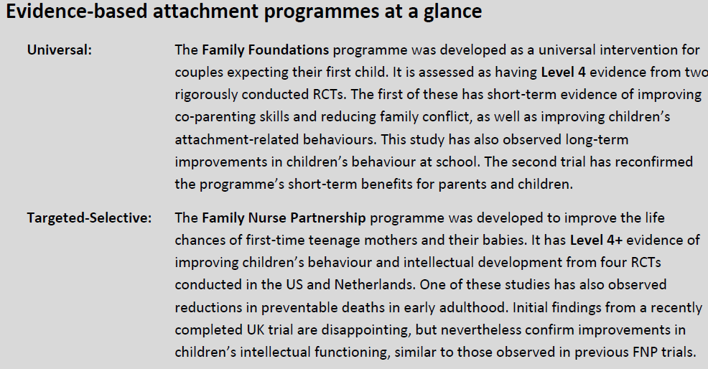
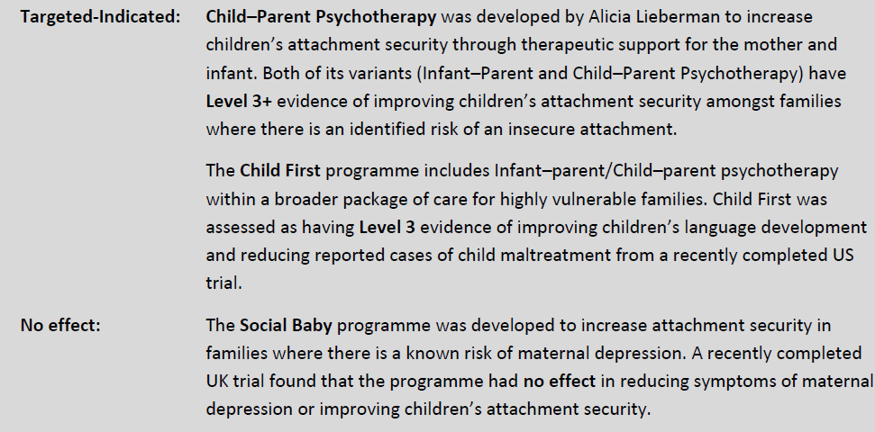
Interventions that help parents manage children’s behaviour
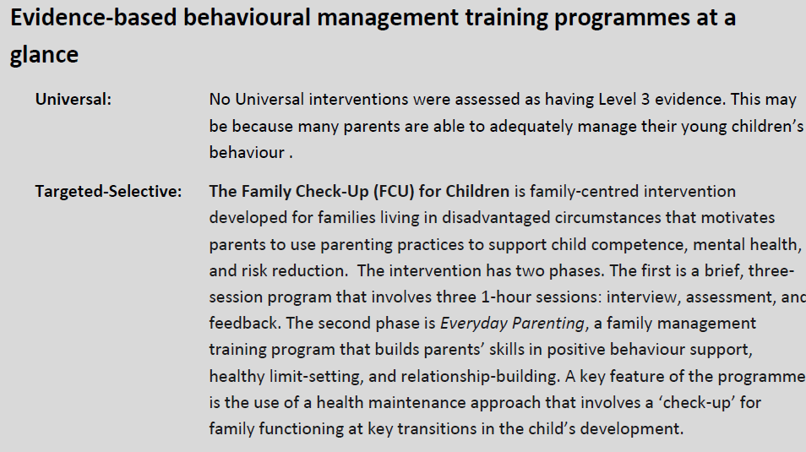
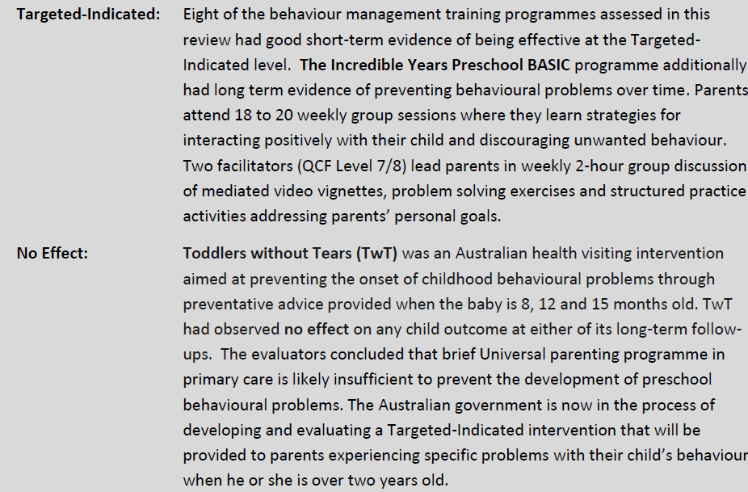

Interventions that support children’s early cognitive and language development
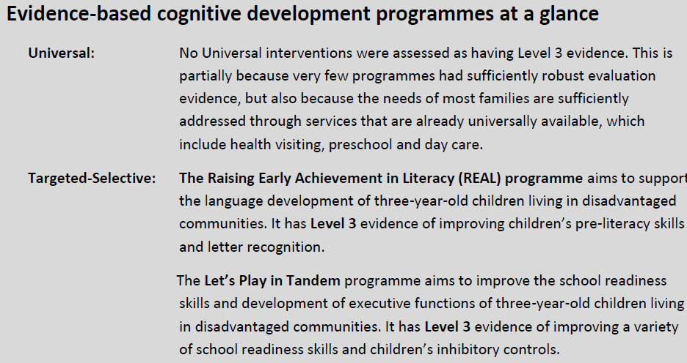
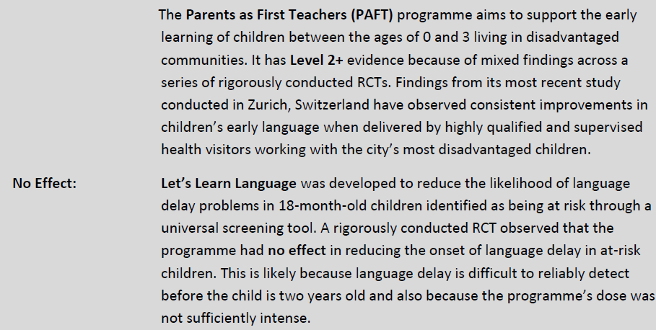

The Healthy Child Programme 0–5

In 2018 the Early Intervention Foundation published a report titled ‘What Works to Enhance the Effectiveness of the Healthy Child Programme: An Evidence Update’. The report states that …“the Healthy Child Programme 0–5 (HCP 0–5) is an evidence-based framework for the delivery of public health services to families with a child between conception and age 5. This is a universal prevention and early intervention programme and forms an integral part of Public Health England’s priority to ensure:
• every woman experiences a healthy pregnancy
• every child is ready to learn by the age of 2
• every child is ready for school by the age of 5
• a reduction in child obesity and inequalities in oral health.”
The programme comprises of child health promotion, child health surveillance screening, immunisations, child development reviews, prevention and early intervention to improve outcomes for children and reduce inequalities.

HCO 0-5 was first introduced in 2009 and was based on evidence from the fourth education of ‘Health for All Children’. The Early Intervention Foundation updated the evidence by conducting two separate evidence reviews. The below table shows the key findings for parents and children during the early years.

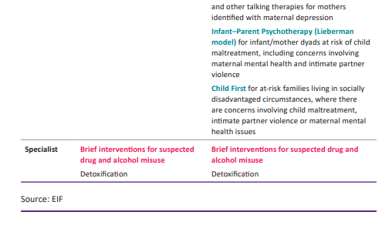
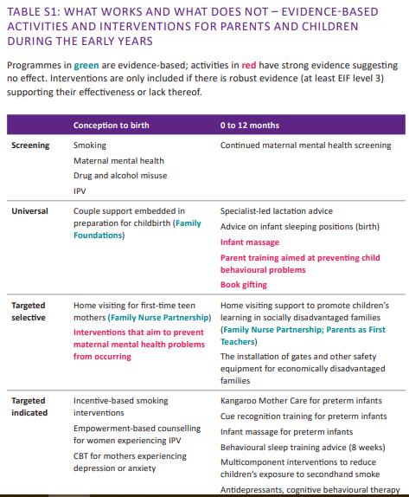

The report found that the knowledge base for the Healthy Child Programme is growing at a rapid pace, and the evidence so far shows that the activities delivered within the programme have a strong evidence base. “For example, studies have now verified that a variety of common screening activities have good evidence of accurately identifying parental mental health problems and effectively monitoring progress. These screening activities also have good evidence of improving parent and child outcomes when evidence-based services are offered as a result.”4 The report also found that many interventions are intensive and long-term including multiple family visits. However it did identify a number of ‘quick wins’ : “relatively short interventions with evidence of improving child and parent outcomes in the short and long term for large sections of the general population.”
These interventions include:
• advice about infant sleeping positions that have dramatically reduced SIDS related deaths over the past 20 years
• parental support offered to couples expecting their first child also appears to measurably improve parents’ ability to establish positive family routines and reduce conflict around childcare issues
• sleep training interventions offered to families experiencing problems with their infant’s sleep at four months or older
• individualised lactation support offered to mothers in the weeks just before and after childbirth.
The report concluded that the HCP 0-5 is a good delivery mechanism for early years intervention for universal programmes as well as targeted programmes. The programme involve minimal additional training for universal programmes whilst a wide variety of targeted indicated interventions could also be delivered by qualified midwives, nurses and health visitors.

Triple P (positive parenting programme)
Triple P: Positive Parenting Programme is one of the most effective evidence-based parenting programmes, backed up by 30 years of ongoing international research. The programme is aimed at children aged 0-1. The programme has 5 Levels which range from a universal approach to tailored approaches for families with complex needs. The aim of the programme is to create a calm and happier family home, teach children the skills they need to socialist and encourage positive behaviour.
Evidence from a randomised controlled trial (RCT) shows that after implementation of Triple P in South Carolina, there was 13-33% reductions in county-wide rates of child maltreatment. The aim of this study was to measure the effect of the Triple P system as implemented community-wide to prevent maltreatment of infants and young children. A further evaluation of a three-year trial in Ireland by UNESCO Child and Family Research Centre found that Triple P interventions led to population-wide change “including reducing cases of children with clinically-elevated emotional and behaviour problems, by 37.5%. The outcomes showed that a pre-emptive public health program can have a huge impact on family wellbeing and entire communities benefit by enhancing traditional models of delivering public health.”
Case Study: Taking parenting help to a mass audience
Sheffield City Council adopted a level 2 “light touch” approach of the Triple P Programme to bring it to a mass audience. Seminars for up to 200 parents are conducted as well as intimate one-off discussion groups. Parenting specialists running the programme report “they are helping them reach more people and “normalise” parenting support.”
“In order to deliver the new levels of support, the parenting team has reduced the number of longer programmes it is delivering by a third. During the next year, Sheffield will evaluate how effective the “light touch” approach is by gathering feedback from those who attend and monitoring referrals for the other parenting programmes.”
A further RCT which measured the effect of the light touch approach of the Triple P programme in Indonesia found that the programme can be effective as well as culturally acceptable. These findings support other bodies of work from China, Japan, Australia, which show that the light touch approach of Triple P can be adjusted and delivered in a culturally appropriate way, which meet the needs of the population.

Delivering parenting programmes online
In response to the COVID-19 pandemic and its effect on public services, the Early Intervention Foundation (EIF) conducted a rapid review on evidence relating to virtual and digital (V&D) delivery of interventions for children and young people. The review and survey found that whilst some interventions have had to pause their delivery, over three-quarters in the survey are adapting their delivery methods to online, phone, text messaging or videoconferencing to enable services to continue. Over 100 virtual and digital interventions for children and young people were listed on clearinghouses and online programme databases. For the purpose of this review, programmes aimed at or included 0-5 year olds will be considered. Universal and targeted programmes were identified which had moved to remote delivery. These include:
 | Universal Programmes | Targeted Programmes
Digital delivery of interactive content |  | Triple P Online (early childhood to age 12) (focused on anti-social behaviour)
Digital delivery of unguided self-help content | Period of PURPLE Crying (ages 0-1) | Crossroads of Parenting and Divorce (Early childhood to age 16)
 | Boot Camp for New Dads (ages 0-1) | Children In Between (early childhood to age 16)
 | All Babies Cry (ABC) (ages 0-1)
Remote delivery of group-based programmes | Fussy Baby Network: Fussy Baby Blues (ages 0-1)
Remote delivery of programmes delivered on a one-to-one bases | Fussy Baby Network: Fussy Baby Warmline
The review found robust evidence for Triple P Online (for children up to 12 years old including 0-5 years):
“Triple P Online aims to improve children’s self-regulation skills and self-confidence, and
to reduce behavioural problems and antisocial behaviour. It is delivered to parents with
children up to 12 years old, with significant social, emotional or behavioural problems.
The programme is delivered via a website which contains eight modules focusing on
positive parenting principles, and includes personalised content, interactive exercises,
and video-based modelling of parenting skills. Two randomised control trials found
that, after completion of the programme, children of participants had significantly
improved behaviour.”4

From the universal programmes, All Babies Cry (ABC) had the strongest evidence:

“All Babies Cry (ABC) aims to reduce parental stress, improve parental understanding
of child behaviour and introduce strategies to calm their baby, with the ultimate aim of
reducing the incidence of infant maltreatment. The programme is delivered primarily via
a package that includes a DVD and a booklet containing four modules which constitute a
set of educational materials. One quasi-experimental study found that, after completion
of the programme, parents reported significantly improved use of strategies to manage
stress, and greater knowledge and self-reassurance.”4

Although the review found that some virtual and digital programmes are effective, they are not proven to be more effective than face-to-face delivery. “V&D interventions are often found to be effective when compared to no treatment or minimal support. However, across the literature, it is less likely to see these interventions tested against interventions that are delivered traditionally, face-to-face. When these comparisons are made, it is rare to find that V&D interventions are superior in terms of outcomes achieved. Typically, V&D interventions are found to be less effective, or equally
as effective.”4 The review did find that the two consistent themes that emerged from the evidence around the effective characteristics of V&D programmes are 1) provision of resources and information is supplemented with additional support from practitioner, and practitioners communicate in real time; 2) Programmes that do not have contact between practitioner and participant are most effective when they are designed to be engaging (quizzes, interactive roleplays, dramatized stories, games).

Limitations and issues were highlighted by respondents (programme developers and providers) in a survey. These included:
- Accessing funding to be able to more to a digital remote platform
- Access to digital platforms for the most vulnerable
- Adapting existing safeguarding procedures
- Setting boundaries (practitioners not feeling they have to be available 24/7)
- Data security
- Adapting practice
- Access to physical ‘safe spaces’
- Maintaining fidelity to the existing programme
Although many interventions are moving to digital delivery, there is no strong evidence to say that the new models are more effective than face-to-face delivery. However, some evidence suggests that for some interventions, either method is as effective as the other.

|

Conclusions
There is a wide body of evidence that has developed around particular parenting programmes, including the HCP 0-5 and the Triple P programme. However more evidence needs to be developed on other programmes and interventions including how these programmes can be developed to be delivered digitally, in times of facing pandemics such as Covid-19. Reviews on digital and virtual delivery of programmes have shown that there are programmes that can be delivered online and that are shown to be as effective as when delivered face-to-face. However, there is no evidence to suggest that digital platforms have a better outcome than face-to-face delivery.

Disclaimer

We hope that you find the evidence search service useful. Whilst care has been taken in the selection of the materials included in this evidence search, the Library and Knowledge Service is not responsible for the content or the accuracy of the enclosed research information. Accordingly, whilst every endeavour has been undertaken to execute a comprehensive search of the literature, the Library and Knowledge Service is not and will not be held responsible or liable for any omissions to pertinent research information not included as part of the results of the enclosed evidence search. Requestors are welcome to discuss the evidence search findings with the librarian responsible for executing the search. We welcome suggestions on additional search strategies / use of other information resources for further exploration. You must not use the results of this search for commercial purposes. Any usage or reproduction of the search output should acknowledge the Library and Knowledge Service that produced it.

|

Appendix A

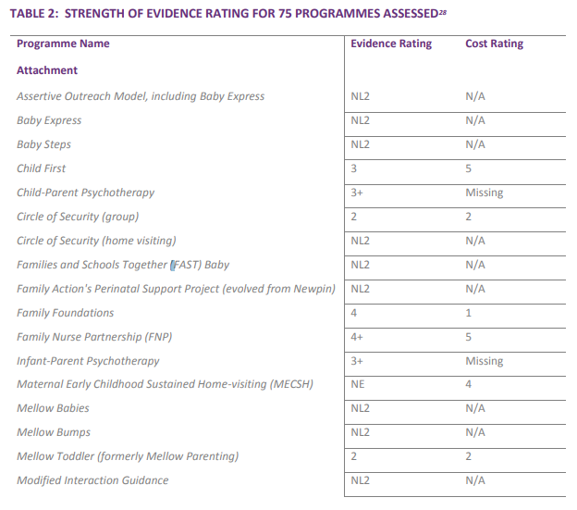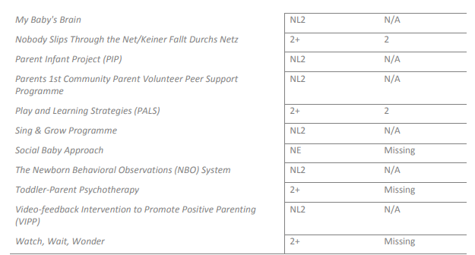
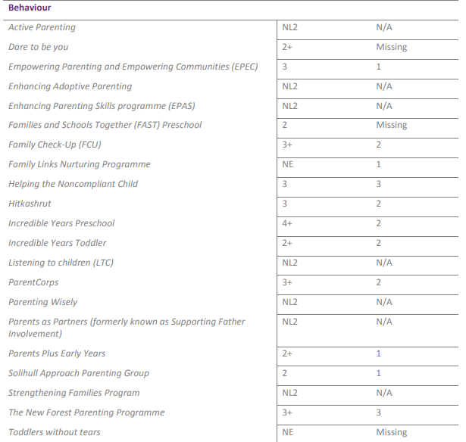
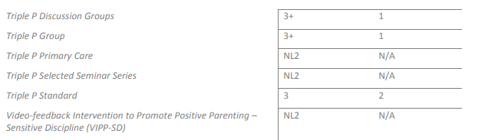
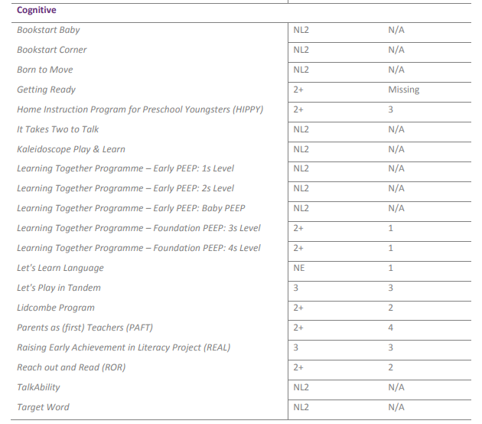

|

Appendix B

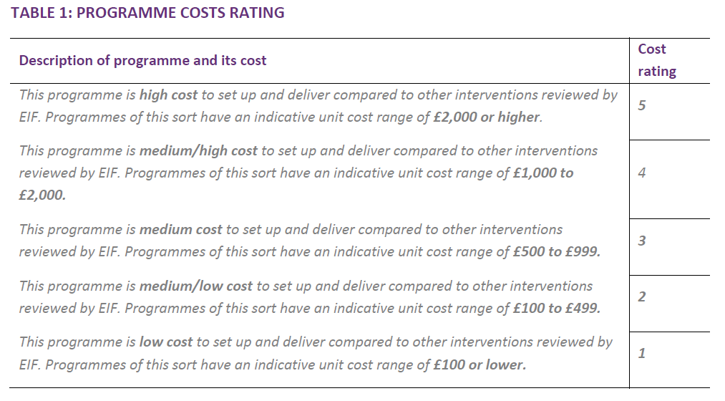

Asmussen, K., Feinstein, L., Martin, J. AND Showdry, H. (2016)Foundations for Life: What works to support parent child interactions in the early years Early Intervention Foundation
Local Government Association (2018) A Better Start: Supporting child development in the early years https://local.gov.uk/sites/default/files/documents/15.51%20A%20Better%20Start_03.pdf
Asmussen, K., Brims, L. (2018) What works to enhance the effectiveness of the healthy child programme: an evidence update Early Intervention Foundation
Hall, D. M., & Elliman, D. (2006). Health for all children: revised fourth edition. Oxford University Press
2017 Evidence Summary for the Triple P System Social Programs That Work Review Laura and John Arnold Foundation https://evidencebasedprograms.org/document/the-triple-p-system-evidence-summary/
Fives, A., Pursell, L., Heary, C., Nic Gabhainn, S. and Canavan, J. (2014) Parenting support for every parent: A population-level evaluation of Triple P in Longford Westmeath. Final Report. Athlone: Longford Westmeath Parenting Partnership (LWPP).
Local Government Association (2016) Working to support positive parenting and relationships: What can councils do? https://www.local.gov.uk/sites/default/files/documents/working-support-positive--437.pdf
Triple P Blog (2016) Sometimes a light touch is all it takes: Triple P Seminars show benefits for Indonesian parents and their children Empirical research, Policy & Practice https://triplepblog.net/triple-p-seminars-for-indonesian-parents-further-cross-cultural-support-that-light-touch-interventions-generate-benefits-for-parents-and-children/
Martin, J., McBride, T Et al (2020) Covid-19 and early intervention Evidence, challenges and risks relating to virtual and digital delivery Early Intervention Foundation

