Literature Review for Amanda Nyeke on Obesity
- Engaging minority groups in Weight-Management Programmes

|
Table of Contents
Introduction 2
Background 2
Search strategy 2
Uptake and Retention 3
Self-Regulating 3
Evidence for Hard to reach individuals 6
Men 6
Ethnicity 8
Type 2 Diabetes prevention 8
Further evidence 9
Learning disabilities 10
Low socio-economic groups 12
Pregnant and postpartum women 14
Conclusion 15

Introduction

Background
Public Health England (PHE) identified obesity as the first of its 7 health priorities in 2014 due to the increasing number of overweight or obese adults in the UK. For most people, bringing their weight down to healthy levels involves both exercising more and eating healthier amounts of healthier foods. Tier 2 lifestyle management programmes are part of a community-wide strategy to prevent obesity. Many people find that participation in a weight management programme helps them to achieve their weight-loss goals.
Some population groups tend to be at higher risk of obesity due to race, age, sex or ability, and so weight management programmes should be targeted at these groups to ensure uptake and retention and to prevent further health risks. Currently, “The provision of mainstream weight management approaches free at the point of access is variable across the country. Where these are provided, they are typically not designed or targeted to meet the needs (lifestyle; behavioural; cultural; psycho-social) or circumstances of these specific population groups”.
For Tier 2 interventions, uptake and retention is essential as evidence shows that the longer (or more sessions) an individual is engaged in a weight management programme (WMP), the more effective the outcome. This has been shown in several studies which include minority groups. Because of this, identifying effective tactics for uptake and retention of WMPs for different minority groups is essential.

Search strategy
Key words were identified and used to search main databases (NICE, TRIP, PubMed, Cochrane). Below outlines the process of selection criteria. Further articles were included from the Public Health England Obesity Bulletin, the 2019 editions were searched for relevant articles. Further articles were included from reference in other materials. 32 articles/reviews were included in the final study.
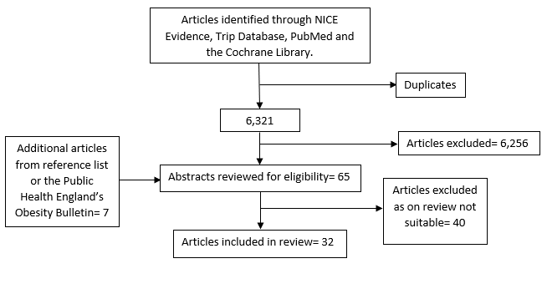

Uptake and Retention

Self-Regulating
Studies have found that self-regulating weight loss is rarely done without external intervention. Self-regulation means controlling your own behaviour, emotions, contact with others and positivity. A self-regulation programme involves tracking weight loss, activity, emotions and discovering what works and what doesn’t. A 2019 UK study showed that self-regulating weight loss is more effective than just daily weighing by an individual. An external prompt improved self-regulation as well as a weigh-in diary to aid tracking and planning. The study also promotes the idea that a reward is effective motivation for retention within a WMP, as participants were rewarded with gift vouchers. Many commercial weight-loss programmes have been developed around this approach and have a high level of success.
Evidence shows that the longer spent engaged in a WMP, the more effective its results become. Public Health England (2018) published a literature review and behavioural report which addressed uptake and retention in group -based weight-management services.

The review identified the most important aspect of programme uptake as: | The most important aspects of programme retention were:
- Capability | - Continued engagement
- Opportunity | - Positive social influence
- Motivation | - Group based delivery including social support
- Social opportunity | - Supportive leader
- Reduced fear of stigma | - Flexibility of group sessions
 | - Inclusion of educational components
 | - Practicalities of attendance
PHE 2018
As social opportunity was found to be the most important component of programme retention, PHE have identified the following interventions to be effective:
- prioritise efforts to foster social support through:
- ensuring that the group leader is supportive
- including activities that encourage support between group members
- including activities that involve participants’ family and friends
- include an educational component to empower participants through increasing knowledge
- include self-monitoring and provision of feedback on behaviour, where possible including biofeedback (eg heart rate monitoring during exercise)
- use graded tasks within programmes to build up sustainable changes in the desired behaviour (eg health-enhancing levels of physical activity; 5 or more fruit and vegetable portions/day) taking the baseline position into account (eg sedentary lifestyle)
- set goals for target behaviours (eg physical activity, diet), as well as for outcomes (eg weight loss, change in % body fat)
- provide sessions that: include exercise classes; are in a convenient location; allow flexibility; ideally, allow choice in delivery mode; are perceived as enjoyable by participants and provide positive reinforcement

The PHE report1 found that the way in which WMPs are ‘sold’ to participants is crucial. “There is an increasing amount of evidence from behavioural insights that the method in which people are invited to take part in preventive health programmes influences participation”1. Location, timing and an understanding of the programme, its content and benefits are other important factors.
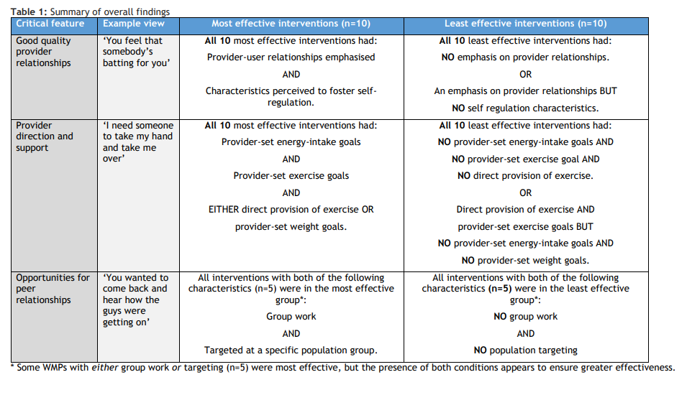
The Policy Research Programme in the Department of Health England commissioned a systematic review of commonalities of effective weight-loss programmes:
‘Targeted to a specific population group’ is noted as being an aspect of the most effective WMPs and the presents of this as well as ‘group work’ had the greatest effect on participants weight loss. The Department of Health England notes that.. “the characteristics of targeted services valued by participants were that they ensured that the providers were those most appropriate for meeting their needs, for example, through ensuring specialist help […] and culturally appropriate assistance”.4

Evidence for Hard to reach individuals

Men
Males have a low level of uptake in WMPs. “Primary care referral to a commercial open-group behavioural weight-loss programme is a cost-effective intervention, but only 10% of patients receiving this intervention are male”. This is because weight loss programmes are rarely aimed at the male market.

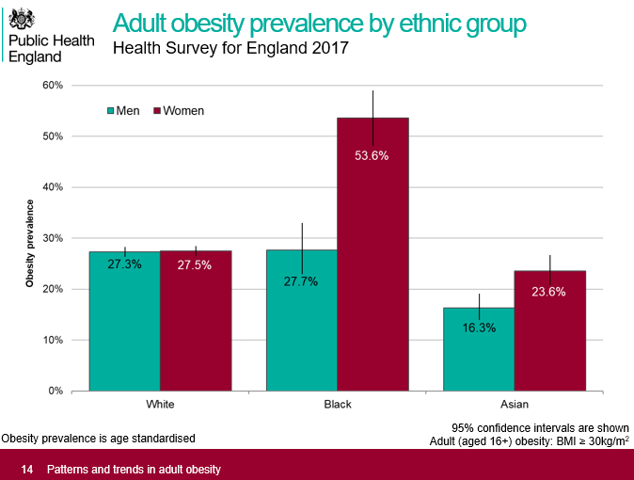 ‘Healthy Dads, Healthy Kids UK, a weight management programme for fathers: feasibility RCT’ (2019) was a trial study which aimed to identify effective interventions for men including men in minority social groups. The study was aimed at fathers, but also included “61% […] from a minority ethnic group; and 54% […] from communities in the most disadvantaged quintile for socioeconomic deprivation” … “Recruitment methods were wide ranging, raising awareness of the study in a number of community settings; however, despite extensive efforts, recruitment to the study was a key challenge”. The overall outcome of the trial was positive, based on response from participants and a positive effect on weight loss. Full attendance of the programme increased weight-loss; however, retention was at 63% after 6 months. Other challenges of the trial were recruitment of an effective male facilitator for the programme and identifying a convenient time for participants to attend sessions.
In 2014 Robertson et al conducted a systematic review of UK interventions (including different settings, design or duration) for men with obesity. From the 26 programmes which were included in the review, “Only seven reports described tailoring intervention delivery to men. Strategies to promote engagement included using male-friendly language, male humour, men-only groups and venues that promoted camaraderie through shared sporting interests.”.7 These strategies were reported as being highly successful in attracting and engaging men with programmes. “The men gave positive evaluations of these interventions, describing them as enjoyable and informative, and welcomed the opportunity to discuss sensitive issues in men-only groups. However, the men-only setting did not appear to be the most important reason for attracting men to join a weight-loss programme. Men particularly enjoyed interventions that were affiliated with their sports club, indicating that this is a potentially useful setting for attracting certain types of men. Indeed, enthusiasm for their chosen football or rugby team appeared to be the biggest driver for motivating men to join the weight-loss programme. These programmes included a structured exercise programme with healthy eating advice, which may suggest that men prefer to lose weight through exercise rather than through a programme requiring adherence to a strict dietary regime. Holding group sessions in the evening was also described as being useful for attendance.”7
Effective tier 2 weight management interventions for men should include:
- Information on weight and health risks -evidence shows that men’s uptake to WMPs are higher when they have had a weight related health scare)
- Informal settings – Informal settings (as appose to health care settings) are shown to improve retention due to relaxed ambiance. Effective places are the workplace or a sports club.
- Physical activity (PA) element- Evidence suggests that men show better weight loss results when they are motivated with a PA. Men are shown to respond to the PA element of a programme better than women. However, PA is not successful on its own.
- No strict dieting- strict dieting is shown to not be appealing or motivating to men. Diets are often seen as feminine. Evidence shows that men are more likely to take advice from a GP as appose to a dietitian.

Ethnicity

Type 2 Diabetes prevention
Evidence shows that there is a link between ethnicity and obesity health risks. Type 2 diabetes is an increasing financial drain for the NHS, due to subsequent health issues onset by Diabetes. However, type 2 diabetes is preventable. Type 2 diabetes treatment accounts for just under nine per cent of the annual NHS budget. This is around £8.8 billion a year. Type 2 diabetes has been shown to be more prominent in some ethnic minorities. Diabetes.co.uk claim “type 2 diabetes is up to 6 times more likely in people of South Asian decent” and “is up to 3 times more likely in African and Africa-Caribbean people”. The Healthier You: NHS Diabetes Prevention Programme (NHS DPP) was launched in 2016 to deliver a systematic approach to support individuals and prevent the risk of diabetes. A 2015 systematic review of the evidence by the NHS concluded that “programmes similar to the NHS DPP can be successful in preventing 26% of people at high risk of Type 2 diabetes from going on to develop the condition. People supported by diabetes prevention programmes lose on average 1.57kg more weight than those not on a programme aiming to significantly reduce diabetes risk“.
Diabetes prevention programmes should be tailored to target those who are at high-risk, although this can be costly it would mean creating several different tailored programmes. The NHS have developed a digital diabetes prevention programme developed from the NHS DPP. Pilot studies have shown an increase in uptake compared to the face-to-face programme. Pilot studies were conducted in 8 sites and represented ethnic minorities; “Sites volunteered to participate in the digital pilot, and were selected to achieve a range of geographies and demograph[ics], including rural, semirural, urban and metropolitan areas, with widely varying proportions of people from black and minority ethnic backgrounds, [socio-economic status] and pre-existing levels of digital readiness and engagement with diabetes prevention”. Success in uptake may be due to the 24/7 accessibility of the programme and the digital aspect which helps engage a wide audience. The programme offers wearable technology which monitors activity as well as online peer support groups. The support groups can help the programme become more targeted. The success of the pilot studies supports the evidence that online support groups may be a cost-effective way to tailor programmes to ethnic minorities.
A 2016 American study aimed to review the potential increase in uptake of ethnic minorities in clinical trials for behavioural weight loss (BWL) programmes and concluded that programmes which included the use of a smart phone had a higher uptake than face-to-face programmes, and programmes which offered both a technological aspect as well as face-to-face sessions had the highest rate of uptake.
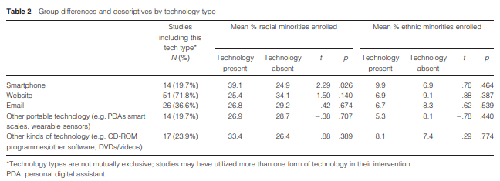

Further evidence
Deprivation- Deprivation is linked to obesity, and evidences shows that “Minority ethnic groups tend to have higher levels of unemployment, experience less social mobility, have lower incomes and are more likely to live in areas of high deprivation within the UK.” 8 Tailoring WMPs to these specific groups in increasingly complicated when they belong to a multiple of minorities.
Cultural Differences- Differences in culture and tradition and perception of body weight can affect obesity levels in minority ethnic groups. “For example, one qualitative study of young Somali women in England found that, whilst they were aware of what constitutes a healthy body size, they were constrained by older Somalis’ cultural attitudes favouring larger body size. Similarly, focus groups with women of Zimbabwean origin suggested that concerns about being overweight were rare in Zimbabwe, but prevalent in the UK” 8
“HABITS, the longitudinal cohort study of adolescent health behaviours in South London, found that an over-estimation of weight was more common in White adolescents and under-estimation of weight was more common in Black adolescents.” 8 Due to difference in perception of weight amongst different minorities, further research needs to be completed on tailoring WMPs to increase the initial uptake from ethnic minority groups.
African Women- Behavioural weight interventions (BWI) are shown to be effective for weight loss generally, however evidence shows that they are less effective for black women. “Several factors may influence the racial disparity in BWI outcomes. Differential adherence to dietary and physical activity (PA) recommendations in BWI between Black and White women may play a role […] Self-reported PA has been reported as higher in White vs. Black women, and PA adherence was strongly related to weight loss in a multicenter trial (Wadden et al. 2009). Taken together, this suggests that greater engagement in PA may improve weight loss.”. A 2019 US study hypothesised that a culturally adapted BWI which encouraged PA would increase weight loss in Black women ages 21-65. The study found that regular monitoring of weight and attendance at the weekly sessions did increase the likelihood of weight loss for black women. However studies should be conducted on the inclusion of a cultural context element to weight loss.

Learning disabilities
Public Health England (2016) stated that “A higher proportion of people with learning disabilities [are] obese. For most of them, the diet and exercise requirements of losing weight are similar to the actions required of others. However, the task of helping them achieve this involves additional complexities.”
NIHR Collaboration for Leadership in Applied Health Research and Care North West Coast (NIHR CLAHRC NWC) (2018) investigated weight management interventions for adults with intellectual disabilities. From conducting interviews, focus groups and surveys they found that there were some systems related issues for those with intellectual disabilities and their carer, including “a lack of accessible healthy lifestyle information, training and resources”.
Healthcare information needs to be adapted for intellectually disabled people to make it accessible. “It’s been shown that the main barrier to participation in physical activity for people with learning disabilities was the lack of understanding of its benefits”… “People with learning disabilities may benefit from health promotion work to help them to understand the health risks of being overweight. This knowledge might be necessary if they are going to maintain healthy lifestyle changes”.15
The evidence shows that:
- promotional health resources are likely to require literacy skills and often use abstract images so accessible information and resources are needed
- people with learning disabilities benefit from a multi-disciplinary and multi-component approach that takes an individualised approach
- people need support to understand the risks to their health to aid sustained motivation so training and appropriate information can help people to feel more positive about physical activity
- the involvement of peer partners without disabilities, who provide reciprocal support, has been shown to encourage participation in exercise in community settings”

Slimming World, who are the UKs largest weight management company have recently launched Easy Read resources to encourage members with learning difficulties and disabilities. A review study found that the Easy Read material was associated with greater weight loss when compared to a control group. Feedback from Slimming World consultants about the material was also positive.
Evidence shows that a multi-component weight loss intervention is effective for adults with intellectual disability. Take 5 is a UK intervention adapted from an existing weight loss programme (Glasgow and Clyde Weight Management Service) for those with intellectual disabilities:“The multicomponent intervention consisted of 9 individual sessions and included a personalised diet with a 2510/d kJ (600 kcal) deficit and behavioural techniques to promote increased PA levels and healthy dietary patterns”.14 Themes discussed in the individual sessions included:
Individualised maintenance dietary planning, the importance of being active and adopting regular eating patterns, regular self- monitoring of weight and food intakes, barriers to healthy eating and physical activity, snacking, lapses, eating out/social activities, healthy menu planning and an overview of the principles of weight maintenance.17
A study was conducted on fifty-four obese (BMI ‡ 30 kg/m2 ) intellectually disabled adults (‡18 years old) on the effect of the Take 5 programme and found that “Approximately 50% of the participants lost 5% or more of their initial body weight.” In 2017, a further study looked at the benefits of Take 5 against a general health education programme and concluded that multi-component weight loss programmes (Take 5) including energy deficit diet (EDD) are much more effective for weight loss in intellectually disabled individuals.
A 2017 review of multi-component weight loss programmes for intellectually disabled individuals notes that “TAKE 5 may not reflect current routine practice. It is not clear whether the implementation of such highly intensive, personalized one- to- one interventions is sustainable in routine practice following completion for trials of such interventions.”
It is known that interventions for individuals with intellectual disabilities who are obese or overweight need to be tailored to meet their needs. However, further studies are needed to identify effective aspects of weight loss programmes.

Low socio-economic groups
The risk of being overweight or obese is even higher among people of lower socio-economic status. Socio-economic status (SES) is a combined measure of an individual’s income, education level and occupation. Evidence suggests that the increased risk of obesity in low socio-economic groups is a result of those living in more deprived areas engaging in more unhealthy behaviours (smoking, drinking) and fewer healthy behaviours (physical activity, eat healthy diets) than those living in more affluent areas.

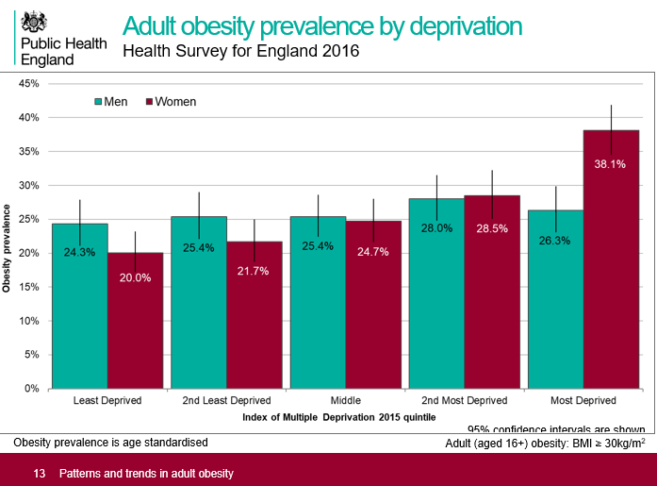
A 2018 research article aimed to “identify important factors to consider when tailoring lifestyle interventions for low SES populations”21. They interviewed 25 participants from the North West of England on their experiences of receiving, delivering and following a weight loss intervention within a low socio-economic community. The site was chosen due the populations poorer health, lower life expectancies and lower rates of employment compared to the UK average.
They found that “Not only were there issues around cost in relation to buying healthy food, but its availability in the area was also identified as an issue to making dietary changes. The most deprived areas were highlighted as having limited availability of fresh and cheap healthy food, and many service users described having to take at least one bus to get to their nearest supermarket, which meant sometimes taking a taxi home because of the weight of the shopping”21. The study also highlighted the importance of a weight loss intervention focusing on a low-pressure, information giving approach because of the fear of disengaging a hard to reach group.
A 2019 study assessed how deprivation can affect uptake and retention of a weight loss programme, and at what point from referral to weight loss goal reached, are these differences most effective. They found that “participants from lower socioeconomic backgrounds were more likely to accept the offer and equally likely to attend a weight loss referral but attended fewer sessions”.
Tabak et al (2018) studied the development of a scalable weight loss intervention for low-income workers through the adaptation of the interactive obesity treatment approach (iOTA). The US study was based in the workplace of low economic individuals and aimed to understand their workplace culture, and where health habits can fit into their daily routines. “Workplace-based efforts that promote diet and activity behavior change among low-income employees have potential to address the obesity epidemic”. The study adapted an already proven to be effective programme called Be Fit Be Well (BFBW), so that it could be applied to different workplace settings and target low socio-economic workers. The programme was largely technology based, in that the sessions were delivered via computer or phone at the workplace, depending on resource available. This meant that individuals did not have to travel and interact with the programme and unsuitable times. The benefit of the adapted programme, ‘Work For You’ (WFY), was that it could be scalable and implemented into different settings in an inexpensive way.

Pregnant and postpartum women
There are a number of health risks which develop as a result of obesity when pregnant for the mother and infant. NHS England have stated that “About half of women of childbearing age in England are either overweight or obese.” and that “research shows an intergenerational effect with higher risks for children whose parents are obese or overweight.” Tackling the weight at the right stage can help prevent obesity for both generations.
A 2013 systematic review of the qualitative evidence found that a major theme which effected weight management for was lack of information for expectant mothers. The review concluded that “evidence suggests that the complexity of interactions with advice sources, bodily changes, feelings of control, as well as perceived risks may explain the relative ineffectiveness of weight management interventions during pregnancy. Focusing on healthy diet and physical activity levels may be more useful and less stigmatising than focusing on weight”. A 2020 UK study into weight management advice during pregnancy found that women are more interested in hearing positive messages around what they should/could do to improve weight, rather than what they shouldn’t be doing. The study also concluded that “A well-designed digital intervention could improve access to pregnancy-specific nutrition information; empowering midwives to communicate patient-centred, healthy eating messages with confidence.”
In the UK, current NICE guidelines suggest “Local authority leisure and community services should offer women with babies and children the opportunity to take part in a range of physical or recreational activities. This could include swimming, organised walks, cycling or dancing. Activities need to be affordable and available at times that are suitable for women with older children as well as those with babies. Where possible, affordable childcare (for example, a creche) should be provided and provision made for women who wish to breastfeed.”
A 2018 UK systematic review of lifestyle interventions in overweight and obese pregnant or postpartum women for postpartum weight management found that “in order to reduce postpartum weight, short, intensive interventions including diet or diet and physical activity, commencing in the postpartum period, may be effective.” Eighteen studies were included in the review but it was concluded that there was not sufficient evidence to suggest effective interventions for pregnant or postpartum women without further research into the interventions long-term effects.

Conclusion
Evidence confirms that WMPs should be tailored to target specific minority groups which are at high risk of obesity and subsequent health problems. More work needs to be done to investigate what methods are best used in engaging hard to reach minority groups. The richest evidence shows that creating online platforms for interventions is an effective way to reach a larger number of people, including minority groups, however by adapting a technical approach, this could isolate non-tech savvy groups. Therefore, a mixed methods approach to WMPs should be most effective. Online support groups which can be tailored to group needs as an extension of a WMP has shown to be a cost-effective approach.

Disclaimer

We hope that you find the evidence search service useful. Whilst care has been taken in the selection of the materials included in this evidence search, the Library and Knowledge Service is not responsible for the content or the accuracy of the enclosed research information. Accordingly, whilst every endeavour has been undertaken to execute a comprehensive search of the literature, the Library and Knowledge Service is not and will not be held responsible or liable for any omissions to pertinent research information not included as part of the results of the enclosed evidence search. Requestors are welcome to discuss the evidence search findings with the librarian responsible for executing the search. We welcome suggestions on additional search strategies / use of other information resources for further exploration. You must not use the results of this search for commercial purposes. Any usage or reproduction of the search output should acknowledge the Library and Knowledge Service that produced it.

Public Health England (2018) Uptake and retention in group-based weight-management services: Literature review and behavioural analysis [Assessed 08/01/2019] <https://www.gov.uk/government/publications/uptake-and-retention-in-group-based-weight-management-services>
NHS England (N.D) ‘Tier 2 weight management services’ Online [Assessed on 15/01/2020] Available at <https://www.england.nhs.uk/ltphimenu/prevention/tier-2-weight-management-services/>
Frie, K., Hartmann-Boyce, J., Jebb, S., Aveyard, P. (2019). Testing the effectiveness of a weight loss intervention to enhance self-regulation in adults who are obese: protocol for a randomised controlled trial. BMJ Open. 9. e031572. 10.1136/bmjopen-2019-031572.
K Sutcliffe, M Richardson, R Rees, H Burchett , GJ Melendez-Torres, C Stansfield, J Thomas1 1 EPPI-Centre, Social Science Research Unit, UCL Institute of Education, University College London, London, UK ‘What are the critical features of successful Tier 2 weight management programmes?’ (2016)
Ahern, A., Aveyard, P., Boyland, E., Halford, J., Jebb, S. Inequalities in uptake of weight management intervention in a pragmatic trial Br J Gen Pract 2016; DOI: 10.3399/bjgp16X684337
Griffin T, Sun Y, Sidhu M, et al. Healthy Dads, Healthy Kids UK, a weight management programme for fathers: feasibility RCT. BMJ Open 2019;9:e033534. doi:10.1136/ bmjopen-2019-033534
Health Technol Assess. (2014) ‘Systematic reviews of and integrated report on the quantitative, qualitative and economic evidence base for the management of obesity in men’. May;18(35):v-vi, xxiii-xxix, 1-424. doi: 10.3310/hta18350
NHS (N.D) ‘NHS Diabetes Prevention Programme (NHS DPP)’ [Online][Assessed on 29/01/2020] Available at <https://www.england.nhs.uk/diabetes/diabetes-prevention/>
Diabetes.co.uk (2019) ‘Diabetes and Ethnicity’ [Online][Assessed on 29/01/2020] Available at <https://www.diabetes.co.uk/diabetes-and-ethnicity.html>
NHS (2015) ‘Five million people at high risk of Type 2 diabetes, new figures estimate’ [Online][Assessed on 29/01/2020] Available at < https://www.england.nhs.uk/2015/08/type-2/ >
Murray E, Daff K, Lavida A, et al (2019) ‘Evaluation of the digital diabetes prevention programme pilot: uncontrolled mixed-methods study protocol’ BMJ Open;9:e025903. doi: 10.1136/bmjopen-2018-025903
D. L. Rosenbaum, A. D. Piers, L. M. Schumacher, C. A. Kase and M. L. Butryn (2016) ‘Racial and ethnic minority enrollment in randomized clinical trials of behavioural weight loss utilizing technology: a systematic review’ Obesity Reviews doi: 10.1111/obr.12545
Loneke T. Blackman Carr, Carmen D. Samuel-Hodge, Dianne S. Ward, Kelly R. Evenson, Shrikant I. Bangdiwala & Deborah F. Tate (2019): Comparative effectiveness of a standard behavioral and physical activity enhanced behavioral weight loss intervention in Black women, Women & Health
Public Health England, (2016) ‘Obesity and Weight Management for People With Learning Disabilities: Guidance’ Public Health England: Online [Assessed on 06/01/2020] Available at <https://www.gov.uk/government/publications/obesity-weight-management-and-people-with-learning-disabilities/obesity-and-weight-management-for-people-with-learning-disabilities-guidance>
National Institute of Healthcare Research (2018) ‘Weight management interventions for adults with intellectual disabilities who are obese’ CLAHRCBITE: Online [Assessed on 03/01/2020] Available at < https://clahrcprojects.co.uk/resources/bites/weight-management-interventions-adults-intellectual-disabilities-who-are-obese>
Bennett, S. E., Lovell, E. Toon, J. et al (2018) ‘Demand for Easy Read resources for people with a learning disability accessing weight loss services’ Slimming World, Alfreton, UK.
Spanos, D. et al (2010) ‘‘Take 5’ – a weight loss intervention for adults with intellectual disabilities and obesity’ Proceedings of the Nutrition Society 69 (OCE6), E505 doi:10.1017/S002966511000368X
Harris, Leanne; Hankey, Catherine; Jones, Nathalie; Pert, Carol; Murray, Heather; et al.(2017) ’A cluster randomised control trial of a multi-component weight management programme for adults with intellectual disabilities and obesity’ The British Journal of Nutrition; Cambridge Vol. 118, Iss. 3: 229-240. DOI:10.1017/S0007114517001933
Doherty, A. J., Jones, S. P., Chauhan, U. (2017) ‘An integrative review of multicomponent weight management interventions for adults with intellectual disabilities’ Journal of Applied Research in Intellect Disabilities. 2018;31(Suppl. 1):39–51.
Miner L, Bolding P, Hilbe J, Goldstein M, Hill T, Nisbet R, Walton N, Miner G, (2014) ‘Practical predictive analytics and Decisioning Systems for Medicine’: Academic Press
Coupe et al. BMC Public Health (2018) 18:967 https://doi.org/10.1186/s12889-018-5877-8
Public Health England (2019) ‘Patterns and Trends in Adult Obesity’ PHE: London [Online] [Assessed on 15/01/2020] Available at <https://digital.nhs.uk/data-and-information/publications/statistical/health-survey-for-england>
Graham et al. (2019) ‘The equity impact of brief opportunistic interventions to promote weight loss in primary care: secondary analysis of the BWeL randomised trial’ BMC Medicine 17:51 https://doi.org/10.1186/s12916-019-1284-y
Tabek, R. Et al (2018) ‘Development of a scalable weight loss intervention for low-income workers through adaptation of interactive obesity treatment approach (iOTA)’ BMC Public Health
NHS England (N.D) ‘Tier 2 weight management programmes’ [Online] [Assessed on 22/01/2020] Available at < https://www.england.nhs.uk/ltphimenu/prevention/tier-2-weight-management-services/ >
Johnson, M Et al (2013) ‘Weight management during pregnancy: a systematic review of qualitative evidence’ DOI: https://doi.org/10.1016/j.midw.2012.11.016
Abayomi JC; Charnley MS; Cassidy L; Mccann MT; Jones J; Wright M; Newson LM (2020) ‘A patient and public involvement investigation into healthy eating and weight management advice during pregnancy’ DOI 10.1093/intqhc/mzz081
NICE (2010) ‘Weight management before, during and after pregnancy’ Public health guideline [PH27]Published date: July 2010 [Assessed 06/02/2020]
Dalrymple, K. V., Flynn, A. C., Relph, S. A., O'Keeffe, M., & Poston, L. (2018). ‘Lifestyle Interventions in Overweight and Obese Pregnant or Postpartum Women for Postpartum Weight Management: A Systematic Review of the Literature’. Nutrients, 10(11), 1704. doi:10.3390/nu10111704

