National Child Measurement Programme 2021/22

March 2023

Table of Contents
Executive summary 3
Introduction 3
Key findings 3
Call to action 3
Profile of the 2021/22 Year R and Year 6 data 3
Year R analysis at Kent level 4
Weight category trends 4
Inequalities analysis 5
Year 6 analysis at Kent level 11
Inequalities analysis 11
Year 6 analysis at district level 11
Appendix 14
References 14

Executive summary

Introduction
This report presents the findings from the National Child Measurement Programme (NCMP) for the 2021/22 academic year for children in mainstream state schools in Kent. Children are measured in reception year (age 4-5) and year six (age 10-11).

Key findings
- More than 1 in 5 children in reception year were either overweight or obese in Kent in 2021/22.
- Reception year children living in the most deprived areas in Kent were twice as likely to be living with obesity than children in the least deprived areas. Obesity in children in the most deprived areas has reduced to 2019/20 levels following an increase in the 2020/21 academic year.
- Black children in Year R have a higher prevalence of obesity than White children in the latest year.
- Obesity analysis by ethnic group should be interpreted with caution due to differences in physical characteristics by ethnicity. BMI includes height measurement and this has been shown to overestimate obesity in Black children¹
- More than 1 in 3 children in Year 6 were either overweight or obese in Kent in 2021/22.
- Obesity, excess weight and severe obesity for Year 6 children were significantly higher in the latest year compared to 2019/20.

Call to action
- To help prevent excess weight in infants by improving awareness of responsive feeding.
- To support the early years settings to implement the voluntary food and drink guidance.
- To pilot a relationship with food programme for families and pregnant women.

Profile of the 2021/22 Year R and Year 6 data
88% of Year R children and 86.9% of Year 6 children were measured in Kent in 2021/22. The deprivation profile of the measured children was similar to previous years for Year R and Year 6. The ethnicity profile was also similar, although the proportion of not stated or missing ethnicity has increased in Year R in recent years.
In 2020/21, 10.6% of Year 6 pupils were measured due to the Covid-19 pandemic and the participation distributions showed it was not a representative sample. The participation distributions in the latest year suggest that the sample is robust for both Year R and Year 6.

Year R analysis at Kent level

Weight category trends
Figure 1: Year R, weight category trends in Kent, 2017/18 - 2021/22
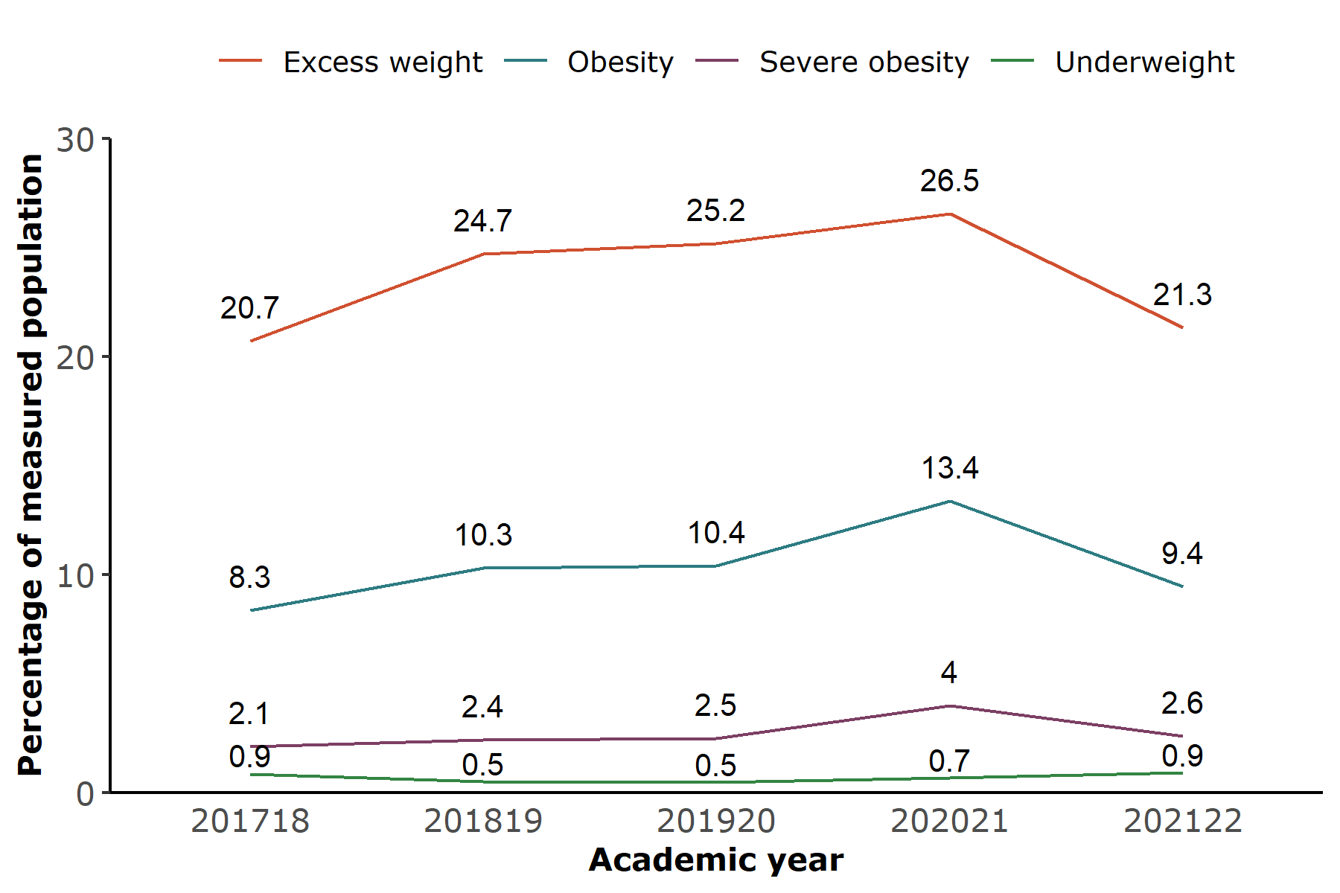 Source: NCMP, prepared by KPHO (SR) January 2023

Excess weight is defined as being obese or overweight.
In reception the prevalence of obesity, excess weight and severe obesity decreased in Kent in the latest year. In 2021/22, 21.3% of reception children had excess weight compared to 26.5% in the previous year. 9.4% of reception children were living with obesity compared to 13.4 in the previous year.
These figures are slightly lower than the England average and the differences are statistically significant. In England in 2021/22, 22.3% had excess weight, 10.1% were living with obesity and 2.9% were severely obese.

Inequalities analysis

Obesity by deprivation
Figure 2: Year R, prevalence of obesity by deprivation in Kent, 2017/18 - 2021/22 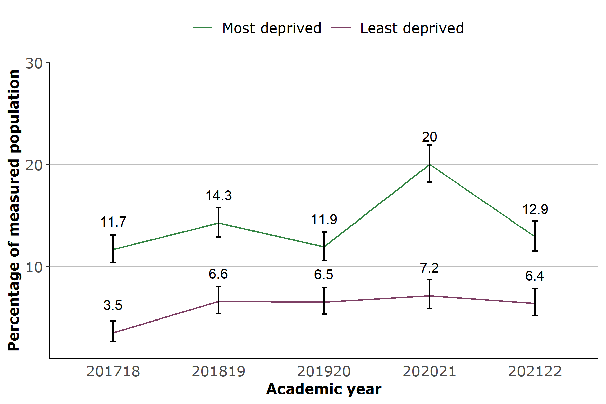 Source: NCMP, prepared by KPHO (SR) January 2023

The most and least deprived areas are defined as the parts of Kent ranked among the most and least deprived tenth of the population. These are also referred to as ‘deprivation deciles’.
In 2021/22 Year R children living in the most deprived areas were twice as likely to be obese than children living in the least deprived areas (12.9% and 6.4% respectively). In the latest year obesity in the most deprived group reduced to 2019/20 levels, following an increase in 2020/21.
In England in 2021/22, 13.6% of reception year children in the most deprived group were living with obesity compared to 6.2% in the least deprived group.
A similar change is evident for children with excess weight. The gap between most and least deprived has reduced to 2019/20 levels primarily due to a statistically significant reduction in the most deprived quintile.

Obesity by ethnicity
Figure 3: Year R, prevalence of obesity by ethnicity in Kent, 2017/18 - 2021/22 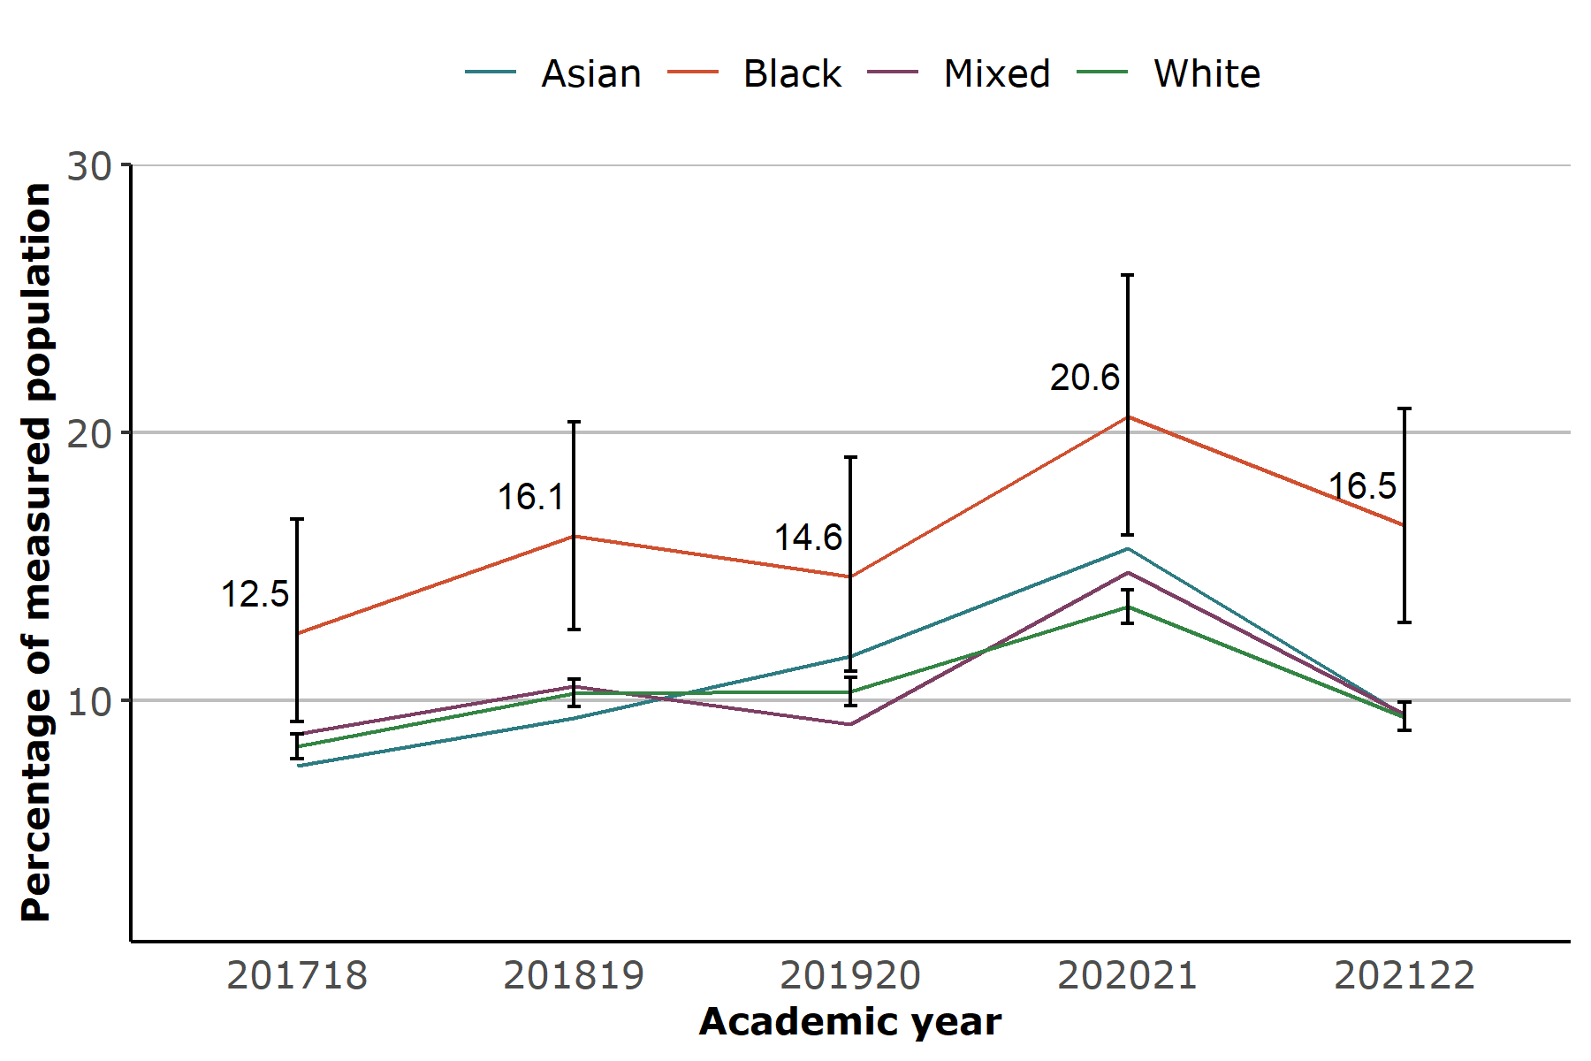 Source: NCMP, prepared by KPHO (SR) January 2023

Black children in Year R had a higher prevalence of obesity than White children in 2020/21 (20.6% compared to 13.5%) and this remained the case in the latest year (16.5% and 9.4% respectively).
A similar difference exists for the excess weight category with 30.6% of Black children having excess weight and 21.8% of White children.
In 2021/22 the prevalence of obesity for Black children in Year R in England was 16.2%, for White children this was 9.7%.
Obesity analysis by ethnic group should be interpreted with caution due to differences in physical characteristics by ethnicity. BMI includes height measurement and this has been shown to overestimate obesity in Black children¹.

Table 1: Year R: obesity by ethnicity in Kent, 2017/18 - 2021/22
Obese % | 201718 | 201819 | 201920 | 202021 | 202122
Asian | 7.6 | 9.3 | 11.6 | 15.7 | 9.5
Black | 12.5 | 16.1 | 14.6 | 20.6 | 16.5
Mixed | 8.7 | 10.5 | 9.1 | 14.8 | 9.5
White | 8.3 | 10.3 | 10.3 | 13.5 | 9.4
Source: NCMP, prepared by KPHO (SR) March 2023

Obesity by gender
The prevalence of obesity was similar among Year R girls and boys in Kent in 2021/22 (9.2% and 9.6% respectively) and there was a reduction in both groups since the previous year (13.6% and 13.1% in 2020/21).
Boys in reception year in England in 2021/22 had a higher prevalence of obesity than girls (10.3% and 9.9% respectively).

Obesity prevalence
Figure 4: Year R, prevalence of obesity by district in Kent, 2021/22 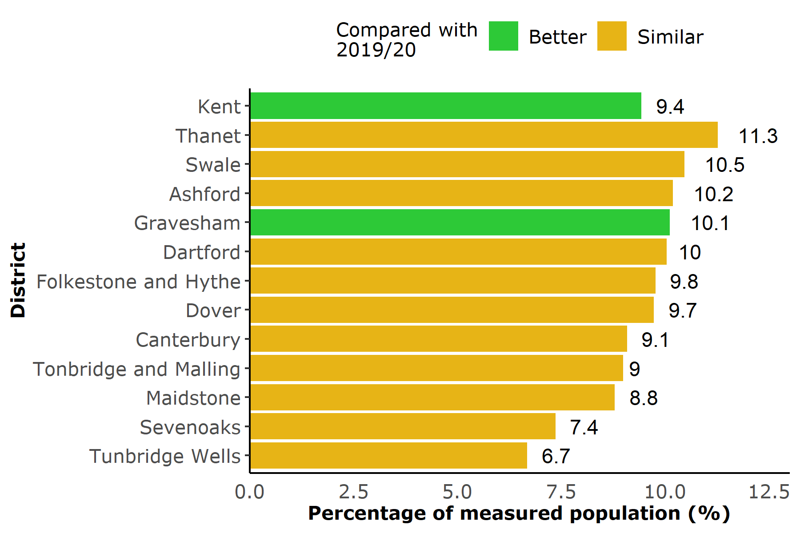 Source: NCMP, prepared by KPHO (SR) February 2023

Across Kent, the prevalence of obesity in Year R was significantly lower in 2021/22 compared to 2019/20.
The prevalence of obesity in most districts has not changed significantly compared to 2019/20. This is likely due to insufficient statistical power in the calculations. The one exception is Gravesham which shows a significant reduction.

Excess weight prevalence
Figure 5: Year R, prevalence of excess weight by district in Kent, 2021/22 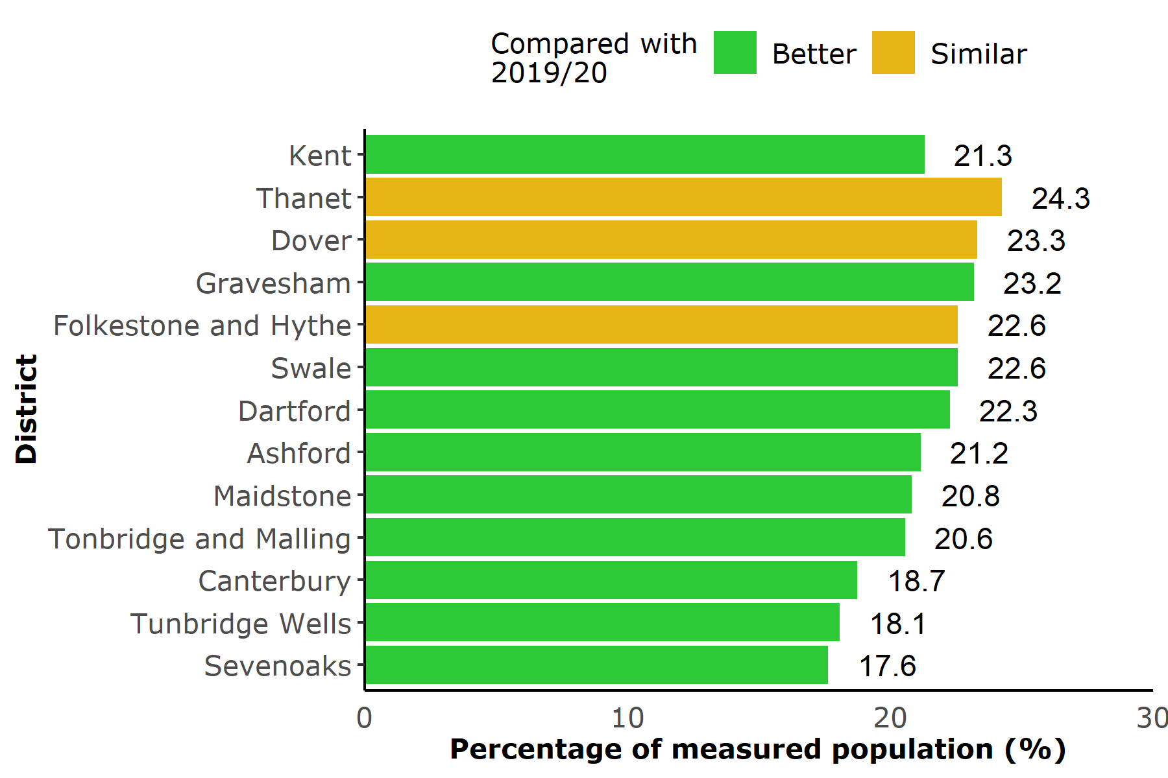 Source: NCMP, prepared by KPHO (SR) February 2023

Most districts had lower levels of excess weight in Year R than they had in 2019/20. For Thanet, Dover and Folkestone and Hythe excess weight was similar to 2 years ago.
Thanet had a significantly higher prevalence of excess weight in Year R children in 2021/22 compared to the Kent average (24.3% and 21.3% respectively).

Severe obesity prevalence
Figure 6: Year R, prevalence of severe obesity by district in Kent, 2021/22 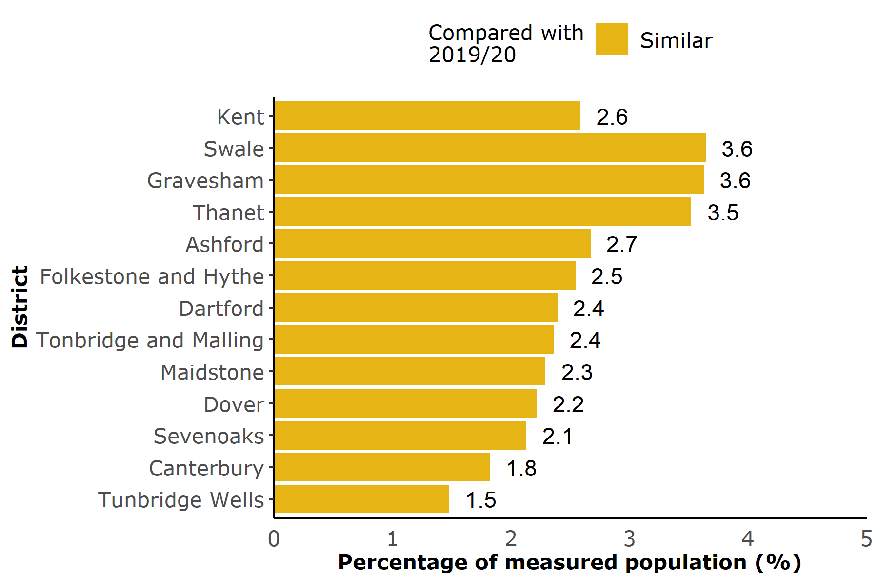 Source: NCMP, prepared by KPHO (SR) February 2023

In 2021/22 reception year children had similar levels of severe obesity by district compared to 2019/20. Swale and Gravesham districts had significantly higher levels of severe obesity, (both 3.6%), than the Kent average (2.6%) in the most recent year.

Year 6 analysis at Kent level

Inequalities analysis

Obesity by deprivation
In 2021/22, Year 6 children living in the most deprived areas of Kent were more than twice as likely to be living with obesity than those living in the least deprived areas, 30.4% compared to 13.2%. For England this was 31.3% compared to 13.5%.

Year 6 analysis at district level

Obesity prevalence
Figure 7: Year 6, prevalence of obesity by district in Kent, 2021/22 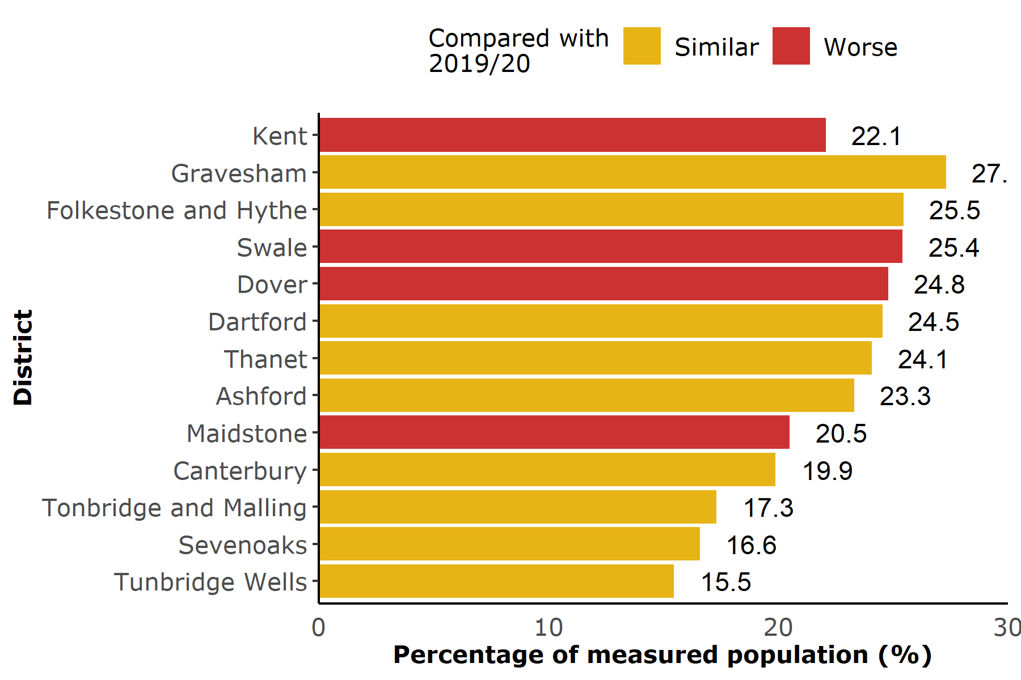 Source: NCMP, prepared by KPHO (SR) February 2023
The prevalence of obesity in Kent Year 6 children increased significantly in 2021/22 compared to 2019/20 (22.1% compared to 19.9%). Swale, Dover and Maidstone districts also had higher levels of obesity in 2021/22 compared to 2019/20.
Gravesham, Folkestone and Hythe, Swale, Dover and Dartford districts had a significantly higher prevalence of obesity than the Kent average in 2021/22.
In 2021/22, 23.4% of Year 6 children in England were living with obesity.

Excess weight prevalence
Figure 8: Year 6, prevalence of excess weight by district in Kent, 2021/22 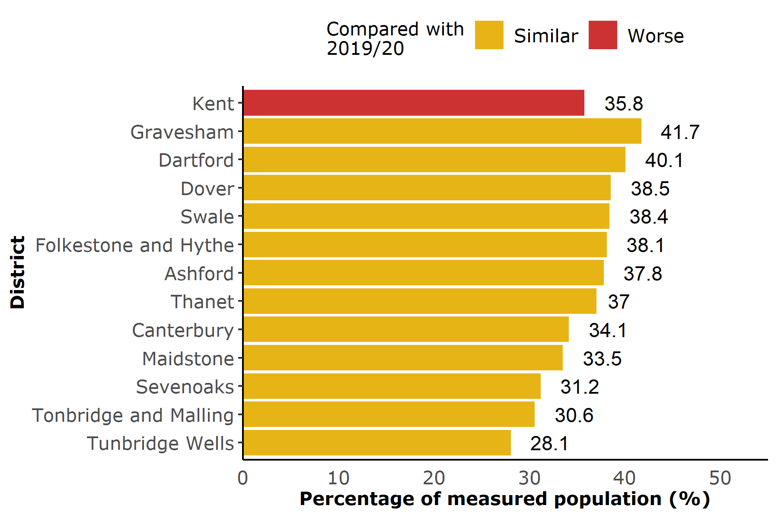 Source: NCMP, prepared by KPHO (SR) February 2023
The prevalence of excess weight in Kent Year 6 children increased in 2021/22 compared to 2019/20 (35.8% compared to 34.6%). None of the districts had significant increases in 2021/22 from 2019/20. This is likely due to insufficient statistical power in the calculations.
Gravesham and Dartford districts had significantly higher prevalence of excess weight than the Kent average in 2021/22 (41.7% and 40.1% respectively).
In the latest year England had a significantly higher level of excess weight in children in Year 6 (37.8%) than Kent (35.8%).

Severe obesity prevalence
Figure 9: Year 6, prevalence of severe obesity by district in Kent, 2021/22 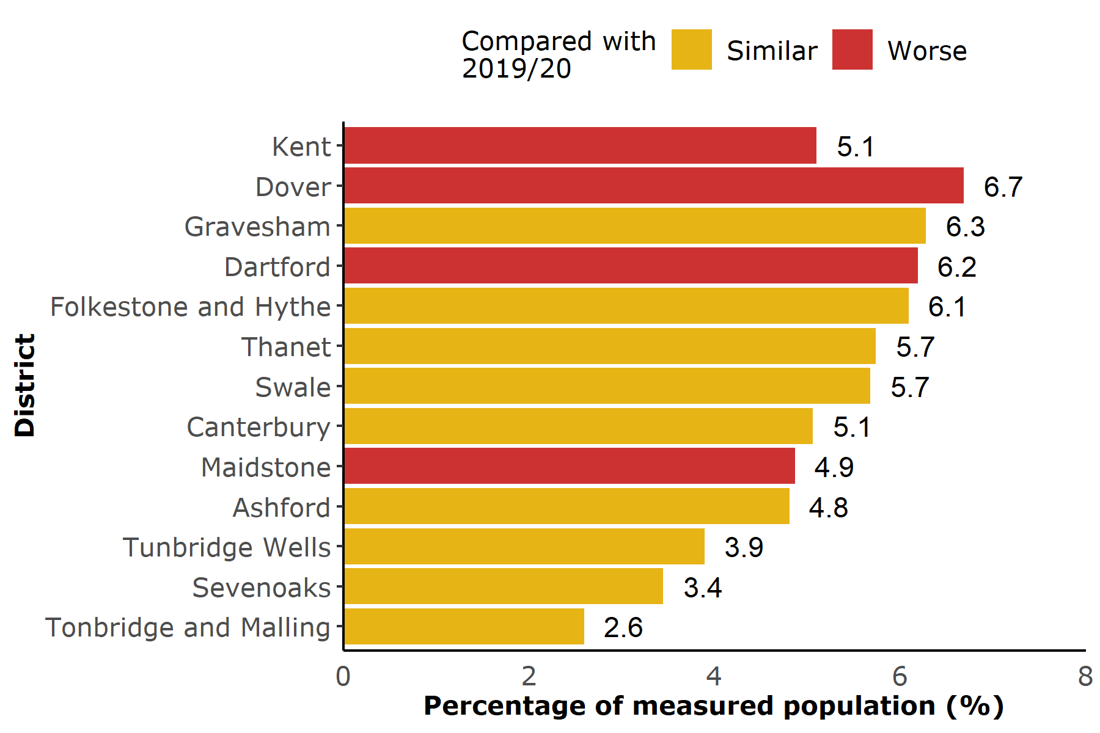 Source: NCMP, prepared by KPHO (SR) February 2023
The prevalence of severe obesity in Kent Year 6 children increased in 2021/22 compared to 2019/20 (5.1% compared to 4.2%). Dover, Dartford and Maidstone districts also had higher levels of severe obesity in 2021/22 compared to 2019/20.
Dover district had significantly higher prevalence of severe obesity than the Kent average in 2021/22 (6.7%).
In the latest year England had a significantly higher level of severe obesity in children in Year 6 (5.8%) than Kent (5.1%).

Appendix
The height and weight measurements of children in reception year and year six are recorded annually as part of the National Child Measurement Programme.
Children living in Kent and attending mainstream Kent schools were included in the analysis. Children attending Free schools were included.
Year 6 data for the academic year 2020/21 has not been presented as it was not a representative sample.

References
- GOV.Uk. 2019. Differences in child obesity by ethnic group. [online] Available at: https://www.gov.uk/government/publications/differences-in-child-obesity-by-ethnic-group/differences-in-child-obesity-by-ethnic-group#fn:3 [Accessed 04 April 2023].

