National Child Measurement Programme 2022/23

February 2024

Table of Contents

Executive summary 3

Introduction 3

Key findings 3

Profile of the 2022/23 Year R and Year 6 data 4

Year R analysis at Kent level 4

Weight category trends 4

Inequalities analysis 6

Year R analysis at district level 9

Year 6 analysis at Kent level 12

Weight category trends 12

Inequalities analysis 13

Year 6 analysis at district level 16

Appendix 19

References 19

# Executive summary

## Introduction

This report presents the findings from the National Child Measurement Programme (NCMP) for the 2022/23 academic year for Kent resident children attending mainstream state schools in Kent. Children are measured in reception year (age 4-5) and year six (age 10-11).

The source of the data for the analysis in this report comes from the pupil level NCMP dataset. This enables analysis to be produced which is not available in the national report.

Where England data is quoted, this is from NHS Digital, National Child Measurement Programme: <https://digital.nhs.uk/services/national-child-measurement-programme>

## Key findings

* More than 1 in 5 children in reception year were either overweight or obese in Kent in 2022/23.
* Reception year children living in the most deprived areas in Kent were more than twice as likely to be living with obesity than children in the least deprived areas. Obesity in children in the most deprived areas in 2022/23 was similar to 2021/22.
* Black children in Year R have a higher prevalence of obesity than White children in the latest year.
* Ethnicity recording has been getting worse. The proportion of ‘not stated’ or missing ethnicity was 15.3% for Year R and 9.6% for Year 6 in the latest year.
* More than 1 in 3 children in Year 6 were either overweight or obese in Kent in 2022/23.
* Gravesham had a higher prevalence of severe obesity than the Kent average in both Year R and Year 6. Thanet also had a higher prevalence for Year 6.
* The prevalence of severe obesity in Year 6 children increased significantly in Tonbridge and Malling in 2022/23 compared to the previous year, from 2.6% to 4.1%.

# Profile of the 2022/23 Year R and Year 6 data

92.9% of Year R children and 90.4% of Year 6 children were measured in Kent in 2022/23.

The deprivation profile of the measured children was similar to previous years for Year R and Year 6.

The proportion of ‘not stated’ or missing ethnicity in Year R was 15.3% and has increased in recent years. In Year 6 the proportion of ‘not stated’ ethnicity in 2022/23 was 9.6% compared to 7.1% in the previous year.

# Year R analysis at Kent level

## Weight category trends

**Figure 1: Year R, weight category trends in Kent, 2017/18 - 2022/23**

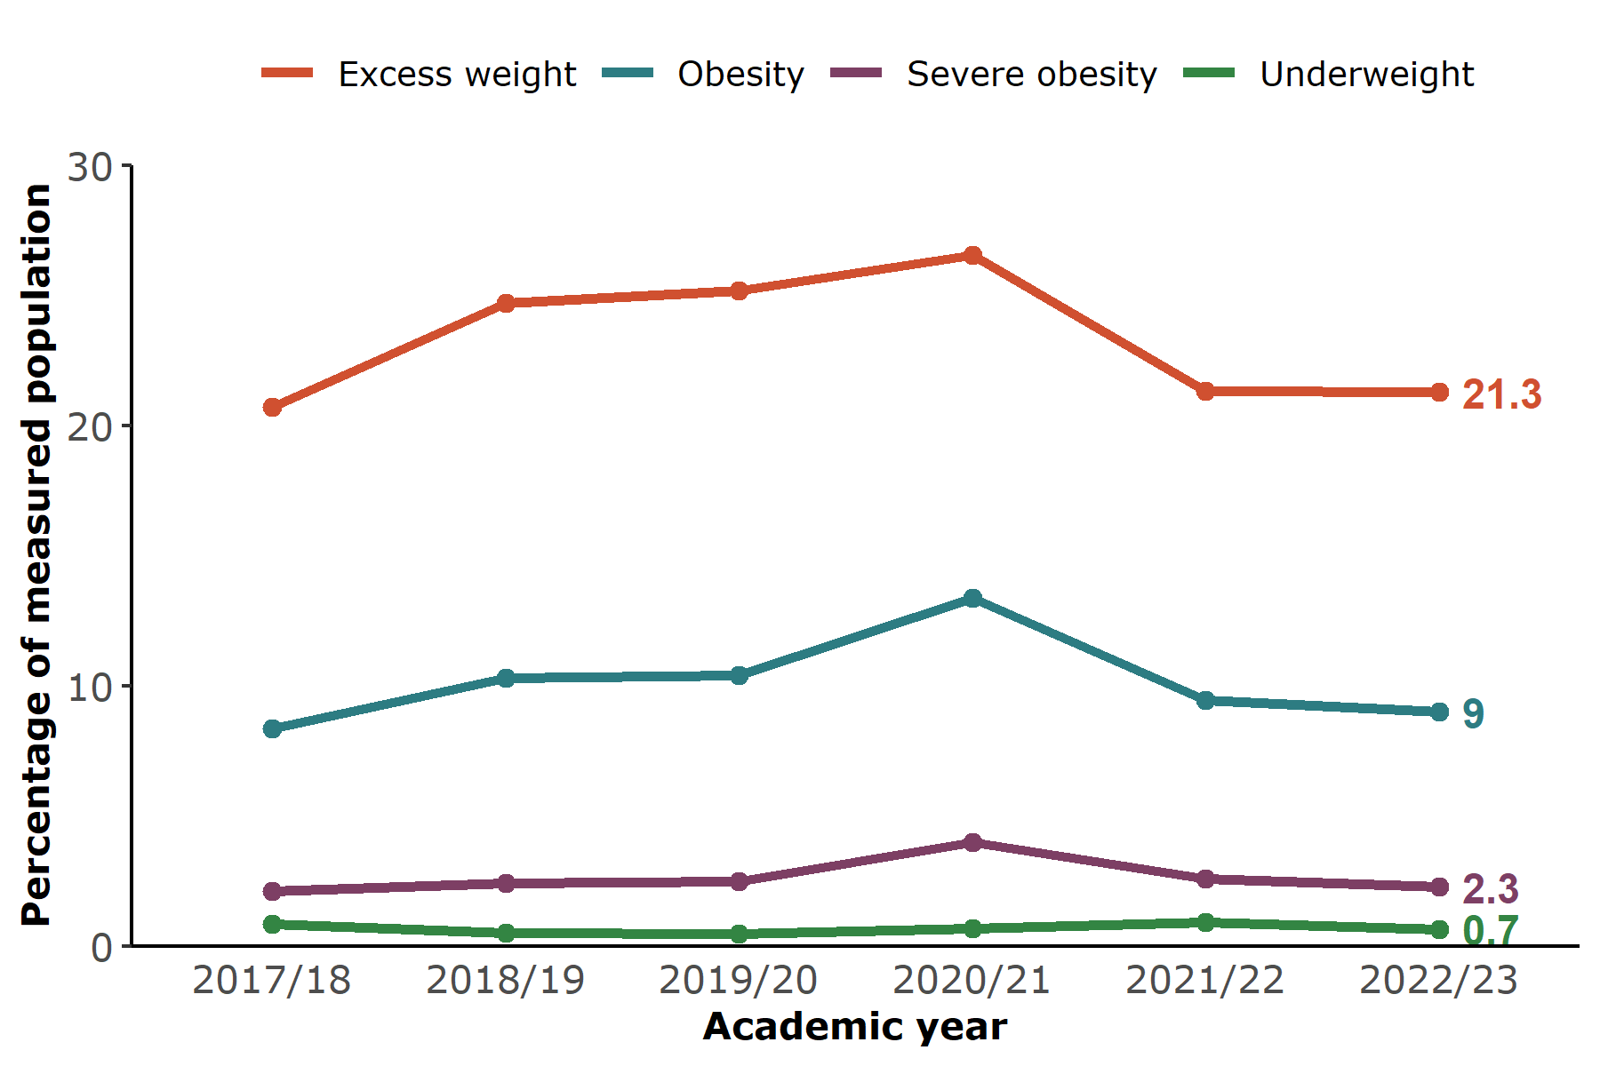 Source: NCMP, prepared by KPHO (SR)

**Table 1: Year R, weight category trends in Kent, 2017/18 - 2022/23**

| **Weight category %** | **2017/18** | **2018/19** | **2019/20** | **2020/21** | **2021/22** | **2022/23** |
| --- | --- | --- | --- | --- | --- | --- |
| Excess weight | 20.7 | 24.7 | 25.2 | 26.5 | 21.3 | 21.3 |
| Obese | 8.3 | 10.3 | 10.4 | 13.4 | 9.4 | 9.0 |
| Severe obesity | 2.1 | 2.4 | 2.5 | 4.0 | 2.6 | 2.3 |
| Under weight | 0.9 | 0.5 | 0.5 | 0.7 | 0.9 | 0.7 |

Source: NCMP, prepared by KPHO (SR)

Excess weight is defined as being obese or overweight.

The prevalence of obesity among reception year children in Kent was 9.0% in 2022/23. This was similar to 2021/22 and lower than the peak seen in 2020/21. Excess weight was 21.3% and severe obesity was 2.3% which were also similar rates to the previous year.

In England, the prevalence of obesity in reception children decreased from 10.1% in 2021/22 to 9.2% in 2022/23. Excess weight in England (21.3%) and severe obesity (2.5%) were similar to the Kent average for reception children.

## Inequalities analysis

### Obesity by deprivation

**Figure 2: Year R, prevalence of obesity by deprivation in Kent, 2017/18 - 2022/23** 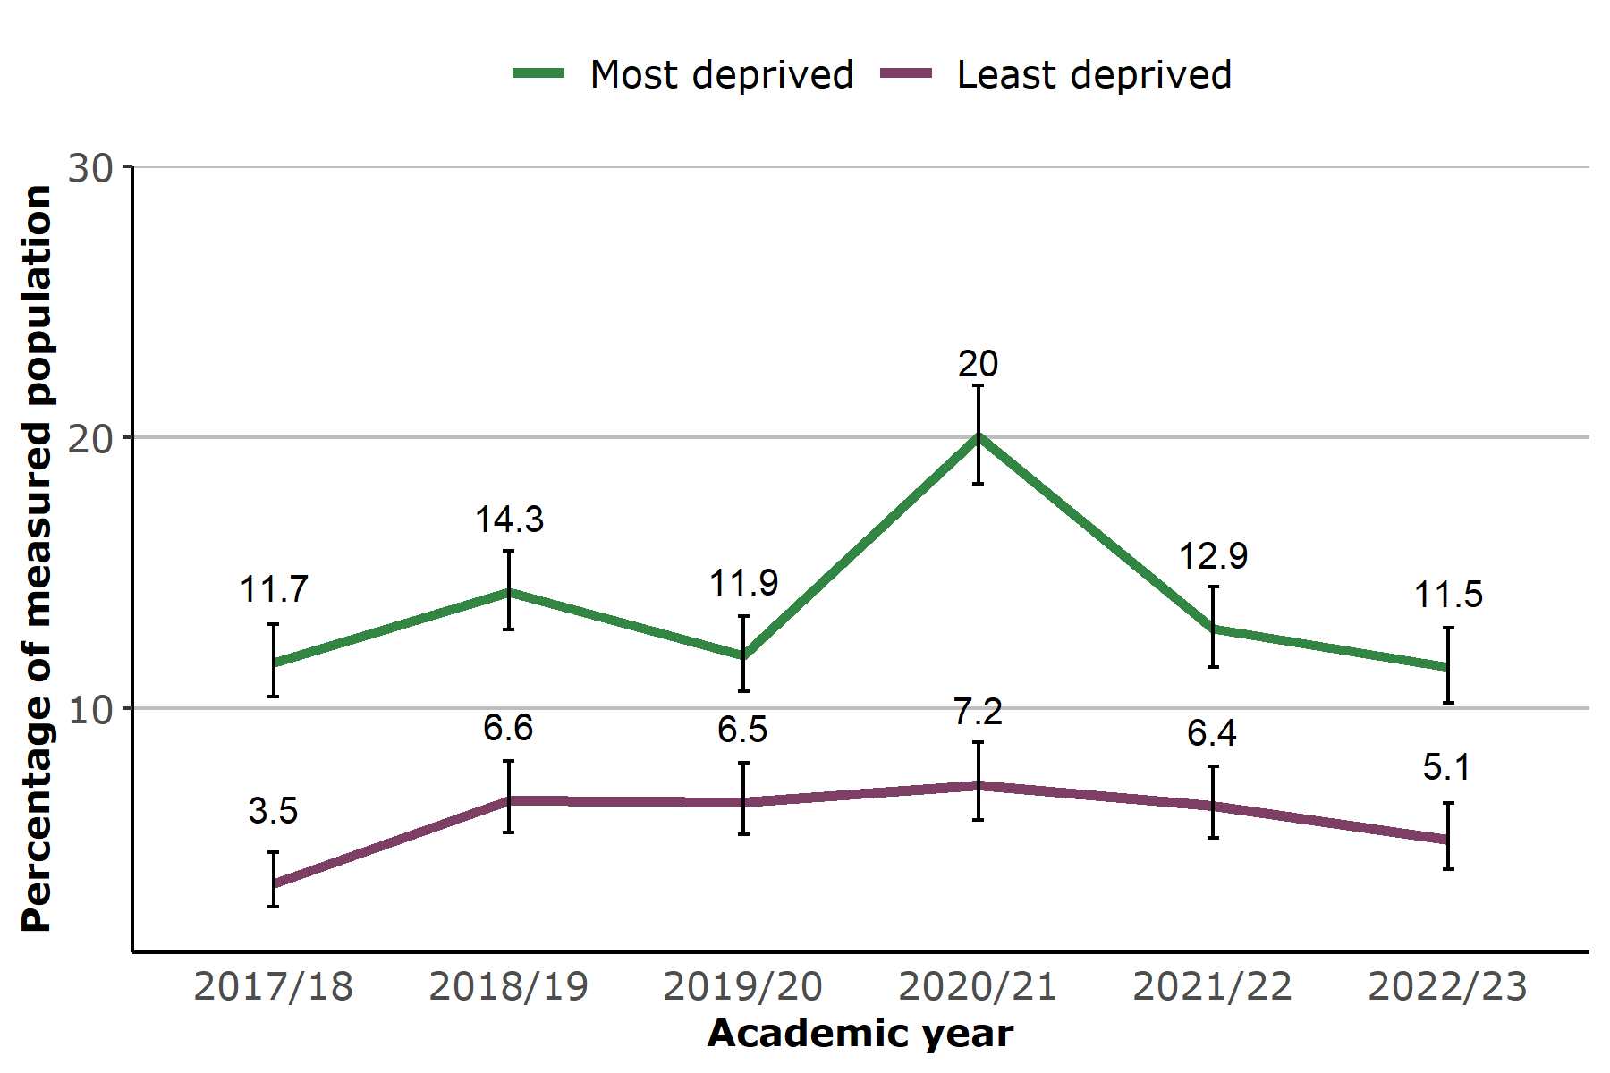 Source: NCMP, prepared by KPHO (SR)

The most and least deprived areas are defined as the parts of Kent ranked among the most and least deprived tenth of the population. These are also referred to as ‘deprivation deciles’.

Year R children living in the most deprived areas were more than twice as likely to be obese than children living in the least deprived areas (11.5% and 5.1% respectively) in 2022/23. This was similar to the previous year and the prevalence of obesity in the most deprived group remains below the peak in 2020/21.

In England 12.4% of reception year children in the most deprived group were living with obesity compared to 5.8% in the least deprived group.

### Obesity by ethnicity

**Figure 3: Year R, prevalence of obesity by ethnicity in Kent, 2017/18 - 2022/23** 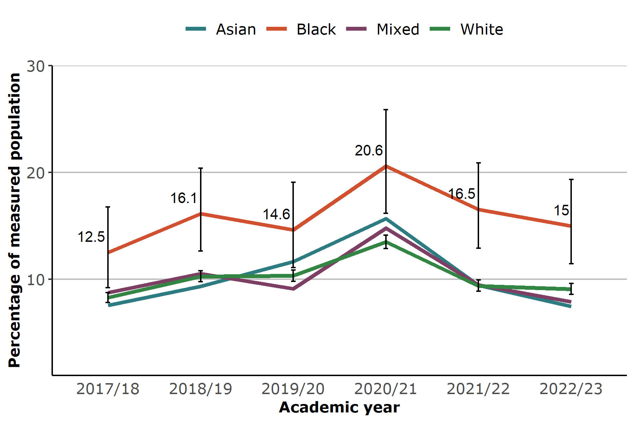 Source: NCMP, prepared by KPHO (SR)

Black children in Year R have consistently had a higher prevalence of obesity than White children in Kent. In 2022/23, 15% of Black children were living with obesity compared to 9.1% of White children. Asian and Mixed ethnicity children had similar levels of obesity to White children.

Similarly in England the prevalence of obesity for Black children in Year R (13.6%) was higher than for White children (8.9%) in 2022/23.

Obesity analysis by ethnic group should be interpreted with caution due to differences in physical characteristics by ethnicity. BMI includes height measurement, and this has been shown to overestimate obesity in Black children1.

**Table 2: Year R: obesity by ethnicity in Kent, 2017/18 - 2022/23**

| **Obese %** | **2017/18** | **2018/19** | **2019/20** | **2020/21** | **2021/22** | **2022/23** |
| --- | --- | --- | --- | --- | --- | --- |
| Asian | 7.6 | 9.3 | 11.6 | 15.7 | 9.5 | 7.5 |
| Black | 12.5 | 16.1 | 14.6 | 20.6 | 16.5 | 15.0 |
| Mixed | 8.7 | 10.5 | 9.1 | 14.8 | 9.5 | 7.9 |
| White | 8.3 | 10.3 | 10.3 | 13.5 | 9.4 | 9.1 |

Source: NCMP, prepared by KPHO (SR)

### Obesity by gender

**Figure 4: Year R, prevalence of obesity by gender in Kent, 2017/18 - 2022/23** 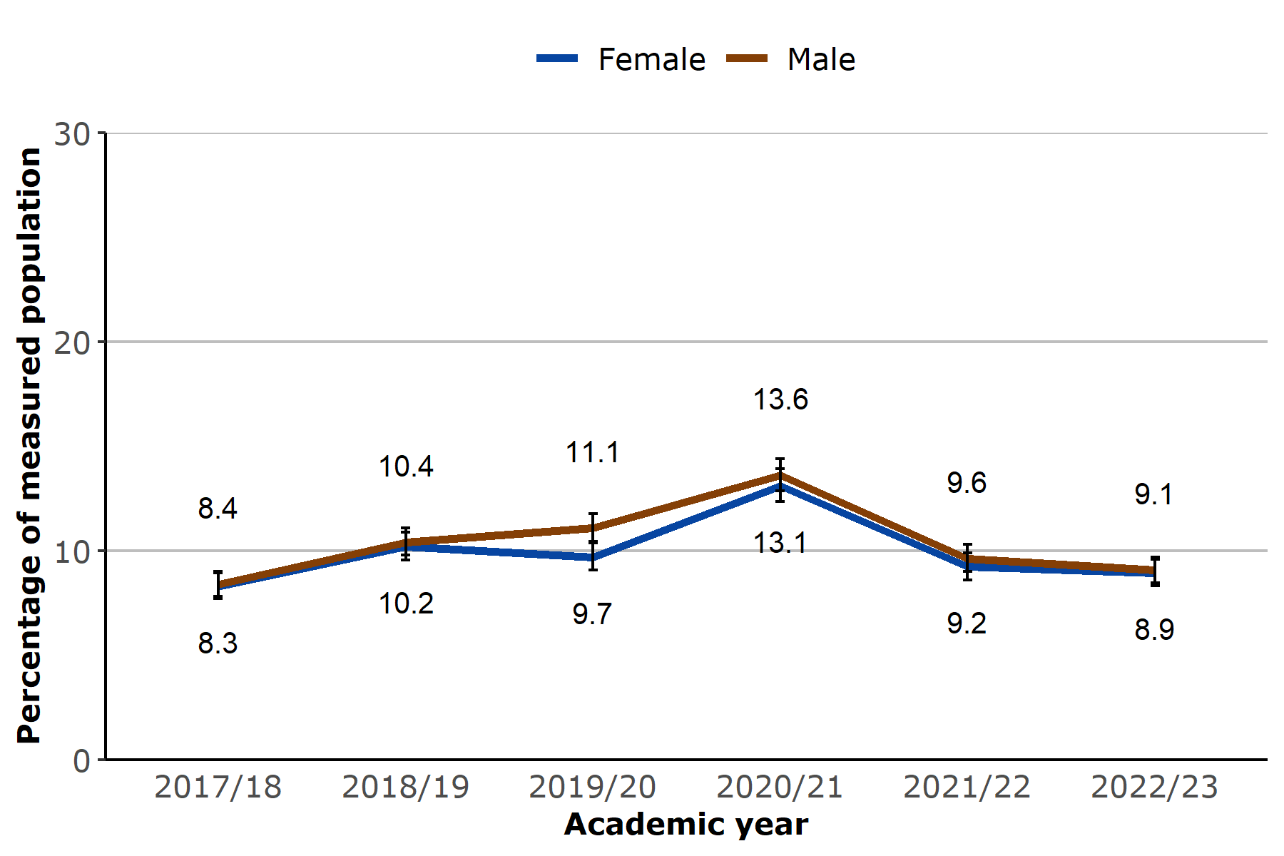 Source: NCMP, prepared by KPHO (SR)

The prevalence of obesity was similar among Year R girls and boys in Kent (8.9% and 9.1% respectively) in 2022/23 and there was no change from the previous year.

In England, the prevalence of obesity was higher for boys than girls in reception year (9.3% compared to 9.0%).

# Year R analysis at district level

### Obesity prevalence

**Figure 5: Year R, prevalence of obesity by district in Kent, 2022/23** 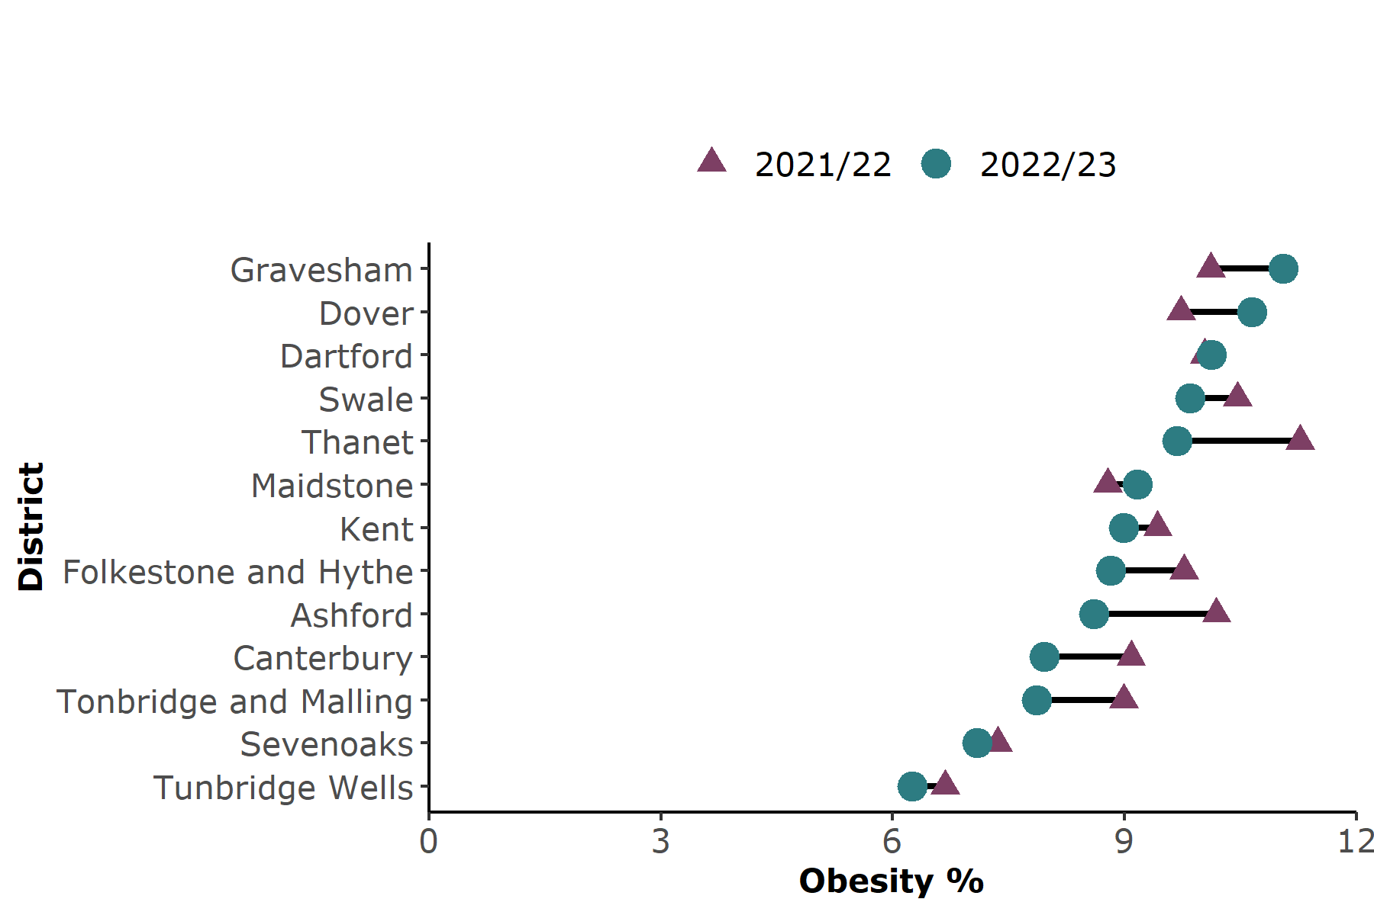 Source: NCMP, prepared by KPHO (SR)

For reception year children most districts had a similar level of obesity to the Kent average of 9.0% in 2022/23. Tunbridge Wells had a lower prevalence (6.3%).

There were no significant changes in obesity prevalence by district comparing 2022/23 with the previous year.

### Excess weight prevalence

**Figure 6: Year R, prevalence of excess weight by district in Kent, 2022/23** 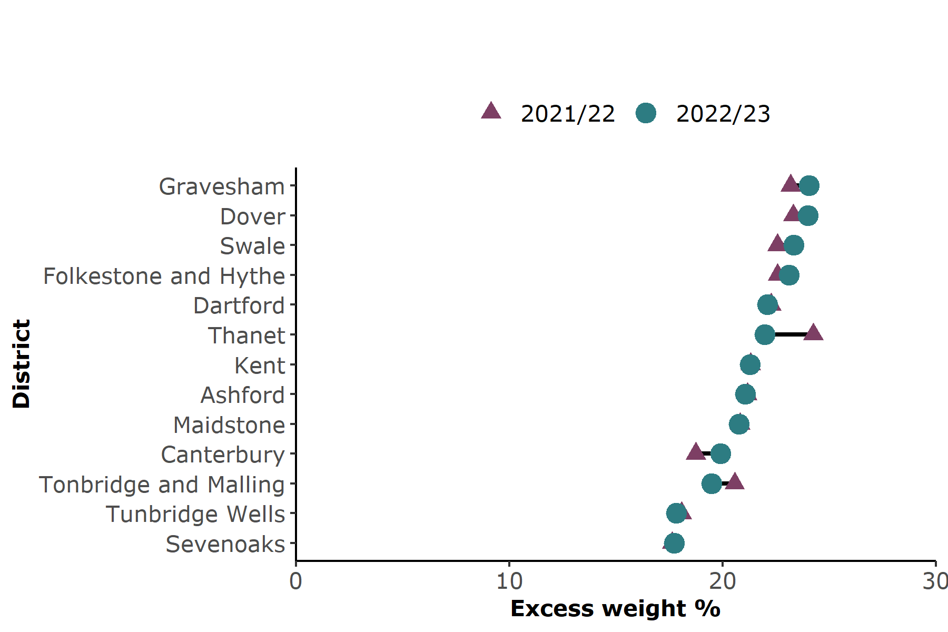 Source: NCMP, prepared by KPHO (SR)

Across all Kent districts obesity among reception year children was similar in 2022/23 to the previous year. Most districts had a similar level of obesity to the Kent average (21.3%). Tunbridge Wells and Sevenoaks had lower prevalence than the Kent average.

### Severe obesity prevalence

**Figure 7: Year R, prevalence of severe obesity by district in Kent, 2022/23** 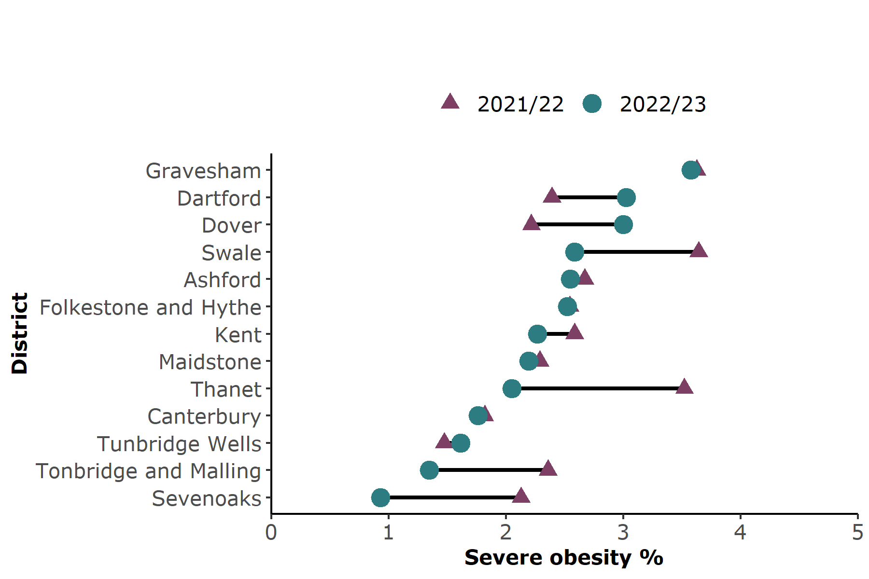 Source: NCMP, prepared by KPHO (SR)

Severe obesity in Gravesham reception year children was 3.6% which was higher than the Kent average (2.3%) for 2022/23.

Thanet and Sevenoaks districts had significantly lower levels of severe obesity in reception year compared to 2021/22. The remaining districts and the Kent average were similar to the previous year.

# Year 6 analysis at Kent level

## Weight category trends

**Figure 8: Year 6, weight category trends in Kent, 2017/18 - 2022/23** 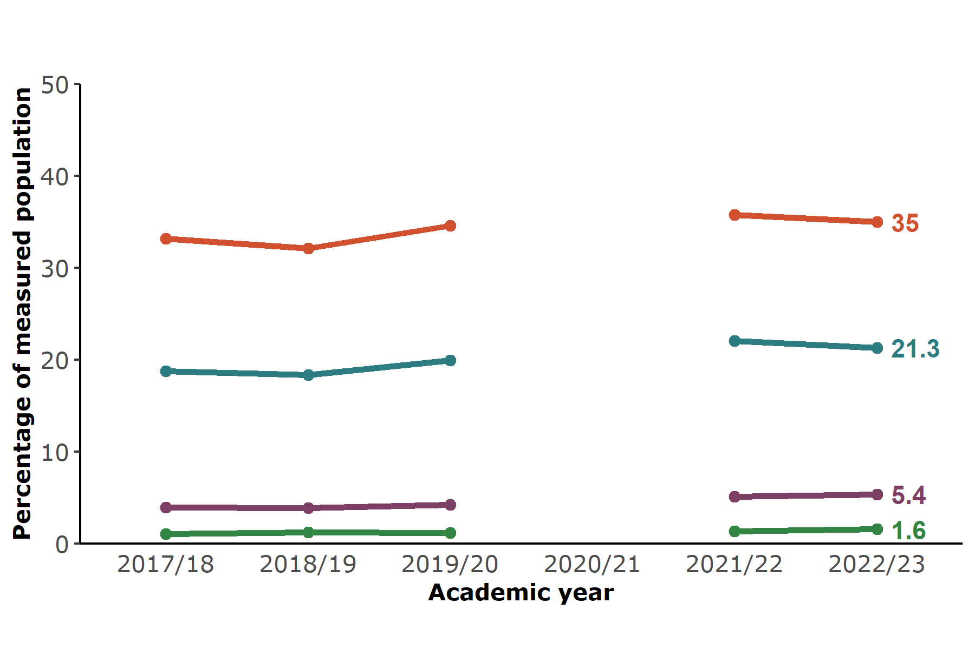 Source: NCMP, prepared by KPHO (SR)

**Table 3: Year 6, weight category trends in Kent, 2017/18 - 2022/23**

| **Weight category %** | **2017/18** | **2018/19** | **2019/20** | **2020/21** | **2021/22** | **2022/23** |
| --- | --- | --- | --- | --- | --- | --- |
| Excess weight | 33.2 | 32.1 | 34.6 |  | 35.8 | 35.0 |
| Obese | 18.8 | 18.3 | 19.9 | 22.1 | 21.3 |
| Severe obesity | 3.9 | 3.9 | 4.2 | 5.1 | 5.4 |
| Under weight | 1.0 | 1.2 | 1.1 | 1.3 | 1.6 |

Source: NCMP, prepared by KPHO (SR)

The prevalence of excess weight in Year 6 was 35% in Kent in the latest year which was similar to the previous year and significantly lower than the England average (36.6%). Obesity was also lower in Kent than the England average (21.3% compared to 22.7%). The trends for both excess weight and obesity in Kent in Year 6 are increasing and getting worse.

Severe obesity for Year 6 in Kent was 5.4% in the latest year, similar to England (5.7%).

Year 6 data for the academic year 2020/21 has not been presented. 10.6% of Year 6 pupils were measured due to the Covid-19 pandemic and the participation distributions showed it was not a representative sample.

## Inequalities analysis

### Obesity by deprivation

**Figure 9: Year 6, prevalence of obesity by deprivation in Kent, 2017/18 - 2022/23** 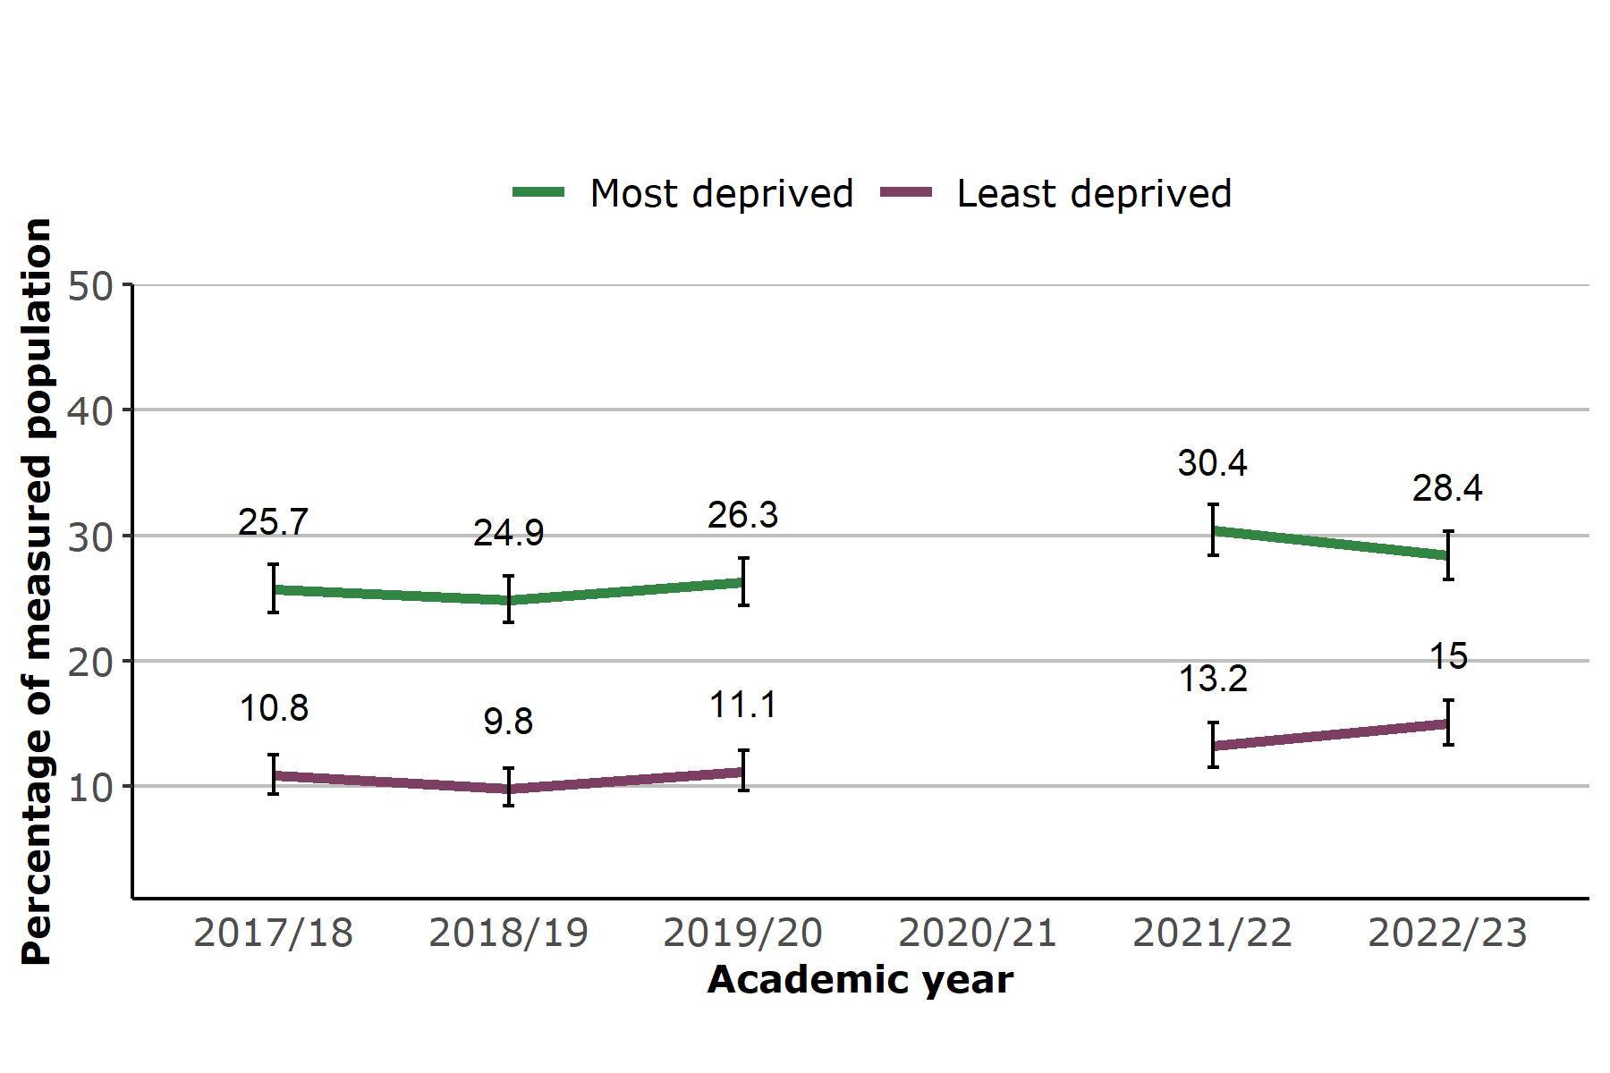 Source: NCMP, prepared by KPHO (SR)

Year 6 children living in the most deprived areas of Kent were nearly twice as likely to be living with obesity than those living in the least deprived areas, 28.4% compared to 15%. For England this was 30.2% compared to 13.1%.

### Obesity by ethnicity

**Figure 10: Year 6, prevalence of obesity by ethnicity in Kent, 2017/18 - 2022/23** 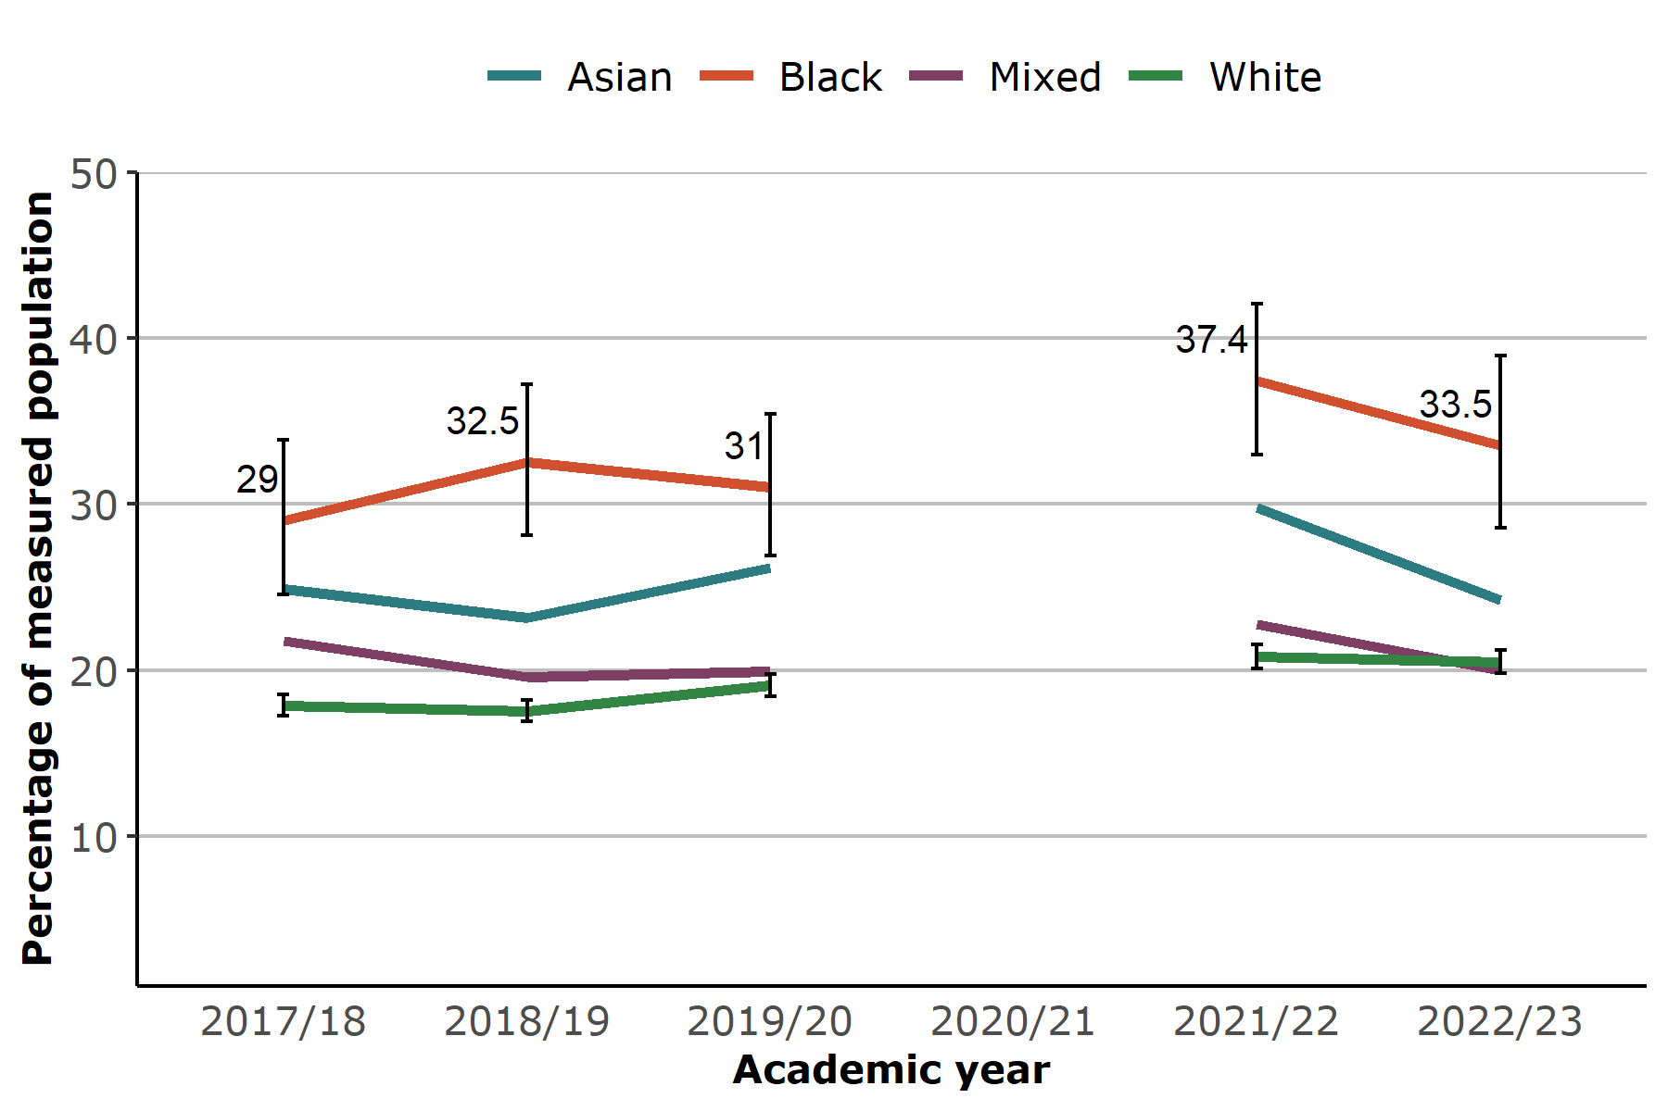 Source: NCMP, prepared by KPHO (SR)

**Table 4: Year 6: obesity by ethnicity in Kent, 2017/18 - 2022/23**

| **Obese %** | **2017/18** | **2018/19** | **2019/20** | **2020/21** | **2021/22** | **2022/23** |
| --- | --- | --- | --- | --- | --- | --- |
| Asian | 24.9 | 23.2 | 26.2 |  | 29.8 | 24.3 |
| Black | 29.0 | 32.5 | 31.0 | 37.4 | 33.5 |
| Mixed | 21.8 | 19.6 | 19.9 | 22.8 | 20.0 |
| White | 17.9 | 17.5 | 19.1 | 20.8 | 20.5 |

Source: NCMP, prepared by KPHO (SR)

Black children in Year 6 had a higher prevalence of obesity than White children (33.5% compared to 20.5%) in 2022/23, similar to previous years. In England this was 31.6% of Black children compared to 21.4% of White children.

### Obesity by gender

**Figure 11: Year 6, prevalence of obesity by gender in Kent, 2017/18 - 2022/23** 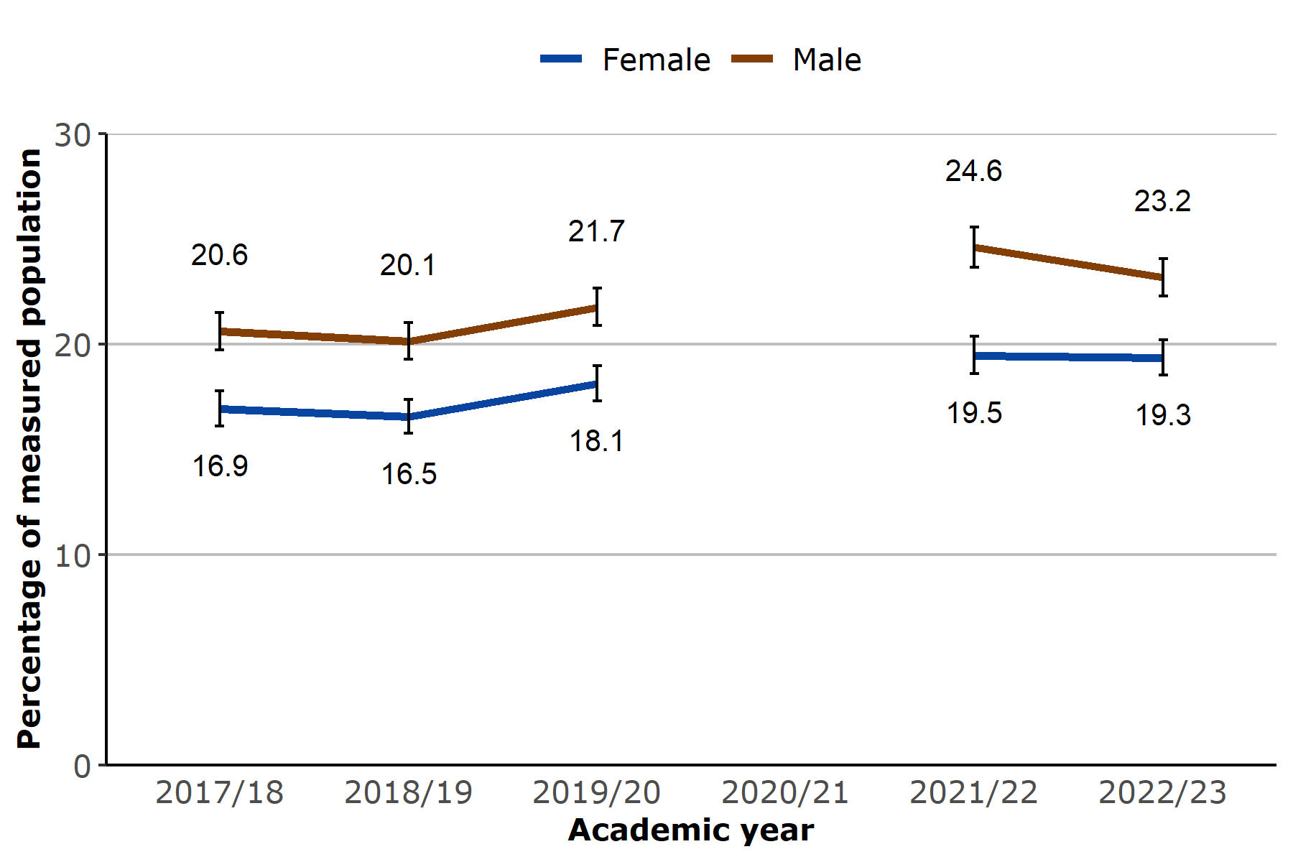 Source: NCMP, prepared by KPHO (SR)

In Year 6 obesity prevalence was higher among boys compared to girls in Kent. 23.2% of boys were living with obesity compared to 19.3% of girls, with a similar gap to previous years. In England 20.1% of girls were loving with obesity compared to 25.1% of boys.

# Year 6 analysis at district level

### Obesity prevalence

**Figure 12: Year 6, prevalence of obesity by district in Kent, 2022/23** 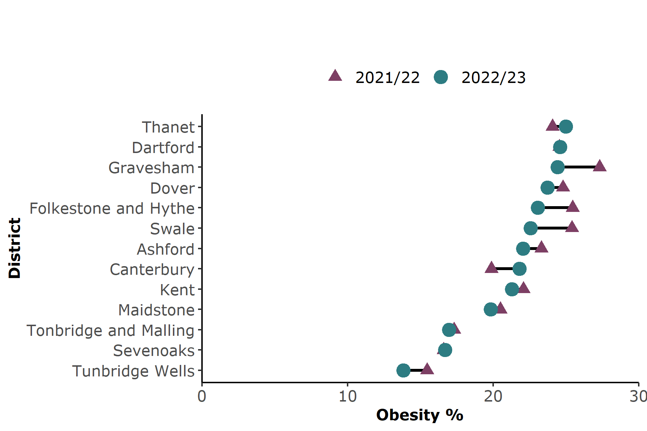 Source: NCMP, prepared by KPHO (SR)

Thanet, Dartford and Gravesham districts had a higher prevalence of obesity in Year 6 than the Kent average of 21.3% in 2022/23 (25.0%, 24.6% and 24.4% respectively).

The prevalence of obesity among Year 6 children was significantly lower in Kent (21.3%) compared to England (22.7%).

### Excess weight prevalence

**Figure 13: Year 6, prevalence of excess weight by district in Kent, 2022/23** 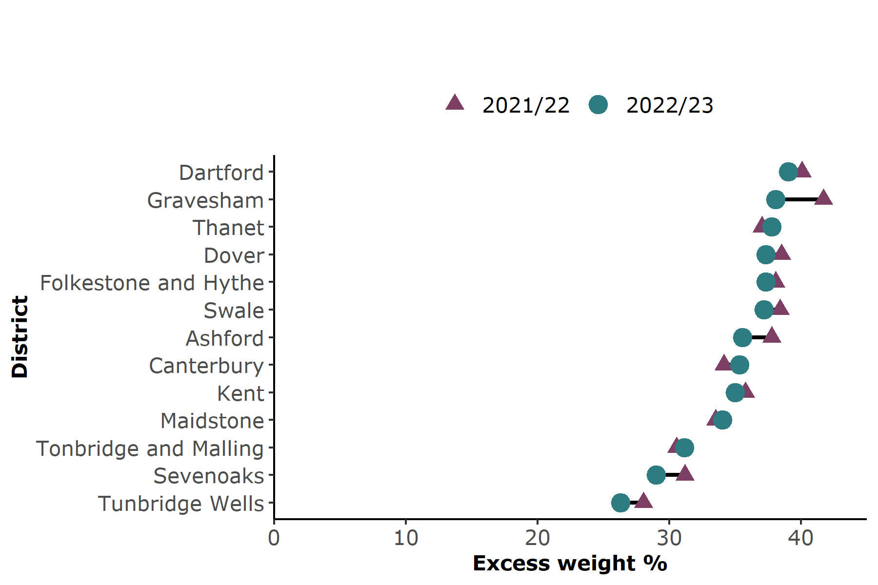 Source: NCMP, prepared by KPHO (SR)

Dartford district had a higher prevalence of excess weight in Year 6 in 2022/23 than the Kent average, this was 39.1% compared to 35.0% for Kent.

Kent had a significantly lower level of excess weight in children in Year 6 (35.0%) than England (36.6%) in the latest year.

### Severe obesity prevalence

**Figure 14: Year 6, prevalence of severe obesity by district in Kent, 2022/23** 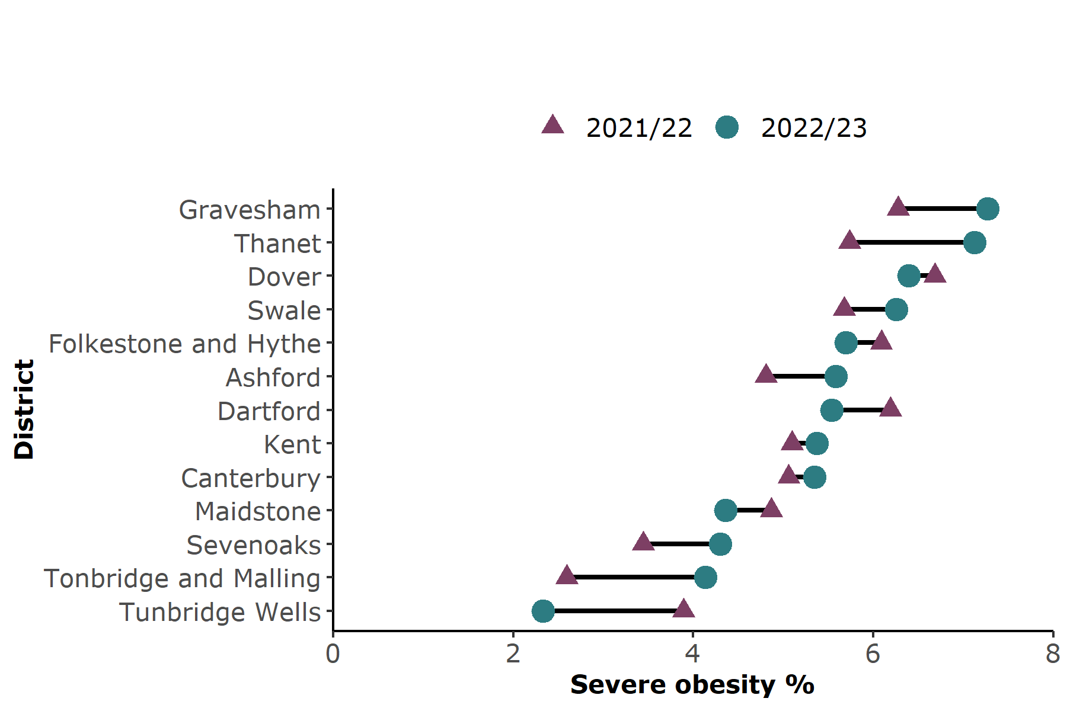 Source: NCMP, prepared by KPHO (SR)

Gravesham and Thanet districts had a higher prevalence of severe obesity in Year 6 in the latest year than the Kent average (7.3% and 7.1% compared to 5.4% in Kent).

The prevalence of severe obesity in Year 6 children increased significantly in Tonbridge and Malling in 2022/23 compared to the previous year, from 2.6% to 4.1%.

England had a similar level of severe obesity (5.7%) to the Kent average (5.4%) for Year 6.

# Appendix

The height and weight measurements of children in reception year and year six are recorded annually as part of the National Child Measurement Programme.

Children living in Kent and attending mainstream Kent schools were included in the analysis. Children attending Free schools were included.

Year 6 data for the academic year 2020/21 has not been presented. 10.6% of Year 6 pupils were measured due to the Covid-19 pandemic and the participation distributions showed it was not a representative sample.

# References

1. GOV.Uk. 2019. Differences in child obesity by ethnic group. [online] Available at: <https://www.gov.uk/government/publications/differences-in-child-obesity-by-ethnic-group/differences-in-child-obesity-by-ethnic-group#fn:3> [Accessed 04 April 2023].