Emergency Admissions for COPD Summary Report

May 2023

Contents
1 Executive summary 3
1.1 Key Findings 3
2 Introduction 3
2.1 COPD epidemiology 3
3 Methods 4
4 Mortality 4
5 Emergency admissions by geography 6
5.1 Districts 6
5.2 HCPs and PCNs 7
6 Deprivation status 11
7 Length of stay and frequency of admission 13
8 Conclusions 19
9 Appendix 20

Executive summary

Key Findings
- COPD admission rates vary significantly across Kent and Medway, with higher rates in Medway Unitary Authority, and Kent districts Swale and Thanet
- There is significant inequality in COPD admissions depending on IMD score, with rates 4.1 times higher in those living in the 20% most deprived areas of Kent and Medway, than in those living in the 20% least deprived areas
- Patients with more emergency admissions had longer average length of stay. The presence of co-morbidities wasn’t present in the data, but may be an explanation for some of the differences observed
- Variation in admission rates between PCNs suggests opportunities for prevention within primary care

Introduction
This report was produced after a request made by a collaboration between Kent Community Healthcare Foundation Trust (KCHFT) and the University of Kent (UKC), which has received funding from the Applied Research Collaboration Kent, Surrey & Sussex (ARC KSS). Their joint project seeks to explore the feasibility of a COPD care at home model, looking at patterns of hospital admissions and community services data.
Within this report, we analyse data extracted from secondary user services (SUS or HES) for COPD patients who experienced unplanned (emergency) admissions to secondary care in Kent and Medway between 2017/18 and 2021/22.

COPD epidemiology
Chronic Obstructive Pulmonary Disorder (COPD) is a common chronic condition which is responsible for early mortality and places significant demand on NHS services. It is characterised by a progressive decline in lung function and in health status, accompanied by repeated acute exacerbations where there is a sustained worsening of symptoms, commonly increased breathlessness, coughing or sputum production (NICE, 2023). These exacerbations can often be treated in primary care however some may need more intensive management in hospital. Frequent exacerbations are a risk factor for faster decline in lung function and poorer quality of life outcomes. The main risk factors are smoking and repeated exposure to poor quality air (NICE, 2023).
COPD is the second most common lung disease in the UK, affecting around 2% of the whole population and 4.5% of those aged over 40 (British Lung Foundation, 2023). Prevalence of COPD has been increasing steadily in England as well as Kent and Medway over the last 20 years. Your chances of being diagnosed with COPD increase with age, if you are male, and if you live in a more deprived area (British Lung Foundation, 2023).

Methods
Data for emergency admissions where COPD was recorded as a primary diagnosis (ICD10 codes ‘J40’ to ‘J44’), counts of episodes and individuals, and length of stay was extracted from the Hospital Episode Statistics (HES). This data was extracted for patients of all ages, for people who are living in and who are registered to a GP practice in Kent and Medway during 2017/18 to 2021/22.
Following extraction, counts of admissions were directly age-standardised using GP registered population for the relevant year as the denominator. Age-standardisation is a technique to adjust for underlying differences in the age structure of different populations. This allows them to be compared more easily.
Two geographies were used as the basis for larger geographic areas in this report. The Lower Super Output Areas (LSOA) of residence was used to derive district and index of multiple deprivation (IMD) scores, and GP practice was used to derive Primary Care Network (PCN) or Health & Care Partnership (HCP) areas.

Mortality
The below Figures 1-3 show the proportions of death registrations due to chronic lower respiratory disease as an underlying cause of death in NHS Kent and Medway ICB, from ONS monthly mortality data. Figure 4 shows COPD as a contributory cause of death (COPD ICD-10 codes recorded in ‘any cause of death’ field with the exception of the underlying cause of death field).
There were a reduced number of deaths due to COPD as an underlying cause of death in most months from January 2020 to October 2022 compared to the preceding 5 years. Conversely, the rate per 100,000 deaths which have COPD as a contributory cause (excluding underlying cause) increased significantly in 2020. This may be due to COVID being reported as the underlying cause of death instead.
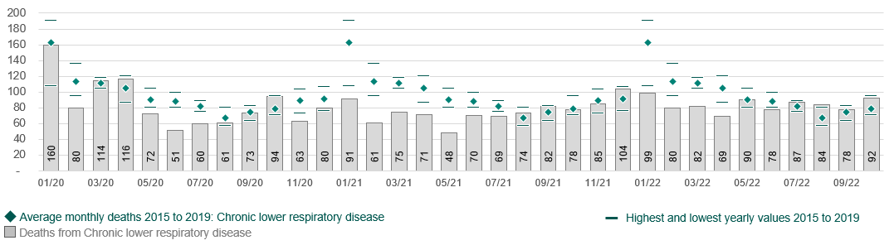
Figure 1. 2020 to 2022 monthly counts of deaths compared to 2015 to 2019 averages. Source: ONS.

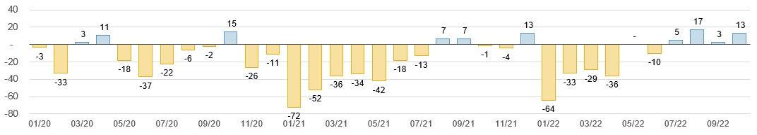
Figure 2. Excess deaths from chronic lower respiratory diseases – gap between numbers of deaths, 2020 to 2022 compared to 2015 to 2019 monthly averages. Source: ONS.

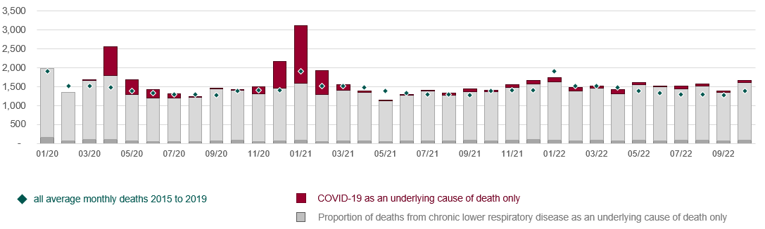
Figure 3. Monthly deaths from covid or chronic respiratory disease as an underlying cause of death in 2020 to 2022, compared to baseline levels of deaths from respiratory disease in 2015 to 2019. Source: ONS.
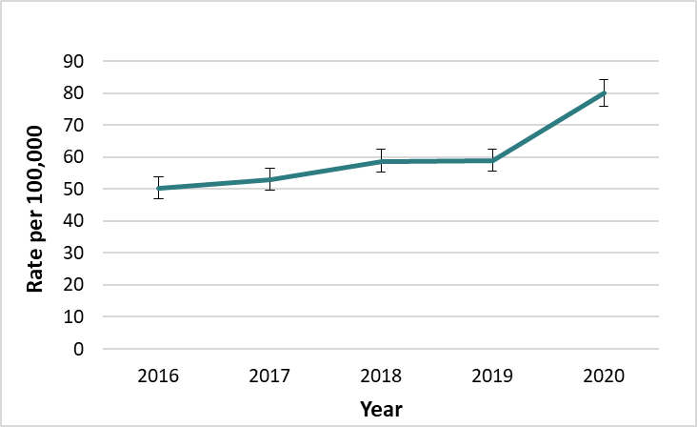
Figure 4. COPD as a contributory cause of death, Kent and Medway 2016-2020, 95% confidence intervals shown. Source: OHID.

Emergency admissions by geography

Districts
For the period 2017/18 – 2021/22, emergency admission rates vary significantly between by geography (Figure 5). Medway has the highest rate at 238 admissions per 100,000 resident population. Dartford, Swale and Thanet also sit above the Kent and Medway average of 190, while Ashford, Canterbury, Maidstone, Sevenoaks, Tonbridge & Malling, and Tunbridge Wells have significantly lower rates.
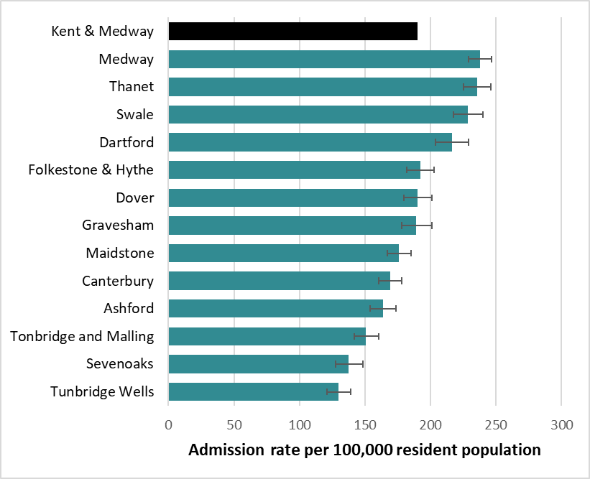
Figure 5. Emergency Admissions for COPD, 2017/18 – 2021/22. Age standardised rate per 100,000 in Kent districts & Medway with 95% confidence intervals shown. Source: HES.
When split by sex, admission rates are higher in men for nearly all areas (Figure 6). However, the difference is only statistically significant in Tunbridge Wells where the rate differs by 52 admissions per 100,000 population. Across all areas, the female average rate is 185.5 (95% CI 181.7 to 189.3) and in males it’s 198.0 (95% CI 193.8 to 202.3) per 100,000 population, a significant difference.

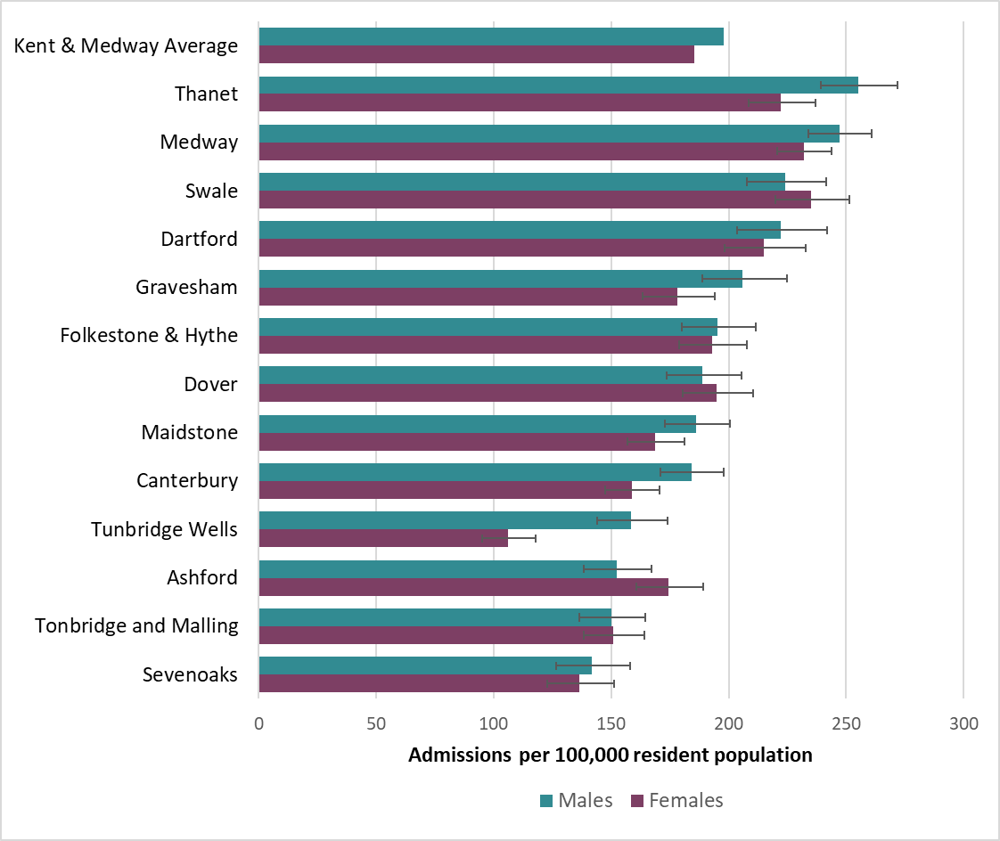
Figure 6. Emergency Admissions for COPD, 2017/18 – 2021/22 by sex. Age standardised rate per 100,000 in Kent districts & Medway, with 95% confidence intervals. Source: HES.

HCPs and PCNs
For the period 2017/18 to 2021/22 there is significant variation in emergency admission rates for COPD across the Kent and Medway HCPs (Figure 7). Medway and Swale HCP has the highest rate at 241 admissions per 100,000 resident population, followed by Dartford, Gravesham and Swanley at 201 per 100,000. Both are significantly higher than the Kent and Medway average of 190.
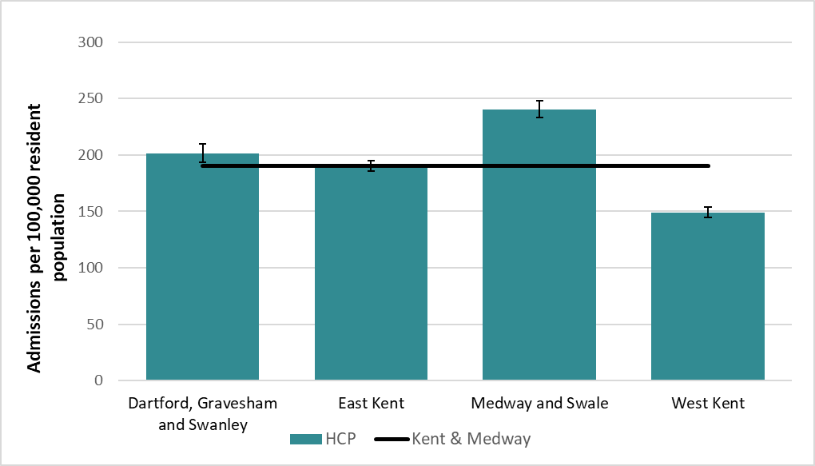
Figure 7. Emergency Admissions for COPD, 2017/18 – 2021/22. Age standardised rate per 100,000 in Kent and Medway HCPs. Source: HES.
Within Dartford, Gravesham and Swanley HCP, Dartford Central, Gravesend Alliance and Gravesend Central PCNs all had statistically significant higher admission rates than the Kent and Medway average of 190 admissions per 100,000 resident population at 282, 219 and 231 respectively (Figure 8).
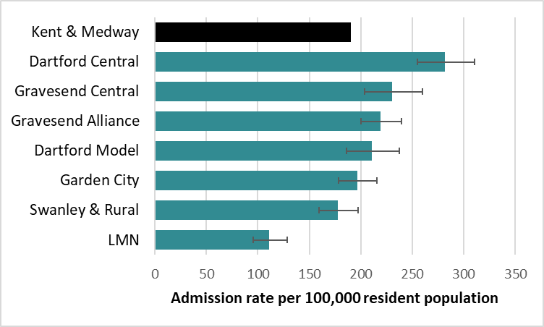
Figure 8. Emergency Admissions for COPD, 2017/18 – 2021/22 by PCN. Age standardised rate per 100,000 in Dartford, Gravesham and Swanley HCP. Source: HES.
In East Kent HCP, the following PCNs have significantly higher admission rates than the Kent and Medway average: Dover Town, Herne Bay, Margate, Ramsgate and Total Health Excellence East. Ramsgate is the highest (277 per 100,000) (Figure 9). Ashford Rural, Canterbury South, CARE Kent, Deal and Sandwich, Folkestone Hythe and Rural, Mid Kent and Whitstable PCNs have lower rates, with Whitstable the lowest at 106.
Nearly all the PCNs in Medway and Swale HCP have higher admission rates than the Kent and Medway average (Figure 10). Medway Central has the highest at 340 per 100,000, nearly double the Kent and Medway average. Only Medway Rainham PCN has a significantly lower rate (153 per 100,000).

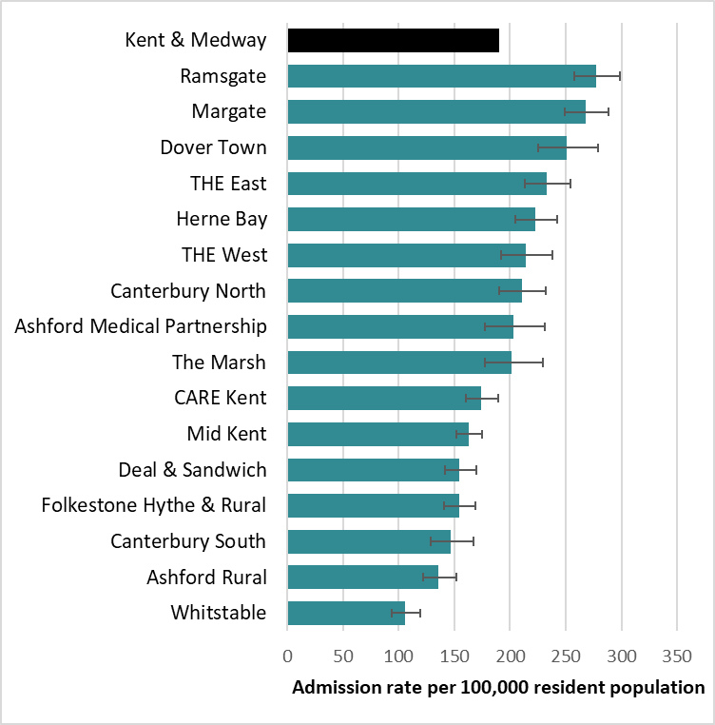
Figure 9. Emergency Admissions for COPD, 2017/18 – 2021/22. Age standardised rate per 100,000 in PCNs in East Kent HCP, with 95% confidence intervals. Source: HES.

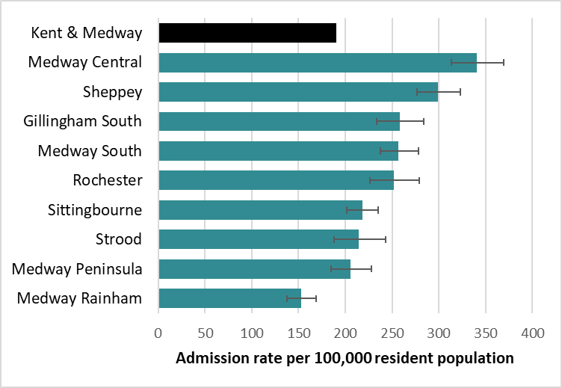
Figure 10. Emergency Admissions for COPD, 2017/18 – 2021/22. Age standardised rate per 100,000 in PCNs in Medway & Swale HCP, with 95% confidence intervals. Source: HES.
Most PCNs in West Kent HCP have lower COPD admission rates than the Kent and Medway average (Figure 11). ABC PCN has a significantly higher rate than all others at 288 per 100,000. The Ridge has the lowest rate at 103 admissions per 100,000. Population weighted deprivation scores at PCN level and smoking rates were considered but did not help to explain these differences.
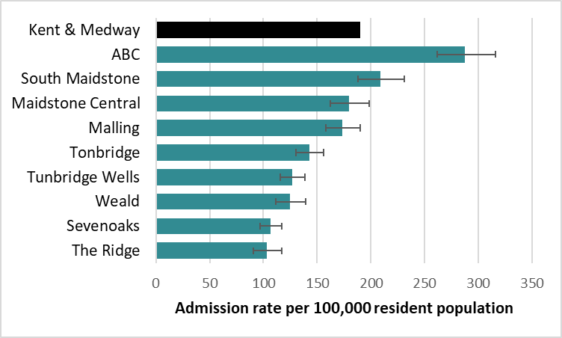
Figure 11. Emergency Admissions for COPD, 2017/18 – 2021/22. Age standardised rate per 100,000 in PCNs in West Kent HCP, with 95% confidence intervals. Source: HES.
Between 2017/18 and 2021/22, admission rates in all HCPs follow a similar trend (Figure 12). There is a sharp drop in 2020/21 where the differences between the four HCPs is smallest. This is likely an artificial drop caused by admissions being coded as COVID-related where COPD was also a contributing or underlying factor. The rate then increases again in 2021/22 but not up to pre-2020 level. West Kent has the lowest rates across all years.
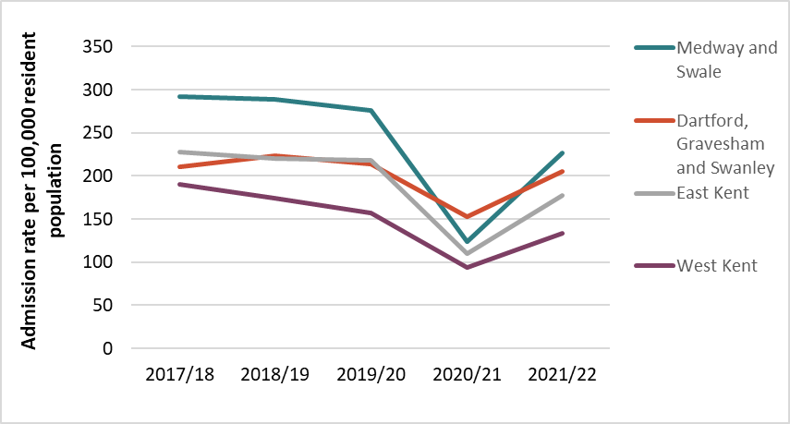
Figure 12. Emergency Admissions for COPD, 2017/18 – 2021/22. Age standardised rate per 100,000 in Kent and Medway HCPs. Source: HES.

Deprivation status
Emergency admission rates for COPD were calculated according to IMD based on the LSOA of the patient. Across all HCPs, those living in quintile 1 (20% most deprived LSOAs in Kent and Medway) had significantly higher admission rates than those in quintile 5 (20% least deprived); around four times higher admission rate. Quintile 1 was also significantly higher than the Kent and Medway average (Figure 13).
The rate for each quintile is similar across the HCPs, though those in East Kent in quintile 1 have significantly lower rates than the other HCPs. The quintile 1 rate is highest in Dartford, Gravesham and Swanley HCP at 470 admissions per 100,000 population. The quintile 5 rate is lowest in East Kent HCP at 81 admissions per 100,000, though there is no significant difference between quintile 5 rates across HCPs.

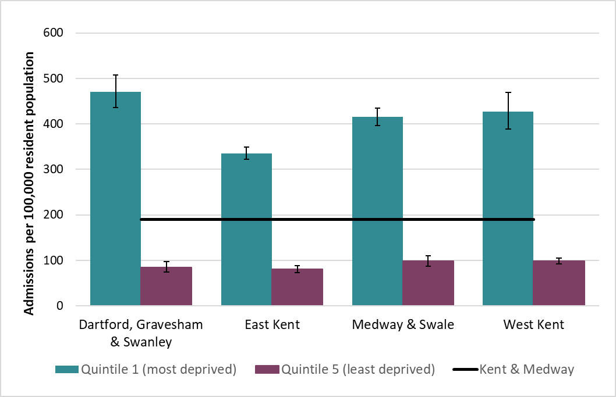
Figure 13. Emergency Admissions for COPD, 2017/18 – 2021/22 by deprivation quintile. Age standardised rate per 100,000 in Kent and Medway HCPs, with 95% confidence intervals. Source: HES.
Between 2017/18 and 2019/20 the admission rates don’t vary significantly within quintiles 1 and 5, however in 2020/21 the admission rates in both quintiles falls by nearly half. In 2021/22 the rate in both groups is still slightly lower than pre-2020 (Figure 14).
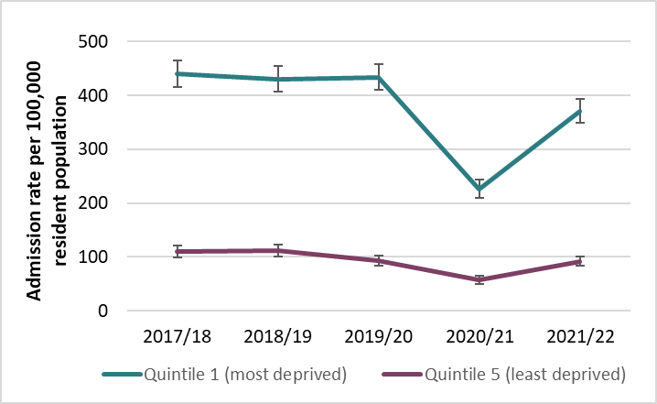
Figure 14. Emergency Admissions for COPD, 2017/18 – 2021/22 by deprivation quintile. Age standardised rate per 100,000 in Kent and Medway HCPs, with 95% confidence intervals. Source: HES.

Table 1 shows admission rates for each deprivation quintile from 2017/18 to 2021/22. There is a very clear trend where increasing IMD quintile is associated with reduced rate of admission.
Year | IMD quintile | Admissions | Age standardised rate per 100,000 | Lower CI | Upper CI
2017/18 | 1 | 1,245 | 440.3 | 416.0 | 465.6
2017/18 | 2 | 960 | 281.8 | 264.2 | 300.3
2017/18 | 3 | 820 | 217.9 | 203.2 | 233.4
2017/18 | 4 | 690 | 173.6 | 160.8 | 187.2
2017/18 | 5 | 445 | 109.7 | 99.7 | 120.5
2018/19 | 1 | 1,230 | 430.3 | 406.4 | 455.2
2018/19 | 2 | 970 | 281.4 | 263.9 | 299.7
2018/19 | 3 | 840 | 218.8 | 204.2 | 234.2
2018/19 | 4 | 615 | 150.8 | 139.1 | 163.4
2018/19 | 5 | 465 | 111.4 | 101.4 | 122.2
2019/20 | 1 | 1,260 | 433.5 | 409.8 | 458.3
2019/20 | 2 | 990 | 283.6 | 266.2 | 301.9
2019/20 | 3 | 765 | 194.4 | 180.8 | 208.8
2019/20 | 4 | 615 | 148.1 | 136.6 | 160.4
2019/20 | 5 | 395 | 93.3 | 84.2 | 103.2
2020/21 | 1 | 660 | 226.3 | 209.2 | 244.4
2020/21 | 2 | 490 | 137.3 | 125.3 | 150.1
2020/21 | 3 | 420 | 105.8 | 95.9 | 116.5
2020/21 | 4 | 365 | 85.6 | 77.0 | 95.0
2020/21 | 5 | 240 | 56.8 | 49.8 | 64.7
2021/22 | 1 | 1,090 | 370.7 | 348.9 | 393.5
2021/22 | 2 | 810 | 225.3 | 210.0 | 241.4
2021/22 | 3 | 645 | 158.9 | 146.8 | 171.8
2021/22 | 4 | 535 | 122.6 | 112.4 | 133.7
2021/22 | 5 | 400 | 91.8 | 83.0 | 101.4
Table 1. Emergency hospital admission age-standardised rates per 100,000 (ASR) for COPD by IMD deprivation quintile, Kent and Medway PCNs, 2017/18 to 2021/22. Source: HES.

Length of stay and frequency of admission
The most recent complete year of data, 2021/22, was analysed for frequency of admission and length of stay. The length of stay varied widely among all groups, ranging from less than one day to 69 days. The data showed that about 79% of patients had only one emergency admission. This group also had the lowest mean length of stay (5.7 days) and a median of 3 days (Table 2). The median length of stay increased to 5 days for patients with 4 or more admissions.
Admissions | Number of patients | As % of total | Average LOS | Median LOS
1 | 1990 | 79.4 | 5.7 | 3
2 | 335 | 13.3 | 6.3 | 4
3 | 105 | 4.2 | 7.0 | 4
4 | 40 | 1.7 | 7.9 | 5
5+ | 35 | 1.5 | 6.0 | 5
Grand Total | 2510 | 100% | 6.05 | 4
Table 2. Number of patients, mean and median length of stay (LOS), by number of admissions, Kent and Medway 2021/22. Source: HES.
Patients in Dartford, Gravesham and Swanley had a median length of stay two days longer than those in any other HCP (Table 3). Most patients who had an emergency admission in the year 2021/22 spent less than one day in hospital in that year (Figure 15). Then generally as total days spent in hospital increases, number of people decreases. There is great disparity here, with number of days spent in hospital ranging from less than 1 day to 108 days. Approximately 11% of patients spent more than 20 days in hospital as a result of an emergency COPD admission, and approximately 1.3% of people stayed for 50+ days. For each individual spell, duration ranged from less than 1 day to 69 days. The majority of spells lasted 4 days or less.
HCP | Number of admissions | Median LOS | Mean LOS
Dartford, Gravesham and Swanley | 493 | 7 | 8.8
East Kent | 1399 | 3 | 5.2
Medway and Swale | 807 | 5 | 6.3
West Kent | 682 | 3 | 5.7
Table 3. Number of admissions, median and mean LOS, by HCP, Kent and Medway 2021/22. Source: HES.

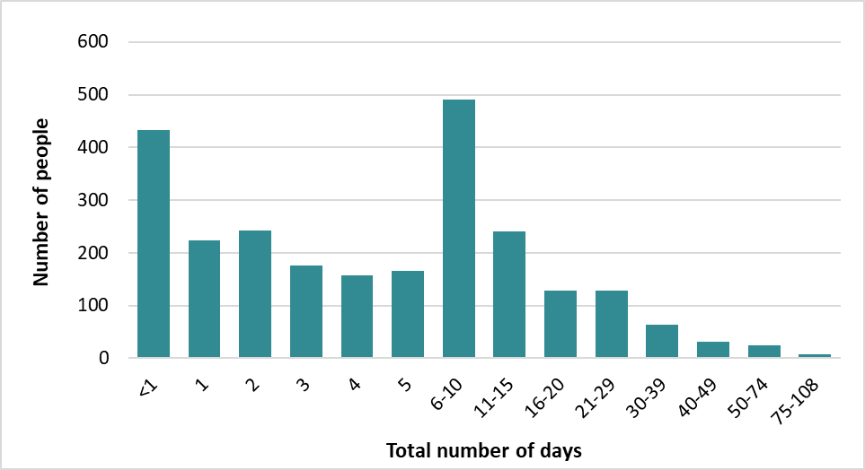
Figure 15. Total number of days each patient spent in hospital as a result of an emergency admission for COPD in the year 2021/22. Source: HES.
The number of admissions per patient was expressed as a ratio for each PCN in figures 16 – 19 for 2021/22. The ratios vary between and within HCPs, but the PCNs in East Kent HCP consistently have a lower ratio of admissions to patients. In order of decreasing ratio, these are the PCNs which have a higher admissions to patients ratio than Kent and Medway as a whole (1.35): Gravesend Central (1.8), Weald, Medway Rainham, Dartford Central, ABC, Tonbridge, Garden City, Medway Central, Dartford Model, South Maidstone, Total Health Excellence West, Sevenoaks, Mid Kent, Swanley and Rural, CARE Kent, Canterbury North.
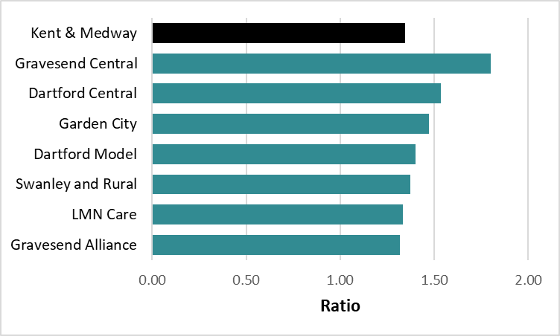
Figure 16. The ratio of admissions to patients by PCN in Dartford, Gravesham and Swanley HCP, 2021/22. Source: HES.
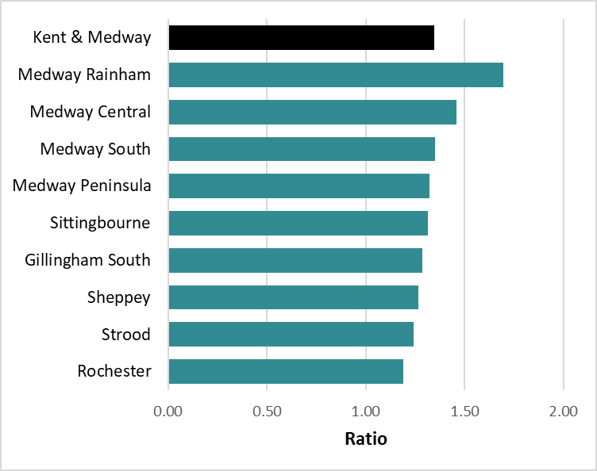
Figure 17. The ratio of admissions to patients by PCN in Medway and Swale HCP, 2021/22. Source: HES.
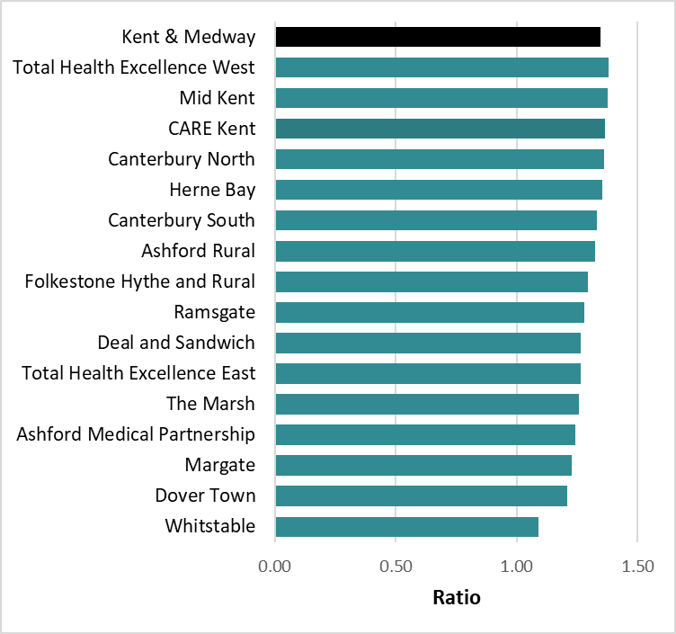
Figure 18. The ratio of admissions to patients by PCN in East Kent HCP, 2021/22. Source: HES.
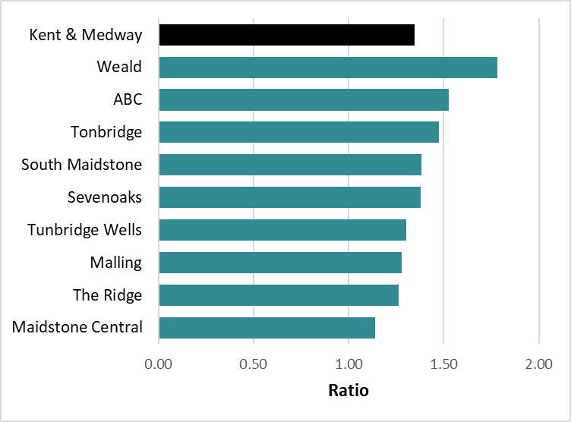
Figure 19. The ratio of admissions to patients by PCN in West Kent HCP, 2021/22. Source: HES.

Conclusions
There is marked variation between admission rates across Kent and Medway. Notably, there are much higher rates in Medway, Swale and Thanet where smoking rates are higher (QOF, NHS Digital). The age-standardised admission rate in Medway and Swale HCP is approximately 60% higher than West Kent HCP. Admission rates nearly halved in 2020/21 financial year. Rates increased in 2021/22, but not to pre-pandemic levels. There is significant inequality in COPD admissions depending on IMD score and this is a well-known relationship nationally. In Kent and Medway between 2017-2022, the age-standardised admission rates are 4.1 times higher in those living in the most deprived quintile than the least.
Most patients only had one emergency admission in 2021/22 and also had the lowest median length of stay. Longer length of stay is associated with number of admissions up to 4 admissions. This phenomenon is likely related to severity and complexity of condition. Further demographic information such as age of patient or presence of co-morbidities may help to explain this difference.
Median spell duration is two or more days longer at Dartford, Gravesham and Swanley HCP compared to the other three HCPs. This could be an opportunity to review clinical procedures to align with the rest of Kent and Medway but that question is beyond the scope of this report.
Furthermore, there is variation between PCNs in the ratio of admissions to patients, suggesting opportunities for prevention within primary care.

|

Appendix
Table 1. Emergency hospital admission age-standardised rates per 100,000 (ASR) for COPD by Kent and Medway PCN, 2017/18 to 2021/22. Source: Hospital Episode Statistics.
Year | PCN | Admissions | Population | Age standardised rate per 100,000 | Lower 95CI | Upper 95CI
2017/18 | ABC | 105 | 30415 | 385.9 | 315.0 | 468.3
2017/18 | Ashford Medical Partnership | 50 | 30789 | 224.5 | 167.1 | 296.9
2017/18 | Ashford Rural | 75 | 35056 | 164.7 | 129.5 | 209.4
2017/18 | Canterbury North | 95 | 48953 | 248.4 | 200.6 | 304.5
2017/18 | Canterbury South | 55 | 31028 | 178.0 | 134.5 | 232.5
2017/18 | CARE Kent | 135 | 47828 | 200.1 | 166.9 | 239.8
2017/18 | Dartford Central | 95 | 33583 | 332.1 | 269.1 | 406.2
2017/18 | Dartford Model | 45 | 31956 | 174.4 | 127.6 | 233.9
2017/18 | Deal & Sandwich | 120 | 48103 | 194.0 | 160.6 | 234.1
2017/18 | Dover Town | 85 | 26869 | 322.2 | 257.6 | 399.4
2017/18 | Folkestone Hythe & Rural | 110 | 49809 | 184.3 | 151.5 | 223.2
2017/18 | Garden City | 80 | 52295 | 191.9 | 152.4 | 238.9
2017/18 | Gillingham South | 100 | 39563 | 317.7 | 258.2 | 387.6
2017/18 | Gravesend Alliance | 110 | 55753 | 247.5 | 203.5 | 298.7
2017/18 | Gravesend Central | 60 | 31225 | 252.5 | 191.9 | 326.9
2017/18 | Herne Bay | 120 | 40732 | 233.4 | 192.9 | 281.7
2017/18 | LMN | 35 | 26679 | 105.9 | 73.7 | 150.2
2017/18 | Maidstone Central | 90 | 50272 | 203.3 | 163.5 | 250.2
2017/18 | Malling | 95 | 58732 | 181.0 | 146.6 | 222.2
2017/18 | Margate | 170 | 54117 | 309.4 | 264.4 | 360.3
2017/18 | Medway Central | 125 | 57873 | 350.2 | 290.5 | 419.3
2017/18 | Medway Peninsula | 90 | 36352 | 267.4 | 214.8 | 330.9
2017/18 | Medway Rainham | 85 | 43826 | 176.4 | 141.1 | 218.7
2017/18 | Medway South | 170 | 56175 | 339.9 | 290.0 | 397.6
2017/18 | Mid Kent | 185 | 98415 | 204.9 | 176.3 | 237.0
2017/18 | Ramsgate | 140 | 51867 | 273.9 | 230.5 | 323.6
2017/18 | Rochester | 95 | 33064 | 339.2 | 274.1 | 415.9
2017/18 | Sevenoaks | 105 | 79805 | 129.3 | 105.7 | 157.2
2017/18 | Sheppey | 145 | 46059 | 336.1 | 282.8 | 398.1
2017/18 | Sittingbourne | 160 | 66542 | 271.0 | 230.7 | 316.6
2017/18 | South Maidstone | 100 | 38278 | 270.5 | 219.9 | 330.1
2017/18 | Strood | 60 | 31989 | 279.8 | 212.7 | 365.1
2017/18 | Swanley & Rural | 75 | 36382 | 188.4 | 147.4 | 238.2
2017/18 | The Marsh | 70 | 17312 | 257.2 | 199.3 | 336.1
2017/18 | The Ridge | 60 | 39513 | 130.9 | 99.9 | 170.4
2017/18 | Tonbridge | 145 | 66635 | 210.2 | 177.0 | 248.1
2017/18 | Total Health Excellence East | 115 | 44131 | 274.5 | 226.6 | 330.2
2017/18 | Total Health Excellence West | 80 | 28124 | 268.6 | 212.1 | 336.9
2017/18 | Tunbridge Wells | 125 | 80101 | 169.0 | 140.7 | 201.7
2017/18 | Weald | 90 | 47400 | 168.0 | 134.6 | 208.7
2017/18 | Whitstable | 90 | 39357 | 187.0 | 150.6 | 231.6
2018/19 | ABC | 95 | 34245 | 297.4 | 240.8 | 363.8
2018/19 | Ashford Medical Partnership | 65 | 31530 | 270.5 | 206.9 | 348.9
2018/19 | Ashford Rural | 85 | 35622 | 176.7 | 141.3 | 221.2
2018/19 | Canterbury North | 80 | 49401 | 213.6 | 169.8 | 265.6
2018/19 | Canterbury South | 50 | 31750 | 152.3 | 112.4 | 202.9
2018/19 | CARE Kent | 140 | 48134 | 199.0 | 166.8 | 237.6
2018/19 | Dartford Central | 95 | 35122 | 318.4 | 256.8 | 391.0
2018/19 | Dartford Model | 60 | 32010 | 220.6 | 166.9 | 286.8
2018/19 | Deal & Sandwich | 120 | 48238 | 189.3 | 156.3 | 229.2
2018/19 | Dover Town | 65 | 27328 | 245.6 | 190.2 | 313.5
2018/19 | Folkestone Hythe & Rural | 115 | 49097 | 186.1 | 153.4 | 225.0
2018/19 | Garden City | 110 | 53911 | 244.9 | 201.1 | 295.9
2018/19 | Gillingham South | 95 | 39414 | 294.2 | 237.6 | 361.1
2018/19 | Gravesend Alliance | 105 | 56252 | 232.7 | 189.9 | 282.6
2018/19 | Gravesend Central | 65 | 31789 | 272.7 | 210.1 | 349.1
2018/19 | Herne Bay | 130 | 40928 | 264.5 | 220.9 | 315.8
2018/19 | LMN | 40 | 26409 | 112.5 | 79.5 | 157.5
2018/19 | Maidstone Central | 100 | 47828 | 233.2 | 189.1 | 285.1
2018/19 | Malling | 110 | 59378 | 204.3 | 168.1 | 247.2
2018/19 | Margate | 190 | 55234 | 340.9 | 294.0 | 393.5
2018/19 | Medway Central | 150 | 58569 | 441.0 | 372.1 | 519.6
2018/19 | Medway Peninsula | 80 | 36368 | 228.5 | 181.2 | 286.6
2018/19 | Medway Rainham | 100 | 44119 | 190.0 | 154.0 | 232.8
2018/19 | Medway South | 160 | 57076 | 320.2 | 272.2 | 375.8
2018/19 | Mid Kent | 155 | 99358 | 172.1 | 146.1 | 201.7
2018/19 | Ramsgate | 180 | 51680 | 343.6 | 295.0 | 398.6
2018/19 | Rochester | 90 | 32926 | 319.2 | 256.7 | 393.2
2018/19 | Sevenoaks | 105 | 81096 | 127.1 | 103.9 | 154.6
2018/19 | Sheppey | 160 | 46650 | 350.2 | 297.1 | 411.9
2018/19 | Sittingbourne | 155 | 67800 | 253.5 | 215.2 | 297.0
2018/19 | South Maidstone | 100 | 37749 | 271.9 | 220.7 | 332.3
2018/19 | Strood | 55 | 32534 | 225.1 | 167.7 | 300.5
2018/19 | Swanley & Rural | 70 | 36510 | 183.5 | 143.0 | 232.9
2018/19 | The Marsh | 60 | 17266 | 216.1 | 163.1 | 290.5
2018/19 | The Ridge | 55 | 40758 | 111.0 | 83.2 | 146.9
2018/19 | Tonbridge | 110 | 67341 | 161.8 | 132.8 | 195.6
2018/19 | Total Health Excellence East | 110 | 44858 | 261.7 | 215.3 | 316.3
2018/19 | Total Health Excellence West | 70 | 29618 | 225.8 | 175.8 | 286.2
2018/19 | Tunbridge Wells | 115 | 80736 | 156.7 | 129.3 | 188.4
2018/19 | Weald | 65 | 48085 | 126.6 | 98.0 | 162.3
2018/19 | Whitstable | 60 | 39899 | 117.4 | 89.5 | 153.2
2019/20 | ABC | 105 | 33768 | 325.4 | 265.8 | 395.0
2019/20 | Ashford Medical Partnership | 50 | 32030 | 223.9 | 165.6 | 297.1
2019/20 | Ashford Rural | 70 | 36016 | 143.4 | 111.3 | 184.5
2019/20 | Canterbury North | 95 | 50014 | 246.5 | 199.8 | 301.1
2019/20 | Canterbury South | 65 | 32019 | 206.0 | 159.3 | 263.4
2019/20 | CARE Kent | 145 | 48651 | 205.4 | 172.7 | 244.5
2019/20 | Dartford Central | 90 | 36306 | 304.7 | 244.9 | 375.2
2019/20 | Dartford Model | 60 | 32273 | 230.1 | 175.3 | 297.7
2019/20 | Deal & Sandwich | 95 | 48122 | 144.7 | 116.3 | 179.8
2019/20 | Dover Town | 85 | 27552 | 300.6 | 239.9 | 373.2
2019/20 | Folkestone Hythe & Rural | 95 | 48870 | 151.3 | 122.4 | 186.5
2019/20 | Garden City | 75 | 55218 | 166.5 | 131.3 | 208.5
2019/20 | Gillingham South | 95 | 39358 | 293.8 | 237.6 | 360.4
2019/20 | Gravesend Alliance | 110 | 57005 | 244.7 | 201.0 | 295.6
2019/20 | Gravesend Central | 50 | 32615 | 208.8 | 154.7 | 276.8
2019/20 | Herne Bay | 145 | 41136 | 289.5 | 244.2 | 342.4
2019/20 | LMN | 45 | 26159 | 127.0 | 91.8 | 175.6
2019/20 | Maidstone Central | 85 | 48195 | 208.3 | 166.6 | 257.6
2019/20 | Malling | 115 | 59850 | 207.2 | 170.9 | 249.8
2019/20 | Margate | 170 | 55420 | 300.0 | 256.5 | 349.2
2019/20 | Medway Central | 155 | 59547 | 430.5 | 364.2 | 506.3
2019/20 | Medway Peninsula | 85 | 36911 | 225.0 | 178.7 | 282.1
2019/20 | Medway Rainham | 90 | 44606 | 174.2 | 140.2 | 214.9
2019/20 | Medway South | 130 | 57674 | 264.2 | 219.9 | 316.3
2019/20 | Mid Kent | 155 | 100124 | 168.3 | 142.9 | 197.2
2019/20 | Ramsgate | 190 | 51494 | 363.9 | 313.8 | 420.3
2019/20 | Rochester | 80 | 33287 | 269.1 | 212.5 | 336.7
2019/20 | Sevenoaks | 90 | 82256 | 107.5 | 86.4 | 132.8
2019/20 | Sheppey | 165 | 47390 | 374.7 | 319.5 | 438.1
2019/20 | Sittingbourne | 160 | 68505 | 260.4 | 221.7 | 304.2
2019/20 | South Maidstone | 70 | 38882 | 186.3 | 144.5 | 237.3
2019/20 | Strood | 55 | 32942 | 225.4 | 169.9 | 298.0
2019/20 | Swanley & Rural | 90 | 36826 | 225.8 | 181.5 | 278.5
2019/20 | The Marsh | 70 | 17365 | 272.3 | 209.7 | 357.0
2019/20 | The Ridge | 60 | 41627 | 120.0 | 91.4 | 156.7
2019/20 | Tonbridge | 95 | 67741 | 134.6 | 108.9 | 165.1
2019/20 | Total Health Excellence East | 120 | 45765 | 274.6 | 227.3 | 329.6
2019/20 | Total Health Excellence West | 85 | 30066 | 271.0 | 215.8 | 336.9
2019/20 | Tunbridge Wells | 95 | 81845 | 127.6 | 103.3 | 156.2
2019/20 | Weald | 70 | 48985 | 129.7 | 101.0 | 165.2
2019/20 | Whitstable | 55 | 40382 | 103.3 | 77.6 | 137.0
2020/21 | ABC | 55 | 33630 | 182.9 | 138.3 | 237.8
2020/21 | Ashford Medical Partnership | 30 | 32175 | 123.6 | 81.7 | 180.6
2020/21 | Ashford Rural | 45 | 36403 | 89.4 | 64.5 | 123.7
2020/21 | Canterbury North | 55 | 49248 | 137.7 | 103.6 | 179.6
2020/21 | Canterbury South | 30 | 32786 | 92.0 | 62.7 | 132.6
2020/21 | CARE Kent | 65 | 48944 | 90.2 | 69.3 | 117.8
2020/21 | Dartford Central | 65 | 36853 | 217.9 | 167.5 | 279.4
2020/21 | Dartford Model | 40 | 32204 | 165.2 | 118.3 | 225.2
2020/21 | Deal & Sandwich | 60 | 48031 | 88.9 | 67.0 | 118.5
2020/21 | Dover Town | 45 | 27731 | 157.4 | 114.3 | 212.8
2020/21 | Folkestone Hythe & Rural | 60 | 47131 | 100.6 | 76.6 | 131.4
2020/21 | Garden City | 85 | 56170 | 183.0 | 146.4 | 226.2
2020/21 | Gillingham South | 50 | 39619 | 154.9 | 115.0 | 205.2
2020/21 | Gravesend Alliance | 70 | 57004 | 153.5 | 119.6 | 194.7
2020/21 | Gravesend Central | 40 | 33091 | 159.0 | 112.7 | 219.2
2020/21 | Herne Bay | 80 | 41227 | 160.6 | 127.3 | 202.0
2020/21 | LMN | 25 | 25951 | 73.1 | 47.2 | 113.5
2020/21 | Maidstone Central | 50 | 47912 | 116.9 | 86.6 | 154.6
2020/21 | Malling | 60 | 60387 | 103.3 | 78.3 | 134.7
2020/21 | Margate | 80 | 55192 | 148.5 | 118.0 | 184.8
2020/21 | Medway Central | 70 | 59817 | 192.6 | 149.9 | 244.6
2020/21 | Medway Peninsula | 40 | 36808 | 108.7 | 77.9 | 150.6
2020/21 | Medway Rainham | 45 | 44701 | 78.7 | 56.9 | 107.4
2020/21 | Medway South | 55 | 57774 | 107.4 | 81.0 | 141.7
2020/21 | Mid Kent | 90 | 100744 | 92.3 | 74.0 | 114.1
2020/21 | Ramsgate | 85 | 51293 | 168.6 | 134.9 | 208.8
2020/21 | Rochester | 35 | 33532 | 125.6 | 88.3 | 174.1
2020/21 | Sevenoaks | 50 | 82955 | 59.4 | 44.2 | 78.9
2020/21 | Sheppey | 70 | 47567 | 157.2 | 122.8 | 200.1
2020/21 | Sittingbourne | 65 | 68905 | 104.0 | 80.6 | 132.7
2020/21 | South Maidstone | 45 | 39934 | 117.7 | 85.4 | 158.9
2020/21 | Strood | 25 | 33231 | 106.8 | 69.6 | 162.3
2020/21 | Swanley & Rural | 45 | 36738 | 118.8 | 87.1 | 159.1
2020/21 | The Marsh | 25 | 17380 | 80.6 | 50.6 | 134.5
2020/21 | The Ridge | 35 | 42089 | 69.2 | 48.2 | 98.2
2020/21 | Tonbridge | 65 | 67791 | 92.8 | 71.6 | 118.8
2020/21 | Total Health Excellence East | 55 | 45989 | 121.9 | 91.2 | 160.3
2020/21 | Total Health Excellence West | 35 | 31851 | 112.4 | 79.0 | 156.2
2020/21 | Tunbridge Wells | 65 | 82486 | 82.9 | 63.6 | 106.6
2020/21 | Weald | 45 | 49668 | 84.8 | 62.2 | 114.1
2020/21 | Whitstable | 25 | 40660 | 45.2 | 29.2 | 70.2
2021/22 | ABC | 80 | 33755 | 264.5 | 210.0 | 329.4
2021/22 | Ashford Medical Partnership | 45 | 33278 | 177.9 | 128.2 | 242.3
2021/22 | Ashford Rural | 60 | 37603 | 114.0 | 86.3 | 150.3
2021/22 | Canterbury North | 85 | 49299 | 205.4 | 163.5 | 255.1
2021/22 | Canterbury South | 35 | 33870 | 110.6 | 77.8 | 154.0
2021/22 | CARE Kent | 130 | 49498 | 177.8 | 148.0 | 213.7
2021/22 | Dartford Central | 70 | 37220 | 233.3 | 181.0 | 297.5
2021/22 | Dartford Model | 65 | 32406 | 258.7 | 199.7 | 330.0
2021/22 | Deal & Sandwich | 110 | 48119 | 160.7 | 131.7 | 196.5
2021/22 | Dover Town | 65 | 28072 | 232.1 | 179.8 | 295.9
2021/22 | Folkestone Hythe & Rural | 95 | 48455 | 149.4 | 120.5 | 185.0
2021/22 | Garden City | 95 | 57848 | 202.6 | 164.0 | 248.0
2021/22 | Gillingham South | 80 | 39765 | 235.4 | 186.2 | 294.9
2021/22 | Gravesend Alliance | 100 | 57219 | 221.4 | 180.1 | 269.5
2021/22 | Gravesend Central | 60 | 33647 | 259.6 | 197.5 | 335.6
2021/22 | Herne Bay | 90 | 41522 | 170.3 | 137.0 | 211.3
2021/22 | LMN | 45 | 26030 | 135.2 | 98.0 | 184.8
2021/22 | Maidstone Central | 60 | 48176 | 137.9 | 105.2 | 178.1
2021/22 | Malling | 100 | 61393 | 173.4 | 140.5 | 212.8
2021/22 | Margate | 140 | 56122 | 242.8 | 204.1 | 287.3
2021/22 | Medway Central | 110 | 62320 | 298.5 | 244.2 | 361.8
2021/22 | Medway Peninsula | 75 | 36926 | 204.5 | 160.4 | 259.0
2021/22 | Medway Rainham | 75 | 44717 | 141.8 | 111.6 | 178.8
2021/22 | Medway South | 135 | 57474 | 260.0 | 217.8 | 309.8
2021/22 | Mid Kent | 175 | 100231 | 180.6 | 154.7 | 209.8
2021/22 | Ramsgate | 130 | 51250 | 238.5 | 198.8 | 284.4
2021/22 | Rochester | 60 | 33676 | 208.0 | 158.9 | 268.1
2021/22 | Sevenoaks | 95 | 84184 | 112.4 | 91.0 | 138.0
2021/22 | Sheppey | 130 | 47639 | 281.9 | 235.5 | 336.3
2021/22 | Sittingbourne | 135 | 70179 | 207.2 | 173.4 | 246.1
2021/22 | South Maidstone | 75 | 41224 | 198.7 | 155.6 | 250.7
2021/22 | Strood | 60 | 33518 | 238.8 | 180.8 | 314.6
2021/22 | Swanley & Rural | 70 | 36770 | 175.8 | 137.2 | 223.0
2021/22 | The Marsh | 50 | 17555 | 189.7 | 139.1 | 261.6
2021/22 | The Ridge | 45 | 44301 | 87.1 | 63.9 | 117.7
2021/22 | Tonbridge | 85 | 68094 | 118.3 | 94.3 | 147.0
2021/22 | Total Health Excellence East | 105 | 46285 | 233.4 | 190.6 | 283.8
2021/22 | Total Health Excellence West | 70 | 31950 | 201.8 | 156.7 | 256.8
2021/22 | Tunbridge Wells | 80 | 83821 | 101.4 | 80.3 | 126.8
2021/22 | Weald | 70 | 50933 | 120.6 | 93.6 | 154.1
2021/22 | Whitstable | 50 | 41592 | 85.6 | 63.1 | 115.6

Table 2. Frequency table of number of admissions per patient by HCP, 2021/22. Source: Hospital Episode Statistics.
HCP | 1 | 2 | 3 | 4 | 5+ | Total
DGS | 255 (75.2%) | 55 | 20 | 10 | * | 340
EK | 865 (80.2%) | 140 | 40 | 20 | 10 | 1075
MS | 485 (82.0%) | 75 | 20 | 10 | * | 600
WK | 390 (80.3%) | 60 | 25 | * | 10 | 495
Grand total | 1995 (80%) | 335 | 105 | 40 | 40 | 2510

