?

Oral Health Survey of 5-year-olds from Deprived Areas of Kent 2021/22

July 2023

|
Contents
1 Oral Health Survey 2021/22 3
1. Executive summary 3
1.1 Key findings 3
1.2 Call to Action 3
2. Introduction 4
3. Method 4
3.1 Survey method 4
3.2 Overview of the Study Population 5
3.3 Analysis method 6
4. Results 8
4.1 Base Observations 8
4.2 Analysis by Local Authority 8
4.3 Analysis by Sex 10
4.4 Analysis by Ethnicity 10
4.5 Analysis of relationships between dental pathologies 12
4.6 Multiple regression analysis 12
5. Conclusions 13
6. References 15
Appendices 16
Appendix 1. Evaluation of final models 16

Oral Health Survey 2021/22
|

1. Executive summary

- Key findings
- A total of 1245 children were examined across the four districts, this was 2409 less than initially enrolled in the study, due to a high rate of non-attendance or consent not being given on the day of the examination
- The most frequently identified dental pathologies in the cohort were Decayed Teeth and Surfaces (228 children had one or more)
- 18.31% of the children examined had one or more Decayed Teeth
- 1.29% of the children examined had one or more Missing Teeth
- 2.17% of the children examined had one or more Filled Teeth
- Plaque severity and the number of Decayed Teeth and Surfaces were found to vary significantly between Districts. Dartford performed the best in these instances, with Gravesham performing the worst
- Sex likely had a minimal effect on the dental pathologies observed, except when considered as an effect modifier in some instances
- Plaque severity, Decayed Teeth and Surfaces, Missing Teeth, Filled Surfaces, and Trauma were found to vary significantly between ethnicities
- Notably some of these associations were driven by just one or two children in the ‘Asian’ or ‘Other’ ethnic groups. This means some findings may be more vulnerable to a higher margin of error created by chance
- Several associations between different dental pathologies were also identified, for example, those with increased Plaque were also likely to have more Decayed Teeth
- Trauma was the only recorded dental pathology found not to be significantly associated with at least one other dental pathology. This is likely because all other recorded dental pathologies relate to poor oral health or hygiene practices, whereas the incidence of Trauma depends on whether an injury has occurred
- Call to Action
The general picture of oral health in this cohort requires improvement. More socio-economic information on the studied children would be beneficial to future surveys, however, over-complexity could increase participant drop-out. Whilst attention is needed towards all the districts covered in this analysis, it may be diligent to prioritise Gravesham.
Children from ‘Asian’ and ‘Other’ ethnic groups may be at higher risk for poor oral health and so should be prioritised for intervention. However, several instances of variation that triggered a statistically significant association in minority ethnic groups were caused by just a handful of children, so some findings may be influenced by chance.
|

2. Introduction
The number of paediatric patients being treated for non-traumatic dental issues at A&E facilities across England is significant¹. Many of these cases are preventable through adopting simple behaviours aimed at maintaining good general oral health. As children from deprived areas are more than twice as likely to have dental decay compared to those from less deprived areas², targeted intervention is required. This will not only prevent the oral health of children in Kent from deteriorating but also relieve pressure from A&E services.
The present report summarises the 2021/22 oral health survey, commissioned by Kent County Council (KCC) and conducted by Kent Community Health Foundation Trust (KCHFT) to assess the teeth of 5-year-olds across Kent. This biannual study was conducted as part of KCC’s Public Health duties, producing a better picture of the oral health needs among children attending schools in the most deprived neighbourhoods of four Kent districts. These four districts were chosen as they are known from previous surveys to have worse child oral health compared to other districts in Kent, as well as being more deprived overall.
This will create an opportunity for intervention on the oral health of children in deprived areas, where dental care may not be as readily available. This will take the form of targeted messaging towards parents or carers around improving behaviours to maintain good oral health on the study participants. Findings from this analysis can also be used to inform future interventions.
As the present report relates solely to the oral health of children from the most deprived neighbourhoods in Kent, the results cannot be used to describe the oral health of children in other areas or across Kent. Based on prior research, it is expected that the oral health of children from these areas will be on average poorer than that of children from less deprived neighbourhoods.
|

3. Method

- Survey method
The process of obtaining consent, conducting examinations, and collating the results was administered by Kent Community Health Foundation Trust (KCHFT). Information on the survey and a consent form was initially sent out to the parents and or carers of children electronically by the participating schools.
Following this, paper forms were also sent out to increase enrolment. After consent was given, some personal information was recorded from the parent and or carer. This was proceeded by a brief physical examination of their child’s teeth by a qualified Dental Professional in the child’s school. This assessment centred around the number of Decayed, Filled, or Missing teeth but also included seven other measures. If on the day of the examination, a child expressed that they no longer wished to participate, they were removed from the study. Also, children that were absent on the day of the examination were excluded.
No treatment was provided, but in cases deemed necessary, parents and or carers were advised by letter to seek further dental examination. Where parents and or carers provided a telephone number and consent to be contacted, some were followed by telephone calls to further urge treatment or to provide advice on how and where to register with a local practitioner. Dental advice was also given on prevention, diet, and good hygiene practices such as supervised brushing.
All the data collected from the survey were recorded as the number of dental pathologies seen in each child, except for Plaque levels which were recorded in categories of severity.
- Overview of the Study Population
This study aimed to target a large portion of the children living in these deprived areas. A total of 3471 children were deemed necessary to make this study successful, with 3654 being initially enrolled to account for consent not being provided or the child being absent on the day of the visit. Only 36% of the desired sample size were assessed by the dentist and therefore included in this report. There is some variation in the population sizes between the studied districts, with the following proportions of desired sample sizes included from each district: Dartford (43%), Gravesham (38%), Swale (31%) and Thanet (31%).
Table 1. The desired, enrolled, and actual sample sizes of children from each district used in this study
District | Desired sample size | Enrolled sample size | Actual sample size
Dartford | 867 | 920 | 370
Gravesham | 916 | 962 | 351
Swale | 859 | 902 | 268
Thanet | 829 | 870 | 256
Total | 3471 | 3654 | 1245
Among the 1245 children included in this report, there were 626 males and 619 females. In terms of ethnicity, population sizes vary much more, with 70% of the cohort being listed as White British. Caution should therefore be taken when interpreting some of the present analysis regarding ethnicity as comparisons may be underpowered.
Figure 1. Recorded Ethnicities of children included in the present study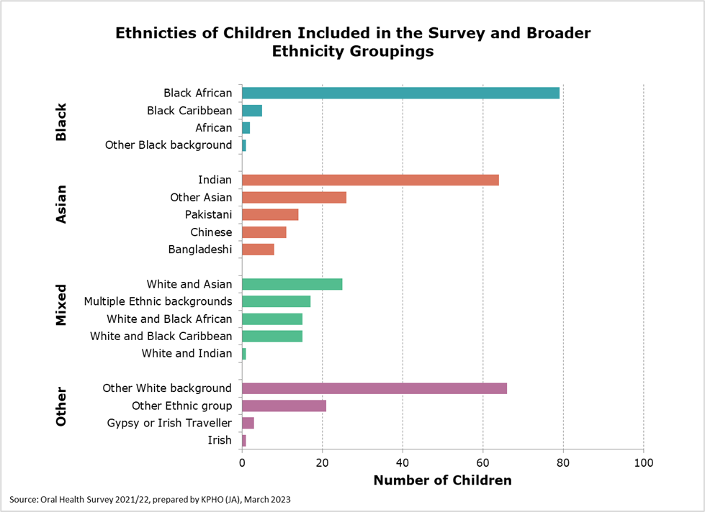
A total of 871 White British children were also enrolled, although are not shown on this graph to make the figure easier to interpret.
- Analysis method
Data collected from the survey were compiled into one dataset for analysis. The child’s Sex, Ethnicity, and District of residence were included along with their oral health survey data in the dataset provided to KPHO. Prior to the analysis, some Ethnicity categories were re-grouped to avoid duplication. This resulted in nineteen ethnic categories being included in the analysis.
To summarise basic observations (for example, the total number of Decayed Teeth), the dataset was initially filtered, with some proportions also being calculated (see Section 4.1). Statistical testing for associations between demographic variables and dental pathologies was then carried out using R statistical software. To examine the relationship of Plaque severity with Local authority, Sex and Ethnicity, the Chi-squared test was selected. For all other (count) variables, one-way ANOVA was used. A significance threshold of α <0.05 was selected for this analysis, although this was not utilised as a definitive guideline of significance to avoid over-reliance on p-values.
Linear regression was used to explore relationships identified through association testing between Ethnicity and dental pathologies. Five broad ethnic groups were used for this: White British, Black, Asian, Mixed and Other. Regression was not able to be applied for the original ethnicity groupings due to the high number of categories with varying sample sizes.
Relationships between the recorded pathologies were also assessed, firstly through linear regression, then explored further through partial F-tests. A partial F-test is a statistical test used to determine whether there is a statistically significant difference between two iterations of a regression model (one including the ‘explanatory’ variable, and one without). This means that in the present context, this test can be used to determine whether one or more variables (i.e., dental pathologies) are relevant and need to be included in the final statistical model.
Practically, this is done by first fitting the full regression model, followed by fitting the reduced (nested) model. An ANOVA test is then used to compare the full and reduced models, which produces an F-statistic. If the corresponding p-value given is below the significance threshold of 0.05, the null hypothesis is rejected. This means we can conclude that the predictor variable removed in the reduced model significantly improves the fit of the full model. This methodology helps to combat the effects of confounding/effect modification (explained below) and provides insight as to what combinations of dental pathologies may be common in this population.
Finally, to follow up on previous findings and explore more complex relationships between variables, multi-level regression was applied, using broad ethnicity groupings. Multiple regression analysis enables the relationships described so far to be explored in further detail. In particular, it can uncover how ‘explanatory’ variables such as District and Ethnicity may interact together to exert an effect on oral health. This produces a model that can be used to predict the outcome of a ‘response’ variable such as the number of Decayed Teeth seen in a child. Complex models like this provide a more realistic image of the factors affecting oral health, as in the real world, this is determined through the culmination of a complex interaction of causes.
An important aspect of regression is the identification of confounders and effect modifiers, the definitions of which are provided below.
- Confounder: a variable that influences both the explanatory and response variables although not causally, therefore creating a spurious association
- Effect modifier: a variable that alters the magnitude of the effect that the explanatory variable has on the response variable, depending on its level
The final models produced will quantify the extent to which a variable is associated with a dental pathology, after adjusting for any confounding or effect modification from other associated variables. This analysis cannot fully explain these relationships, however, as not all possible explanatory variables have been recorded. Akaike Information Criterion (AIC) and Bayesian Information Criterion (BIC) were also calculated to assess the final models produced. AIC/BIC are both measures of the quality of a statistical model and can be used to evaluate how well a model fits the data it is generated from.
|

4. Results

- Base Observations
A range of key summary statistics were generated from the dataset. These are provided below,
- The most frequently identified dental pathologies in the cohort are Decayed Teeth and Surfaces (228 children had one or more of each)
- The least commonly identified were Crowns (5 children had one or more)
- In addition, respective numbers of children were recorded as having one or more of the following: Filled teeth (27), Filled Surfaces (25), Missing teeth (16) and Dental Trauma (16)
- No Sealed Teeth, Abscesses or Sepsis were recorded in the cohort
- There were no children recorded with ‘High’ levels of Plaque
- Percentage of the cohort with one or more Decayed Teeth: 18.31% (highest in Gravesham)
- Percentage of the cohort with one or more Missing Teeth: 1.29% (highest in Dartford)
- Percentage of the cohort with one or more Filled Teeth: 2.17% (highest in Gravesham)
- Analysis by Local Authority
Plaque levels were found to vary significantly between Districts (p=0.044). However, this p-value is only just below the significance threshold, and so should be interpreted with caution. Simple linear regression found that this is driven by children in Dartford having less plaque relative to Thanet (p=0.004) and possibly also Gravesham (p=0.053).
Furthermore, Decayed Teeth (p=0.002) and Surfaces (p=0.001) varied significantly between each district. Non-adjusted Pairwise T-tests were conducted showing that Dartford has significantly less decayed teeth than Gravesham (p<0.001), Swale (p=0.0012) and possibly Thanet (p=0.05).
The same methodology for decayed surfaces gave similar results, indicating that Dartford has significantly fewer decayed surfaces than Gravesham (p<0.001), Swale (p=0.0012) and Thanet (p=0.022). From this, it seems likely that on average the children in Dartford had fewer Decayed Teeth and Surfaces as well as Plaque, than children in the other districts in most cases. In contrast, this also means that children in Gravesham had the worst number of decayed teeth and surfaces of out all four districts.
Figure 2. Bar chat showing the distribution of Plaque severity between Districts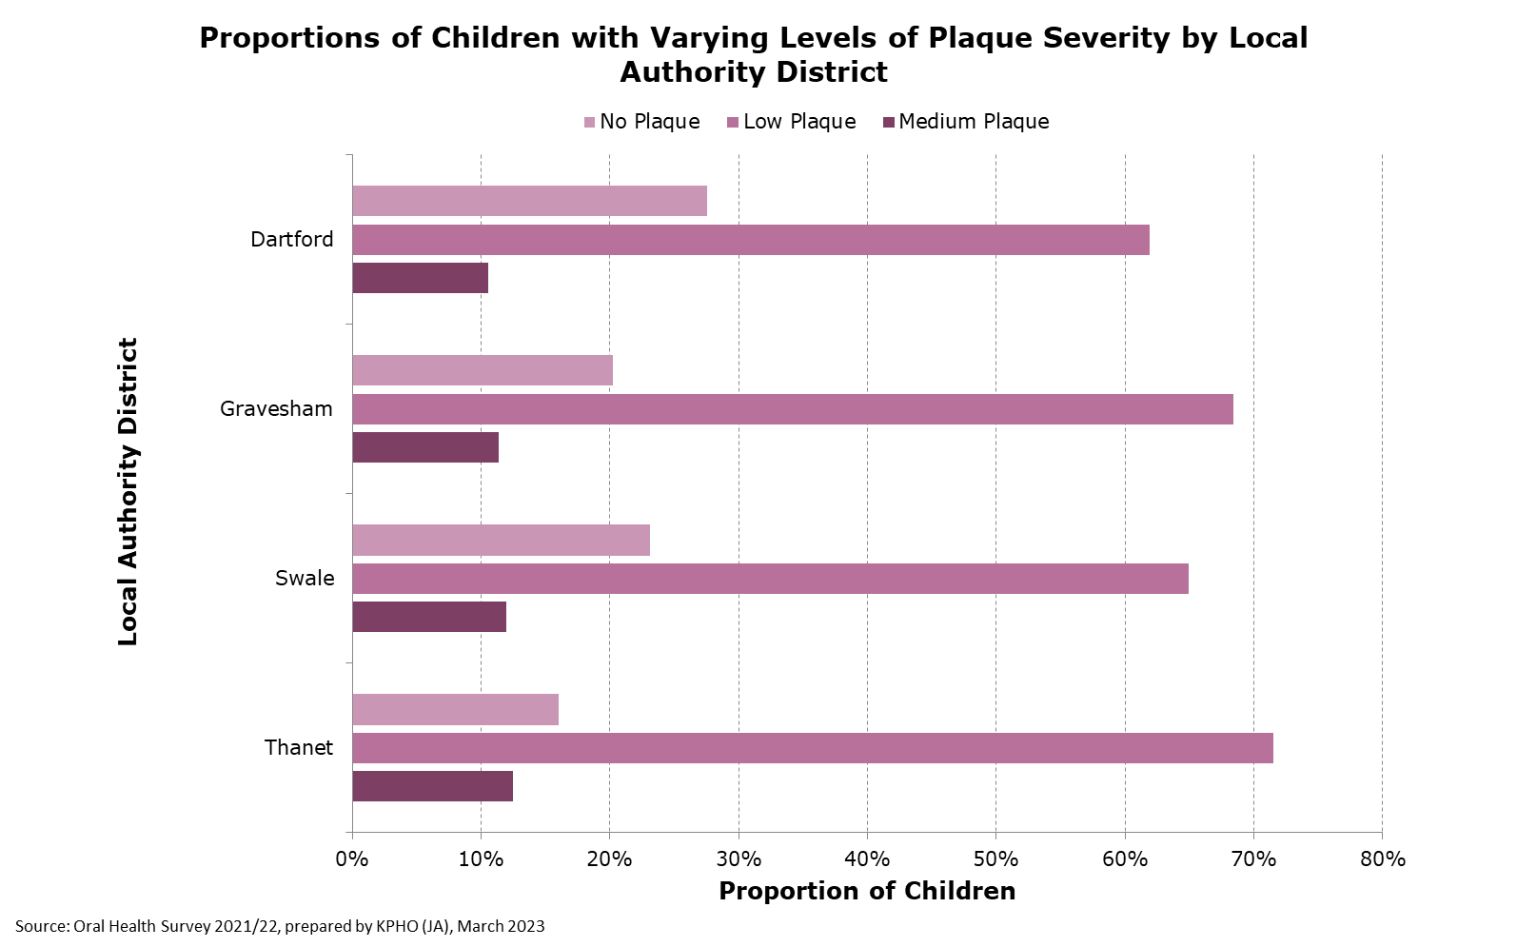

Figure 3. Bar chart showing the distribution of children having one or more Decayed Teeth between Districts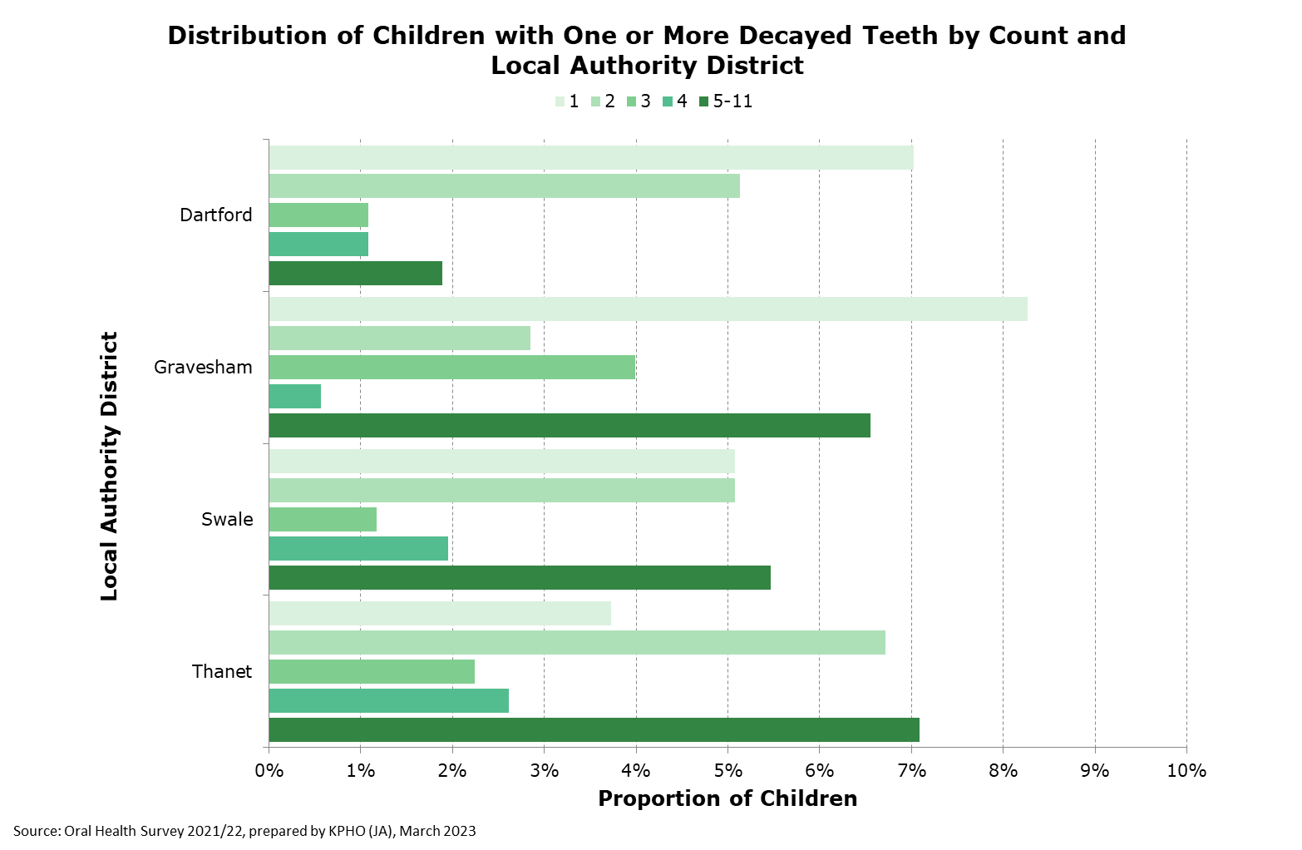
The following proportions of children from each district were found to have no Decayed Teeth: Dartford (84.9%), Swale (83.2%), Thanet (80.2%) and Gravesham (78.3%). The plot for Decayed Surfaces was very similar and so has not been included.
- Analysis by Sex
Simple association tests revealed no significant differences in dental pathologies seen between male and female participants. It is therefore unlikely that sex alone influences the dental health of children in this cohort.
- Analysis by Ethnicity
The levels of plaque found in the enrolled children may have varied significantly between ethnicities (p=0.051), although more complex analysis is required to confirm this as the p-value lies just beyond the threshold (see Chapter 3.6). Moreover, Missing teeth (p<0.001), Filled Teeth (p=0.016), Filled Surfaces (p<0.001), Trauma (p<0.001) and Crowns (p<0.001) were all found to vary significantly between ethnicities.
Simple association tests were re-run using the five broad groupings created for the multiple regression analysis. The following pathologies were found to be significantly associated with ethnicity: Plaque (p=0.012), Decayed Teeth (p=0.0045), Filled Surfaces (p=0.033), Missing teeth (p<0.001), Filled Surfaces (p=0.02) and Trauma (p=0.021).
The drivers of these effects were explored through linear regression of broad ethnicity groups. These findings are listed below,
- Decayed Teeth: Children in ‘Other’ (p=0.03) and ‘Asian’ categories have significantly more Decayed teeth (p<0.001). Also, some less significant variation is seen in children of ‘Black’ ethnicity having slightly less Decayed Teeth (p=0.08)
- Decayed Surfaces: ‘Asian’ (p<0.001) and possibly ‘Other’ children (p=0.07) seem to have more Decayed Surfaces
- Missing: Children from the ‘Other’ group (p=0.008), and possibly also the ‘Asian’ group (p=0.09) have more Missing Teeth
- Filled Surfaces: Children of ‘Asian’ ethnicity have more Filled Surfaces (p<0.001). In contrast, ‘White British’ (p=0.003) and ‘Black’ children have less (p=0.016)
- Trauma: The ‘Mixed’ group is the only category in which Trauma was observed (p=0.004)
- Plaque: Children in the ‘Asian’ category have more plaque (p<0.001), and those in the ‘Black’ category have less (p=0.032). This is visualised in Figure 4
Figure 4. Stacked bar chart showing the proportion of children in each Plaque Severity category by ethnicity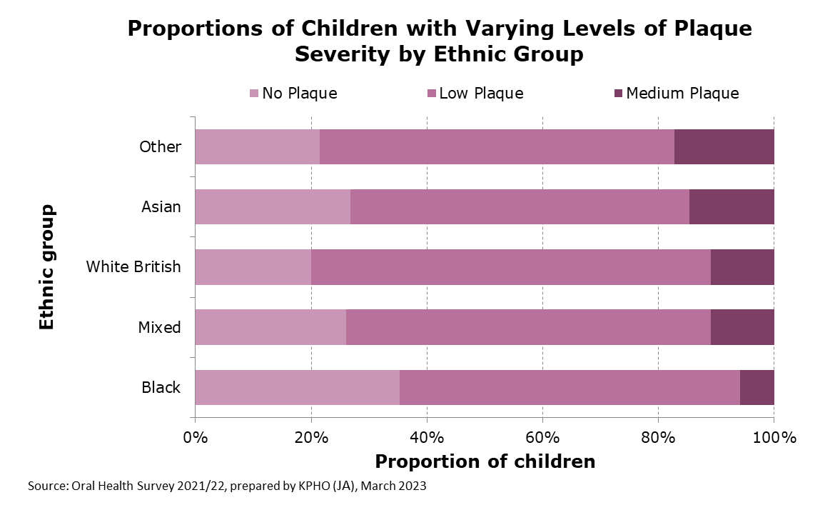
From these results, it seems that ‘Asian’ and ‘Other’ ethnic groups have on average significantly worse oral health, whereas children from ‘Black’ ethnic groups may have on average better oral health. However, many of the significant differences seen in ethnic groups with smaller sample sizes are driven by one or two children. This means these findings could be highly susceptible to outliers, and so should be interpreted cautiously.
- Analysis of relationships between dental pathologies
Relationships between the recorded pathologies were also assessed, firstly through linear regression, then confirmed through partial F-testing between models both with/without the pathology in question. The analysis was done in this way to provide an extra layer of certainty as the partial F-tests can confirm if when the pathology in question is included in the model, it significantly differs from not including it.
Because of this, some relationships which initially seemed significant from the linear regression alone, but that were not confirmed via F-tests, have not been included below.
The following relationships were identified and later confirmed:
- Decayed Teeth & Plaque (p<0.001)
- Decayed Teeth & Decayed Surfaces (p<0.001)
- Decayed Teeth & Filled Surfaces (p<0.001)
- Decayed Surfaces & Filled Teeth (p<0.001)
- Filled Surfaces & Filled Teeth (p<0.001)
- Crown & Missing Teeth (p<0.001)
- Crown & Filled Teeth (p=0.02)
- Crown & Filled Surfaces (p<0.001)
Trauma was the only pathology found not to be significantly associated with any other pathology. Several other associations were identified through linear regression but not confirmed through partial F-tests, and so are not listed here.
- Multiple regression analysis
Final models were produced and then assessed. Akaike Information Criterion (AIC) and Bayesian Information Criterion (BIC) were calculated for each of these models, both including and excluding Districts as part of the model. They have been used in this context to assess whether including/excluding District as an explanatory variable is preferable, with a lower value indicating a preferred model.
The AIC indicated that including District all relevant models was preferable, whereas the BIC indicated excluding it was, however, this is likely because the BIC gives preference to shorter/simpler models. Interestingly, the values obtained were very similar when compared between models (see Appendix 1). The decision was therefore made to exclude District, as the similarity indicates that it likely does not exert a great effect.
Additionally, there is theoretical backing for excluding districts. District in this case only serves as a proxy for other (socio-economic) unmeasured variables and as we assume deprivation is more or less the same between districts, including district may not add any value. Excluding district also provides a simpler model, which is always preferred.
The finalised relationships are provided below, with the demographic variables included having been confirmed to still have a significant effect on the listed outcome, after accounting for the other recorded demographic variables. Sex was included as an effect modifier rather than a confounder as Chi-squared tests found it to not be associated with either Ethnicity or District.
Final models
- Plaque: Ethnicity with sex as an effect modifier
- Decayed teeth: Ethnicity
- Decayed surfaces: Ethnicity
- Missing teeth: Ethnicity
- Filled surfaces: Ethnicity with sex as an effect modifier
- Trauma: Ethnicity

From this analysis, Sex looks to be an effect modifier in a couple of instances, as it does not have a significant impact on the outcome on its own, it can only be included in the final model when considered with Ethnicity. This means that when considered with another variable such as ethnicity, variation of sex can influence the effect that the other variable has on the relevant dental pathology.
|

5. Conclusions
Whilst the present study did not include as many participants as was originally planned, it still provides useful insight. This analysis provides a succinct summary of oral health among 5-year-olds in deprived Kent neighbourhoods, identifying which elements of poor oral health are most common and identifying children who may be at higher risk. Decayed Teeth and Surfaces were found to be the most common dental pathology measured, whilst no children were recorded as having any Sealed Teeth, Abscesses or Sepsis.
Crowns are likely the least common pathology because most children still not having their adult teeth, which might not start coming through until the age of 6 or 7 for many. This may put some parents or guardians off the decision of having a crown put in, which can involve a high cost if not deemed essential. Furthermore, these are often only used when the tooth is severely decayed, in place of one or more fillings.
Whilst there were significant differences between districts in the dental pathologies seen in the children in this cohort, there did not appear to be any significant differences between male and female children. Sex may have acted as an effect modifier in some instances, however.
Children in ‘Asian’ and ‘Other’ ethnicity groupings may be at higher risk of poor oral health according to this study. This correlates with the findings from the “Predicting the presence or absence of tooth decay in the South East: briefing note for local Authorities” report produced by Public Health England in 2015. A possible explanation for this (other than socio-economic) could be differences in hereditary dental characteristics between ethnicities. For example, a difference in the presentation of crowded teeth has been previously evidenced³.
There are several limitations to the present study, notably that not all possible explanatory variables were recorded in the survey. This means that much of the variation seen may have an unknown origin, however explaining the reasons for variation is outside of the current remit of this report.
Failure of the study to recruit the desired total of 3471 participants not only means that the intervention was limited to comparatively few children, but also reduces the potency of this analysis. Observed differences between ethnic groups are often down to just a few children driving the significant changes, especially in groups with fewer participants. This makes this aspect of the analysis quite vulnerable to outliers, meaning it’s difficult to determine whether this effect is a product of random variation. Furthermore, by grouping ethnicities some detail in the analysis is lost, however, this also helps to reduce inaccuracies caused by small sample sizes seen in some ethnic groups. Successfully recruiting more children into the study could have solved these limitations.
There is also the risk that non-attendance of enrolled children on the day of the dental examination has a positive correlation with deprivation. This means non-attendance to school could create a non-representative sample by contributing to study dropout disproportionately in more deprived children. This is supported by data from the Department of Education which states that children eligible for Free School Meals are four times as likely to be severely absent (50% or more of sessions missed).
Finally, it is important to state again that the present analysis is limited to the most deprived neighbourhoods, in four districts within Kent, meaning the results are not generalisable across Kent and should not be compared to other areas.

|

6. References
- Bassey O, Csikar J, Hallam J, Sandoe J, Thompson W, Douglas G. Non-traumatic dental presentations at accident and emergency departments in the UK: a systematic review. British Dental Journal. 2020 Feb;228(3):171-6.

- Public Health England. Oral Health Survey of 5-Year-Old Children 2019 [Internet]. United Kingdom: Public Health England; 2020 [updated 19 Mar 2020; cited 15 Mar 2023]. Available from: https://www.gov.uk/government/statistics/oral-health-survey-of-5-year-old-children-2019.

- Mugonzibwa E, Eskeli R, Laine‐Alava MT, Kuijpers‐Jagtman AM, Katsaros C. Spacing and crowding among African and Caucasian children. Orthodontics & Craniofacial Research. 2008 May;11(2):82-9.

|

Appendices

Appendix 1. Evaluation of final models
Values highlighted green indicate a preferable model, as identified by either AIC or BIC
Model |  | AIC | BIC
Dental Pathology | Variables
Plaque | Ethnicity (with Sex as an effect modifier) | -1401.45 | 2169.593
 | District and Ethnicity (with Sex as an effect modifier) | -1401.74 | 2184.68
Decayed Teeth | Ethnicity | 1002.01 | 4567.93
 | District and Ethnicity | 993.91 | 4575.21
Decayed Surfaces | Ethnicity | 2371.38 | 5937.30
 | District and Ethnicity | 2362.314 | 5943.613

