[](http://www.kpho.org.uk)

Analysis of Active Travel in Kent

(2016 to 2021)

**July 2023**



**|**

Contents

Analysis of Active Travel Data for Kent 2

1. **Executive Summary** 2

1.1 Key Findings 2

1.2 Call to Action 2

2. **Introduction** 3

3. **Method** 3

4. **Results** 5

4.1 Overview of the study population 5

4.2 Walking or cycling for any purpose 6

4.3 Active Travel for the purpose of leisure 7

4.4 Active Travel for the purpose of travel 13

4.5 Comparing Kent with CIPFA Neighbours 19

5. **Discussion and Conclusion** 20

References 22

Supplementary data (Census 2021) 23

Appendices 24

Appendix 1. A list of the datasets included in the statistical release analysed by the present report. 24

Appendix 2. Additional Nationwide Data summaries. 25

**|**

# Analysis of Active Travel Data for Kent

## 1. Executive Summary

### 1.1 Key Findings

* People are walking and cycling less for the purpose of travel (this includes commuting). Walking for leisure has increased steadily over recent years. Cycling for leisure increased up until 2020 but decreased in 2021, the most recent year.
* The Covid-19 pandemic affected Active Travel in Kent considerably, causing a decrease in walking for travel but an increase in walking for leisure. Additionally, from 2019 to 2020 cycling for leisure rose significantly and then sharply dropped in 2021. Cycling for travel saw a decline post-Covid but this was less significant.
* Across all the analysed forms of Active Travel, the proportion of individuals undertaking the form of travel decreases as the frequency of travel increases.
* Canterbury, Dover, and Ashford had on average the highest rates of Active Travel from 2016 to 2021.
* Dartford and Gravesham had on average the lowest rates of Active Travel from 2016 to 2021.
* The rates observed in Kent are similar to those seen in its socio-economic neighbours. Kent ranks well in walking for travel and cycling for leisure, but lower in walking for leisure and cycling for travel.

### 1.2 Call to Action

Active Travel has benefits for the health of both the individual and the environment, therefore initiatives to encourage it are needed. Such initiatives may now be more needed to combat the decrease in walking for travel and cycling for leisure post-Covid. More detailed local data on the key demographics to be targeted for these initiatives is vital to improving Active Travel rates in the future.

## 2. Introduction

Active Travel refers to the act of making everyday journeys in physically active ways, such as walking or cycling1. Encouraging Active Travel in communities is considered a priority for local authorities due to the improvements in public health and well-being it can bring. Whilst links between general increased physical activity and improved health are well-known, the World Health Organisation (WHO) recently published a report highlighting the health benefits of Active Travel2. This report summarised that,

* Walking for 30 minutes or cycling for 20 minutes on most days reduces mortality risk by at least 10%
* Active commuting is associated with; an estimated 10% decrease in risk for cardiovascular disease, a 30% decrease in type 2 diabetes risk, and a 30% lower cancer-related mortality in bike commuters

Active Travel can also bring environmental benefits, improving local air quality by reducing emissions of Nitrogen Dioxide and Carbon Dioxide from vehicles. In addition, it can reduce road congestion thereby decreasing journey times for those making longer journeys and increasing road safety.

A summary of the Active Lives Adults Survey 2021/22 from Active Kent and Medway3 found that 24.2% of adults in Kent and Medway are considered ‘Inactive’ (undertaking an average of fewer than 30 minutes of sport or physical activity a week). Although this is 1.6% lower than the national average, this still represents a large number of people achieving far below the 150+ minutes of aerobic exercise per week recommended by the NHS. According to the same survey, 63.5% of adults in Kent and Medway achieve this target.

Most of the journeys made in England are relatively short, with 25% of trips taken in 2021 under 1 mile and 72% under 5 miles4. This means there is a high potential for more people to be using Active Travel to reduce physical inactivity. This report aims to summarise Active Travel rates in Kent and each of its districts, as well as highlight key areas where improvement is needed.

## 3. Method

This report uses data from the [National Travel Survey](https://www.gov.uk/government/collections/national-travel-survey-statistics) from the Department for Transport and the [Active Lives Survey](https://www.sportengland.org/research-and-data/data/active-lives) from Sport England. These were both accessed via a [Statistical Release](https://www.gov.uk/government/statistics/walking-and-cycling-statistics-england-2021) from the Department of Transport.

The National Travel Survey is a household survey designed to monitor trends in how, when, where, and why people travel, forming a primary data source for personal travel patterns in England. All age groups are included, covering approximately 16,000 individuals each year. The Active Lives Survey covers around 175,000 people each year, gathering data on how residents in England engage in sport and physical activity. This is formed from an Adult Survey and a Children and Young People Survey, with their respective, methods and evaluation differing slightly.

The statistical release this report is based on concerns a total of twelve datasets, three of which provide data by local authority and district level with the remainder being national or regional. A list of what each dataset describes can be found in Appendix 1 of this report. As the aim of the present report is to summarise Active Travel in Kent, only parts of the release were analysed. The main relevant datasets provide data from November 2015 to November 2021. Each year shown covers a period from mid-November in the previous year to mid-November in the year in question. For example, data for 2021 covers mid-November 2020 to mid-November 2021. Appendix 2 provides a summary of national travel statistics included in the statistical release by different demographic groupings, outlining details potentially relevant to the Kent data.

In the core analysis, each of the 12 Kent districts were separated from the rest of England. Data on walking and cycling for all reasons, walking for leisure, cycling for leisure, walking for travel, and cycling for travel were analysed independently for the Kent districts. For each of these activity groups, the frequency of activity was also given. This is split into the four following groups; at least once a month, at least once a week, at least three times a week and at least five times a week. These groups are not mutually exclusive.

Cross tabulations were performed so that the frequencies of walking and cycling were shown along with the respective proportion of the sampled population for each year (from 2016 to 2021). Trend plots were produced to show yearly trends in walking and cycling frequencies in Kent. Using Excel’s conditional formatting function, the values in tables showing the proportion of individuals sampled who walk or cycle ‘x’ number of times were highlighted so that lower values appear red and higher ones appear green. This allows trends to be visualised quickly. Bar graphs were also produced from these tables to aid the interpretation of the data.

Data for Kent’s closest economic neighbours were obtained using the Chartered Institute of Public Finance and Accountancy (CIPFA) ranking. The CIPFA neighbours used presently are local authorities that rank closest to Kent based on 40 metrics from a broad range of socio-economic indicators5. This allows objective comparisons using other local authorities that are similar to Kent. Only the top five of Kent’s nearest neighbours were selected, using the CIPFA neighbour ranking given on OHID’s Fingertips. Five neighbours were selected as an arbitrary cut-off point, to keep the comparison concise.

These neighbours were Lancashire, Essex, East Sussex, Hampshire, and West Sussex. An average for each activity type was calculated across all four recorded frequencies and years (a total of 24 values), which was then used for this comparison. Kent was then ranked based on its rates for each activity type against rates from its neighbours. Using all the graphs and tables produced, summaries were written to highlight key findings. Summaries of key findings from six national-level datasets included in the release were also produced.

## 4. Results

### 4.1 Overview of the study population

The three core datasets concern between 300 to 600 survey participants from each district, with the number of participants decreasing in each successive year for most districts (see Table 1 below). Canterbury and Maidstone have the most participants, making up 11% and 10.8% of the total participants respectively. Gravesham and Dartford have the least, with each comprising 6.7% of survey participants.

**Table 1. Population sizes used in the core datasets by District and Year (Relative to each other; values in green are higher, those in amber are intermediate and values marked in red are lower).**

|  |  |  |  |  |  |  |  |  |
| --- | --- | --- | --- | --- | --- | --- | --- | --- |
| **District** | **Year** | | | | | | **Total** | **Total (%)** |
| **2016** | **2017** | **2018** | **2019** | **2020** | **2021** |
| Ashford | 448 | 424 | 402 | 411 | 401 | 394 | 2,087 | 8.03 |
| Canterbury | 601 | 596 | 558 | 553 | 550 | 549 | 2,858 | 11.03 |
| Dartford | 368 | 364 | 335 | 337 | 338 | 332 | 1,741 | 6.71 |
| Dover | 411 | 407 | 384 | 381 | 376 | 380 | 1,960 | 7.58 |
| Folkestone and Hythe | 406 | 407 | 372 | 370 | 366 | 368 | 1,921 | 7.41 |
| Gravesham | 373 | 374 | 329 | 333 | 327 | 329 | 1,736 | 6.69 |
| Maidstone | 601 | 587 | 531 | 541 | 531 | 537 | 2,791 | 10.77 |
| Sevenoaks | 418 | 406 | 389 | 389 | 378 | 380 | 1,980 | 7.64 |
| Swale | 503 | 502 | 460 | 473 | 469 | 465 | 2,407 | 9.29 |
| Thanet | 508 | 483 | 456 | 458 | 454 | 452 | 2,359 | 9.10 |
| Tonbridge and Malling | 446 | 446 | 412 | 419 | 408 | 412 | 2,130 | 8.23 |
| Tunbridge Wells | 410 | 407 | 379 | 379 | 373 | 373 | 1,949 | 7.52 |
| ***Total*** | ***5,493*** | ***5,403*** | ***5,009*** | ***5,044*** | ***4,972*** | ***4,970*** | ***25,920*** | ***100*** |

### 4.2 Walking or cycling for any purpose

A higher proportion of adults walked or cycled at least once a month compared to five times a week. Overall, higher frequencies of activity are less common than lower frequencies of travel. This trend was constant between 2016 and 2021, with the proportion of adults engaging in physical activity increasing from 2016 to 2019. Between 2019 and 2021, decreases can be seen in the proportion of adults exercising once a month, once a week and three times a week. Conversely, the proportion of adults exercising five times a week increased.

The changes after 2019 can more than likely be attributed to the impact of Covid-19 and the restrictions put into place across subsequent years. To view these trends in more detail, the data will now be split between walking and cycling and by purpose. Changes caused by Covid will be discussed in more detail in Section 5 of this report.

**Figure 1. Trend plot showing the proportion of adults who do any walking or cycling by frequency in Kent, 2016 to 2021.**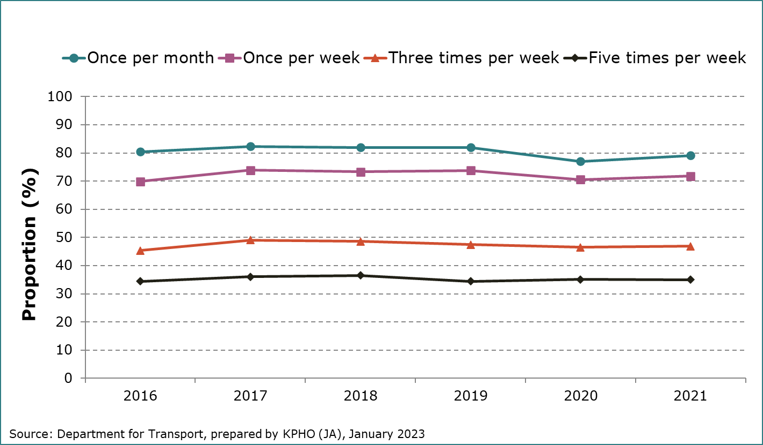

### 4.3 Active Travel for the purpose of leisure

**4.3.1 Walking for leisure**

Figure 2 shows an overall steadily increasing trend from 2016 to 2021, which is noticeable across all frequency categories. This rate seems to accelerate slightly in 2020, likely due to people exercising more during Covid-19 restrictions6. The same trend can be seen across all 12 districts to varying extents but is clearer in the higher frequencies.

**Figure 2. Trend plot showing the proportion of adults who walk for leisure by frequency in Kent, 2016 to 2021.**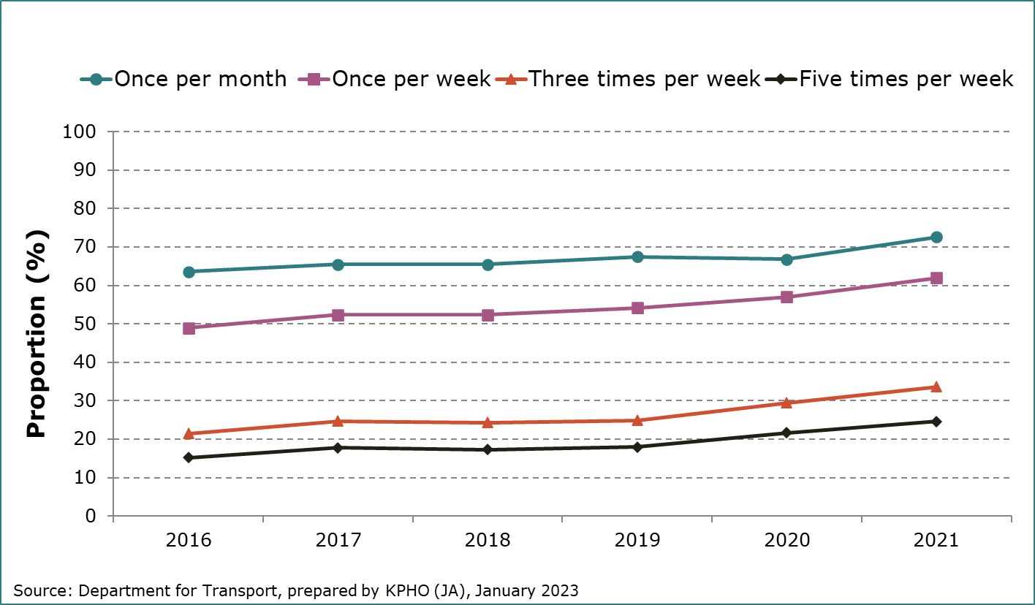

Data for each district from 2016 to 2021 is given below, for those walking for leisure at least once a month and at least five times a week. The middle two frequencies have been left out of this report. Trends for each district mostly match those seen for Kent overall. Dover has the highest overall rates whilst Dartford and Gravesham have the lowest (see Figures 3 and 4).

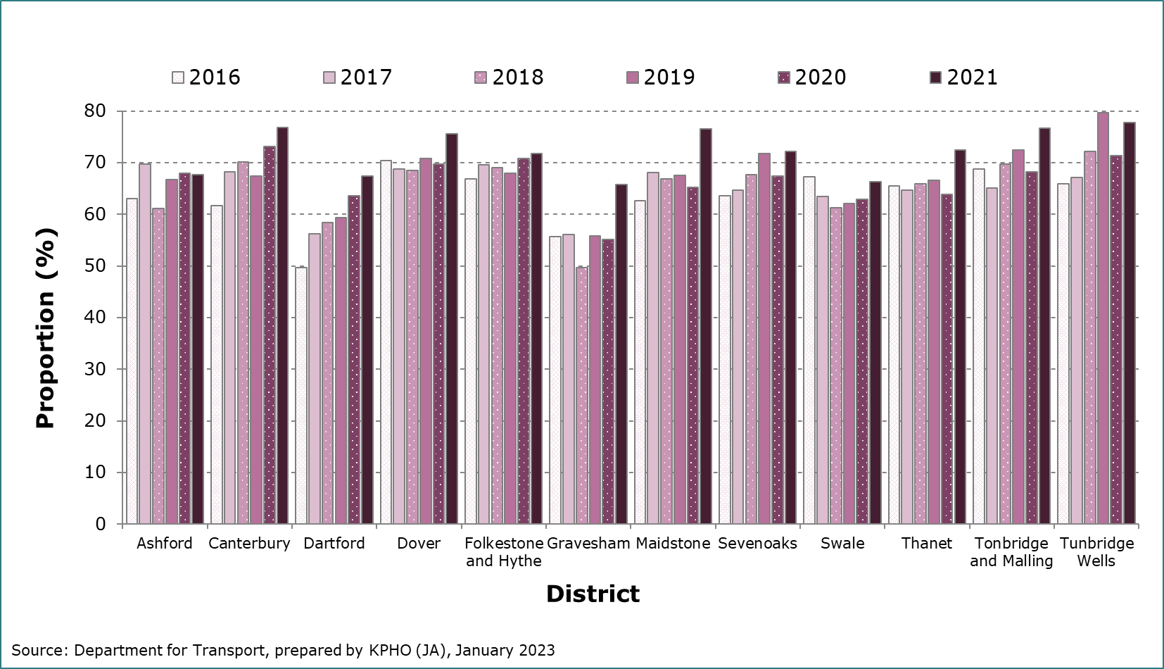**Figure 3. Bar chart showing the proportion of adults who walk for leisure at least once per month by Kent districts, 2016 to 2021.**

**Figure 4. Bar chart showing the proportion of adults who walk for 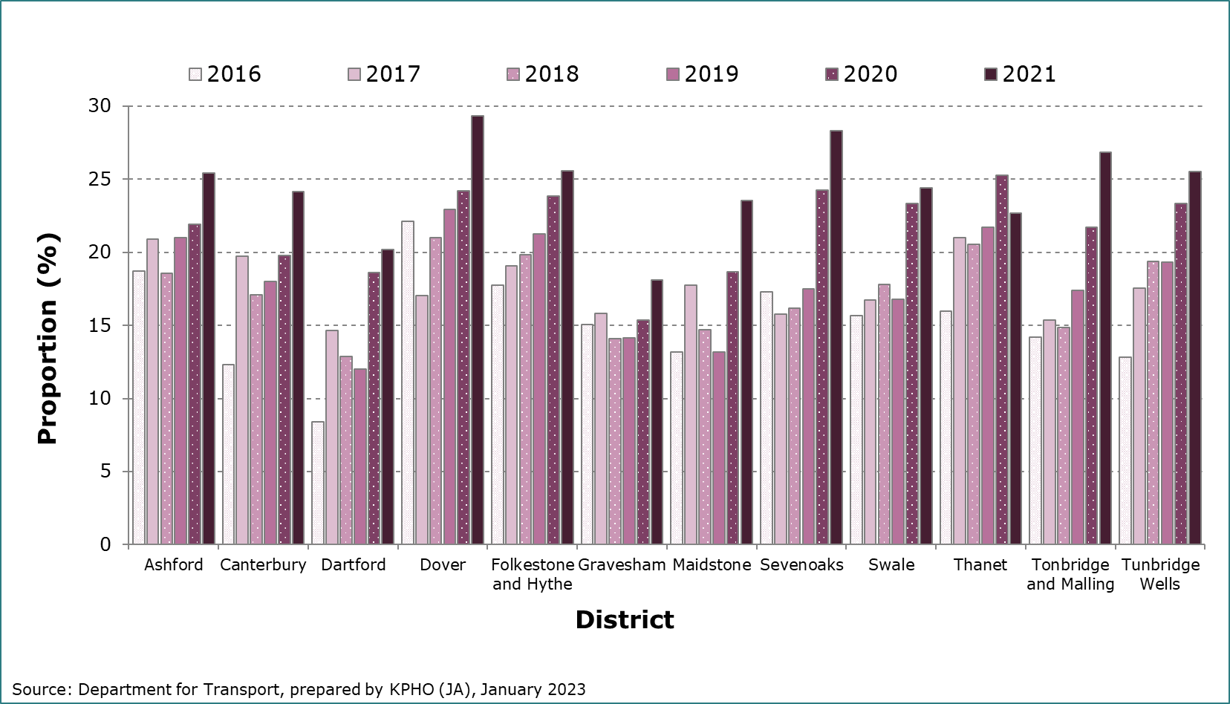leisure at least five times per week by Kent districts, 2016 to 2021.**

**4.3.2 Cycling for Leisure**

Cycling is much less popular than walking, meaning the proportions in this section are much lower than those seen previously. For those who cycle for leisure, relative stability is seen from 2016 to 2019 followed by a considerable increase in 2020, and a large decrease in 2021 (see Figure 5). This decrease is seen across all frequency groups but is more noticeable in lower frequencies of activity. The increase in 2020 is likely due to Covid-19 restrictions causing an uptake in cycling as a hobby, with the end of lockdowns in 2021 causing many to stop.

**Figure 5. Trend plot showing the proportion of adults who cycle for leisure by frequency, Kent, 2016 to 2021.**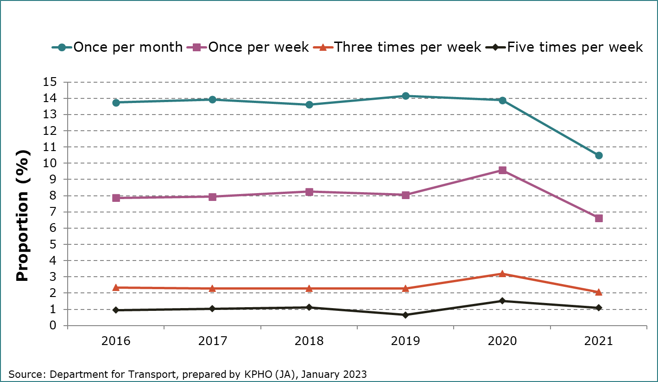

Data for each district from 2016 to 2021 is given below, for those cycling for leisure at least once a month and at least five times a week. The middle two frequencies have been left out of this report. A yearly trend cannot be distinguished across all the districts, with several years appearing to spike sporadically, particularly Dover in 2016. Overall, trends are much more variable by district compared to data for walking for leisure (see Figures 6 and 7). Ashford, Canterbury, and Dover on average have the highest rates, whilst Dartford and Gravesham rank the lowest.

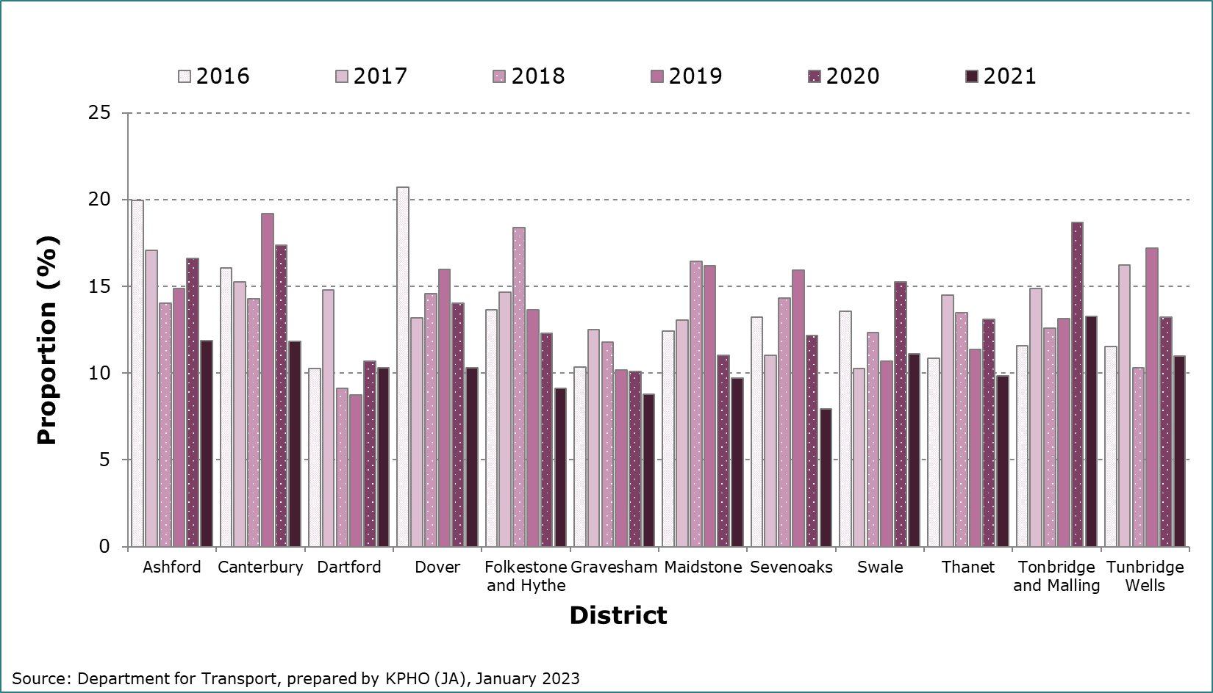**Figure 6. Bar chart showing the proportion of adults who cycle for leisure at least once per month by Kent districts, 2016 to 2021.**

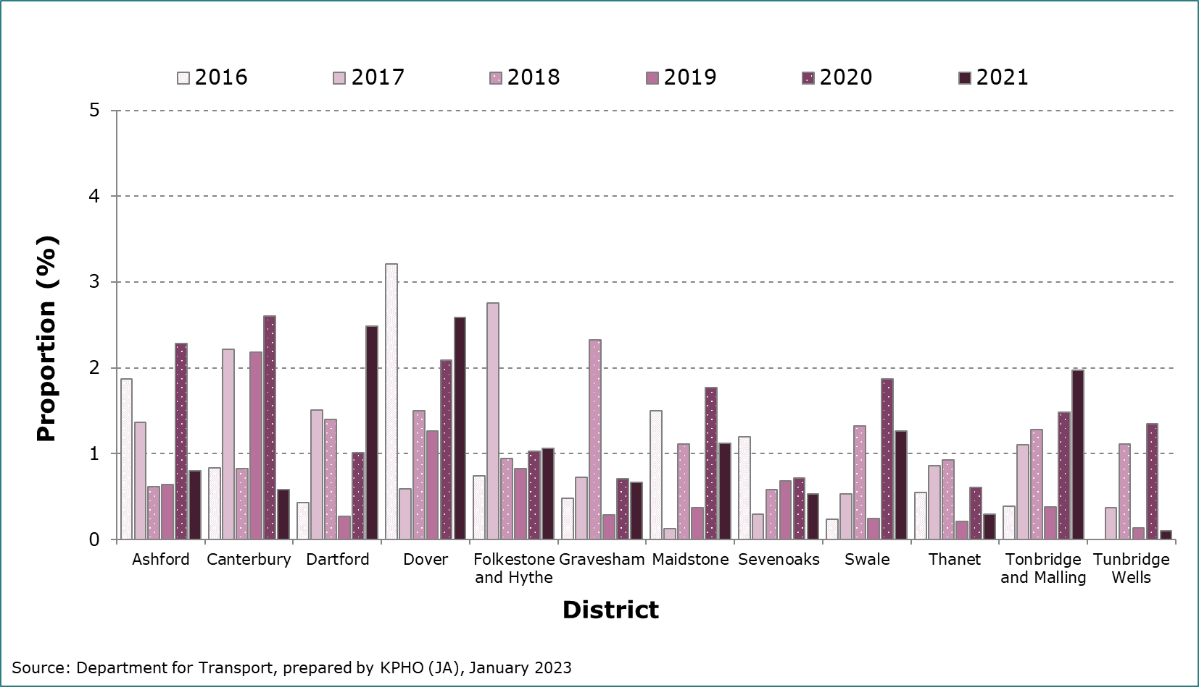**Figure 7. Bar chart showing the proportion of adults who cycle for leisure at least five times per week by Kent districts, 2016 to 2021.**

### 4.4 Active Travel for the purpose of travel

**4.4.1 Walking for travel**

Walking for travel is less popular than walking for leisure in the two lowest frequencies, however, the two types of walking show similar proportions in the two highest frequencies of activity (see Figure 8). A slight increase and then decrease is observed from 2016 to 2019 across all frequency groups. This decrease then proceeds more dramatically from 2019 to 2020. A further decrease is observed in the subsequent year, although this change is more similar to the trend seen pre-Covid.

**Figure 8. Trend plot showing the proportion of adults who walk for travel by frequency in Kent, 2016 to 2021.**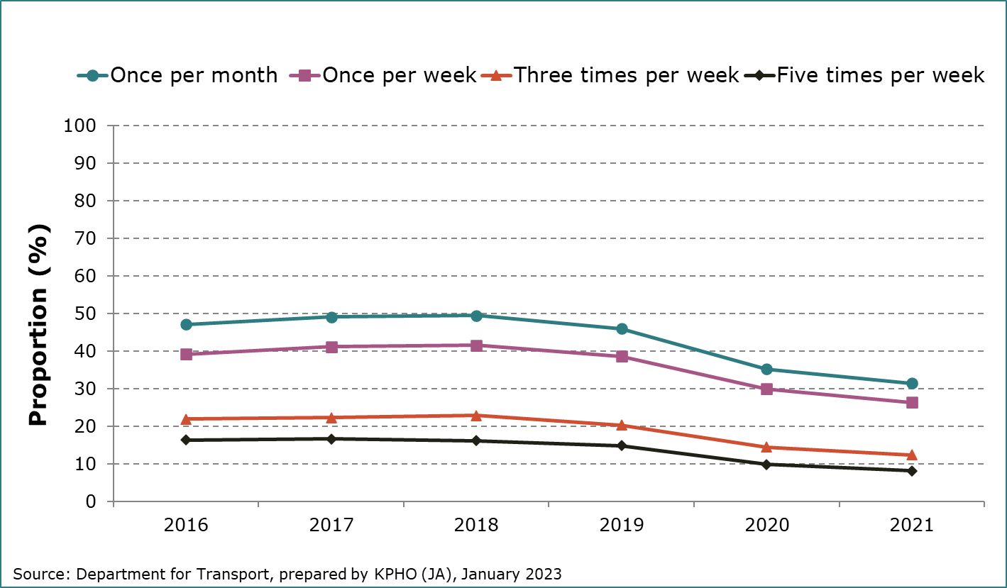

Data for each district from 2016 to 2021 is given below, for those walking for travel at least once a month and at least five times a week. The middle two frequencies have been left out of this report. Similar trends are observed for most districts (see Figures 9 and 10). Although there is variation from year to year and between districts, Canterbury, Tunbridge Wells and Dartford appear to have the highest rates, with this being much clearer in the higher frequency groups. Maidstone and Ashford rank lowest of the districts in walking for travel rates.

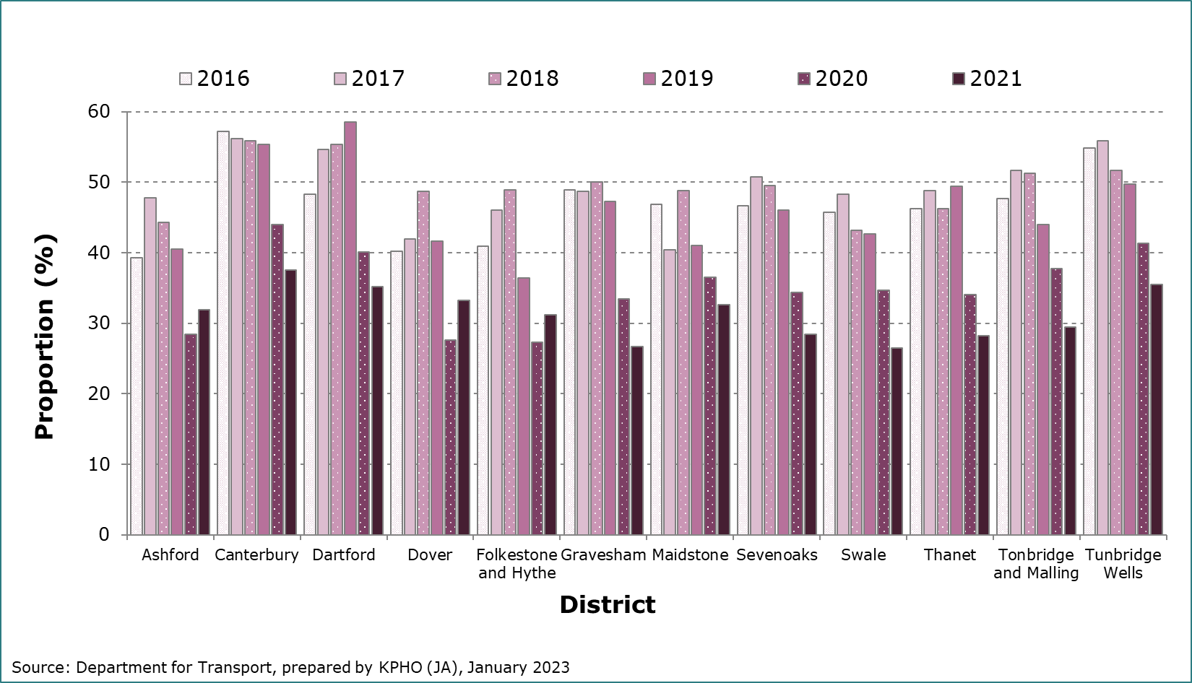**Figure 9. Bar chart showing the proportion of adults who walk for travel at least once per month by Kent districts, 2016 to 2021.**

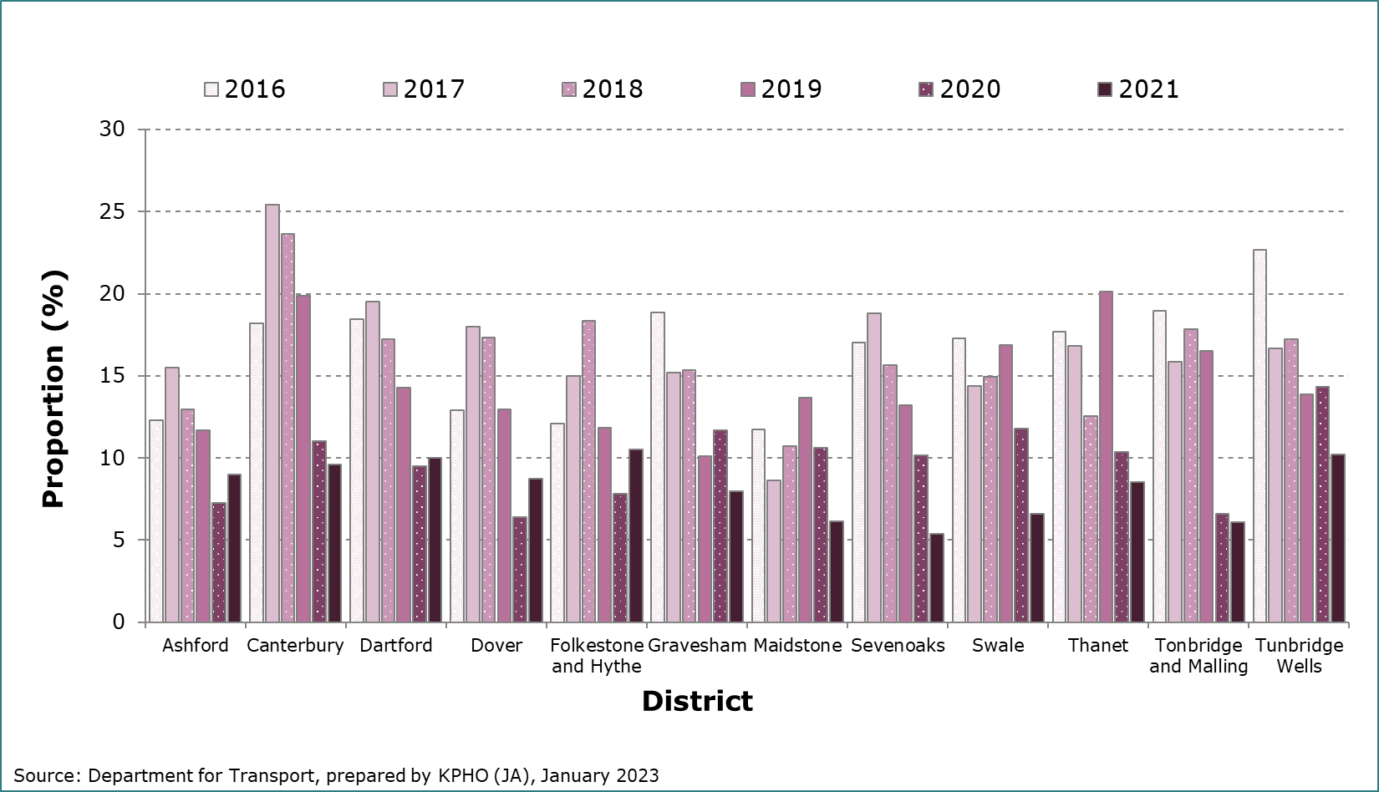**Figure 10. Bar chart showing the proportion of adults who walk for travel at least five times per week by Kent districts, 2016 to 2021.**

**4.4.2 Cycling for travel**

Cycling for travel is on average, less popular than cycling for leisure in Kent. An overall increase is observed from 2016 to 2018 across all districts, followed by a decrease from 2018 to 2021, which is largest between 2019 and 2020 (see Figure 11). Whilst there is a noticeable trend, it seems that cycling for travel was less affected by Covid-19 than other forms of activity.

**Figure 11. Trend plot showing the proportion of adults who cycle for travel by frequency, Kent, 2016 to 2021.**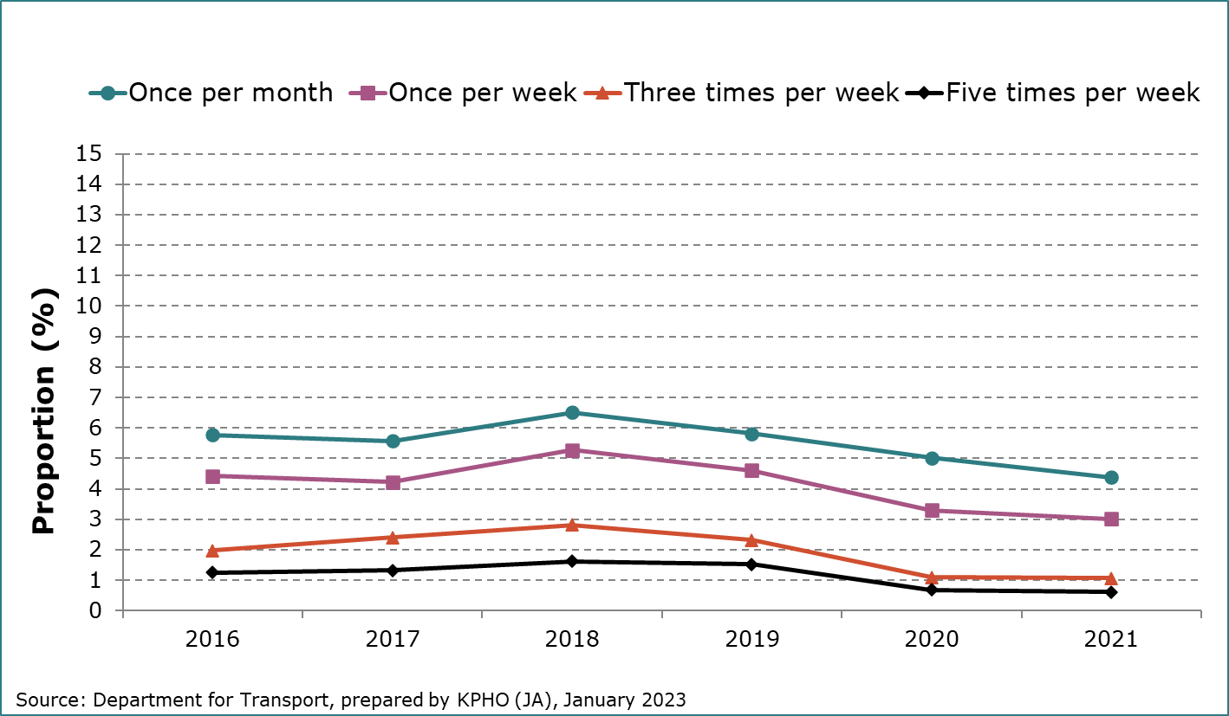

Data for each district from 2016 to 2021 is given below, for those cycling for travel at least once a month and at least five times a week. The middle two frequencies have been left out of this report. Canterbury is a clear frontrunner across all frequencies, with Ashford and Thanet also showing high rates (see Figures 12 and 13). Gravesham and Dartford again rank lowest overall. Interestingly, Folkestone and Hythe has a sudden peak in 2018, which then greatly reduces in the following year. The post Covid-19 pandemic trend varies a lot between districts with some seeing dramatic increases or decreases.

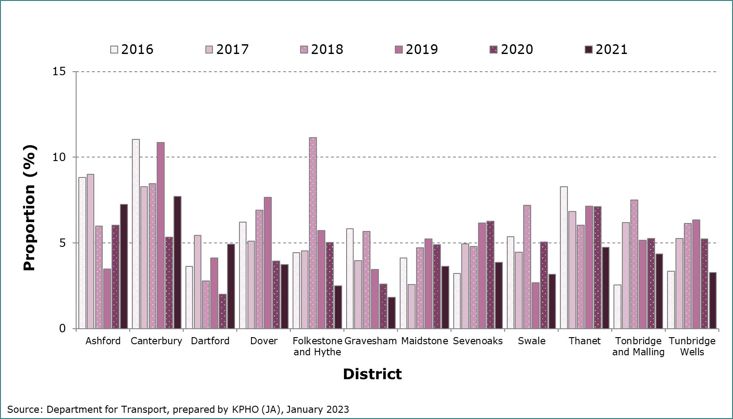**Figure 12. Bar chart showing the proportion of adults who cycle for travel at least once per month by Kent districts, 2016 to 2021.**

**Figure 13. Bar chart showing the proportion of adults who cycle for 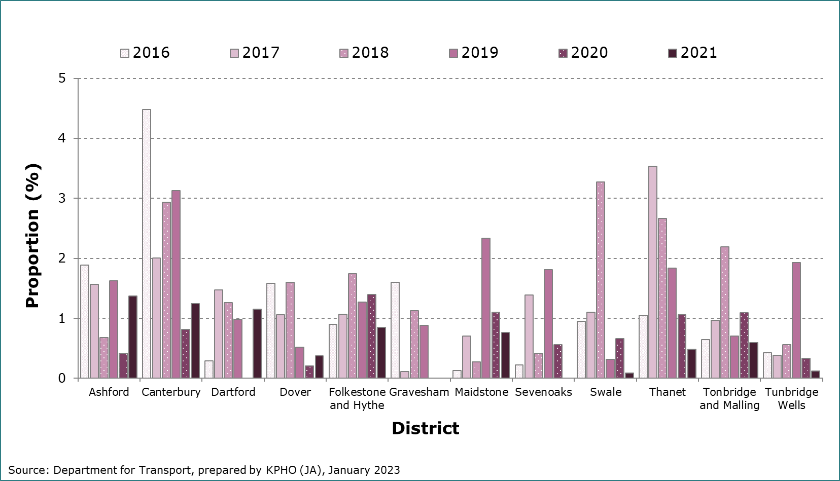travel at least five times per week by Kent districts, 2016 to 2021.**

### 4.5 Comparing Kent with CIPFA Neighbours

To allow for equitable comparisons, data from CIPFA was used to compare Kent to five of its closest economic neighbours. England was also included in this comparison. In no order, these neighbours were Hampshire, East Sussex, Essex, Lancashire, and West Sussex. The results of this are shown in Figure 15.

Figure 15 shows each activity type to be relatively similar between counties, although once this is broken down to frequency level year by year, more variation can be seen. None of the listed counties display any major differences and generally follow the same trends but to differing extents. This detail is too extensive to explore in the present report, however. Kent ranks; 5 of 6 in walking for leisure, 2 of 6 in walking for travel, 3 of 6 in cycling for leisure and 5 of 6 in cycling for travel. West Sussex, Hampshire and East Sussex had the highest average rates. Essex, Lancashire, and Kent had the lowest average rates.

**Figure 15. Comparison of Kent with CIPFA neighbours by Active Travel type and purpose, 2016 to 2021.**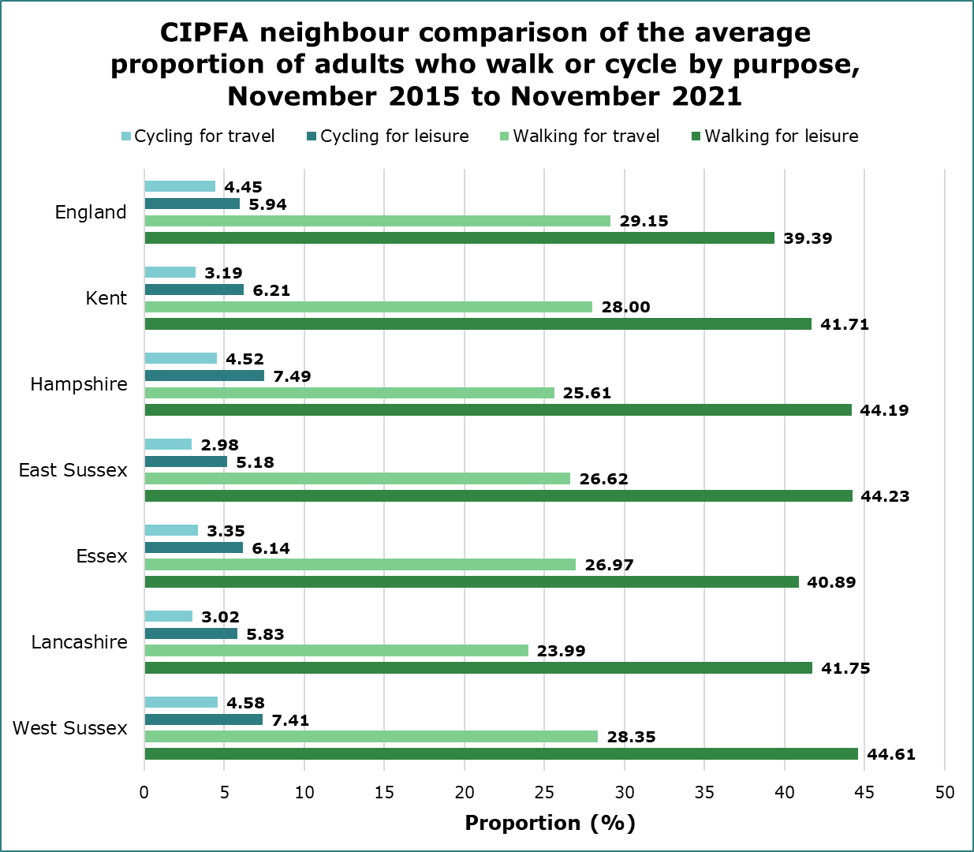

## 5. Discussion and conclusion

This report provides a descriptive summary of two key modes of Active Travel in Kent and its districts. Most importantly, this report found that people are walking and cycling less for the purpose of travel (this includes commuting for work). Walking for leisure has increased steadily over recent years. Cycling for leisure increased up until 2020 but decreased in 2021, the most recent year. Cycling is overall much less popular than walking in Kent, as it also is across the rest of England.

Covid-19 had notable different effects on each form of Active Travel. Rates of walking for leisure increased slightly post-Covid, whereas they decreased in walking for travel. This is not dissimilar to trends displayed before 2020, although seemingly accelerated. Cycling for leisure saw a sharp increase from 2019 to 2020 followed by a considerable decrease in the next year. Cycling for travel saw a more modest decline post-Covid.

Across England in 2020, decreases in all modes of transport were observed due to the impact of Covid-19, apart from cycling and walks over a mile6. This could be due to guidance published by the Department of Transport in late 2020, which stated that people should try to walk or cycle where possible when they needed to travel7. This is in addition to exercise such as walking and cycling for leisure being permitted throughout 2020. The lack of alternative activities likely led many people into leading more active lives.

From the 2021 data, it seems that Active Travel rates are not yet returning to pre-pandemic levels. The continued decline in Active Travel for the purpose of travel may be explained by the large and sustained increase in homeworking post-Covid. A report from the Office for National Statistics (ONS) showed that homeworking in the UK more than doubled between 2019 and 20228. As Active Travel data past 2021 has not yet been published, it is unclear how this trend has continued or if rates have now stabilised.

Although previous reports have suggested that people at higher risk of deprivation are less likely to cycle9, the present report found little evidence of this. Cycling rates were compared to the 2019 Index of Multiple Deprivation (IMD) scores for each district, with no discernible association observed. Cycling may also be less popular than walking due to the associated cost of buying and maintaining a bike9. The increased physical exertion of cycling, the perceived danger of cycling on roads and poor infrastructure also act as barriers to cycling. This intersectionality of reasons why someone may choose to walk instead of cycle makes it difficult to justify why certain local authority districts display their respective proportions of cycling rates.

Whilst variation between the Kent districts over recent years can be observed for all activity types, definitive differences are difficult to determine from this analysis alone. Canterbury has on average the highest rates of active travel, followed by Dover and Ashford. Interestingly, Ashford shows low rates of walking but much higher rates of cycling. Dartford shows high rates of walking for travel but some of the lowest in walking for leisure and cycling. Gravesham has slightly lower rates of walking for travel but is otherwise similar to Dartford. However, it is important to highlight that Dartford and Gravesham, also had the lowest number of study participants out of the districts (see Table 1). These unequal sample sizes between districts could produce inaccuracies in comparisons.

There are some additional limitations to this report that should be considered. Participants for the Active Lives survey and National Travel survey are selected at random to increase the likelihood of the sample being representative of the wider population. However, this does not eliminate bias, as there is still the possibility that those who choose to participate are systematically different from those who refuse. There is also the possibility that participation from 2020 to 2021 was influenced by the Covid-19 pandemic, meaning that the changes observed during this time could have been non-representative of the wider population.

In addition, the reliance on averages as a measure of central tendency could oversimplify the present data but does serve an important function in this report. Furthermore, demographic data as well as qualitative information on people’s behaviour surrounding walking and cycling was not available on the Kent or Kent district level but would have provided valuable additions. Finally, the determination of ‘similar’ neighbours based solely on CIPFA status may disregard some heterogeneity of population geography within counties but does provide some insight into how rates in Kent compare relative to other counties.

## References

1. Department for Transport. Active travel: local authority toolkit [Internet]. United Kingdom: Department for Transport; 2022 [updated 10 Aug 2022; cited 1 June 2023]. Available from: <https://www.gov.uk/government/publications/active-travel-local-authority-toolkit/active-travel-local-authority-toolkit>
2. World Health Organization. Cycling and walking can help reduce physical inactivity and air pollution, save lives and mitigate climate change [Internet]. Europe: World Health Organization; 2022 [updated 7 June 2022; cited 23 May 2023]. Available from: <https://www.who.int/europe/news/item/07-06-2022-cycling-and-walking-can-help-reduce-physical-inactivity-and-air-pollution--save-lives-and-mitigate-climate-change#:~:text=walking%20for%2030%20minutes%20or,30%25%20lower%20among%20bike%20commuters>
3. Active Kent and Medway. Active Lives Adult Survey [Internet]. Kent and Medway (UK): Active Kent and Medway; 2022 [updated 2022; cited 23 May 2023]. Available from: <https://activekent.org/support-resources/insight-2/active-lives-adults-survey/>
4. Department for Transport. National Travel Survey: 2021 [Internet]. United Kingdom: Department for Transport; 2022 [updated 31 Aug 2022; cited 23 May 2023]. Available from: <https://www.gov.uk/government/statistics/national-travel-survey-2021/national-travel-survey-2021-mode-share-journey-lengths-and-public-transport-use>
5. Chartered Institute of Public Finance and Accountancy. Nearest Neighbours Model (England) [Internet]. United Kingdom: CIPFA; 2020 [updated 2020; cited 1 June 2023]. Available from: <https://www.cipfa.org/services/cipfastats/nearest-neighbour-model>
6. Department for Transport. The impact of the coronavirus pandemic on walking and cycling statistics, England: 2020 [Internet]. United Kingdom: Department for Transport; 2021 [updated 22 Sep 2021; cited 13 June 2023]. Available from: <https://www.gov.uk/government/statistics/walking-and-cycling-statistics-england-2020/the-impact-of-the-coronavirus-pandemic-on-walking-and-cycling-statistics-england-2020#:~:text=different%20data%20sources.-,Main%20findings,and%20walks%20over%20a%20mile>.
7. Department of Health and Social Care. Local COVID-19 alert level update: 15 October 2020 [Internet]. United Kingdom: Department of Health and Social Care; 2020 [updated 12 Oct 2020; cited 13 June 2023]. Available from: <https://www.gov.uk/government/news/local-covid-19-alert-level-update-15-october-2020>
8. Office for National Statistics. Homeworking in the UK – regional patterns: 2019 to 2022 [Internet]. United Kingdom: Office for National Statistics; 2022 [updated 11 July 2022; cited 11 July 2023]. Available from: <https://www.ons.gov.uk/employmentandlabourmarket/peopleinwork/employmentandemployeetypes/articles/homeworkingintheukregionalpatterns/2019to2022>
9. Arup. Cycling for Everyone [Internet]. United Kingdom: Arup and Sustrans; 2020 [updated 28 July 2020; cited 23 May 2023]. Available from: <https://www.arup.com/perspectives/publications/research/section/cycling-for-everyone-a-guide-for-inclusive-cycling-in-cities-and-towns>

## Supplementary data (Census 2021)

Data from the most recent census has been included below in Figure 16 to provide a possible explanation for why rates of walking or cycling for travel may be higher or lower in some districts. In terms of walking for travel, the Census data seems to coincide with a lot of but not all the results from this study, whereas the relationship with cycling for travel is much less clear.

Another potential reason for this variation could be a lack of suitable roads or sparse distances between amenities discouraging people from using Active Travel. In rural areas, this is likely to be a greater issue, however, poor planning or infrastructure in towns and cities can also make Active Travel more difficult1.

**Figure 16. Bar chart showing the proportion of households without access to one or more personal cars or vans.This figure is a bar chart showing the proportion of the households from each Kent district without any cars or vans. This is compared with the Kent average. Ashford, Dartford, Maidstone, Sevenoaks, Swale, Tonbridge and Malling and Tunbridge Wells fall below the Kent average. Canterbury, Dover, Gravesham, Folkestone and Hythe and Thanet lie above the Kent average.
**

## Appendices

### Appendix 1. A list of the datasets included in the statistical release analysed by the present report.

**Cw0301:** Proportion of adults who do any walking or cycling, for any purpose, by frequency and local authority, England, November 2015 to November 2021

**Cw0302:** Proportion of adults who cycle, by purpose, frequency, and local authority, England, November 2015 to November 2021

**Cw0303:** Proportion of adults who walk, by purpose, frequency, and local authority, England, November 2015 to November 2021

**Cw0304:** Usual time spent per day walking or cycling, by purpose, and time interval, England, November 2015 to November 2021

**Cw0305:** Proportion of adults who cycle, by purpose, frequency, and demographic, England, November 2015 to November 2021

**Cw0306:** Weighted sample sizes - number of adults surveyed, England, November 2015 to November 2021

**Cw0307**: All walking and cycling data in tables CW0301 to CW0303, England, November 2015 to November 2021

**Cw0401:** Total stages walked, with the 3-year average, England, 2005 to 2021

**Cw0402:** Average number of stages walked1 per person, with a 3-year average, England, 2005 to 2021

**Cw0403:** Total stages cycled1, with the 3-year average, England, 2005 to 2021

**Cw0404:** Average number of stages cycled per person, with 3-year average, England, 2005 to 2021

**Cw0405:** Walks of 20 minutes or more by age: England, 2002 onwards

**Cw0406:** Frequency of use of different transport modes: England, 2003 onward

**Cw0410:** Percentage of children aged 5-16 who usually walk or cycle to school, with a 3-year average, England, 2003 to 2021

**Cw0411:** Percentage of children aged 5-10 who usually walk or cycle to school, with a 3-year average, England, 2003 to 2021

**Cw0412:** Percentage of children aged 11-16 who usually walk or cycle to school, with a 3-year average, England, 2003 to 2021

### Appendix 2. Additional Nationwide Data summaries.

The datasets described below provide national travel statistics from different demographic groupings. The following summaries are not intended to be comprehensive of the datasets included in the statistical release, instead aiming to outline details relevant to the Kent data described in previous sections of this report.

**Average stages walked per person**

England saw a steady decrease in the average stages walked per person from 2005 to 2014. Levels then increased from 2015 to 2018 before decreasing again from 2019 to 2021. London has higher rates than any other region by far, with most of the other regions showing rates similar to each other. The data also showed that on average,

* People in urban areas walk more often than those in rural areas
* Females walk more than males but roughly follow the same trends over the years
* Those aged 17 to 20 years and 50+ years walk the least, whilst middle-aged and younger age groups walk the most
* People with no mobility difficulties walk more than those without
* People with disabilities walk more than those without
* Most of those walking for travel are commuters, followed by those travelling for education and personal business respectively
* Most of those who walk for leisure are not doing so for shopping

**Average stages cycled per person**

Trends from 2005 to 2019 appear sporadic for England overall but variations are relatively small. A sharp increase is seen in 2020 and followed by a large decrease in 2021. This coincides with what was seen in more detail for Kent. Again, London has the highest rates, but this time is closely followed by the East of England. The data also showed that on average,

* People in urban areas cycle more often than those in rural areas
* Males cycle more than females and saw less of a decrease in 2021
* Those aged 30 to 59 years cycle the most, with ages on either side of this bracket showing a gradual decrease
* Ethnic minority groups cycle much more than White ethnic groups (although this grouping was made up of only two categories)
* Those with no disabilities cycle much more than those with disabilities
* Most of those cycling for travel are commuters, whilst levels of those travelling for education and personal business are both low
* Most of those cycling for leisure are not doing so for shopping

**Walks of 20+ minutes, three times a week or more**

Those aged 17 to 20 years walk more than three times a week for longer periods than any other age group, whilst the 70+ age group walk the least.Furthermore, all age groups saw an increase between 2020 and 2021, supporting the trend seen in Kent.

**Frequency of use of different transport modes**

This data showed that on average,

* Domestic air travel use has decreased from 2005 to 2021 (remaining at low levels throughout)
* Coach and non-local bus use has seen a slight decrease from 2005 to 2021 but data from some years is missing
* Private car use has remained remarkably similar from 2009 to 2021 but has seen a slight shift between 2019 and 2021 from use in higher frequencies towards use in lower frequencies
* Local bus use remained stable from 2005 to 2019 but has seen a slight decrease during and after Covid-19. The same can be said for surface rail and taxi use

**The proportion of children (aged 5 to 16 years) who usually walk or cycle to school**

The following data was only provided up until 2018, but on average showed that,

* From 2003 to 2018 around 40 to 50% of children in this age group walk to school, whilst 2 to 3% cycle
* Urban rates were much higher than rural
* There is not much variation between regions
* For walking, the Southeast and East of England have the lowest rates
* For cycling, London has the lowest rates, followed by Yorkshire and the Humber

**The proportion of adults who cycle, by purpose, frequency, and demographic**

This data was initially examined but later excluded from this report due to its size and complexity to keep the present report brief. This gives national-level data for Active Travel on the following demographic groupings,

* Gender
* Age
* Ethnicity
* Disability status
* Socioeconomic class
* Deprivation
* Rural or Urban living status