National Child Measurement Programme
2020/21

March 2022

|
Contents
1 Executive summary 3
1.1 Introduction 3
1.2 Key findings 3
1.3 Call to action 3
2 Profile of the Year R and Year 6 2020/21 data 4
2.1 Distributions of measured pupils 4
3 Year R analysis at Kent level 4
3.1 Weight category trends 4
3.2 Inequalities analysis 5
3.2.1 Obesity by deprivation 5
3.2.2 Excess weight by deprivation 6
3.2.3 Obesity by ethnicity 7
3.2.4 Excess weight by ethnicity 8
3.2.5 Obesity by gender 9
4 Year R analysis at district level 10
4.1 Weight categories 10
4.1.1 Obesity prevalence 10
4.1.2 Excess weight prevalence 11
4.1.3 Severe obesity prevalence 12
4.2 Dover district analysis 13
5 Technical notes 15
6 References 16

Executive summary

Introduction
This report presents the findings from the National Child Measurement Programme (NCMP) for the 2020/21 academic year for children in mainstream state schools in Kent. Children are measured annually in reception (age 4-5 years) and year six (age 10-11 years). In the academic year 2020/21 there was a delay to the commencement of the national child measuring programme due to management of the Covid-19 pandemic with primary children more consistently taught in school during the summer term. The national requirement was to measure 10% of the total cohort for each of the age groups. Locally the aim was to measure most of Year R. The proportion of Year R measured in Kent in 2020/21 was 89.4%.

Key findings
- Over a quarter of children aged 4-5 years in Kent in 2020/21, were either overweight or obese
- The prevalence of excess weight in Year R has increased from 25.2% in the academic year 2019/20 to 26.6% in 2020/21.
- Insufficient numbers of children aged 10-11 were measured to produce robust prevalence estimates
- Year R children living in the most deprived areas were nearly three times more likely to be obese than those living in the least deprived areas. The gap has widened in the latest year due to an increase in obesity in the most deprived group.
- Reception year children from Black ethnic groups have the highest prevalence, as observed in previous years. Over the last year, the prevalence of excess weight has increased the most in the Asian and Mixed ethnic groups.
- White ethnic groups have the lowest obesity prevalence but the highest prevalence of being overweight in Year R
- Caution should be used when using BMIs to compare ethnic groups in children due to differences in body composition¹. BMI has been shown to overestimate body fat in Black African children and underestimate it in South Asian children².
- In Dover district, obesity prevalence amongst reception year children has doubled from 9.6 percent to 18.3 percent in the latest year. A significant increase occurred in both the most and least deprived populations within the district.

Call to action
The overall prevalence of excess weight among children aged 4-5 years has increased. There is clear evidence that the inequality gap between the most and least deprived 10 percent has widened. Children from Black, Mixed and Asian ethnic groups have higher prevalence on average than children from White ethnic groups.
Childhood obesity increases the risk of obesity in adulthood and of conditions such as high blood pressure and pre-diabetes, and premature mortality. Children can experience stigma due to obesity and it is associated with poorer emotional wellbeing³.

Profile of the Year R and Year 6 2020/21 data

Distributions of measured pupils
89.4% of Year R pupils and 10.6% of Year 6 pupils in Kent were measured. Ethnicity, gender and deprivation distributions in the 2020/21 data were compared to previous years for Year R and Year 6. This showed that the Year 6 data was not a representative sample, so Year 6 data has not been analysed as part of this report.

Year R analysis at Kent level

Weight category trends
Figure 1: Prevalence of weight categories in Year R children from the NCMP, 2016/17-2020/21
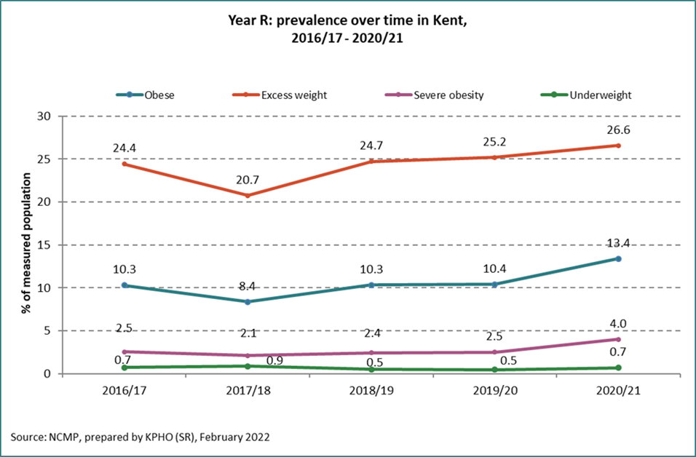
The prevalence of obesity, excess weight and severe obesity have all increased in the latest year. In 2020/21 over 1 in 4 reception year children had excess weight (26.6%) and more than 1 in 8 were obese (13.4%). 4% of Year R children were severely obese in 2020/21 compared to 2.5% in 2019/20. In England in the latest year, 27.7% of children had excess weight in Year R, 14.4% were obese and 4.7% were severely obese.

Inequalities analysis

Obesity by deprivation
Figure 2: Prevalence of obesity by deprivation in Year R children in Kent, 2016/17-2020/21
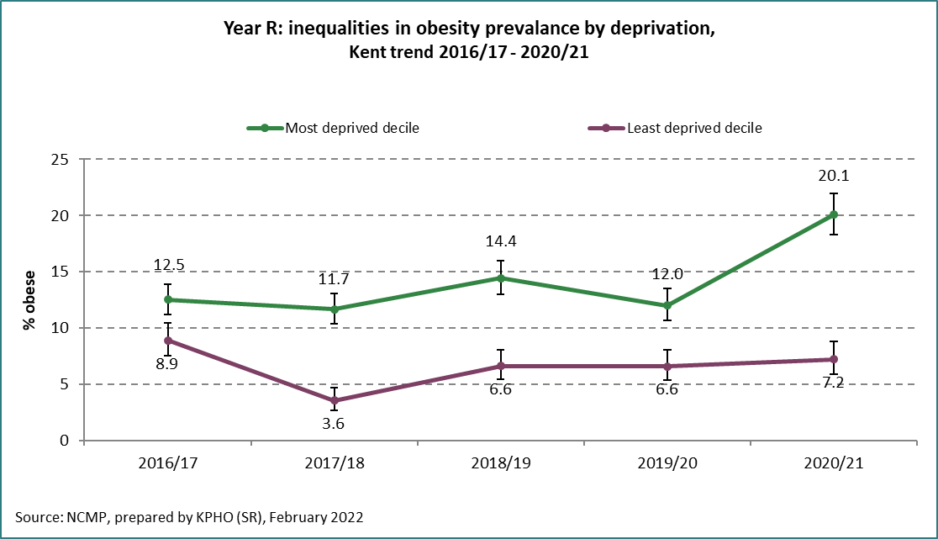
In 2020/21, Year R children living in the most deprived areas were nearly three time as likely to be obese than those in the least deprived areas (20.1% and 7.2% respectively). The gap has increased in the latest year mainly due to an increase in obesity in children in the most deprived areas.
In England, 20.3% of Year R children in the most deprived areas were obese compared to 7.8% of those in the least deprived areas.

Excess weight by deprivation
Figure 3: Prevalence of excess weight by deprivation in Year R children in Kent, 2016/17-2020/21
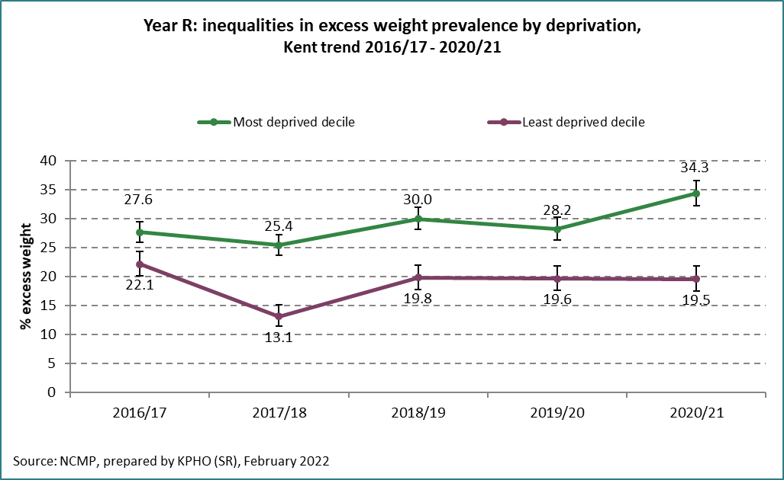
In 2020/21 over 1 in 3 Year R children living in the most deprived areas had excess weight (34.3%) compared to around 1 in 5 for those in the least deprived areas (19.5%). The gap has widened in the latest year due to an increase in excess weight in children in the most deprived areas.
In England, 34.5% of children had excess weight in the most deprived areas compared to 19.7% in the least deprived areas.

Obesity by ethnicity
Figure 4: Prevalence of obesity by ethnicity in Year R children in Kent, 2016/17-2020/21
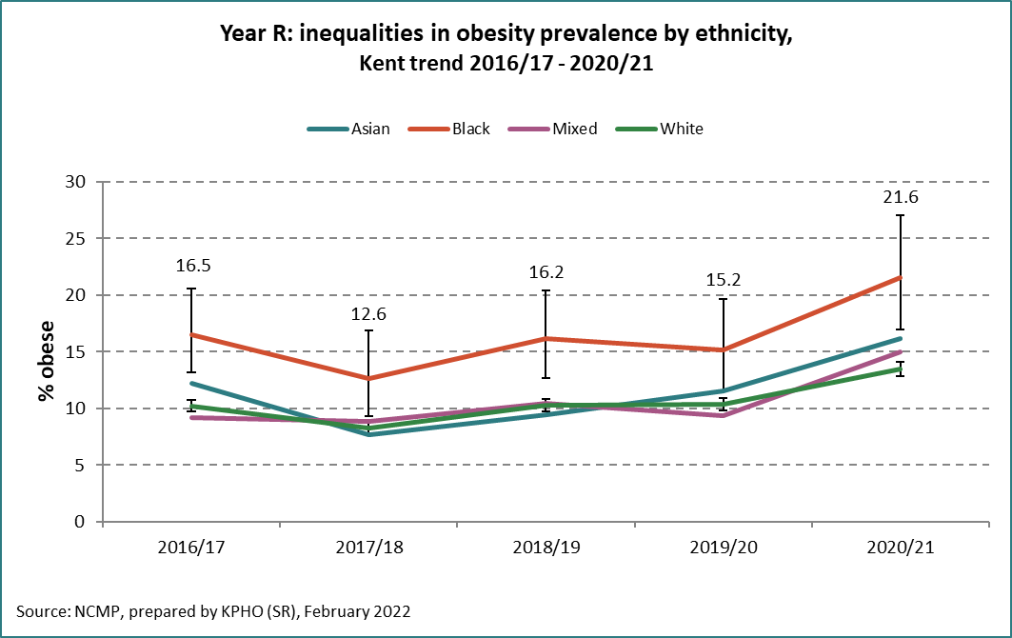

Table 1: Prevalence of obesity and number of Year R children measured from the NCMP by ethnic group, Kent 2016/17 - 2020/21
 |  | 2016/17 | 2017/18 | 2018/19 | 2019/20 | 2020/21
Asian | % obese | 12.2 | 7.7 | 9.5 | 11.5 | 16.2
 | Measured | 680 | 590 | 570 | 520 | 465
Black | % obese | 16.5 | 12.6 | 16.2 | 15.2 | 21.6
 | Measured | 380 | 295 | 345 | 295 | 255
Mixed | % obese | 9.2 | 8.9 | 10.4 | 9.3 | 15.0
 | Measured | 740 | 655 | 650 | 645 | 665
White | % obese | 10.2 | 8.3 | 10.3 | 10.3 | 13.5
 | Measured | 14680 | 13020 | 12950 | 12420 | 11230

Excess weight by ethnicity
Figure 5: Prevalence of excess weight by ethnicity in Year R children in Kent, 2016/17-2020/21
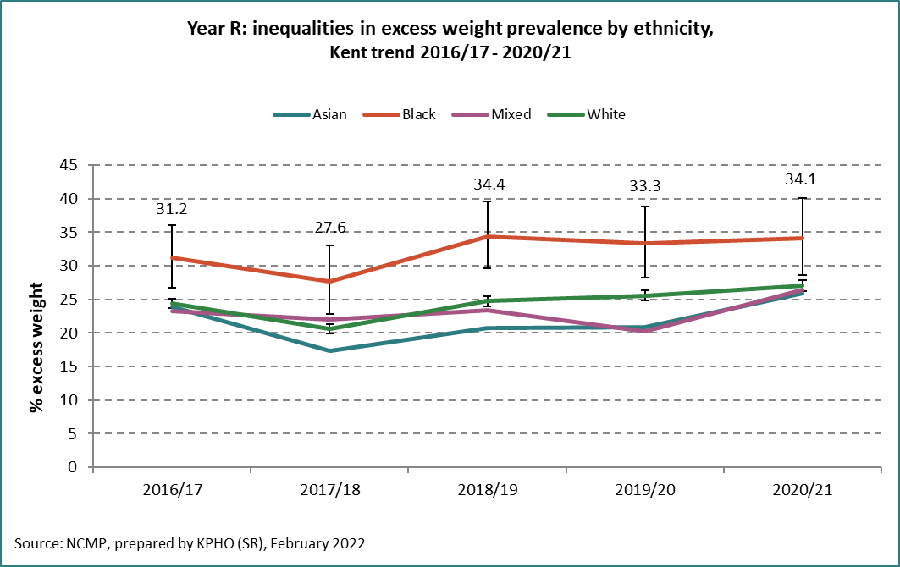

Table 2: Prevalence of excess weight in Year R by ethnic group, Kent 2016/17 - 2020/21
Excess weight % | 2016/17 | 2017/18 | 2018/19 | 2019/20 | 2020/21
Asian | 23.9 | 17.3 | 20.7 | 20.9 | 25.9
Black | 31.2 | 27.6 | 34.4 | 33.3 | 34.1
Mixed | 23.3 | 22.0 | 23.3 | 20.2 | 26.4
White | 24.4 | 20.6 | 24.7 | 25.6 | 27.1

Black children had a higher prevalence of excess weight and obesity than White children in the latest year (Figures 4 and 5). 34.1% of Black children had excess weight compared to 27.1% of White children. In England this was 37.9% and 27.4% respectively.
In Kent in the latest year the greatest increase in excess weight was in the Mixed and Asian groups.

Obesity by gender
Figure 6: Prevalence of obesity by gender in Year R children in Kent, 2016/17-2020/21
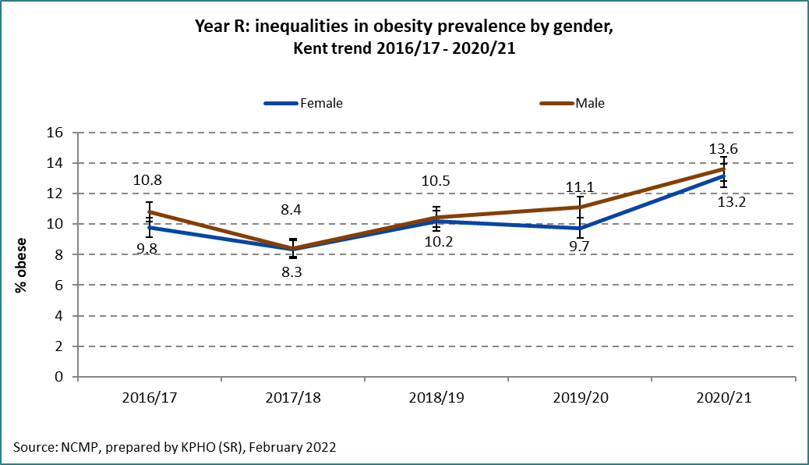
Boys and girls had similar levels of obesity in Year R in Kent. 13.6% of boys were obese compared to 13.2% of girls and in England this was 14.8% and 14.1% respectively.

Year R analysis at district level

Weight categories

Obesity prevalence
Figure 7: Prevalence of obesity in Year R by district in Kent, 2020/21
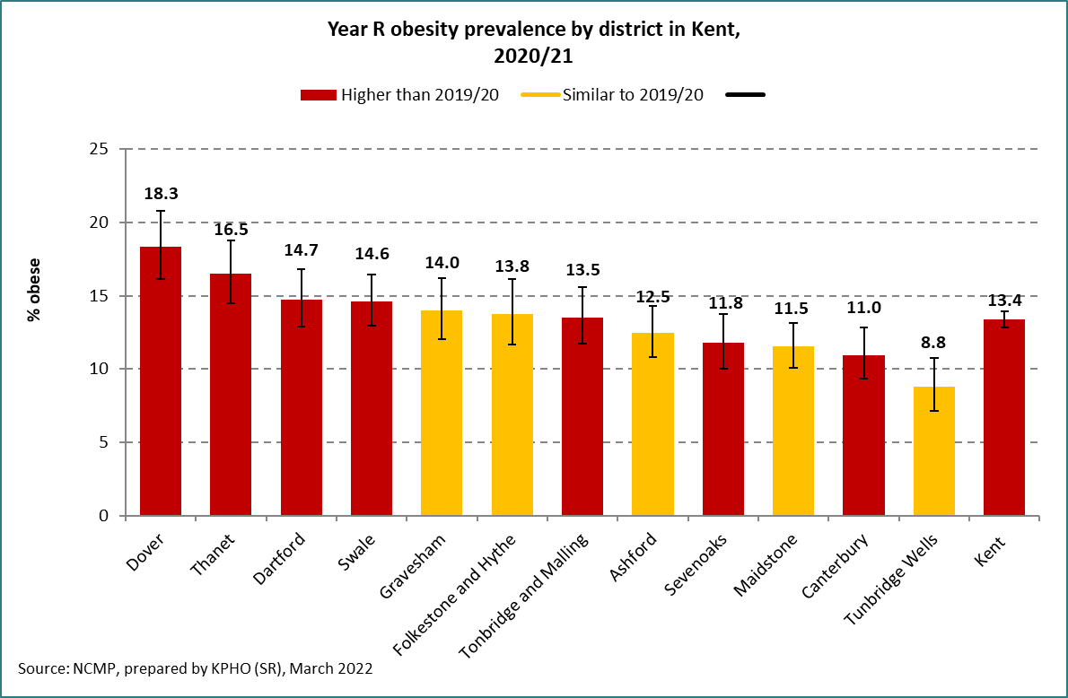
Dover and Thanet districts have higher levels of obesity compared to Kent overall in Year R in 2020/21 and there has been an increase in both districts since the previous year. Obesity has also increased in Dartford, Swale, Tonbridge and Malling, Sevenoaks and Canterbury since the previous year.

Excess weight prevalence
Figure 8: Prevalence of excess weight in Year R by district in Kent, 2020/21
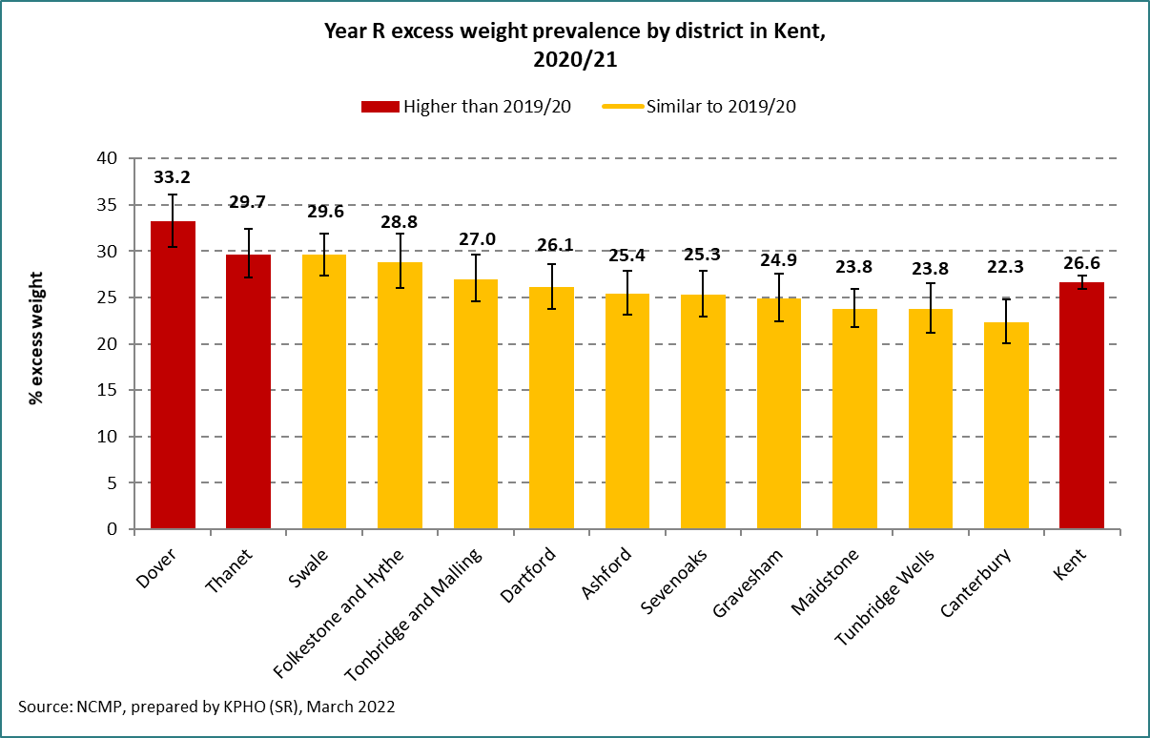
Dover, Thanet and Swale districts have a higher prevalence of excess weight in Year R than the Kent average in 2020/21. Dover and Thanet districts have higher a prevalence in 2020/21 compared to the previous year.

Severe obesity prevalence
Figure 9: Prevalence of severe obesity in Year R by district in Kent, 2020/21
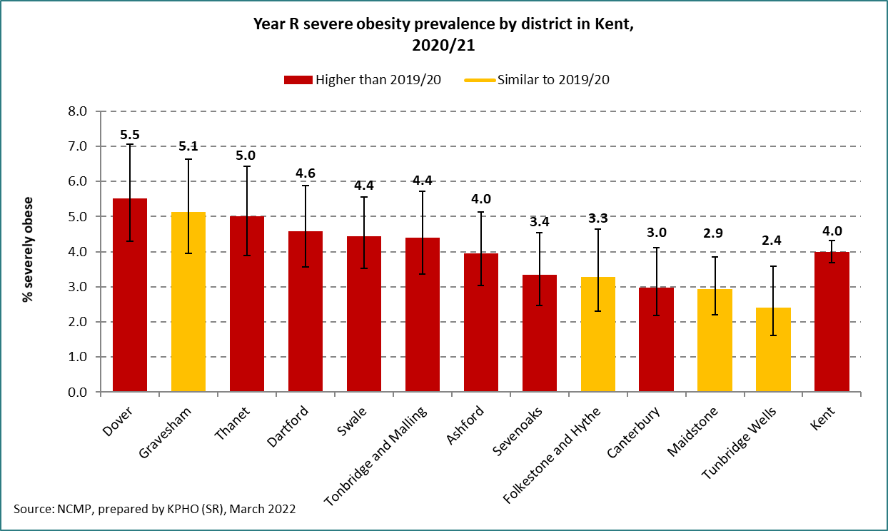
Dover has the highest prevalence of severe obesity across the Kent districts (5.5%) and it shows an increase from the previous year. Thanet, Dartford, Swale, Tonbridge and Malling, Ashford, Sevenoaks and Canterbury districts all have a higher prevalence in 2020/21 compared to the previous year.

Dover district analysis
Figure 10: Prevalence of obesity in Dover district in Year R, 2016/17-2020/21
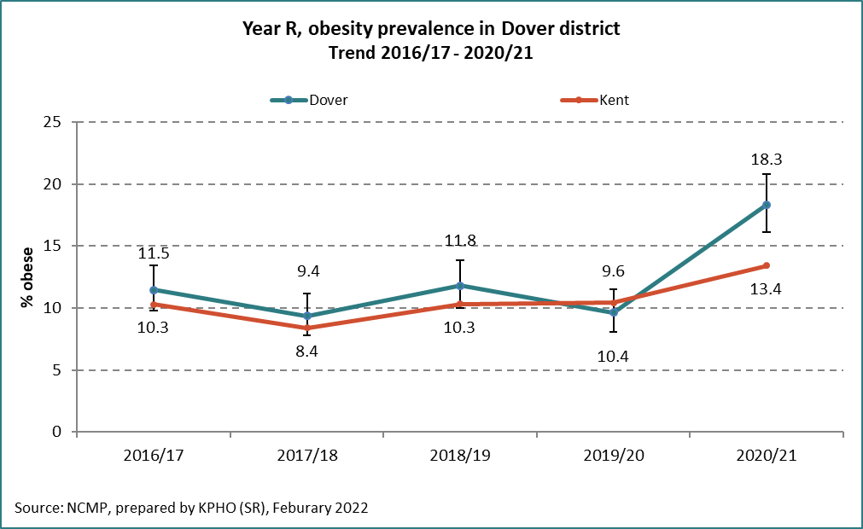
The prevalence of obesity in Year R in Dover district was similar to Kent from 2016/17 to 2019/20 but it increased in 2020/21 and was higher than the Kent average in that year (18.3% and 13.4% respectively). Excess weight is also higher in the latest year in Dover district, 33.2%, compared to 26.6% in Kent overall (Figure 11). In the most deprived group excess weight was 37.3% compared to 29.0% in the least deprived group in the latest year in Dover district (Figure 13).
Figure 11: Prevalence of excess weight in Dover district in Year R, 2016/17-2020/21
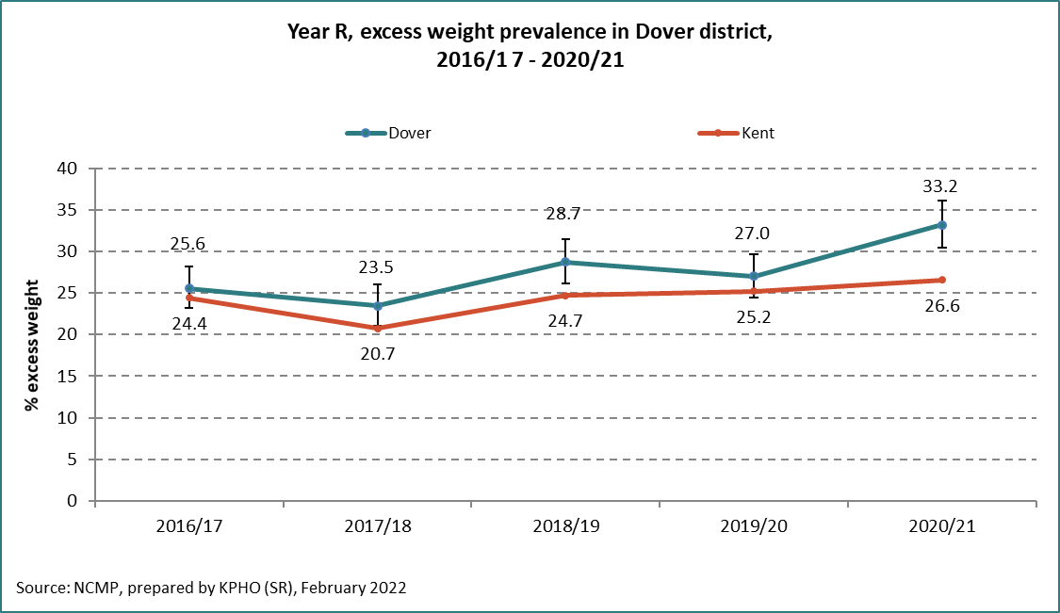

Figure 12: Prevalence of severe obesity in Dover district in Year R, 2016/17-2020/21
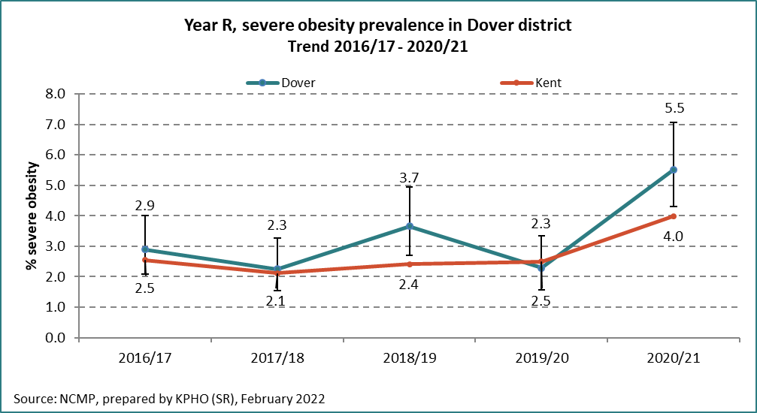

Figure 13: Prevalence of excess weight by deprivation in Dover district in Year R, 2016/17-2020/21
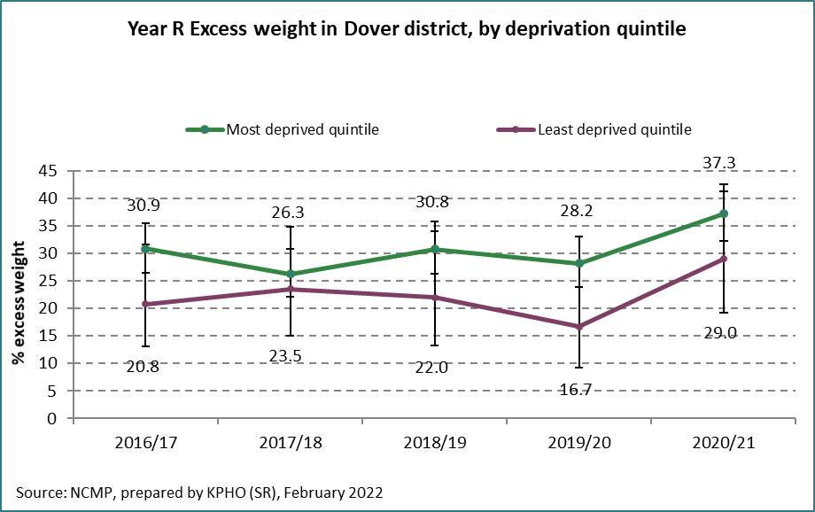

Figure 3 provided an overview of the prevalence of excess weight by deprivation quintile. This showed that the prevalence of excess weight in the least deprived decile had remained stable over the years 2018/19 – 2020/21 in Kent. The difference in Dover district is stark with a significant increase in the least deprived quintile having excess weight in Year R in 2020/21 which is nearly 10% higher than the Kent figure.

Technical notes
The height and weight measurements of children in reception year (aged 4-5 years) and year six (aged 10-11 years) are recorded as part of the National Child Measurement Programme annually. The analysis presented includes Kent resident pupils who attend mainstream Kent schools.

References
- GOV.UK. 2019. Differences in child obesity by ethnic group. [online] Available at: <https://www.gov.uk/government/publications/differences-in-child-obesity-by-ethnic-group/differences-in-child-obesity-by-ethnic-group#fn:3> [Accessed 24 March 2022].

- Hudda, M., Nightingale, C., Donin, A., Fewtrell, M., Haroun, D., Lum, S., Williams, J., Owen, C., Rudnicka, A., Wells, J., Cook, D. and Whincup, P., 2017. Body mass index adjustments to increase the validity of body fatness assessment in UK Black African and South Asian children. International Journal of Obesity, 41(7), pp.1048-1055.

- GOV.UK. 2020. Childhood obesity: applying All Our Health. [online] Available at: <https://www.gov.uk/government/publications/childhood-obesity-applying-all-our-health/childhood-obesity-applying-all-our-health> [Accessed 24 March 2022].

