Tobacco Control Needs Assessment

Debbie Smith

Public Health Specialist

22 December 2022

A red and white logo with a horse

Kent County Council Logo

**Tobacco Control Needs Assessment Contents**

Introduction 4

Why Smoking is a Priority 5

Smokefree Policies 6

Summary of Smokefree Policies 11

Smoking Prevalence 12

Who is at risk and why 16

Illicit Tobacco 18

Young People, Smoking and Vaping 20

Underage Sales – Tobacco and Nicotine Inhaling Products 28

Summary and Recommendations 32

Smoking in Pregnancy 33

Summary and Recommendations 36

Mental Health and Smoking 37

Summary and Recommendations 42

Ethnicity 43

Smoking among Ethnic Groups Recommendations 45

Age 46

Sexual Orientation 47

Smoking and Homelessness 48

Smoking in Prisons 49

Smoking and Substance Misuse 50

Smoking Prevalence in Targeted Groups 52

Smoking Related Morbidity and Mortality 55

Morbidity 55

Mortality 57

Lung Cancer 58

Smoking Related Morbidity and Mortality Summary 59

Local Stop Smoking Services 61

E-cigarettes 69

E-cigarette Summary and Recommendations 70

Future Stop Smoking Services 70

Local Authority Commissioned Services Summary and Recommendations 72

Stop Smoking Campaigns 73

Summary of Smokefree Campaigns 73

Overall Conclusion 74

Summary of Recommendations 76

Contributors to this document 79

Appendix 1 80

# Introduction

The proportion of adults who smoke in Kent has fallen, from 16.3% in 2017 to 11.6% in 2022. This is in line with the national trend where the prevalence has declined from 14.9% to 12.7% in the same period. The success is attributable to smoke-free legislation and regulatory changes, the use of vapes as a quitting aid, and to a whole systems approach to help smokers to quit. Further investment is still needed to drive motivational campaigns to encourage more people to quit smoking and promote a healthier, smoke-free environment for adults and children. Without continued investment and a collaborative, multi-agency drive to further reduce smoking prevalence, more lives will be lost to smoking. Smoking still remains the major risk factor for premature mortality and health inequalities and the highly addictive nature of nicotine present in cigarettes makes it difficult for many smokers to quit.

Smoking prevalence is particularly high among groups of people, such as routine and manual workers, people with mental health illness, and across some ethnic groups. Motivating smokers to quit can be particularly challenging as these groups are more likely to smoke more and less likely to want to quit. The cost of smoking can very often exacerbate their financial problems.

Further research and Government impact on the attitudes and behaviours toward smoking in our changing society. Policies that reduce the visibility of smoking and cigarettes in our daily lives go some way to de-normalizing smoking and making it less attractive. However, the illicit tobacco market and entrenched smoking behaviours among some groups undermine national and local measures to tackle smoking rates. The Khan Review conducted in 2022 sets out evidence-based recommendations that can make a collective difference to reach the ambition of Smokefree by 2030 (smoking prevalence of 5% or less)

The Tobacco Control Needs Assessment explores the profile of smokers in our communities, the services and methods that support smoking quit attempts, and addresses the take up of smoking, which usually starts at a young age. It also considers the emerging issue of young people and vaping as national datasets give rise to concern of a future gateway to young people becoming nicotine dependent. The assessment seeks to understand our smoking population and evaluate the ways in which smokers can be supported to quit. Past and emerging policy regulations and evidence-based best practices are addressed, and gaps identified to culminate in a set of recommendations for local stakeholders to work collaboratively to further reduce smoking prevalence in Kent.

There are significant economic, social, and health benefits to reducing smoking prevalence in our communities. The current trajectory is positive, but progress is slow, and we must also counter risks that threaten prevention and the uptake of smoking in the first place. The government’s ambition to become a Smokefree society by 2030 will not be achieved unless there is a multi-agency collaborative approach, and all stakeholders play their part.

# Why Smoking is a Priority

Smoking rates have declined steadily since 2017. Despite this decline, smoking remains the main cause of preventable disease in the UK and is accountable for 1 in 6 of all deaths in England. It is a major risk factor for 16 different cancers and 18 other health conditions, such as lung cancer, chronic obstructive pulmonary disease (COPD), heart disease, and stroke.[1].

Mortality rates due to smoking are 3 times higher in the most deprived areas than the most affluent areas, demonstrating that smoking is intrinsically linked to inequalities[2]. More than 77,000 people die each year from smoking, more than obesity, alcohol, and illegal drugs together.[3] 5,980 of these deaths are Kent residents. Action on Smoking and Health (ASH) estimates that smoking costs the Kent economy £499.4 million every year, which includes £51.9m in healthcare costs alone[4].

Chart 1. Annual Cost of Smoking in Kent

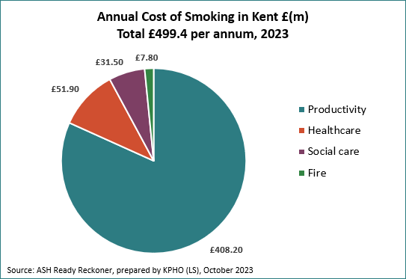

Effective tobacco control measures can reduce smoking prevalence in the population. Preventing ill health through smoking cessation can significantly reduce premature mortality and morbidity, relieve some of the burden on NHS resources, and help reduce inequalities.

# Smokefree Policies

Tobacco regulations started to be introduced from the 1960s onwards with the aim to reduce the take up of smoking through minimum age of sale laws, encourage smokers to quit through increased taxation and restricted advertising laws, and to protect against the harms and risks of smoking through smoke-free policies. These regulations often have a positive effect on reducing smoking rates whereas voluntary measures make very little impact on the population. Smokefree laws can also influence public opinions on the acceptability of smoking and change social norms which can potentially prevent youth and young adult smoking initiation.

Annex 1 provides a list of key smoke-free regulations and policies that have been introduced over the years alongside the smoking prevalence rate of that time. The most significant of these is the Smokefree legislation in 2007, prohibiting smoking in enclosed public and workspaces under the Health Act 2006. Although smoking rates did not decline significantly at the time, the health of many people exposed to passive exposure to smoke greatly increased. Studies showed that the smoke exposure to bar-workers showed reductions of 80-90% and an additional 300,000 smokers were inspired to make a quit attempt as the law came into force.

As more is understood about the risks and harms of smoking and the need to protect the public from second-hand smoke, further policies have since been introduced to meet the ambition of a smoke-free society.

Towards a Smokefree Generation

The Tobacco Control Plan for England, ‘Towards a Smokefree Generation’[5] set challenges to local services to reduce smoking prevalence, particularly in communities where smoking rates are highest, with the vision of creating a smokefree generation. The table below sets out some of the key milestones of the plan and the national and local progress made towards the targets:

|  |  |  |  |
| --- | --- | --- | --- |
| By 2022: | Target | Current Position | Progress |
| Reduce the prevalence of 15 year olds who smoke regularly | From 8% to 3% or less | 3% | Achieved nationally (local data not available) |
| Reduce Smoking Prevalence among Adults | From 15.5% to 12% | England: 12.7%  Kent: 11.6% | Nationally: Not Achieved Kent: achieved |
| Reduce the inequality gap in smoking prevalence between those in R&M occupations and the general population | From 2.44 in England and 3.42 in Kent | England: from 2.44 to 2.46  Kent: from 3.42 to 2.2  2017- 2019 data | Nationally: not achieved  Kent: Achieved Continuous improvement required |
| Reduce smoking during pregnancy | From 10.7% to 6% or less | England: 9.1%  Kent: 10.8% | Not achieved nationally or locally. |

The Plan introduces measures to reduce the gap in inequalities caused by smoking, focusing predominantly on routine and manual workers, pregnant women who smoke, and adults with mental health conditions. A smoke-free generation is expected to lift 2.6 million adults and 1 million children out of poverty.

By 2019, a target date of 2030 was set for this ambition; formalized in the Advancing Our Health: Prevention in the 2020s Green Paper[6]. Smoke-free is defined as 5% or less smoking prevalence among the adult population and meeting the key milestones set out in the Tobacco Control plan were crucial to achieving this. Kent has a similar smoking prevalence to the South East regional average (11.7%) and higher than the national average among women who smoke in pregnancy (10.8% in Kent compared to 9.1% in England), so there is still a long way to go to achieve a smokefree community (i.e., smoking prevalence needs to reduce by 6.6%).

The Khan Review

In June 2022, Javed Khan delivered an independent review[7] into the progress of the 2030 smoke-free policies at the request of the Secretary of State for Health and Social Care. The review concludes:

1. England is not on target to achieve the smoke-free aim by 2030.
2. Without further action, England will not achieve a smoke-free status until 2044 in the poorest areas.
3. Failure to achieve the Smokefree objective will prevent the government from fulfilling the ambitions of the 10-Year Cancer Plan
4. To meet the smoke-free 2030 target, the decline of people who smoke will need to be accelerated by 40%.

The Khan Review sets a revised timescale for every community to achieve 5% or less smoking prevalence by 2035. To achieve this, 15 recommended actions will inform the new national Tobacco Control Policy, Stopping the Start[8], published in October 2023. 5 of these recommended policies can be implemented locally. These are:

|  |  |  |
| --- | --- | --- |
|  | Recommendation: | Type: |
|  | £125m per annum government investment needed | Critical Funding |
|  | Age of Sale to be increased | Critical |
|  | Raise the cost of Duties by 30% and abolish duty-free tobacco at borders | National Action |
|  | Introduce tobacco licenses for retailers | National Action |
|  | £15m to support Trading Standards to tackle illicit tobacco | Funding |
|  | Reduce the appeal of cigarettes (design, media, etc.) | National Action |
|  | Increase Smokefree places (to de-normalise smoking and protect against second hand smoke) | Local delivery |
|  | Promote vaping as a means of quitting smoking (and introduce Swap to Stop schemes in poorer areas) | Critical, Local delivery |
|  | Improve delivery of quality stop smoking services | Local Delivery |
|  | Increase mass media campaigns to promote a Smokefree culture | National Action |
|  | Improve prevention in the NHS – prioritise action and treatment across all services including Primary Care. | Critical |
|  | £15m to help pregnant women who smoke to quit (including incentive schemes) | Funding |
|  | Tackle smoking and mental health – to include Public Health information, campaigns, and training | National and Local Action |
|  | £8m for ICS leadership to prioritize local stop smoking interventions with annual targets and reporting | Funding, Local Delivery |
|  | Invest £2m per year in new research and data (focus on disparities) | Funding |

The Khan review recommendations were intended to inform a new national Tobacco Control plan expected at the end of 2021. With competing priorities and political divergences, the government has delayed its delivery of a new, updated plan with no dates proposed for publication. There is, however, continued funding and support to deliver the local tobacco dependency service as part of the NHS Long Term Plan (part of recommendation 8), but in the absence of further funding and commitment, there are many recommendations that can still be developed within current local resources. For example, local public sector employers, voluntary and community organisations can take the initiative to promote a smokefree workforce and to ensure that their health policies protect their staff from exposure to second-hand smoke during home visits. There are also opportunities to capitalise on smokefree policies and smokefree public spaces.

Further to the recommendations in the Khan review, in October 2023, the Government has published Stopping the Start[9], our new plan to create a smokefree generation. This includes £70million per year for 5 years in additional funding to local authorities, starting 2024/25 to support stop smoking services to help reach the Smokefree 2030 ambition. There is also funding allocated to fund a new national anti-smoking campaign.

At the time of writing, there is also proposed legislation around children turning 14 or younger in 2023 never legally sold tobacco products.

The NHS Long Term Plan

The 2010 Royal College of Physicians report, Hiding in Plain Sight[10], calls for the NHS to address and not just treat, health harms arising from patients who smoke:

*“We argue that responsibility for treating smokers lies with the clinician who sees them, and that our NHS should be delivering default, opt-out, systematic interventions for all smokers at the point of service contact.”*

This concept of treating tobacco dependency in the clinical setting (known as the Ottawa model) was piloted in Manchester in 2019 and is called the Cure Project. The model has been refined, packaged, and funded to be delivered in each Acute Trust by the end of 2023 as part of the NHS Long Term Plan. Additional pathways for Mental Health inpatients and pregnant women who smoke have also been adapted and are being delivered.

The principle of the plan is for the Acute Trusts to deliver an in-house tobacco dependency service, where all planned inpatients are routinely screened for smoking status and all known smokers be supported to abstain from smoking whilst in hospital with the offer of Nicotine Replacement Therapy (NRT) and behavioural support to manage their nicotine addiction.

On discharge from hospital, all smokers will be referred to a community stop smoking service, either through the locally commissioned stop smoking service or at their local pharmacy through an Advanced Pharmacy Contract with NHS England. Accurate and systematic recording of smoking status and patient outcomes are key components of the model and currently pose challenges across varying local IT systems and platforms, but solutions are being sought. Outcome data on the quit success of each smoker needs to be reported by the respective trust which will in turn be submitted to NHS digital within the reporting timeframes. Although stop smoking services are likely to see an increase in referrals, numbers of quitters achieved through local stop smoking services will be reported and ‘owned’ by the Acute Trust.

Commissioners should be mindful that a higher volume of service users may not result in more quitters and there may be a decline in the number of reported quits within the service.

The maternity pathway requires Maternity Support Workers (MSWs) recruited into Midwifery Teams to provide stop smoking support to all pregnant women who smoke throughout the full pregnancy term. This pathway is designed to reduce the number of pregnant smokers who decline referrals, do not engage with local stop smoking services (currently 58% in Kent) or relapse by providing a maternity-led in-house stop smoking support service throughout the pregnancy. On completion of the home visit programme, the MSW will continue or resume quit support throughout the remainder of the pregnancy. See the Smoking in Pregnancy chapter below for more detail of the model.

Localised Kent and Medway NHS LTP Inpatient pathway: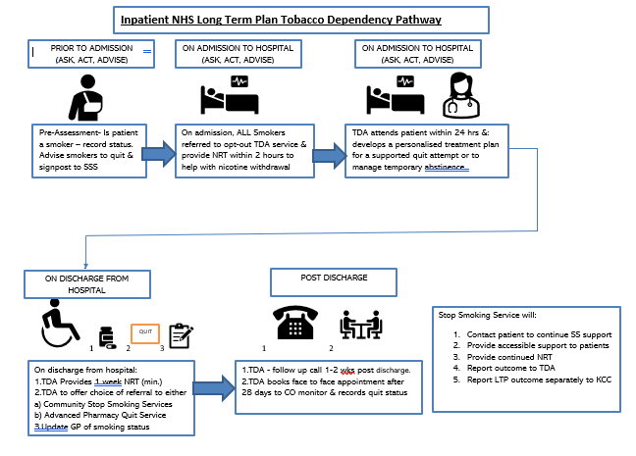

## **Summary of Smokefree Policies**

There is a Government ambition for a Smokefree population (smoking prevalence of 5% or less) by 2030. The 15 recommendations identified in the Khan Review: Making Smoking Obsolete and further proposals announced in October 2023 as part of the Governments Stopping the Start plan support this ambition.

The development of the NHS Long Term Plan will provide new health-led quit support services within hospital inpatient and maternity settings. With the influx of discharged hospital patients being referred into local stop smoking services, demand for services is expected to increase. Conversely, there will be fewer pregnant smokers accessing community stop smoking services and these quantities are yet unknown.

A comprehensive approach to tobacco control, bringing together current policies in Kent will:

* Protect children from harm, giving them a better start in life.
* Increase disposable income of the poorest and help lift them out of poverty.
* Cut costs to local public services such as the NHS, Social Care, Fire and Rescue Services
* Improve key measures of population health (e.g., Deaths from cancer, heart disease, respiratory disease, number of children living in poverty, sickness absence.

Based on the evidence, the Tobacco Control Needs Assessment will help inform the development of local priorities and guide commissioning of tobacco control activities. A newly established Kent Tobacco Control Alliance will co-ordinate strategic leadership to locally deliver the national smokefree approach.

In the development of this, there are opportunities for local government and health organizations to demonstrate leadership in delivering a smokefree policy for their workforce by reviewing occupational health policies for staff who may be vulnerable to exposure to second and smoke during home visits, support staff who smoke to quit in a variety of different ways and increase more smokefree public spaces.

Recommendations

|  |  |  |
| --- | --- | --- |
|  | Recommendation | Lead |
| 1. | Set up a Kent Tobacco Control Alliance with CLeaR outcomes prioritising key areas of work | Public Health |
| 2. | Review occupational health policies for staff who may be vulnerable to the exposure of second-hand smoke during home visits and capitalise on increasing smokefree initiatives for more public spaces (public sector, voluntary and community organisations) | Public Health  Kent CC  District Councils  NHS, etc. |
| 3. | Partner organisations to have a clear smokefree policy and promote a range of services to support staff to give up smoking | Public Health  Kent CC  District Councils  NHS, etc |

# Smoking Prevalence

In Kent, there are an estimated 145,215 adult smokers in Kent, equal to 11.6% of the adult population (18 years +)[11]. Since 2011, there has been an 8.6% decline in smoking prevalence and 85,113 fewer smokers. Kent’s prevalence is slightly lower than the England rate (12.7%) which has seen a 7.1% decrease since 2011. Chart 2 presents the annual decline in prevalence in England v Kent.

Chart 2. Estimated Smoking Prevalence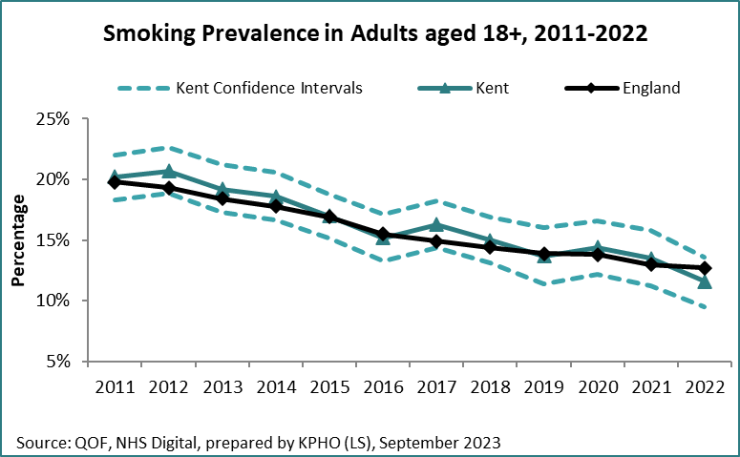

There is significant variation in smoking prevalence at district level[12], as shown in Table 1, reflecting higher rates in areas of deprivation and among routine and manual workers, where people are likely to be heavy smokers with high nicotine dependency.

Coastal Towns

Coastal towns typically experience poorer health outcomes and lower life expectancy compared to similar inland towns, with higher smoking rates being a major risk factor in the most deprived communities. The Chief Medical Officer Report 2021[13] suggests an excess smoking prevalence of 6.71% in coastal towns, necessitating targeted interventions to high-risk groups and geographies. The report highlights that unique patterns in demography, migration, deprivation, employment, and housing in coastal regions can be hidden by relative affluence in adjoining inland areas which is often lost in local data. This may be why ONS smoking prevalence rates by districts are not exclusively higher in Kent coastal districts (see table 1).

Despite this, deprivation in coastal Local Super-Output Areas (LSOAs) appears to be higher than the equivalent non-coastal LSOAs and the report claims that socio-economic and environmental factors play a significant role in determining health outcomes. Some rates of long-term conditions (such as stroke and hypertension) are linked to the demography of coastal towns where smoking for example is more linked to deprivation. Health risking behaviour is also considered to be much more common among young people in coastal communities so initiatives targeted to young people should also focus on those who live in coastal towns.

Table 1. Estimated Smoking Prevalence (District level).

|  |  |  |
| --- | --- | --- |
| **Area** | **% Smoking Prevalence** | **Estimated Number of Smokers** |
| Ashford | 13.6% | 13,721 |
| Canterbury | 11.2% | 15,322 |
| Dartford | 12.0% | 10,254 |
| Dover | 11.8% | 11,239 |
| Folkestone & Hythe | 18.9% | 17,399 |
| Gravesham | 8.3% | 6,751 |
| Maidstone | 7.8% | 10,489 |
| Sevenoaks | 15.3% | 14,382 |
| Swale | 11.1% | 12,952 |
| Thanet | 12.8% | 14,293 |
| Tonbridge and Malling | 6.7% | 6,838 |
| Tunbridge Wells | 11.3% | 10,375 |
| Kent | 11.6% | 144,128 |
| England | 12.7% | 5,614,225 |

*Source: Local Tobacco Profiles, Office of Health Improvement and Disparities (2022 data)*

Chart 3. Estimated Smoking Prevalence: Ashford, Canterbury, and Maidstone Districts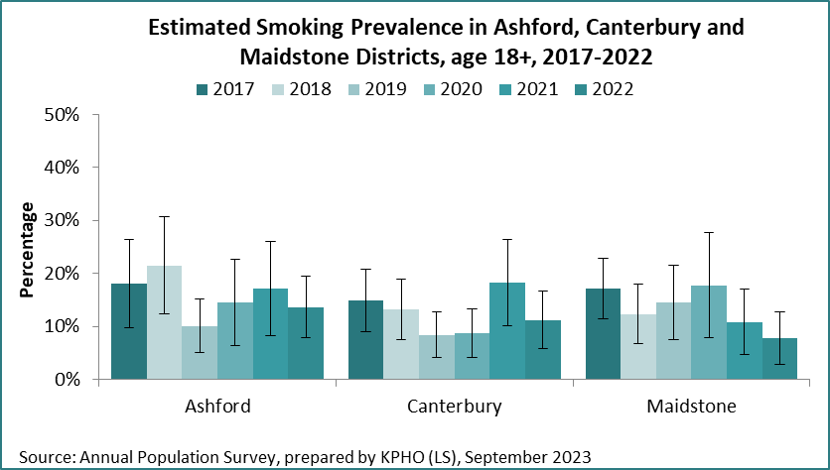

Chart 4. Estimated Smoking Prevalence: Dover, Folkestone and Hythe and Thanet Districts 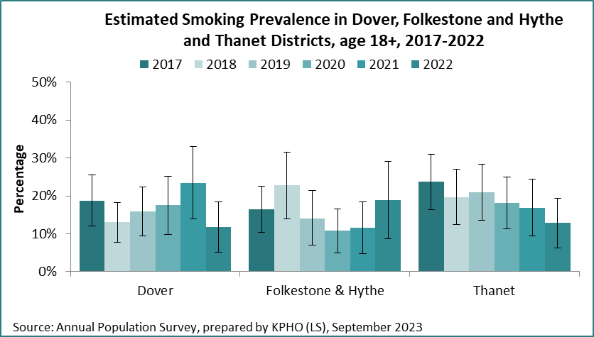

Chart 5. Estimated Smoking Prevalence: Dartford, Gravesham, and Swale Districts

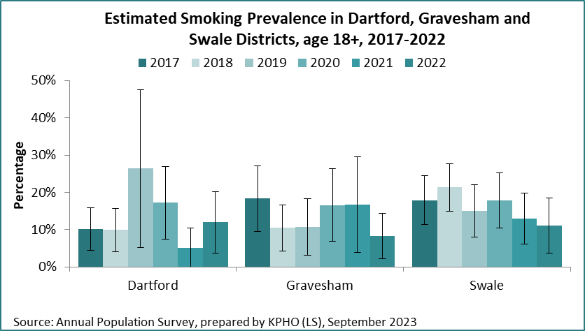

Chart 6. Estimated Smoking Prevalence: Sevenoaks, Tonbridge and Malling and Tunbridge Wells Districts

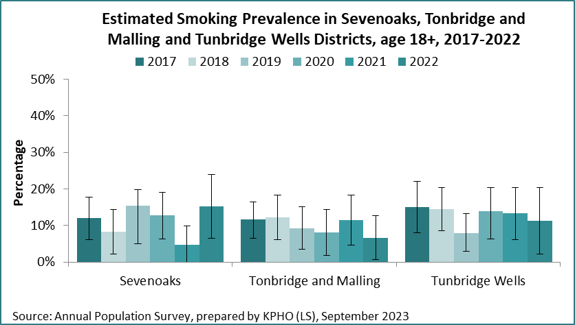

In 2022 the lowest smoking prevalence was in Tonbridge and Malling (6.7%) and Maidstone (7.8%). Typically, there are low rates in Sevenoaks and Tonbridge and Malling, districts with the greatest affluency. Folkestone and Hythe (18.9%) and Sevenoaks (15.3%) districts currently have the highest smoking rates, but levels fluctuate year on year, depending on survey response rates so annual figures alone should not be regarded as accurate indicators of smoking prevalence. The high prevalence rate for Sevenoaks in 2022 is likely due to be the low survey response rate rather than an increase in smoking rates. Thanet, Swale and Dover districts have had higher smoking rates over time, commensurate with areas of deprivation.

## **Who is at risk and why**

Higher smoking rates are more common in those who live in deprivation, with cumulative disadvantage increasing the likelihood of smoking. According to Action on Smoking and Health (ASH), higher smoking prevalence has been identified among the following groups:

|  |  |
| --- | --- |
| People with a mental health condition | People on a lower income |
| Those who are unemployed | People experiencing homelessness |
| People without qualifications | Those in social housing |
| LGBTQ | Lone Parents |
| People in contact with the criminal justice system | |

Lower Socio-economic Groups

Smoking rates are higher in lower socio-economic groups causing greater health inequalities. In 2022, 1 in 4 people in routine and manual occupations in Kent were smokers (24.5%), higher than the England average (22.5%)[14]. Smoking rates among this group have declined in Kent since 2017 and faster than the England rate.

Chart 7 Smoking Prevalence (Routine and Manual Workers)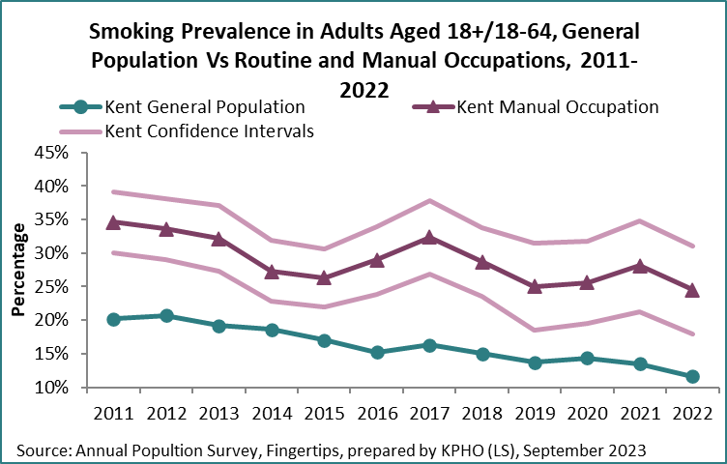

Despite this, it is estimated that 26% of households containing smokers in the South East of England live in poverty[15]. People living with social and economic hardship tend to smoke more, be more addicted and find it harder to quit, although they may try just as often. The cost of smoking is more likely to perpetuate poverty among those who are least likely to be able to afford it.

26% of those who live in social housing in Kent are smokers, compared to 11.6% of the Kent population as a whole. This is a particular concern as children and adults are at risk of the harms caused by second hand smoke. Second hand smoke contains over 4,000 chemicals; 60 of which are known to cause cancer. These toxic particles may not be visible and can embed in furniture and furnishings for up to 3 hours before reducing to safe levels.[16]

Households where people smoke tend to be poorer because of an addiction which usually started in childhood[17]14. 90% of children are more likely to start smoking if they live in a household where their parents smoke[18]14. Two thirds of adult smokers started before they reached 18[19]14 and most of them go on to become regular adult smokers*.* There is a strong association with children taking up smoking and smokers from low socio-economic groups engaging with the illicit tobacco trade.

## **Illicit Tobacco**

Illicit tobacco products include counterfeit branded cigarettes and hand rolled tobacco and tobacco products illegally imported into the UK. The sale of illicit tobacco compromises public health policies encouraging smokers to quit. It adversely impacts Revenue and Customs tax increases aimed at reducing the demand for tobacco products by supplying cheaper, unregulated alternatives.

The Illicit Tobacco trade is a huge global industry with estimated tax gap of £2.4b in the UK between 2015-16[20] Much of the trade is led by criminal gangs supplying merchandise to local sellers and retailers and is often engaged in wider organisational crime. Illegal cigarettes are often responsible for initiating children into smoking at affordable ‘pocket money’ prices and with no regard to who they are being sold to.

Detailed localised information on smokers’ attitudes, experiences and behaviours of illicit tobacco activity is reported in the NEMS survey conducted in the Southeast in 2018. It reveals the profile of those targeted to sell illicit tobacco which also mirrors the profile of those who purchase the products (i.e.. Males, younger smokers, and those from lower socio-economic groups). 11% of Kent respondents admitted buying illicit tobacco and 24% had ever been offered it. The survey estimates that 5% of the market share of tobacco is illicit in the Southeast.

Policies seeking to tackle the illicit tobacco trade aim to:

1. reduce the **supply** of illicit products through increasing intelligence to Trading Standards organisations to inform targeted enforcement.
2. reduce the **demand** by raising public awareness of the harms and associated dangers of the illicit trade.

The NEMS survey[21] provides a local profile of activity, risks, and barriers useful to target and execute effective policy measures. 16% of smokers and 42% of illicit tobacco users in the survey reported being comfortable with illicit tobacco. Policies that disrupt the supply chain, such as retail ‘closure orders’ are effective, but require collaboration between local authorities and Trading Standards and are a lengthy process. Understanding the barriers to engagement and the drivers to report illicit use (including reporting on the nuisance illicit trade causes) can help reduce demand in our community.

Campaigns and media reports should focus on the reasons given for not purchasing illicit products as a means of prevention:

* uncertainty of what they contain (37% first reason given)
* fear of being caught (13% first reason given)
* if it affected children (10% first reason given).

Most people surveyed said they are not at all likely to report illicit sales activities (30%) and only 18% said they are very likely to report then. To increase reporting incidents, there needs to be greater public awareness of the propensity for children being involved (see Table 2).

Table 2. Reporting the Sale of Illicit Tobacco

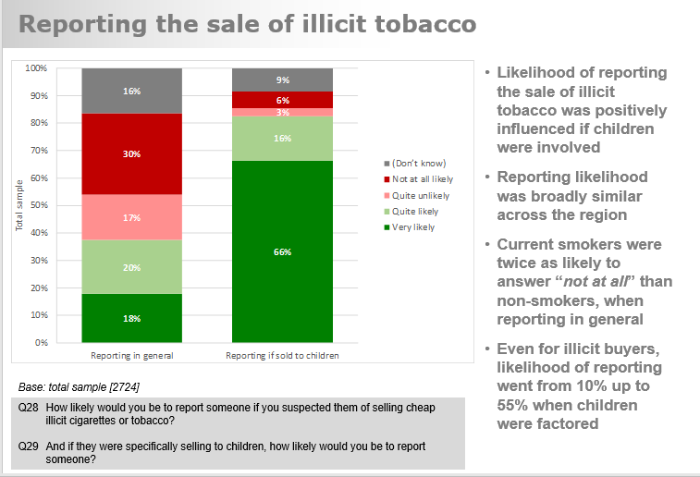

*Source: NEMS 2018*

Promoting campaigns and raising public awareness are effective through Illicit Tobacco Roadshows; multi-agency targeted public events, led by Trading Standards teams. The Roadshows often incorporate intelligence gathering, retail inspections involving sniffer dogs and raising public awareness of the dangers and association with organised crime.

Kent Trading Standards forms part of the Trading Standards South East (TSSE) network, sharing local intelligence, resources, and enforcement powers to seize illicit tobacco products and conduct closure orders to offending premises. Kent Public Health and Trading Standards have worked collaboratively since 2016 to deliver roadshows in town centres across Kent. In a series of 15 commissioned roadshows across East Kent in 2019-20, 179,240 cigarettes and 71.1kg of hand rolling tobacco with a value of £120K were removed from premises and over 224,000 people were reached through accompanying social media messaging.

Roadshow events and trained sniffer dogs generate media attention and are effective at raising public awareness. Procuring organizations that supply detection dogs can be costly and currently deployed in other detection services, so alternatives need to be sought.

## **Young People, Smoking and Vaping**

Starting Smoking

There is clear evidence that most smokers take up smoking at a young age. In 2011, 40% of adult smokers surveyed reported smoking regularly before the age of 16[22] Further studies show two thirds started before the age of 18 and more than 80% before the age of 20[23]. Only one third of those who continue to smoke will manage to quit in their lifetime. Children who grow up in households where parents smoke are three times more likely to start smoking themselves. Passive smoking bears health risks of asthma, sudden infant death syndrome, bronchitis and pneumonia and is associated with increased likelihood to take up smoking in adolescence. Factors associated with the take up of smoking include peer pressure from friends who smoke, curiosity and the accessibility and availability of affordable cigarettes. A more recent modelling system identifies e-cigarette use as the strongest association with current smoking.

Diagram 1. Association of taking up smoking: NHS Logistic Regression Model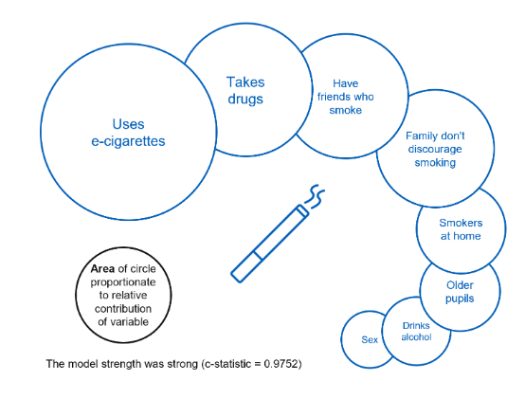

*Source: NHS Smoking, Drinking and Drugs Survey 2021*

Children who smoke are more at risk of impaired lung growth, respiratory illnesses, Chronic Obstructive Pulmonary Disease (COPD) and lung disease later in life. High nicotine levels contained in cigarettes and e-cigarettes can also adversely affect brain development in children.[24]

The ‘Towards A Smokefree Generation’ tobacco control plan sets a national target to reduce regular smoking among 15-year-olds to 3% or less by 2022[25]. The national target was achieved in 2021, with a smoking prevalence of less than 1% for all ages 11-14 years and 3% among 15-year-olds in the NHS Smoking, Drinking and Drug Use among Young People (SDD) survey[26].

The survey also reveals that the rate of 11–15-year-olds having ever smoked or tried smoking have been declining since 1996 from 49% to 12% in 2021. Young people may experiment with or try smoking, but less than 1% of 11-year-olds report to be current smokers (i.e., don’t smoke regularly) and this prevalence increases with age to 9% of 15 year olds.

Chart 8. Pupils who are Current Smokers by Age (i.e.. Those that smoke occasionally and/or regularly)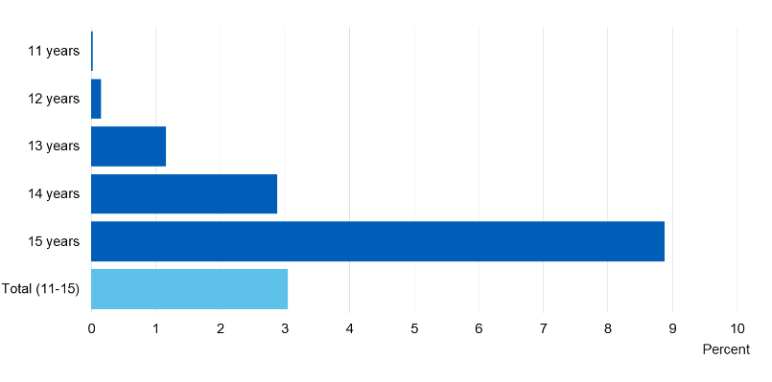*Source: NHS Smoking, Drinking and Drugs Survey 2021*

The following table shows the declining trend in different categories of smoking across all 11–15-year age groups with likelihood of ‘ever trying’ smoking, ‘current’ smoking and ‘regular’ smoking increasing with age.

Table 3. Smoking status among 11–15-year-olds

|  |  |  |  |  |  |  |  |  |  |  |  |  |
| --- | --- | --- | --- | --- | --- | --- | --- | --- | --- | --- | --- | --- |
| **Smoking Status** | **11 years 2018** | **11 years 2021** | **12 years 2018** | **12 years 2021** | **13 years 2018** | **13 years 2021** | **14 years 2018** | **14 years 2021** | **15 years 2018** | **15 years 2021** | **All 2018** | **All 2021** |
| Ever Smoked | 2% | 2% | 7% | 4% | 13% | 8% | 22% | 15% | 31% | 25% | 16% | 12% |
| Currently Smoke | 0% | 0% | 2% | 0% | 3% | 1% | 6% | 3% | 11% | 9% | 5% | 3% |
| Regularly Smoke | 0% | 0% | 0% | 0% | 1% | 0% | 3% | 1% | 5% | 3% | 2% | 1% |

*Source: NHS Digital, Smoking, Drinking and Drug Use Survey 2021*

Making cigarettes less accessible and affordable can deter children from smoking. The 2022 Khan Review[27] recommends introducing licencing for tobacco sales to better manage underage sales and impose sanctions where these regulations are breached. Local priorities can include strategic joint working initiatives with Trading Standards to systematically educate local tobacco retailers and routinely undertake test purchasing schemes.

Anti-smoking campaigns directed at young people can increase knowledge about the risks of smoking and addiction. NICE Guidance (NG209[28]) recommends engaging young people in the design of targeted campaigns and to collaborate with wider partners in the delivery, which should include media platforms used by young people. The distribution of campaigns is more easily measured than smoking prevalence outcomes, making efficacy and value for money hard to quantify. Campaign messages also need to ensure that they deter young people from smoking and vaping rather than appeal to further curiosity, which may have a harmful, negative effect. For these reasons, ASH claim that anti-smoking campaigns are not effective in reducing smoking rates and nationally led campaigns tend to focus cost and resources to motivate adults to quit rather than discourage the take up of smoking in the first place. Two co-designed local Kent campaigns; HOUSE (part of the KCC Towards 2010 initiatives) and Quit Coach pilot in Shepway (2016) were later managed by the Kent Youth Service and eventually dissolved through reduced or lack of funding and staff resources. An additional ‘peer support’ stop smoking programme piloted at Ashford Youth Centre in 2019/20 achieved 12 young people quitting smoking in the year, compared to 23 quitters under the age of 18 supported by the local community stop smoking services. New Zealand Public Health have set the path for rising awareness to young people about vaping[29], although there is no similar platform yet endorsed in England.

School based educational programmes can be effective but struggle to compete with the wider PSHE agenda for prioritisation. There is no systematic or strategic take up of smoking related educational programmes across schools in Kent. All schools should have an accessible smokefree policy with a clear position on vaping and supports healthy choices and encourages smokers to quit.

Further effective multi-agency approaches need to be explored to prevent young people taking up smoking and to encourage young smokers to quit as early as possible.

Vaping

The use of e-cigarettes (known as vaping) can be an effective quitting aid for smokers, but, although safer than smoking, its use is not risk free and should be discouraged among non-smokers as well as children and young people. It is illegal to sell (or proxy-sell) e-cigarettes containing nicotine to people under the age of 18 years old and further research is needed to understand the potential health risks of vaping. Lung damage (known as EVALI[30]), increased risk of respiratory infections and chronic coughs are recorded health risks particularly related to vaping among young people[31]. High nicotine levels present in e-cigarettes targeted to adolescents is a concern as children are more vulnerable to nicotine addiction than adults and can have a negative effect on brain development[32].

Data Collection and Trend

Under-age smoking is a well-established public health concern; however, underage vaping is an emerging issue. Although regular smoking rates have declined among 15-year-olds (to 3% in 2021[33]), there are recent media reports and public perception of an increase in e-cigarette use among school aged children which could introduce a new gateway to taking up smoking, particularly as nicotine is so addictive.

The SDD survey 2021 reveals that 25% of 15-year-olds have ever tried smoking but a higher percentage (39%) have ever used an e-cigarette. Although the prevalence of ‘ever use’ is lower than 2018 across most age groups, it does reveal an increase in all age groups ‘currently’ and ‘regularly’ vaping with a significant increase among 15-year-olds. The table below highlights increases in vaping between 2018 and 2021 and shows that 39% of 15-year-olds have tried vaping, 18% are current vapers and 10% vape regularly.

Table 4: Vape Use among 11-15 year olds by age 2018-2021

The boxes highlighted in red show an increase in vaping between 2018 and 2021.

|  |  |  |  |  |  |  |  |  |  |  |  |  |
| --- | --- | --- | --- | --- | --- | --- | --- | --- | --- | --- | --- | --- |
| **Vape Status** | **11 years 2018** | **11 years 2021** | **12 years 2018** | **12 years 2021** | **13 years 2018** | **13 years 2021** | **14 years 2018** | **14 years 2021** | **15 years 2018** | **15 years 2021** | **All 2018** | **All 2021** |
| Ever vaped/ever tried | 7% | 5% | 12% | 12% | 22% | 18% | 34% | 27% | 41% | 39% | 25% | 22% |
| (-2%) | 0% | (-2%) | (-7%) | (-2%) | (-3%) |
| Currently vape | 0% | 1% | 2% | 3% | 5% | 6% | 8% | 11% | 11% | 18% | 6% | 9% |
| (+1%) | (+1%) | (+1%) | (+3%) | (+7%) | (+3%) |
| Occasionally Vape | 0% | 0% | 1% | 2% | 4% | 4% | 5% | 6% | 7% | 8% | 4% | 4% |
| 0% | (+1%) | 0% | (+1%) | (+1%) | 0% |
| Regularly Vape | 0% | 0% | 1% | 1% | 1% | 2% | 3% | 5% | 4% | 10% | 2% | 4% |
| 0% | 0% | (+1%) | (+2%) | (+6%) | (+2%) |

*Source: NHS Digital, Smoking, Drinking and Drug Use Survey 2021*

The YouGov survey (ASH, 2022[34]) reports much lower estimates of e-cigarette use among 11–15-year-olds; with the SDD survey reporting 6.5% ‘ever using’ e-cigarettes in 2021 compared to 6.5% in the YouGov survey, rising to 10.4% in 2022). It is worth noting that the although the SDD survey results provide the national official figures and the YouGov survey has a smaller sample size, YouGov does confirm the age-related growing interest in vaping among young people. The trend in vaping at a young age extends to 18-year-olds where nearly half had ever tried vaping (41%) and 20.2% report that they currently vape.

Table 5. Vaping use among 11-18 year olds

|  |  |  |  |  |
| --- | --- | --- | --- | --- |
| **Ever Tried Vaping (2022)** | **11-15 year olds** | **16-17 year olds** | **18 year olds** | **11-17 year olds** |
| % Ever Tried Vaping | 10% | 29% | 41% | 15.8% |

Source: ASH, YouGov 2022

Attention to smoking and e-cigarette use within specific age groups is important as the high prevalence rates are masked by all age group totals, particularly because the take up among 11–14-year-olds is low in comparison. For example, the table below from the YouGov survey shows a 5% increase in 16–17-year-olds currently vaping between 2020-2022, but only 2.9% increase across all 11–17-year age groups. The wider age band masks the more significant increase between 16–17-year-olds. This is particularly stark in table 4 where there is a 2% increase in 11–15-year-olds regularly vaping between 2018–2021, but a more significant 6% increase among 15-year-olds in the same period.

Table 6. Current e-cigarette use among 11-18 year olds.

|  |  |  |  |
| --- | --- | --- | --- |
| **Current e-cigarette use (2020-2022)** | **16-17 year olds** | **18 year olds** | **11-17 year olds** |
| % current use of e-cigarettes 2020 | 9.1% | 8.5% | 4.1% |
| % current use of e-cigarettes 2021 | 5.9% | 9.6% | 3.3% |
| % current use of e-cigarettes 2022 | 14.1% | 20.2% | 7.0% |

*Source: ASH, YouGov survey 2022*

From 2021, it is clear that trends have now reversed and vaping rates among young people are now significantly higher than smoking with a gradient in age. Although rates for those ever vaping or trying e-cigarettes has declined slightly since 2018 (possibly due to the COVID-19 pandemic restricting socialising) there is a significant increase among 15 years onwards who go on to vape on a current or regular basis. The table below shows that while only 3% of 15-year-olds have gone on to be smokers, 10% have gone on to vape regularly.

Table 7. Smoking and Vaping among 11–18-year-olds

|  |  |  |  |  |  |  |  |  |
| --- | --- | --- | --- | --- | --- | --- | --- | --- |
| **% Smoking/Vaping, 2021-2022** | **11 yr olds (SDD)** | **12 yr olds (SDD)** | **13 yr olds (SDD)** | **14 yr olds (SDD)** | **15 yr olds (SDD)** | **11-15 yr olds SDD)** | **16-17 yr olds (YouGov)** | **18 yr olds (YouGov)** |
| **Ever Smoked** | 2% | 4% | 8% | 15% | 25% | 12% | N/A | N/A |
| **Ever Vaped** | 5% | 12% | 18% | 27% | 39% | 22% | 29% | 41% |
| **Currently Smoke** | <1% | <1% | 1% | 3% | 9% | 3% | N/A | 20%* |
| **Currently Vape** | 1% | 3% | 6% | 11% | 18% | 9% | 14% | 20% |
|  |  |  |  |  |  |  |  |  |
| **Regularly Smoke** | <1% | <1% | <1% | 1% | 3% | 1% | N/A | N/A |
| **Regularly Vape** | <1% | 1% | 2% | 5% | 10% | 4% | 3.1% | N/A |

*Source: NHS digital, SDD survey 2021 and ASH YouGov survey 2022 (*Data from UCL survey)*

One of the reasons for the marked increased levels of e-cigarette use may be the 14- fold concurrent increase in disposable e-cigarette use among 18 year olds in the last year, from 0.89% in 2021 to 56.7% in 2022[35]. This trend is also replicated among younger pupils aged 11-17 seeing a 7-fold increase in disposable e-cigarettes from 7.7% to 52% in the same period[36]. However, there has been a 40.9% reduction in rechargeable and refillable e-cigarettes in this age group, indicating that the increase in disposable products use is largely due to current-cigarette users switching products rather than being indicative of a new cohort of vapers. Although research findings claim that there is currently no evidence to suggest that the disposable products have a causal effect on the increased levels of vaping, the marketing and accessibility of some products appeal to younger audiences despite the minimum age of sale.

Most 11–15-year-olds who vape regularly say they obtained e-cigarettes from other people (61%), most of whom were friends (45%). Purchasing from shops was the second most common answer (57%) with newsagents being most common (41%)[37]. Trading Standards have a role to test purchase to ensure retailers comply to UK standards and age of sales laws but have competing priorities and limited resources to overcome the challenges of a complex and persistent market. Products sold on street markets or via the internet may have an increased risk of failing to comply with UK regulations.

Table 8. Reported methods of obtaining vape products among young people.

|  |  |  |  |  |  |  |
| --- | --- | --- | --- | --- | --- | --- |
| **Reported ways of obtaining vape products** | **Retail shops** | **Given (informally/ friends/ family)** | **Purchased from Friends/ Family/ Informally** | **Purchased from street markets** | **Purchased from Internet** | **Where seen promoted (72% of users)** |
| **% of under 18s who Vape** | 47.0% | 43.0% | 18.0% | 11.0% | 10.0% | Tik Tok / Instagram |

*Source: ASH YouGov survey 2022*

The Advertising Standards Agency prohibit the promotion of nicotine-containing e-cigarettes not registered under the Medicines and Health Regulatory Association (MHRA) and restrict the advertisement of non-nicotine containing products among children and young people. However, 72% of those surveyed who have ever tried vaping have reported seeing promotions; 56% of 11 – 17-year-olds have seen in-store promotions, 45% from Tik Tok and 31% on Instagram. Fruit flavours, disposable products and Elf Bar and Geek Bar brands are most popular[38].

Despite the increased trend in vaping among young people, more children than adults think vaping is as harmful or more harmful than smoking (44% v. 33%)[39].

The Future

The dichotomy is whether the increase in e-cigarette uptake is a gateway to future smoking habits (thus reversing the current downward trend) or if a proportion of e-cigarette users would have likely taken up smoking if they didn’t vape. It is currently too early to tell, but careful monitoring is required to ensure that the surge in 15–18-year-olds vaping does not lead to a new future generation of smokers. At the very least, future services may be required to treat young people with nicotine dependency although current research does not differentiate between nicotine-containing and non-nicotine containing products. Tighter regulations are needed in the manufacturing of vape products to ensure that the colours and flavours are not targeted to appeal to children and that e-cigarettes are not sold in person or by proxy to under 18s. The use of research data of smoking and vaping among 11–18-year-olds should be categorised and reported by age as the current low levels of take up among 11–14-year-olds masks the rate of increase in current and regular e-cigarette use among 15–18-year-olds. There are a range of social, legal and health risks associated with children and young people vaping and all underage smoking and vaping should be discouraged.

### **Underage Sales – Tobacco and Nicotine Inhaling Products**

It is a criminal offence under the Children and Young Persons Act 1933[40] to sell **any** tobacco or cigarette products to a person below the age of 18.

The sale of nicotine inhaling products (vapes) is also restricted to those aged 18 or over in the UK subject to the Children and Families Act 2014[41]. This Act also introduced the offence of proxy sales (buying on behalf of a minor) for both tobacco and vape products to limit accessibility of both categories of product to young people. At present other nicotine products, such as tobacco free nicotine pouches, are not an age restricted product despite their potential to lead to addiction.

The age restrictions for both tobacco and vapes are enforced by Trading Standards who are required under the Children and Young Persons (Protection from Tobacco) Act 1991[42] to consider “at least once in every period of twelve months, the extent to which it is appropriate for them to carry out in their area a programme of enforcement action” for those products and carry out such an exercise as considered appropriate. The current capacity within Trading Standards to take investigations from failed test purchases is restricteddue to limited resources and competing pressures from other statutory functions.

Trading Standards receive reports of underage sales from partner agencies and directly from members of the public. These reports are used as intelligence and support the justification for test purchasing operations and is a prerequisite to obtaining an authorisation to carry out test purchases which requires court approval.

Trading Standards must follow a Code of Practice in relation to underage sales test purchases that require the test purchaser to be no older than 18 months below the legal age limit (i.e., 16 years and 6 months) and not to lie about their age. This requirement can only be departed from in limited circumstances where intelligence dictates. The rationale ensures only those that habitually sell to those under the legal age limit are subject to criminal proceedings rather than those who make an error in judgement but leaves a potential window of opportunity at perhaps the most critical age where young people seek to obtain age restricted products.

It should also be noted that test purchasing alone can only provide a snapshot based on the time/day and member of staff who happens to be at the chosen till point. It is therefore beneficial to consider a programme of activities aimed at ensuring a broad coverage.

Tobacco

One of the Khan Review: Making Smoking Obsolete[43] key recommendations are to increase the age of sale for **tobacco** products to meet the 2030 objective of a smoke free generation. Trading Standards remain ready to implement programmes of advice and support should this measure be enacted, but it would remain a logistical challenge with current resources in a county the size of Kent. It is without doubt that the ‘final push’ to the 2030 objective requires more intensive strategies to overcome the remaining hurdles and while a rise in the age of sale may not come to fruition, it will be extremely important to ensure the current age restriction is complied with where current gaps may lie.

The landscape of underage sales intelligence in Kent gravitates towards the ‘illegal’ tobacco shops, those selling counterfeit or duty evaded tobacco. These shops have a cumulative impact in the community. It is acknowledged that these shops present a major challenge, however such premises will not be brought into compliance through regular compliance means (test purchase and prosecution) and should therefore be considered separately. These shops are widely reported for their organised criminal activity therefore risk assessments dictate that young people should not be sent to these locations providing another barrier to test purchase operations based on existing intelligence. These shops are addressed through separate workstreams, therefore the needs assessment focusses on the ability to engage with the remaining business community.

Vapes

While vape products have been in existence for over ten years, there has been a recent emergence in the UK of disposable devices. Disposable devices legally available have a maximum liquid capacity of 2ml. They are predominantly available in one strength 20mg/ml (sometimes given as 2%) which is the maximum legal strength in the UK. Refillable devices which previously dominated the vape market would be available in varying strengths, most commonly in 3mg/ml increments allowing a user a taper their nicotine use to reduce their nicotine dependence.

Disposable products are popular because of their convenience. A UK legal 2ml product will deliver 40mg of nicotine. This is in comparison to a cigarette which is estimated to provide a smoker with approx. 1mg per cigarette[44] (or 20mg for a 20/day smoker). Products have been identified on sale in the UK above 10ml which risks a greater addiction due to habitual use of the product ‘on demand’.

The message is very clear that those who have never smoked, and young people should not vape as the relative long-term harms are unknown. Despite this, disposable products are incredibly popular (accounting for 77.2% of the vaping market share in the last 6 months)[45] and this is particularly true of the youth market. The current evidence does not suggest vape products to be a gateway to tobacco despite the nicotine link, however the epidemic of young people using these devices risks damage to the reputation and viability of vapes as an alternative for current tobacco users.

Both ASH[46] and NHS[47] Digital have provided survey data on an increase in vape usage amongst young people. This corroborates the intelligence received by Trading Standards which has pointed to a 450% increase in complaints around vape products nationally over the last year. The level of complaints received in Kent are unsustainable if test purchase were the only option to ensure compliance.

Due to the growth in popularity the spread of outlets for disposable products is extremely wide, between specialist vape shops, retailers of traditional age restricted products, but also now at retailers not familiar with selling age restricted goods. The latter provides a challenge in respect of the number of emerging shops on the high street.

Response

For alcohol sales it is common for retailers to follow a Challenge 25 principle, whereby purchasers appearing under 25 years of age are challenged to provide evidence that they are of legal age. In Kent, ten areas are active Community Alcohol Partnerships (CAP) which embed Challenge 25 and regularly test the retailers against this measure. Challenge 25 Test Purchasing is simple to resource without the regulatory hurdles associated with a formal ‘Under 18’ test purchase.

The CAP programme educates retailers, ensuring they have the necessary tools to refuse sales, and for managers to train staff. Those who fail a Challenge 25 test purchase will not have committed a criminal act but will receive further advice and training to bring them into compliance with formal action being a last resort. As investigations are time consuming and expensive, a programme of compliance mirroring that of the CAP is a possible tool to provide greater reach to tobacco retailers and communities. Investigations and criminal proceedings would then be reserved for those who repeatedly fail to engage and apply the advice provided. Increasing business engagement helps identify and correct other tobacco related regulations including:

* Display of tobacco
* Advertising of tobacco
* Statutory tobacco notices
* Pricing of tobacco
* ‘Single’ sales of cigarettes
* Other ‘non-mainstream’ tobacco products (shisha, chewing & oral tobacco)
* Product monitoring of ‘illegal vapes.’

Each of the tobacco measures mentioned above has contributed to the gradual decline in smoking prevalence. Annex 1 shows further detail of changes in adult smoking prevalence against a timeline of regulatory measures.

Likewise, the lack of knowledge in the non-mainstream vape shops as well as the prevalence of non-compliant devices makes for easy accessibility to young people that is unacceptably high at this moment in time.

As a note on proxy sales, for both tobacco and vapes, this would be a Trading Standards offence to enforce, however the practicality of identifying offences and taking them forward in the public interest is limited. It is however possible to develop retailer education and point of sale material to help educate members of the public as well as empowering retailers to refuse sales where they believe the age restricted product will be passed onto a young person.

Kent Trading Standards ran a programme in 2012 known as Targeting Tobacco, which at the time focussed on ward level data of smoking prevalence. In effect these were mini-CAP areas focussing on tobacco sales. Following advisory visits, initial test purchases carried out at all retailers of tobacco in an identified area led to higher-than-average failure rates, however subsequent advice work lowered the failures significantly. Such a programme is not feasible with the current competing resources pressures, however if funded a similar role could be developed to adopt a CAP type approach to tobacco and vape products.

**Smoking and Vaping Among Young People**

### **Summary and Recommendations**

Although smoking rates among young people shows a declining trend, there is emerging evidence of an increase in young people vaping, particularly disposable vapes which are packaged and marketed to young audiences. While vaping is considered to be safer than smoking, it is not risk free and the health risks on developing bodies is still unknown. Consequently, it is illegal to sell tobacco and vape products to anyone under the age of 18 and ways in which the public can report illegal sales needs to be promoted. In addition, Trading Standards need further resources to respond to the increase in demand.

The likelihood of young people taking up smoking or vaping is determined by peer pressure, availability and growing up in environments where family and friends either smoke or vape. There are opportunities for children and young people centred establishments to work collaboratively to reduce the take up of smoking or vaping and to encourage quitting. Effective age-appropriate services need to be commissioned to support young people quitting and treat nicotine dependency.

Recommendations

|  |  |  |
| --- | --- | --- |
|  | Recommendation | Partner Agencies |
| 1. | Improve public reporting systems of illicit tobacco, non-compliant vape products and underage sales of tobacco and vape products to contribute to Trading Standards intelligence | Led by Trading Standards.  Include Youth Service, Education, School Nursing, Public Health |
| 2. | Use local data to target tobacco and vape retailers and suppliers of underage sales. Expand the Challenge 25 schemes, test underage sales compliance and conduct Advisory visits to retailers. | Trading Standards (funding required) |
| 3. | Multi-agency approach to reducing the take up of smoking and vaping among young people. New and innovative ways of working required, supported by an effective campaign | School Nursing, Youth Service, Education, Public Health, Communications, Trading Standards |
| 4. | New age-appropriate nicotine-dependency treatment service to be commissioned to support young people to quit smoking and vaping and reduce the risk of vaping as a gateway to smoking. | Public Health Commissioners |
| 5. | All schools to have a clear smokefree and vape-free policy which supports and facilitates healthy choices and encourages smokers to quit. | Education Commissioners, school nurses, head teachers and board of governors |

## **Smoking in Pregnancy**

Smoking during pregnancy is associated with health risks and birth abnormalities such as heart defects, premature birth, low birth weight, placental abruption, and eclampsia. It also doubles the risk of stillbirth, increases the likelihood of miscarriage by 24-32% and is 3 times more likely to cause sudden infant death[48]. The national Tobacco Control Plan sets a target to reduce smoking at the time of delivery (SATOD) to 6% by the end of 2022. Kent is unlikely to achieve this target. Between 2021 and 2022, 1,928 pregnant women in Kent and Medway[49] were recorded as smokers by the time their babies were delivered. This is 10.8% of all live deliveries compared to the England rate of 9.1%[50] Pregnant women who smoke are more likely to be younger and live in poorer communities. Regional differences in smoking in pregnancy rates reflect the area’s general smoking prevalence, so activities that reduce the adult smoking population are likely to also reduce smoking in pregnancy*.*

Chart 9. Smoking in Pregnancy, smoking at time of delivery

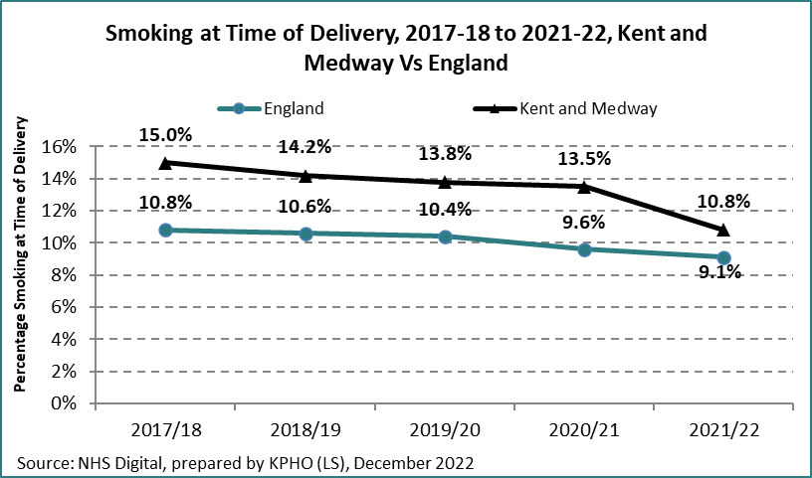

*Source: NHS Digital, Smoking at time of Delivery*

In line with the Royal College of Midwives policy, all pregnant women in Kent are offered a carbon monoxide (CO) test at their maternity appointments and all smokers routinely given very brief advice (VBA) and referred to dedicated opt-out stop smoking behavioural support[51]. Since 2017, locally commissioned stop smoking services have offered home visit quit smoking services to pregnant smokers and their partners. More than 3,000 women are referred into the service each year. 42% of women accept the service compared to less than a third prior to the home visit service (27% in 2019/20). Despite improved success rates, only 17% of referred pregnant smokers went on to successfully quit smoking in 2021/22. The low rate of pregnant women accepting stop smoking support and successfully quitting, mirrors the national picture and the challenges are similar. Nicotine addiction, complex daily lives, and fear of being judged are all barriers to pregnant smokers accepting stop smoking support. Additional VBA training for all midwives and the recruitment of specialist midwifery smoking in pregnancy roles have helped improve referral rates, but women declining or not responding to quit services results in too many women smoking at the time of delivery.

Chart 10. Smoking in pregnancy access to stop smoking services.

*Source: NHS Digital and KCHFT Babyclear data April 2019-July 2022*

*\*Number of appropriate referrals after deducting non-smokers with high CO readings and non-Kent residents*

In 2021, as part of the national response to smoking in pregnancy, NHS England mandated the local delivery of a new in-house maternity-led stop smoking services delivered by dedicated Maternity Support Workers (MSWs). This is being introduced gradually in Kent from September 2022, starting in the Maidstone area, with full coverage expected by 2024. MSWs will provide stop smoking behavioural support and NRT throughout the duration of pregnancy, sustain quit attempts or reconnect with smokers who lapsed with the overall aim to reduce smoking at time of delivery rates. This new model will decrease overall referral rates into the local stop smoking but will release current capacity to support smokers at time of delivery to quit smoking on discharge from hospital alongside health visiting services.

NICE guidance (NG209) and the Royal College of Midwives suggest that services should consider offering e-cigarettes as an aid to quit alongside behavioural support[52]. A national randomised control trial of e-cigarette use in pregnancy is currently underway[53] and a pilot programme in Kent shows early indication of e-cigarettes being popular with pregnant women who are trying to quit smoking.[54] The results of the trial and local pilot, when available, may accelerate a systematic offer of e-cigarette use as part of the local quit support programmes.

There is some evidence that financial incentives schemes[55] for pregnant smokers can be effective to encourage women to stop smoking in pregnancy but further evidence is needed to identify whether financial incentives can generate longer-term sustained quits. A recent study published in the British Medical Journal[56] shows that a £400 voucher scheme resulted in 27% of the intervention group quitting smoking (versus 12% in the control group) but relapse was high in both groups in the 6 months post-partum. Further research is suggested to measure efficacy of longer-term incentives schemes.

**Smoking in Pregnancy**

### **Summary and Recommendations**

SATOD rates in Kent and Medway are higher than the national average. The dedicated home visit stop smoking support has increased the number of pregnant women who smoke engaging in quit services, but still only 17% of referred women go on to quit. The NHS Long Term Plan offers an additional, mandatory in-house model of smoking cessation led by maternity services. The new services will start to be delivered in Kent from September 2022. It is too early to determine success, but close monitoring will be required and a collaborative approach to improving quit rates among pregnant women who smoke. Further exploratory work is needed in Kent, but the use of public money to fund public health incentive schemes can be controversial and politically sensitive, so may require testing for public opinion first.

Recommendations

|  |  |  |  |  |
| --- | --- | --- | --- | --- |
|  | **Recommendation** | **Aim** | **Description** | **Lead Partners** |
|  | Explore ways Smoking in Pregnancy advisers can support new groups alongside NHS LTP model | Identify new groups of smokers that can be supported by smoking in pregnancy advisers as pregnant women who smoke will be served by Maternity Trusts. | As smoking in pregnancy is delivered through Maternity trusts, there will be opportunities for current advisers to deliver to new groups of women (e.g., smokers at time of delivery who are discharged from hospital). | Local SSS |
|  | Expand maternity model across Kent | NHS Long Term Plan Maternity model equitable to all Kent pregnant women who smoke | Roll out maternity model and promote effectively, raising awareness of risks of smoking in pregnancy. | LMNS  Trust Comms  KCC Comms  KCHFT Comms |
|  | Consider incentive schemes | Evidence suggests incentive schemes can be effective in helping pregnant women to quit smoking | Commissioners to consider voucher schemes as an incentive to help pregnant women quit smoking | LMNS Commissioners  KCC Public Health Commissioners |

## **Mental Health and Smoking**

Smoking Rates

Smoking rates are higher among people with a mental health illness compared to the general population, with smoking prevalence increasing relative to the severity of mental health condition. This trend is also reflected in Kent, where it is estimated that 26% of adults with anxiety or depression smoke compared to 16% of the general population. This rises to 38% among those with a serious mental illness[57] (ICB data).

Chart 11. Smoking prevalence among adults with a mental health illness

Despite the overall decline in smoking prevalence in recent years, the rate has not reduced equally among people with a mental health condition. Control trials have revealed that people with schizophrenia are more likely to have the highest smoking prevalence as well as the highest rates of cancer, heart disease and respiratory conditions, thus widening the gap in health inequalities and contributing to a reduced life expectancy of 10-20 years[58].

The chart below illustrates how smoking rates remain stubbornly high among people with long-term mental health conditions. The sharp decline in 2019/20 may be attributable to the lockdown restrictions incurred by the COVID-19 pandemic.

Chart 12. Smoking Prevalence among adults with a long-term mental health condition

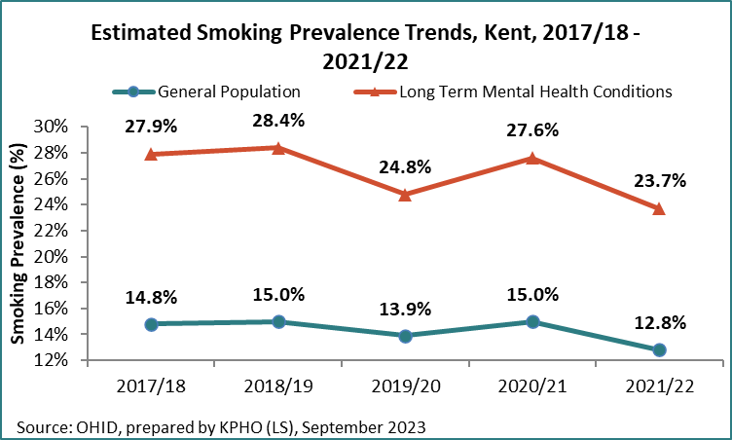

Data Issues

Accessing reliable and up to date data on smoking prevalence among people who experience a range of mental health conditions is problematic. There are inconsistencies in recording smoking status among service providers with some good examples of acute in-patient services routinely recording smoking status on patient records and other services (such as locally commissioned Adult Improving Access to Psychological Therapies (IAPT) services) not recording client smoking status at all. The GP Patient Survey (GPPS) records smoking status among people with a range of mental health conditions but is not published frequently and is restricted to those on GP lists at that time, excluding smokers who live in an institution. The Kent and Medway Partnership Trust report 17% of inpatients smoke although this figure may be under reported.

Smoking and Mental Health

There is a strong association between smoking and mental health as nicotine produces an immediate feeling of relaxation, creating the impression that smoking is relieving stress and anxiety. As this feeling is temporary, smokers soon experience withdrawal symptoms and cravings which heighten further feelings of stress. This creates nicotine dependency which can be more pronounced for smokers with a mental health condition[59], exacerbating addiction which in turn, can result in worse health outcomes.

The experience of withdrawal symptoms can also be prominent in people with depression who use smoking as a means to increase dopamine levels in their brain. Nicotine stimulates the release of dopamine which triggers positive feelings but over time the supply of dopamine can decrease, so people may find that they smoke more to compensate and find it harder to quit.

Stopping smoking can improve symptoms of anxiety and depression but there are misperceptions among some smokers and health care professionals that smoking helps manage stress and anxiety levels. The evidence suggests that smoking is a causal factor in mental health and can exacerbate rather than reduce stress*.*

Quitting smoking not only has immediate physical benefits for health, but reduces the risk of cancer, heart disease and respiratory illness. In the long term it can reduce depression, anxiety and stress and help to improve mood.[60]

There is also a strong link with smoking in pregnancy as a risk factor for attention deficit hyperactivity disorder (ADHD) in children[61]. Teenagers with untreated ADHD are more likely to take up smoking,[62] smoke more regularly and be more at risk of severe nicotine dependency; going on to develop drug and alcohol disorders.[63] Quitting smoking before pregnancy or as early in pregnancy as possible can potentially break the link between ADHD and smoking.

Smoking also increases the metabolism of some psychiatric medication, making it less effective and resulting in the need for higher dosages. People who quit smoking can be prescribed lower doses of medication as a result, which, in turn can help reduce obesity and inactivity issues also related to higher doses of some medications.

Sustaining a smoking habit is expensive, particularly for those who are economically inactive or on a low income. Smoking rates tend to be higher among those who can least afford it and increase the risk of turning to cheap and less safe illicit tobacco to make their habit more affordable. Some people with a mental health illness may be more vulnerable to the wider tactics of criminal groups and organizations who deal in illicit tobacco and wider criminal activities. Highlighting the health benefits of quitting smoking may be less likely to resonate or be a motivator for people with mental health conditions. However, financial pressures can be an additional source of stress and allayed to an extent with cost savings made from quitting smoking. Health and care professionals can provide advice and support to explain the financial benefits of quitting smoking, making alternative health affirming activities more affordable. Useful resources to illustrate this can be made available.

Quitting

There is an urgent need for evidence-based strategies and targeted approaches to motivate and support people with mental health conditions to quit smoking. Whilst these have been trialled and implemented in acute settings, community-based services tend not to be commissioned to record smoking status or deliver opportunistic quit support to known smokers. There can be a general empathy from staff towards those who smoke as a means of self-medicating, particularly if they are smokers themselves. In January 2022, Kent Public Health, Stop Smoking Services and Live Well Kent and Medway co-designed a campaign to encourage Live Well Kent clients to access local services to quit smoking. A local survey among service users revealed that 32% were current smokers and 22% of clients were ex-smokers at the time. The campaign was supported by trained staff who offered very brief advice on smoking and quitting as part of the client health checks. Myth busting posters giving factual information on the benefits of smoking were distributed to known smokers. The campaign has met with limited success as smokers have indicated their fears of increased anxiety levels if they quit smoking.

However, locally commissioned stop smoking services routinely record self-reported mental health status from clients who access their services. In 2021/22 23% of all clients reported a mental health concern. 68% of this group went on to set a quit date (versus 41% of clients without a mental health concern) and 52.5% of those successfully quit. The success rate is slightly lower than clients without a mental health concern (58%). The psychological experience of reward or pleasure from smoking needs to be acknowledged and alternative approaches to encourage quitting needs to be explored. Further consideration should be given to co-designed service options that can include harm reduction, cut down to quit services and in-house quit support from known, trusted key professionals on one-to-one, peer support or a group basis.

The NHS Long Term Plan

The NHS Long Term Plan mental health inpatient pathway is based on evidence obtained from the SCIMITAR+ trial[64] for people with severe mental health illness. The trial, conducted by University of York illustrates how an in-house comprehensive stop smoking programme delivered in mental health settings can achieve successful quit results among those who want to quit. This model forms the basis of the NHS Long Term Plan (mental health) being implemented by the Kent and Medway Partnership Trust (KMPT). The plan requires all mental health inpatient establishments to:

* Record smoking status on admission (preferably electronically)
* Provide NRT and availability of e-cigarettes.
* Recruit Tobacco Treatment Advisers to conduct an initial consultation within 48 hrs of admission.
* Provide ongoing treatment & support: as admissions in Mental Health Hospitals tend to have longer length of stay, it is anticipated that they will have frequent contact with a Tobacco Treatment Adviser during the first month.
* Plan onward support prior to discharge: the Tobacco Treatment Adviser should plan continued support and medication post discharge to complete standard the 12-week programme.
* Support and encourage intentions to quit smoking for all staff who smoke.

KMPT already systematically identify smokers and supports them to quit with staff trained to level 2 stop smoking advisor qualification, offering NRT and e-cigarettes. Many patients will leave the acute setting before the end of the quit support programme, so referral into the community stop smoking services on discharge will help support continued abstinence to achieve and sustain a successful quit. Further analysis of service engagement and outcomes will help shape and improve service delivery and outcomes for people with mental health conditions. Diagram 2 below shows the Long-Term Plan pathway to be implemented by March 2024.

Diagram 2. NHS Long Term Plan Mental Health tobacco dependency treatment pathway and role of the Tobacco Dependency Adviser (TDA) 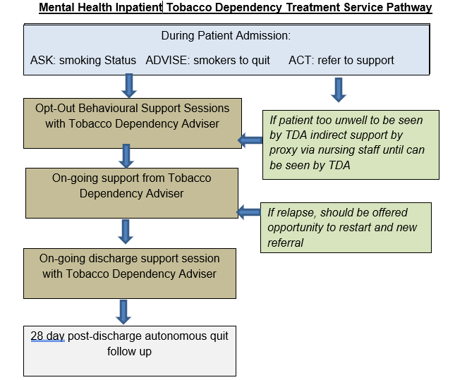

**Smoking and Mental Health**

### **Summary and Recommendations**

Smoking rates are higher among people with mental health conditions, with prevalence relative to the severity of mental health illness. The NHS Long Term Plan is going some way to ensure that smokers with a mental health condition are identified and treated and should deliver improved health outcomes and reduce health inequalities caused by smoking. Analysis of the mandatory data reports will help identify best practice and where further improvements are needed.

However, more needs to be done to identify and motivate smokers with a mental health condition to quit. If we do not act, the gap in inequalities will increase and people with a mental health illness will continue to die earlier than the general population.

Commissioned services and partners have an opportunity to routinely record smoking status, provide very brief advice to smokers and either provide or refer to bespoke stop smoking services that are supportive and effective. Harm reduction programmes in one-to-one and group settings should be considered and staff training and resources (such as cost-saving smoking calculators) should be explored, along with the option to vape. To achieve success, people with mental health conditions should be engaged in the design of these services.

## **Ethnicity**

Although the Office of National Statistics (ONS) do not record smoking prevalence by ethnicity at a local level, a recent analysis conducted by Kent and Medway Cancer Alliance accesses GP recorded smoking status and reported smoking quit data from the Kent One You stop smoking service. The GP Primary Care data reports a slightly higher Kent smoking prevalence than the ONS (13.6% v 11.6%) but provides a useful breakdown on the recorded smoking rates by ethnic group. The 2022 study shows a 16.5% smoking prevalence among White British people in Kent. Groups with higher rates are:

* Gypsy/Irish Travellers (36.4%) – highest smoking rate
* Other White (24%)
* Arab (21.9%)
* White and Black Caribbean (19.4%)

Ethnic groups with a lower smoking rate than White British are Bangladeshi, Indian, Pakistani, and other Asian, ranging from 6.7% to 13.1% prevalence.

However, numbers of smokers among most ethnic groups are small. White British make up 89.4% of all smokers in Kent and account for 90.4% of those who set a quit date with the stop smoking service and 90.1% of all those who quit. This equates to 14.2 quitters by 1,000 smokers among White British groups. Mixed White and Black African, Other Mixed, Bangladeshi, Indian, Pakistani, Black African, Other Black and Any Other Ethnic Group all have a higher quit rate per 1,000 smokers by ethnicity than White British, showing that although numbers accessing the stop smoking service may be low, they are proportionate to the numbers of smokers in that group.

Chart 13. Quits per 1,000 smokers per year by ethnic group: Kent, 2019/20 - 2021/22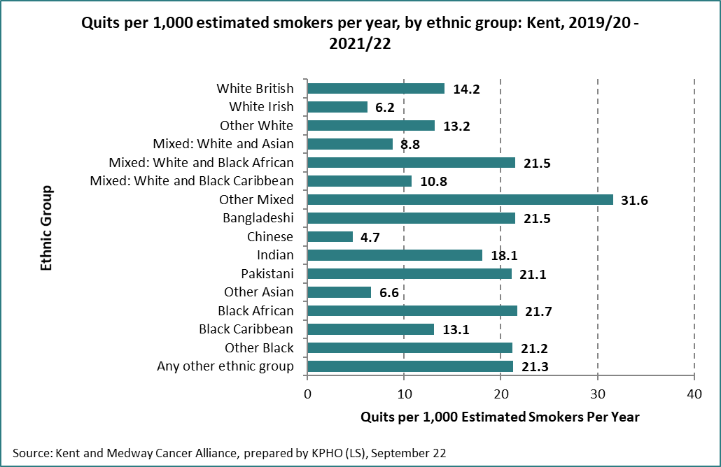

Smokeless tobacco use may not always be recorded in smoking status datasets. In the UK, smokeless tobacco products (grouped within “niche” tobacco) are consumed mainly by ethnic minority groups, predominantly Bangladeshi, Indian and Pakistani cultures. Smokeless tobacco products may contain nicotine and other stimulants and are usually either chewed, inhaled (e.g., Snuff) or taken orally; the latter of which is illegal in the UK. There is little research and direct evidence of the health risks associated with smokeless tobacco in the UK, however global evidence suggests it can be associated with oral and pharyngeal cancers, ischaemic heart disease, periodontal disease, tooth loss and stroke.). In England, cancer registries show a significantly higher risk of oral and pharyngeal cancers in South Asian groups compared to the general population. NICE guidance recommends commissioning tailored cessation services in areas of identified need, co-designed with local communities. Smokeless tobacco is subject to UK regulatory framework but has fewer requirements than combustible tobacco products. Despite this, it is estimated that only 50% of smokeless products comply with regulations. The Office for Health Inequalities and Disparities have developed a CLeaR deep dive toolkit to address smokeless tobacco[65]and can be used to audit current processes to develop strategic approaches to tackling local issues.

Recent migrants of BME status are likely to have different attitudes to smoking than those in established BME communities. Language and communication barriers along with service engagement are likely to pose additional challenges. Targeted campaigns and offering information on tobacco related harm and engagement with migrant groups can help raise awareness and availability of local stop smoking services.

### 

### **Smoking among Ethnic Groups Recommendations**

It is important to ensure that all tobacco control activity is culturally appropriate and information accessible by Black and Minority Ethnic groups for whom English is not their first language by:

1. Raising awareness and engaging with smokers in culturally and linguistically appropriate ways, to reduce the impact of advertising from unregulated overseas TV channels.
2. Using local data to determine the most commonly spoken languages in their area.
3. Providing campaign materials, signable, leaflets and web-based information in a range of languages
4. Raising awareness of barriers to some therapies for certain religious groups (e.g., considering alternatives to NRT patches which contain alcohol for religions which prohibit alcohol).

## **Age**

Smoking prevalence by age and gender is unavailable at a local level, but the 2020 Opinion and Lifestyle Survey (OLS), based on an unweighted sample of 1,903 smokers aged 16+ show that smoking rates are higher in males (12.8%) than females (11.5%) and lowest among age 60+ age groups (7.7%). Males aged 50-59 have the highest smoking prevalence (17.75%) and females aged 60+ the lowest (6.7%). The table below shows the smoking profile by age and gender reported in the OLS[66].

Table 9. Smoking Prevalence by Age and Gender

|  |  |  |  |  |  |
| --- | --- | --- | --- | --- | --- |
| **Smoking Prevalence by Age and Gender, 2022** | **16-24** | **25-34** | **35-49** | **50-59** | **60+** |
| **Males** | 9.7% | 14.6% | 13.0% | 17.7% | 8.9% |
| **Females** | 10.6% | 12.5% | 9.9% | 12.2% | 6.7% |
| **All** | 10.1% | 13.5% | 11.4% | 14.9% | 7.7% |

*Source: Office of National Statistics 2022*

The survey also shows an overall increase in the number of smokers intending to quit in 2022[67], with:

18.1% of smokers not intending to quit.

22.5% of smokers wanting to quit but with no time frame.

25.1% of smokers wanting to quit in the next 3 months.

34.3% of smokers say they don’t know.

These indications help estimate how campaigns and services can target the numbers of smokers in Kent to encourage behaviour change. Smokers wanting to quit in the next 3 months are more ready to access stop smoking support. Those with no time frame have intention but not necessarily the readiness to quit. National campaigns (such as Stoptober) may go some way to preparing for readiness, but signpost to national and local resources. Data on campaign response and outcomes is not provided at a local level and local stop smoking services report a moderate increase in numbers accessing quit support, making it difficult to measure efficacy and value for money.

Action on Smoking and Health recommends Local Authorities apply the survey results to their smoking population to identify expected numbers of those who would be prime to access stop smoking services[68]. This model has been applied to Kent on the chart below.

Chart 14. Smokers’ intention to quit smoking (Kent)

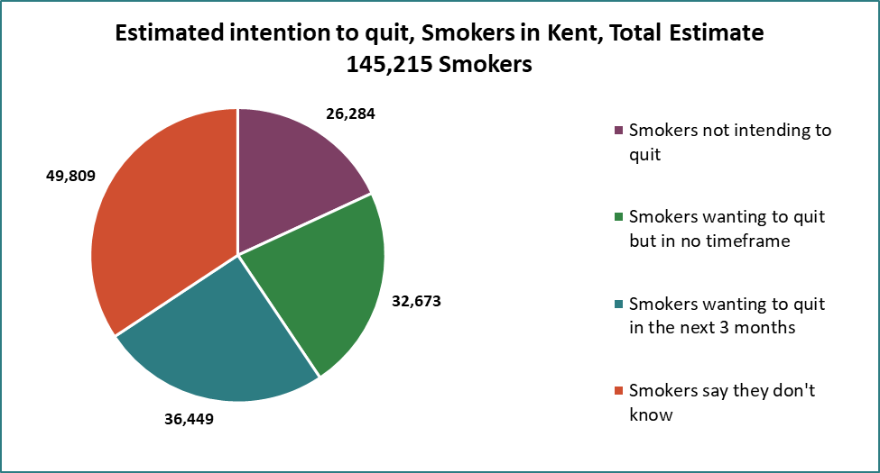

## **Sexual Orientation**

Smoking prevalence is higher among lesbian, gay, and bisexual people than in the general population[69], although data sources are limited. The Office of National Statistics 2018 gives the latest comparison:

Table 10. Adult smoking habits in the UK: 2018, ONS

|  |  |
| --- | --- |
| **Sexual orientation** | **Smoking prevalence** |
| Heterosexual (straight) | 15.9% |
| Other | 17.3% |
| Gay/Lesbian | 23.1% |
| Bisexual | 23.3% |

*Source: Action on Smoking and Health, LGBT Evidence into Practice briefing*

NICE guidance emphasises the need for vulnerable groups, including LGBTQ+ smokers to be targeted and prioritised in smoking cessation services, although currently, data on gender is not routinely recorded.

Although the reason for higher smoking prevalence among the LGBT community is not known, managing stress associated with transphobia, prejudices and attitudes of some non-LGBT people is one possible theory[70]. Other factors associated with higher smoking prevalence are being single, homeless and being part of other groups with higher smoking rates.

The LGBT Foundation suggest that visibility of LGBT people (as a high smoking prevalence group) should be included in campaign communications and offering drop-in stop smoking sessions in voluntary sector premises.

## **Smoking and Homelessness**

Data on smoking prevalence among homeless people is not routinely collected in the UK but it is estimated that 77% of people experiencing homelessness smoke (2014 figures[71]) which increases risks of lung cancer and a three times higher chance of dying from chronic lower respiratory disease caused by smoking[72].

Riskier smoking behaviours, such as sharing cigarettes with other people or using discarded cigarette butts and poor mental health issues are disproportionately high among people experiencing homelessness.

The Groundswell Report[73] estimates that more than 50% of homeless people want to quit smoking and recommends that local authorities, public health teams and homelessness support should collaborate to ensure stop smoking support is provided to people experiencing homelessness. Very often, there are factors that pose challenges in homeless shelters:

* Support staff may not be equipped or trained to deliver behavioural support or may not prioritise the value of quitting.
* Homeless people may only access shelters for a short and erratic periods
* Sustained access to pharmacotherapies and/or vapes.

A randomised clinical trial in two homeless shelters in the Upper Midwest in 2017[74] provided insights into increased pressure to smoke in and around shelters, leading some people to start or resume smoking and making it very challenging to quit. Despite this, there were clear levels of interest from homeless people who smoke to want to quit. Shelter staff will need to be motivated and willing to support smokers to quit to achieve success and short-term abstinence and harm reduction programmes should also be considered.

The National Institute for Health and Care Research are conducting a national trial of smoking cessation in homeless shelters (SCetch) across the UK. The trial has delivered stop smoking support to 379 homeless people and trained 179 staff across 31 homeless shelters. Although not yet concluded, there could be significant learning from potential outcomes, including measuring quit outcomes, maintaining access to quit resources (e.g., NRT and vapes) and sustaining quit attempts. There may also be opportunities to expand the programme to homeless shelters in Kent although none have accepted the offer of participating in the national trial.

## **Smoking in Prisons**

In 2015, the Office of Health Inequalities and Disparities (OHID), formerly Public Health England, reported that smoking rates were four times higher in prisons than the general population[75]. This is corroborated in a 2014 survey of prisons in Kent, Surrey, and Sussex where the smoking population varied from 62%-81%[76]1 when the smoking prevalence in the general population was 18.6[77]%.

Smoking prevalence is elevated among prisoners due to compounding factors such as poor mental health, substance misuse and disadvantaged backgrounds. Smoking rates are generally highest among 25–29-year-olds[78]2 and this age group dominates the offender population. However, rather than smoking prevalence reducing with age, rates are sustained life-long among offenders and therefore remains high across all offending age groups. It has been reported that limited access to and cost of tobacco can inhibit smoking in prisons, but boredom, stress, socialising, and tobacco used as currency could all influence smoking behaviour. There were also concerns that the relationship between illicit tobacco and criminal activity could act as a route to re-offending, but more research is needed to substantiate this.

From 1 May 2018, prisons became smokefree and no prisoners, staff or visitors are allowed to smoke on prison sites, with the exception of open prisons where smoking is allowed at designated times and places. Since this legislation, dedicated vaping areas are permissible and NHS England commissioned stop smoking services should be offered to all prisoners who smoke. Minimum standards and service specifications have been agreed by HM Prison and Probation Service, OHID and NHS England[79], but smoking status in prisons, quit data and service outcomes are not routinely reported in a publicly accessible format. Some local authority stop smoking services have also been commissioned to deliver support in prisons, mainly in the London areas, but the numbers are small (124 quitters nationally in 2021/22[80]). Despite and maybe because of this, the quit success rate is high (88%).

Further work in Kent prisons is needed to determine the smoking prevalence of prisoners when entering prisons and to explore Smokefree legislation compliance and ensure that prisoners are achieving successful quitting outcomes from NHS Commissioned services. There is potential to work collaboratively to increase quit rates among the prison population and extend smokefree support across the whole prison care pathway.

## **Smoking and Substance Misuse**

Some drug use, particularly cannabis, is administered by smoking. 7.4% of 16–59-year-olds in the UK report to be cannabis users[81]. The Global Drugs Survey (2014) suggests that 65.6% of cannabis users world-wide use tobacco as the route of administration (ROA) although the rates are much higher in Europe (77.2%-90.9%)[82]. Cannabis and tobacco use is much lower in the Americas (4.4%-16%) where vaporizers are more common in an attempt to reduce tobacco intake.

Smoking status is often under-reported by drug users. Action on Smoking and Health’s media report on the Kings College London study shows that 5% of cannabis users who smoke as their ROA identified themselves as non-smokers. Many of these were unaware that they were developing tobacco addiction as a consequence of their drug use[83].

Smoking prevalence is likely to be higher among drug users in accordance with risk taking behaviours. The UK government estimates that nearly 100% of opioid dependent users also smoke and suggests that drug users are more likely to die from smoking-related illnesses than drug use[84]. Adverse Childhood Experiences (ACEs) also increase the risk of smoking, drug, and alcohol addiction later in life. Compared with people with none, adults with 4 or more ACEs are[85]:

4 times more likely to be a high-risk drinker.

6 times more likely to have had or caused unintended teenage pregnancy.

6 times more likely to smoke e-cigarettes or tobacco.

6 times more likely to have had sex under the age of 16 years.

11 times more likely to have smoked cannabis.

Smoking status is not systematically recorded for clients accessing drug and alcohol dependency services; however, smoking prevalence is shown to be higher among adults admitted into substance misuse treatment services using the National Drug Treatment Monitoring System (NDTMS). Smoking status among non-opiate users is considered to be particularly high, with two thirds of those admitted, identified as smokers.

Table 11. Smoking Prevalence in Adults (19+) admitted to treatment for substance misuse (NDTMS)

|  |  |  |  |  |
| --- | --- | --- | --- | --- |
| **Smoking Prevalence in Adults admitted to treatment for substance misuse.** | **Period** | **Kent %** | **Kent count** | **England %** |
| Alcohol and non-opiates | 2019/20 | 67.60% | 217 | 64.60% |
| non-opiates | 2019/20 | 67.20% | 154 | 62% |
| opiates | 2019/20 | 48.90% | 483 | 43.90% |

*Source: The National Drug Treatment Monitoring System (NDTMS), Public Health England 2020*

Intervention strategies to treat drug dependency should identify smoking status and offer effective harm reduction or cessation support to all clients who smoke either as part of or alongside their drug treatment. All smokers should be encouraged and motivated to quit. It may be worth exploring whether clients engaged in treatment services would benefit from quit smoking support from the drug dependency services or from locally commissioned stop smoking services.

## **Smoking Prevalence in Targeted Groups**

Summary

Despite smoking rates decreasing, prevalence is still stubbornly high among the more vulnerable groups in society, who will need more quit attempts and have less chance of successfully quitting. These vulnerable groups are identified among young people, those with mental health issues, some ethnic minority groups, the LGBTQ+ community, women who smoke in pregnancy, those in prisons and the criminal justice system and people who are at risk of substance misuse. Agencies and advocates who work in communities with high smoking rates have a role in motivating smokers to quit by offering Very Brief Advice through Making Every Contact Count.

Stop Smoking behavioural support alongside nicotine replacement therapy or vapes still offer smokers the best chance of quitting but numbers of those choosing to quit via these services is declining. Services must be commensurate to the diverse needs of the community and should be culturally and linguistically aware of these needs in service delivery and information materials. Commissioners should consider how services could support nicotine dependency aside from smoked tobacco (e.g., Smokeless tobacco, heat not-burn products and vaping).

Recommendations

1. Increase motivation for smokers to quit through targeted campaigns and collaborative working with organisations that serve and support groups where there is high smoking prevalence.
2. Local Stop Smoking Services should be commissioned to deliver quit support to all targeted groups, with clear measurable outcomes. Funding support may be needed to secure additional resources for service providers to meet the level of commitment needed to achieve agreed outcomes.
3. Develop a multi-agency Tobacco Control Alliance to deliver a partnership approach to reducing smoking prevalence in high smoking prevalence groups using priorities identified through applied CLeaR assessments.
4. Public Health Commissioners to ensure stop smoking services effectively target quit support to those on the following table:

**Smoking Prevalence in Targeted Groups**

Recommendations (Continued)

**\*Note, these rates are from different data sources and are therefore not comparable**

|  |  |  |
| --- | --- | --- |
| Target Group | Objective | Other Recommended key partners |
| Routine and Manual Workers | Motivation to quit.  Access to quit support.  Debt management | Local Businesses  Community Centres  Healthy Living Centres  Childrens Centres |
| Long Term Sick and Unemployed | Motivation to quit.  Access to quit support.  Improved health | Social Services  Organisations offering benefit and debt management advice. |
| Social Housing Tenants | Motivation to quit.  Access to quit support.  Reduce 2nd hand smoke exposure | Kent Housing Group  Social Housing Associations  District Councils |
| Pregnant Women Who Smoke | Motivation to quit.  Access to quit support.  Improved health outcomes at birth | Local Maternity Services (progress *current working on NHS Long Term Plan objectives*) |
| Those accessing Illicit Tobacco | Raise public awareness.  Disrupt supply.  Reduce demand | Trading Standards |
| Young People (smoking) | Reduce take up.  Motivate to quit.  Access to quit support | Schools  Education services  Youth services |
| Young People (vaping) | Factual information  Treat Nicotine dependency | Schools, Youth services, education |
| Young People (under-age smoking and vaping) | Raise awareness (law)  Scope issue in Kent  Improve retail practice | Trading Standards  Schools  Youth Service |
| Mental Health | Motivation to quit.  Access to Quit support.  Develop bespoke services | KMPT  Live Well Kent & Medway |
| LGBTQ | Motivation to quit.  Access to quit support | LGBTQ Groups |
| Homelessness | Increase opportunities for homeless people who access homeless shelters to quit | Local Authorities  Public Health  Stop smoking services.  Shelter Centres |

|  |  |  |
| --- | --- | --- |
| Target Group | Objective | Other Recommended key partners |
| Prisoners and Offenders | Work with partners to potentially improve smoking quit rate in prisons and offender pathways. | NHS England  Prison Health Trainers  Stop Smoking Service |
| Smokers in Substance Misuse Treatment Services | Identify smoking status of clients in treatment services, explore methods of offering harm reduction and quitting. | D&A Service Providers  Stop Smoking Services |
| Black and Ethnic Minority Groups, Roma, Gypsy & Travellers | Ensure public messages on tobacco control are not solely on smoking but have a multi-agency approach to the supply, demand, and use of all types of tobacco and are delivered in a culturally appropriate way. | Public Health, communications,  stop smoking services, Trading Standards, NHS |
| Use local data to determine commonly spoken languages in the area and ensure tobacco control messages and service delivery are accessible. | Public Health, communications,  stop smoking services, Trading Standards, NHS |
| Provide campaign materials, signage, leaflets, and web-based information in a range of languages | Public Health, communications,  stop smoking services, Trading Standards, NHS |
| Raise awareness of barriers to some therapies for certain religious groups (e.g., Consider alternatives to NRT patches which contain alcohol for religions which prohibit alcohol) | Public Health, communications,  stop smoking services, Trading Standards, NHS |

# Smoking Related Morbidity and Mortality

## **Morbidity**

The Royal College of Physicians identify 16 cancers and 18 non-malignant health consequences causally linked to smoking:

Table 12. Smoking Related Diseases

|  |  |
| --- | --- |
| **Cancers** | **Non-malignant conditions** |
| Lung | Chronic Obstructive Pulmonary Disease |
| Oropharynx | Pneumonia |
| Larynx | Tuberculosis |
| Oesophagus | Asthma |
| Trachea | Coronary heart disease |
| Bronchus | Stroke |
| Acute Myeloid leukaemia | Aortic aneurysm |
| Stomach | Peripheral vascular disease |
| Liver | Diabetes |
| Pancreas | Congenital orofacial cleft |
| Kidney | Rheumatoid arthritis |
| Ureter | Hip fracture |
| Cervix | Cataract |
| Bladder | Age related macular degeneration |
| Colon | Periodontitis |
| Rectum | Ectopic pregnancy |
|  | Male erectile dysfunction |
|  | Reduced fertility in women |

*Source: US Surgeon General Report 2014[86]*

Smoking related conditions account for 5.5% of the NHS budget[87], place a high demand on NHS resources and an additional burden on social care services as people live longer but in poorer health. There were 10,139 smoking related admissions across hospitals in Kent in 2019/20. Smoking related illnesses create a financial burden in society and puts additional strain on the national health system, costing the Kent health economy £51.9m and additional social care costs of £31.5m each year[88]. It is estimated that over 41,000 Kent residents who have smoking related illnesses are being cared for informally by friends and family or have unmet care needs, which, if replaced with formal paid care would cost the system an additional £367m.[89] This could affect immediate savings (both individual and societal) if there were fewer smokers and provide immediate health benefits.

Chronic Obstructive Pulmonary Disease (COPD) is a debilitating respiratory condition with a strong association with smoking. Smokers have a 4.01 risk of developing COPD[90], either directly or through exposure to smoking and generate 3,380 emergency admissions in Kent hospitals each year (2019/20 figures[91]).

Smoking contributes to the largest proportion of cancers, accounting for 15% of all cases. Lung, tracheal and bronchus cancer are rated the main burden of disease for cancer in Kent and Medway,[92] with the highest cancer incidences occurring in Thanet and Swale. In 2017-19, there were 3,420 lung cancer registrations and 5-year survival rates in Kent and Medway were 12%, 5% lower than the England average in 2014-18.

85% of all lung cancers[93] are caused by smoking and smokers have an 11-fold risk of developing lung cancer compared to non-smokers. The risk increases in relation to duration and intensity of smoking. 90% of lung cancers are considered preventable[94]47. Studies show that the risk reduces quickly after quitting smoking, proportionate to the length of time quit. The risk of other cancers, such as head and neck cancer, may also have a strong association with smoking and the intensity of smoking, but the risk is not significantly reduced after quitting. Studies show that risk of head and neck cancer among former smokers are only slightly lower than among current smokers (relative risk 1.73 and 2.89 respectively)[95].

Chart 15. Smoking related morbidity by condition 2017/19

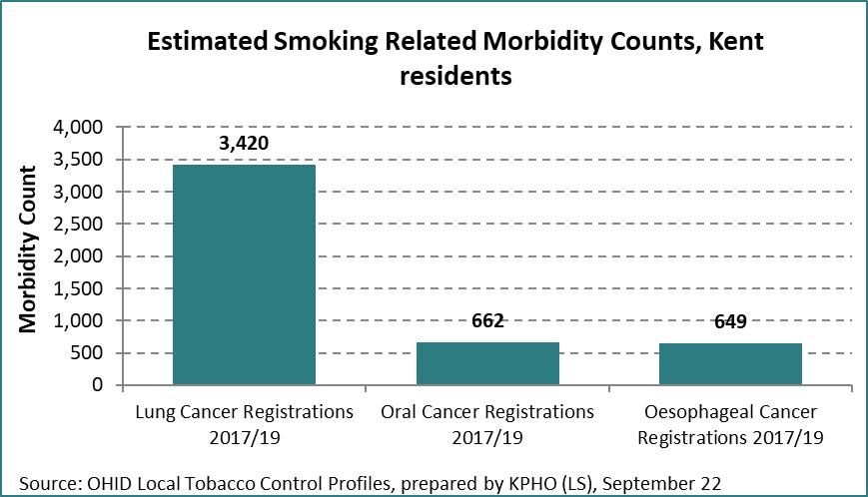

Chart 16. Smoking related morbidity by condition 2019/20

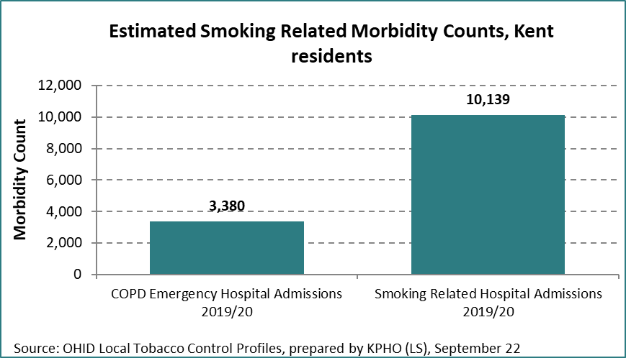

As smoking prevalence is higher in lower socio-economic classes, lung cancer incidents are also consistently higher among these groups, as diagnosis, survival and mortality rates in Kent all perform below the England average. In 2020, 35% of lung cancers were diagnosed as an emergency in Kent and Medway (up from 32.1% in 2018), meaning patients are likely to have poorer clinical outcomes resulting in a greater risk of mortality within the next 12 months than non-emergency presentation diagnoses. Overall, there were fewer early diagnoses of lung cancer in Kent and Medway than the England average, with later diagnoses also reducing chances of survival rates. Fewer than 25% of lung cancers were diagnosed early among all age groups under the age of 80 in Kent, with only 10.9% early diagnosis among the 0-49 age group and 15.3% among the 50–59-year age group. Rates are particularly low among Asian groups (11.1%) and mixed other and where ethnicity is unknown. Only 20% of early lung cancer diagnosis were made in the most deprived groups and emergency admissions for lung cancer were higher than the average for all cancers, particularly from older age groups (aged 80+).

## **Mortality**

5,960 smoking related deaths were recorded in Kent in 2017-19, comparing slightly worse than the England average. There were 28,798 potential years of life lost due to smoking related illness between 2016-18[96] calculating sickness and premature death due to smoking. In England, 15% of all adult deaths aged 35+ were caused by smoking in 2019; most of these deaths are from either lung cancer, COPD, or coronary heart disease[97].

Chart 17. Smoking attributable mortality

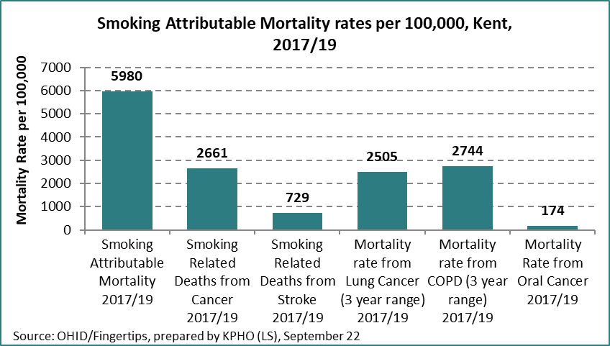

## **Lung Cancer**

Recent analysis of lung cancer rates conducted by Kent and Medway Cancer Alliance (K&MCA) identified:

* late presentation of symptoms, particularly at emergency presentation stage
* fewer treatment rates for stage III non-small-cell lung cancer and stage I–III small-cell lung cancer.
* In 2020, 51% of patients received curative intent treatment (a reduction from 57% in 2019)
* 24% of patients received no active treatment at all.

The National Optimal Lung Cancer Pathway aimed to improve patient outcomes sets an ambition of 49 days from presentation to treatment and is not currently being met by any Alliance. Furthermore, data recording patient smoking status is inadequate and data completeness has reduced from 61% in 2019 to 51% in 2020. It is anticipated that the NHS Long Term Plan will systemise smoking status data which can provide opportunities for health professionals to maximise every opportunity to encourage smokers to quit. NICE Guidance QS17 recommends:

“*People with suspected or confirmed lung cancer who smoke should be encouraged to stop smoking services to reduce the risk of treatment related complications and other smoking related conditions and increase their life expectancy.”*

The Alliance recommends improving access to services and reducing emergency presentations by prioritising:

1. Increased awareness of signs and symptoms, particularly for people aged 75+ and ethnic minorities, who are likely to present as an emergency.
2. Improve GP awareness of symptoms.
3. Establish pathways for vague symptoms so possible cancers can be investigated earlier.

There are also opportunities for smokers to be encouraged to quit at each stage of the cancer pathway (diagram 3) designed to identify key factors and drivers in the lung cancer patient pathway.

Diagram 3. Diagnosis of cancer as an emergency pathway

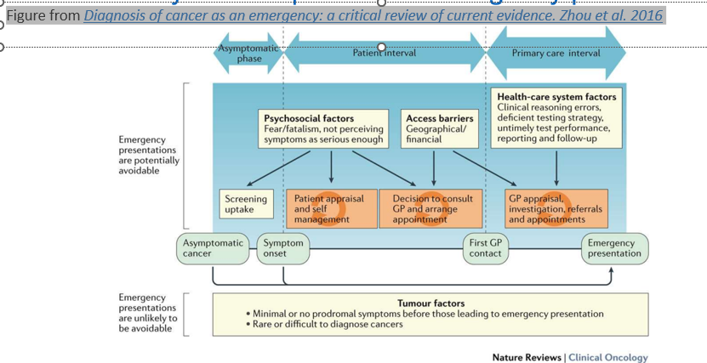

## 

## **Smoking Related Morbidity and Mortality Summary**

Smoking related illnesses are the main cause of death in the UK and a major factor of health inequalities with mortality rates 3 times higher in the most deprived areas. Smoking is a major risk factor for lung cancer, COPD, heart disease and stroke and the cost of treatment places a burden on local healthcare services (£51.9m pa) and social care systems (£31.5m pa).

In Kent, further partnership working is needed to improve early diagnosis of lung cancer, which will in turn improve survival and reduce mortality rates. Routine recording of smoking status is also poor and needs to be addressed in primary care and secondary care (although the NHS Long Term Plan Tobacco Dependency Service will encourage this). There are opportunities within the health systems to identify smokers and offer Very Brief Advice (VBA) and referral into stop smoking services to reduce the risk of advancing smoking related diseases.

**Smoking Related Morbidity and Mortality Recommendations**

|  |  |  |  |
| --- | --- | --- | --- |
| Recommendation | Aim | Objective | PH Commissioners, Stop Smoking Service, and other key partners: |
| Improved data records on smoking status | Reduce risk of smoking illnesses | Smokers identified.  VBA offered.  Referral to Quit Service | Primary Care  Secondary Care (LTP)  Overseen by ICS?  K&MCA |
| Targeted Campaigns to raise awareness of lung cancer and COPD symptoms | Increase early diagnosis rates | Early presentation of symptoms  GP texts to patients who smoke | K&MCA  Communications  Primary Care  ICS |
| Lung Health Screening Programmes | Increase early diagnosis rates.  Encourage quit smoking. | Early presentation of symptoms  VBA offered.  Referral to Quit Service | Lung Health Programme  K&MCA |
| Continue to work with Cancer networks to embed quitting smoking in the cancer prevention pathway. | Reduce cancer rates | Smoking status identified.  Smokers referred to Quit Service | Public Health |
| Work closely with stroke, CVD, and hypertension networks to embed quitting smoking in the prevention pathways. | Reduce rates of stroke, CVD, and hypertension | Smoking status identified.  Smokers referred to Quit Service | Public Health |

# Local Stop Smoking Services

NHS Stop Smoking Services

In Kent, community stop smoking services are commissioned by Kent County Council. The service provider, Kent Community Health NHS Foundation Trust (KCHFT) is an NHS provider delivering a range of population health services including the One You stop smoking programme. The contract operates under a partnership agreement across the whole of Kent local authority area, giving flexibility to both partners to deliver against the changing population needs and demands. The Care Quality Commission (CQC) has rated the organisation as ‘Outstanding.’ The stop smoking service is delivered as an individual service rather than an integrated lifestyle service, ensuring that staff are specialised in the delivery of stop smoking support. Making Every Contact Count (MECC) opportunities ensure that all identified smokers who access other lifestyle services are encouraged to quit and refer into stop smoking services. Quit programmes are offered to smokers as part of a group session or individual drop-in support at a range of local community venues; or one to one sessions either face to face, telephone or by virtual video support. Although statistically more successful, group support is less popular in Kent and face to face appointments have declined in favour of telephone support since the COVID-19 pandemic. The stop smoking service comprises two individual teams; a self-referral core service available to the public who are ready to quit smoking and a dedicated smoking in pregnancy service offered at home to all pregnant smokers (and their partners) referred into the service on an opt-out basis by their midwife. Quit success rates are lower than the core service (42% v 57%) as many of the women referred may not be psychologically ready to quit. Typically (and in line with NCSCT standards), quit programmes comprise 7 weeks of behavioural support, in which time a planned ‘Quit Date’ is set followed by four weeks of complete abstinence from smoking. Nicotine Replacement Therapy (NRT) and pharmacotherapy can be supplied throughout for a 12-week period and is funded by the commissioning authority.

Intentions to Quit Smoking

The Office of National Statistics report that, on average, 47.8% of current smokers intend to quit smoking, with 25.1% of these intending to quit within the next three months[98]. Of the estimated 145,215 smokers in Kent, it can be assumed that 69,122 intend to quit smoking at some point and 36,449 are more ready and prepared to quit in the near future. Most smokers who try to quit will need to make several attempts before succeeding[99] and the majority will try to quit without any support at all. The End of Smoking Pathway projects only 5% of attempts will be successful and of these, only 2% of all smokers who quit have done so with the support of local stop smoking services[100].

Table 13. How Quitters try to quit

|  |  |
| --- | --- |
| **Of the 5% of smokers who Successfully Quit:** |  |
| Stop Smoking Service, advice & medication | 10% |
| NRT purchased at pharmacy | 14% |
| Without any assistance | 35% |
| Use an E-cigarette | 41% |
| Total | 100% |

*Source: ASH, End of Smoking Pathway*

In Kent, the locally commissioned providers, KCHFT sub-contract GPs and pharmacies to deliver stop smoking services in the community which enables them to oversee service training, quality, and performance. Using the national End of Smoking pathway projections, it could be assumed that the 2,883 reported quitters in 2021/22 represent 10% of Kent’s smoking quitters (2% from stop smoking services and 8% from professional advice and NRT) giving a total estimate of 28,830 quitters in the year. There are no data sets available to validate other quit methods used outside of the commissioned stop smoking services but the estimates on the chart below go some way to indicating the market for intention and attempts to quit.

Chart 18. How smokers quit

A pie chart showing how many smokers who quit used:
e-cigarettes (11820), no assistance (10091), NRT purchased at pharmacy (4036), stop smoking service, advice and medication (2883). 

Smokers are four times more likely to quit with the support of commissioned stop smoking services, making them cost effective. The average cost per quitter in Kent is £730, slightly higher than the Kent average in 2019/20 (£635 per quitter) and higher than the England average (£484 per quitter in 2019/20[101]).

Demand and Delivery

There have been fluctuations in the number of people setting quit dates with the highest rate in 2019/20 (6,510) before declining sharply the following year (4,089). This may be attributable to people’s lifestyle behaviour changes during the COVID-19 pandemic where some smokers felt prompted to quit and others smoked more to cope with anxiety. Other contributing factors were the combination of lower numbers of referrals and the discontinuation of third-party providers (GPs and pharmacies), delivering stop smoking support with immediate effect to prioritise pandemic treatment services. Prior to the pandemic, GP surgeries, pharmacies, and the core service each delivered a third of community stop smoking support with higher 4 week quit success rates from the core services. In 2020, the core service delivered 81.3% of all set quit dates and 81% of all quits as GP surgeries and pharmacies were unable to deliver stop smoking services. Although numbers of set quit dates and quits have started to increase among GPs and pharmacies, these are not at pre-COVID-19 pandemic levels. In 2021/22, core services delivered 77% of all quits. GP surgeries and pharmacies delivered 8% and 17% respectively.

Table 14. Local Stop Smoking Services by core (community), GP and pharmacy service, Set Quit Date (SQD), Quits and Success Rates

|  |  |  |  |  |  |  |  |  |  |  |  |  |
| --- | --- | --- | --- | --- | --- | --- | --- | --- | --- | --- | --- | --- |
| Kent | Core | | | GP | | | Pharmacy | | | Total | | |
|  | SQD | Quit | % success | SQD | Quit | % success | SQD | Quit | % success | SQD | Quit | % success |
| 2017/18 | 2037 | 1358 | 66.7% | 1933 | 889 | 46.0% | 2228 | 942 | 42.3% | 6198 | 3189 | 51.5% |
| 2018/19 | 2386 | 1436 | 60.2% | 1475 | 758 | 51.4% | 1941 | 1022 | 52.7% | 5802 | 3216 | 55.4% |
| 2019/20 | 2740 | 1670 | 60.9% | 1639 | 908 | 55.4% | 2131 | 1320 | 61.9% | 6510 | 3898 | 59.9% |
| 2020/21 | 3323 | 2079 | 62.6% | 291 | 186 | 63.9% | 475 | 301 | 63.4% | 4089 | 2566 | 62.8% |
| 2021/22 | 3838 | 2224 | 57.9% | 397 | 207 | 52.1% | 835 | 452 | 54.1% | 5070 | 2883 | 56.9% |

*Source: NHS Digital, Stop Smoking Support*

As a result, KCHFT One You stop smoking services increased staffing resources to cope with the demand of being the sole service provider. Although set quit dates have risen in the last year (5,070 in 2022), numbers fall short of pre-pandemic rates and third-party providers are still unable to commit to previous levels of offering stop smoking support.

Table 15. Local Stop Smoking Services Supporting Smokers to Quit

|  |  |  |  |
| --- | --- | --- | --- |
|  | **Set Quit Dates** | **4-week Quits** | **% Success Rate** |
| 2017/18 | 6,198 | 3,189 | 51.5% |
| 2018/19 | 5,802 | 3,216 | 55.4% |
| 2019/20 | 6,510 | 3,818 | 58.6% |
| 2020/21 | 4,089 | 2,566 | 62.8% |
| 2021/22 | 5,070 | 2,883 | 56.9% |

*Source: NHS Digital*

Numbers successfully quitting had increased each year up until the pandemic in 2020/21 when, in line with referral and set quit date rates, the figures declined significantly. They have started to increase again in 2021/22 but not to pre-pandemic levels.

Chart 19. Stop Smoking Services 4 week quits.

Who is Using Stop Smoking Services

In 2021/22, 94% of smokers who set a quit date with the stop smoking services were of White ethnicity. 1.3% were from mixed ethnic groups and 1% were Asian/Asian.

Table 16. Local Stop Smoking Services Quitting by ethnicity.

|  |  |  |
| --- | --- | --- |
| **Ethnicity of Stop Smoking Service Users 2021/22** | **SQD %** | **Quit %** |
| White | 94% | 94% |
| Mixed | 1% | 2% |
| Asian/Asian British | 1% | 1% |
| Black/Black British | 1% | 1% |
| Other | 1% | 1% |
| Not Stated | 2% | 2% |

Quit success rates are higher in Asian/Asian British, Black/Black British, and Mixed groups than in White groups. This may be due to small numbers from minority groups accessing the service.

Chart 20. Stop Smoking Services 4 week quit rates by ethnicity.

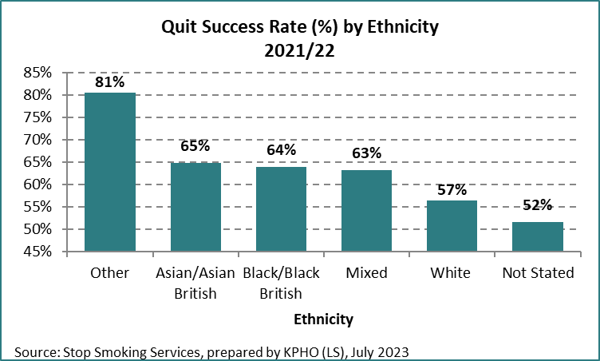

Although there is significantly higher engagement from White groups, the following chart illustrates that quit rates by smokers (by 1,000 population) are representative across ethnic groups and that local stop smoking services are successfully reaching and supporting smokers in the community proportionately.

Chart 21. Local Stop Smoking Services quits per 1,000 smokers.



Accessing Services by Age

The highest smoking prevalence and number of those setting a quit date are from the 18-34 age group although the quit success rate is one of the lowest in this age band (46.1%). Over a quarter of those setting a quit date are aged between 45-59 years old and have the highest quit success rates. The lowest numbers setting a quit date and successfully quitting are under 18-year-olds despite smoking prevalence estimates of 19.4% among 18–24-year-olds[102]. Only 232 of the 10,864 referrals in 2021/22 were aged 14–19-year-old. Further consideration should be given to how young people can be motivated to quit smoking and whether current community stop smoking services are suitable for young people or whether bespoke services are required.

Table 17. Age Bands of Stop Smoking Service Users 2021/22

|  |  |  |
| --- | --- | --- |
| **2021/22** | **Set Quit Date %** | **Quit %** |
| Under 18 | 1% | 1% |
| 18-34 | 35% | 29% |
| 35-44 | 18% | 18% |
| 45-59 | 28% | 32% |
| 60+ | 19% | 22% |

Chart 22. Stop Smoking Services 4 week quit rates by age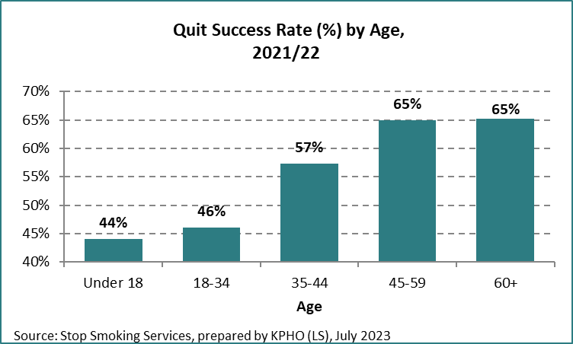

Socio-economic groups

Of those accessing local stop smoking support, more people quit smoking from Routine and Manual groups (20.9%), confirming that services are serving the population with the highest smoking prevalence. 69.3% of all 4-week quitters are from the most disadvantaged and economically inactive groups (Unemployed, Sick/unable to work, unpaid carers, Routine and Manual workers).

Table 18. Local Stop Smoking Services quitting by occupation.

|  |  |  |
| --- | --- | --- |
| **2021/22** | **Set Quit Date** | **Quit** |
| Retired | 11% | 13% |
| Intermediate | 14% | 15% |
| Managerial | 11% | 12% |
| R&M | 21% | 21% |
| Students | 1% | 1% |
| Sick/unable to work | 13% | 13% |
| Unemployed | 18% | 16% |
| Unpaid carers | 8% | 7% |
| Cannot code | 3% | 2% |

Success rates are higher among retired smokers, managerial and intermediate groups (67.1%, 59.9% and 61.6% respectively), reflecting the difficulty of quitting among disadvantaged groups.

Chart 23. Stop Smoking Services 4 week quit rates by socio-economic group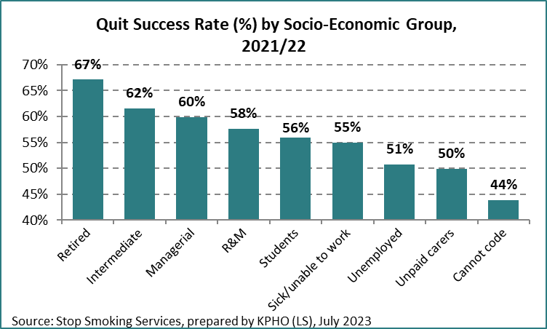

Medication

The most effective medication to help smokers quit is varenicline (commercially known as Champix) with a 79% quit success rate in Kent in 2020/21. However, Nitrosamine levels present in the product were considered to be above the acceptable levels of daily intake which may increase the risk of cancer if exposed to them over long periods of time. This led to the national recall of varenicline, and the product was eventually withdrawn from circulation and manufacturing ceased later in 2021. In addition, there were long-term supply issues with the alternative pharmacotherapy, bupropion (Zyban) which have only recently been resolved. Currently, stop smoking services provide dual Nicotine Replacement Therapy (NRT) to 60% of those engaging in smoking cessation programmes and single NRT to 13.5% of clients. NRT is available in a range of different sources with fast acting and slow-release nicotine combination being most effective. The chart below shows the efficacy of Varenicline and NRT in quit attempts with longer-term cut down to quit programmes being most effective. This may be partially due to longer term behavioural and medicinal support for those who may find quitting abruptly more daunting.

Diagram 4. Effectiveness of smoking medication

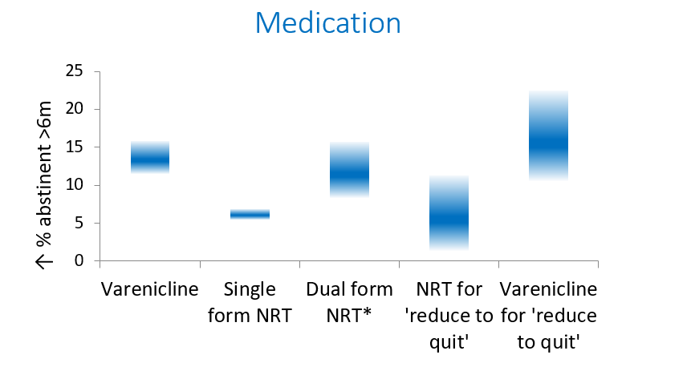

*Data from RCTs; Cochrane reviews (NRT 2013; Varenicline 2016); Wu 2015 doi:10.3390/ijerph120910235; *Estimated by combining effect sizes; All comparisons are active medication versus placebo in context of behavioural support.*

## **E-cigarettes**

E-cigarette use is popular among smokers trying to quit, with more than 3 million[103] people in England vaping. They can be an effective means of quitting smoking and considered to be safer than smoking cigarettes as they do not contain tobacco, tar, or carbon monoxide. However, vaping may not be totally risk free and therefore non-smokers should not be encouraged to vape.

Despite the need for further research, vaping products are the most common aid used by people to help them stop smoking with only 1.8% of users never having smoked[104]. E-cigarettes are regulated as consumer products, most of which contain nicotine and can be purchased as disposable or rechargeable devices, in refillable tank formats or prefilled cartridges. Most people report purchasing devices from specialist vape shops (40%), supermarkets or newsagents. Retailers registered with the IBVTA[105] are monitored to conform to product regulations, age of sale laws and are regarded as an approved retailer.

NICE Guidance (NG209)[106] and the NCSCT[107] recommend that e-cigarettes be used as part of a quit attempt in stop smoking services. Kent’s One You stop smoking service and Totally Wicked vaper retailer piloted e-cigarette use alongside behavioural support early in 2022. The aim was to test the popularity and success rate of e-cigarettes as a quit aid. Further analysis to review outcomes is being conducted among specific priority groups but end of year data returns for 2021/22 show e-cigarettes alone had a 73% quit success rate and dual use of NRT and e-cigarettes a quit success rate of 77%.

Table 19. Effectiveness of smoking pharmacotherapy in stop smoking services in Kent

|  |  |
| --- | --- |
| **NHS Digital 2021/22** | **Quit Success rate** |
| One NRT Product | 63% |
| Two NRT products | 53% |
| Bupropion (Zyban) | 66% |
| Varenicline (Champix) | 70% |
| Product + e-cig together | 77% |
| Switch product + e-cig | 73% |
| E-cig only | 73% |
| No product | 53% |
| Overall success rate | 57% |
|  |  |

### **E-cigarette Summary and Recommendations**

As research develops, more information and guidance are available on the recommended use of e-cigarettes or vapes. More considerations are being given to vaping as an effective quit aid as varenicline and bupropion have recently been withdrawn from the list of pharmacotherapies available. E-cigarettes are offered by local stop smoking services as an aid to quit but are also widely available on the internet and from retailers who can give advice on how to use the products effectively for quitting. Kent Public Health will provide clear guidance to health professionals and the public on the use of e-cigarettes and vaping as a quit or harm reduction technique and the potential risk of continued nicotine addiction.

|  |  |
| --- | --- |
| Recommendation | Lead Partner: |
| Provide clear guidance to the public and health professionals on the use of e-cigarettes and vaping, including the use of e-cigarettes as an approach to harm reduction. | Public Health |
| Raise the potential risk of continued nicotine addiction | Public Health |

# Future Stop Smoking Services

The COVID-19 pandemic has disrupted trends of referrals into stop smoking services, numbers who set a quit date and who go on to successfully quit. Although the trend is showing an increase post-pandemic, rates are still lower than previous levels and it is uncertain whether GPs and pharmacies will have the capacity to deliver stop smoking support in the near future.

The NHS Long Term Plan provides NHS funding to deliver new-in house and opt-out stop smoking services for pregnant women which will impact significantly on demand for community stop smoking services. Previously, 2,500 pregnant smokers were referred into community stop smoking services each year which offered home-visit stop smoking support. As this cohort will now be in receipt of in-house maternity stop smoking services, Maternity Trusts will need to ensure that their new delivery model will improve on current quit outcomes and community services will need to divert their existing resources to other areas of need. Once the inpatient model is implemented, patients who are smokers and discharged from hospital will be referred into local stop smoking services or pharmacies that are engaged in the Advanced Pharmacy Contract. Gauging demand for local stop smoking services is difficult; implementation is likely to be gradual and patient choice will impact on service delivery. Discharged patients may not be mobile and have communication difficulties creating further potential challenges to service delivery and quit rates may be affected as those referred into services may not be willing or ready to quit abruptly. All quits achieved through the NHS Tobacco Dependency Programmes will be recorded and submitted by the respective Trust. Local Authority commissioners may also wish to acknowledge and record this data although it cannot be submitted formally or double-counted. KCC commissioned Stop Smoking Services will need to be adaptable but at present, there is too much uncertainty to understand how the Long-Term Plan will impact on sustainable future services.

The view of smokers also needs to be considered in shaping stop smoking provision for the future. Earlier in the year, Bluegrass were commissioned to engage with smokers in a series of focus groups[108]. In interviews with smokers from disadvantaged backgrounds, many smokers said they had smoked since being a teenager and although most wished they had never started smoking, there was a notable lack of motivation or inclination to quit. Of those who considered quitting, the majority would not consider asking for support and some actively rejected the idea of asking for help, feeling it would create extra pressure, remind them of something they want to ignore, or feel awkward engaging with a stranger. Some in the group were disinterested in support services and others were not aware of them.

## **Local Authority Commissioned Services Summary and Recommendations**

The quality and reach of local stop smoking services in Kent is good with good representation of service users across most age bands, socio-economic groups, and ethnicity. Numbers accessing and quitting through stop smoking services are lower than pre-pandemic rates although quit success rates remain high, and services are delivered flexibly to meet client needs and preferences. As smokers are more likely to quit with stop smoking support, new ways of motivating smokers to quit and increasing access into stop smoking services is vital. There are still 145,000 smokers in Kent so new ways of reaching high smoking prevalence groups (such as people with mental health conditions and LGBT groups) need to be explored. The local stop smoking services face initial challenges as new NHS tobacco dependency services are implemented with supply and demand currently an unknown quantity.

**Public Health Commissioners are recommended to:**

|  |  |  |
| --- | --- | --- |
|  | Recommendation | Actions |
| 1. | Arrange a partnership meeting to review KPIs and commissioning arrangements in response to the NHS Long Term Plan Tobacco Dependency Services (Core and pregnancy) | Review Quit Targets  Review Success rate target  Allowances for access to services |
| 2. | Consider Harm Reduction/Cut Down to Quit Services, especially for high smoking prevalence groups. (i.e. 12 week quit programme or longer) | Identified by smokers in Bluegrass Focus Groups and mental health service providers |
| 3. | Identify needs of young people who smoke, understand motivators and appropriate quit services that may need to be commissioned | Set up focus groups with young people and young people services |
| 4. | Explore the long-term use of vaping and nicotine addiction and consider whether future services may be necessary. | Test need and cost of nicotine addiction treatment services |
| 5. | Ensure commissioned services target smokers in high smoking prevalence groups to help tackle inequalities caused by smoking. | Set up partnership groups to identify how to effectively target smokers and support them to quit |
| 6. | Commissioners to consider opportunities to identify smokers who access other commissioned lifestyle services and offer Smoking Very Brief Advice as part of delivered services through Making Every Contact Count (MECC) | List services delivering MECC.  Identify services that can benefit from identifying and referring smokers to stop smoking support. |
| 7. | Commissioners and stop smoking service providers to review how services are to be effectively delivered in the future, considering the capacity, priorities, and efficacy of third-party providers with client access contributing to overall decision making | Working group between commissioners and providers to determine third party provision of stop smoking support.  Engaging the views of smokers to gauge access and choice. |

# Stop Smoking Campaigns

Fewer smokers are attempting to quit smoking and only 5% will successfully quit. In 2010, 36% of smokers attempted to quit compared to 29% in 2019[109]. Motivation and willpower are vital requirements to succeed and yet the national marketing budget to deliver stop smoking campaigns have reduced from £23m to £2m in the last 10 years[110]. Kent Public Health supports the two main Stop Smoking campaign events each year, Stoptober (in October) and No Smoking Day (in March). The campaigns are delivered in partnership with providers and local NHS communication teams, signposting smokers to locally commissioned support services and other resources such as the NHS Quit Plan app. Audiences are targeted in key geographical areas of high smoking prevalence through a variety of channels. In 2022, Stoptober was promoted through:

* Facebook advertising
* Spotify – 125,000 adverts
* Kent Online – 436,000 impressions
* Smooth and Heart FM adverts
* Geo-targeted mobile adverts – 5.2million impressions

Key messages focus on the physical and mental health harms of smoking plus the financial impact and the benefits of quitting.

The campaign generated 3226 page views of KCC smokefree website: ([www.kent.gov.uk/smokefree](http://www.kent.gov.uk/smokefree)) during this period - the most visited of the One You Kent pages during October.

## **Summary of Smokefree Campaigns**

The Khan review (Making Smoking Obsolete) recognises the need for further investment in well-designed mass media campaigns to motivate smokers to quit and dispel myths about vaping. The £15m per year investment should include re-introducing television adverts alongside targeted social media. The recommended investment is vital to encourage smokers to quit and re-energise motivation for positive behaviour change. It also supports wider national ambitions to deliver NHS tobacco dependency treatment services and the overall aim of increasing the chances of making smoking obsolete.

National and local Stoptober and National No Smoking Day campaigns can also be effective to increase motivation to quit and signpost to local stop smoking services. Campaigns need to be sensitive and appropriate to range of diverse high smoking prevalence groups and information materials need to be available in a range of languages.

**Summary of Smokefree Campaigns (continued)**

Local communities and target groups should be involved in campaigns and campaigns should aim to de-normalise all types of tobacco use in society.

A clear social marketing strategy will be useful to prevent the take up of smoking, particularly among young people and encourage all smokers to quit.

**Recommendations**

|  |  |  |
| --- | --- | --- |
|  |  |  |
| 1. | Continue to promote Stoptober and National No smoking Day campaigns, ensuring they are targeted to high smoking prevalence groups and are available in appropriate languages | Comms,  Public Health |
| 2. | Involve local communities and target groups in campaigns to encourage people to stop using tobacco and de-normalise all types of tobacco use in our society | Comms,  Public Health,  LSSS |
| 3. | Develop a clear marketing strategy to address de-normalisation of tobacco use and vapes particularly by adolescents using proven social marketing techniques and implementing NICE guidance | Comms,  Public Health,  Schools,  Youth Service |

# Overall Conclusion

Although prevalence rates have been declining, 11.6% of adults in Kent smoke, costing society £499.4m each year. Smoking is a major risk factor for 16 different cancers, COPD, heart disease and stroke causing approximately 6,000 deaths in Kent each year. Smoking rates remain stubbornly high among our vulnerable communities such as those who live in areas of deprivation, people with mental health illness, LGBT groups etc. The Government has published a new national tobacco control plan, Stopping the Start[111], to create a smokefree generation. This includes £70million per year for 5 years in additional funding to local authorities, starting 2024/25 to support stop smoking services to help reach the Smokefree 2030 ambition. There is also funding allocated to fund a new national anti-smoking campaign and a proposal to increase the minimum age of sale of tobacco products. The plan is based on the 15 recommendations set out in the Khan review and can be localised for a newly established Tobacco Control Alliance to deliver. In addition, local maternity systems and Acute Trusts will be delivering in-house stop smoking support in response to the NHS Long Term Plan. This should complement locally commissioned stop smoking services, but commissioners will need to be mindful that it will impact upon services resources and performance indicators.

There has been a decline in the number of people using stop smoking services to quit, representing only 6.5% of smokers. Stop smoking services need to be effectively promoted and delivered to high smoking prevalence groups (such as people with a serious mental illness (40% smoking prevalence), Black and Ethnic minority groups, LGBT communities. More information is needed to ensure that messaging and services are culturally appropriate and may require extending the length of quit programmes or introduce harm reduction programmes prior to quitting. There are also opportunities to deliver smokefree activities in workplace and residential settings, particularly social housing, and prisons.

The Tobacco Control Alliance should produce a prevention strategy aimed at young people (noting that most smoking starts in adolescence) and should include vaping. Vapes are considered an effective quit aid for smokers but should not be used by anyone under the age of 18 or by non-smokers. It is yet unclear whether vaping is likely to be a gateway into smoking and clear information and guidance is needed. It is also likely that services will be required to treat nicotine dependency in the future. It is also apparent that there is a need to improve regulations for vape products and their packaging and to address underage sales, all of which makes demands on Trading Standards services.

The recommendations in this document highlight the extensive work that still needs to be addressed if we are to reduce smoking prevalence in our society. The challenges require a more targeted approach to service delivery, meeting the changing needs of our society and ensuring we all have a role in motivating smoking to quit through Making Every Contact Count.

# Summary of Recommendations

Below is a summary of the recommendations listed in this needs assessment. The lead agency identifies the teams responsible for initiating the recommended activity, but it is recognised that each will need to be delivered in partnership with other key agencies.

|  |  |
| --- | --- |
| Smokefree Policies | Lead Agency |
| 1. Set up a Kent Tobacco Control Alliance with CLeaR outcomes prioritising key areas of work | Public Health |
| 1. Review occupational health policies for staff who may be vulnerable to the exposure of second-hand smoke during home visits and capitalise on increasing smokefree initiatives for more public spaces | Public Health |
| 1. Partner organisations to have a clear smokefree policy and promote a range of services to support staff to give up smoking | Public Health |
| Young People, Smoking and Vaping |  |
| 1. Commission an effective stop smoking service for young people | Public Health Commissioning |
| 1. Improve public reporting systems of illicit tobacco, non-compliant vape products and underage sales of tobacco and vape products to contribute to Trading Standards intelligence | Trading Standards |
| 1. Use local data to target tobacco and vape retailers and suppliers of underage sales. Expand the Challenge 25 schemes, raise awareness of the law, scope the issues of underage sales and test underage sales compliance. Improve retail practice by conducting advisory visits to retailers. | Trading Standards |
| 1. Multi-agency approach to reducing the take up of smoking and vaping among young people. New and innovative ways of working required, supported by factual information and an effective campaign | Public Health |
| 1. New age-appropriate nicotine-dependency treatment service to be commissioned to support young people to quit smoking and vaping and reduce the risk of vaping as a gateway to smoking. | Public Health Commissioning |
| 1. All schools to have a clear smokefree and vape-free policy which supports and facilitates healthy choices and encourages smokers to quit. | School Nursing |
| Smoking in Pregnancy |  |
| 1. Explore ways Smoking in Pregnancy advisers can support new groups alongside NHS LTP model (e.g., Deliver to women identified who smoke at the time of delivery). | Local Stop Smoking Services |
| 1. NHS Long Term Plan Maternity model to be rolled out and promoted effectively across Kent, raising awareness of risks of smoking in pregnancy and the services available to support women | Maternity |
| 1. Consider Incentive Schemes as evidence suggests these can be effective in helping pregnant women to quit smoking | Maternity and Public Health Commissioning |
| Mental Health |  |
| 1. Improve data on smoking status to identify smokers and offer very brief advice on quitting smoking and signpost to stop smoking services. | KMPT  Public Health Commissioners |
| 1. Mental Health services are best place to encourage and motivate smokers with a mental health condition to quit. Consider opportunities to dispel myths around smoking as a coping mechanism to relieve stress and anxiety. | Public Health Commissioners |
| 1. Public Health commissioners to consider bespoke stop smoking support for people with mental health conditions. Harm reduction programmes in one-to-one and group settings should be explored alongside service staff training and resources (such as cost-saving smoking calculators) and the option to vape. To achieve success, people with mental health conditions should be engaged in the design of these services. | Public Health Commissioners |
| Ethnicity |  |
| 1. Raise awareness and engage with smokers in culturally and linguistically appropriate ways, to reduce the impact of advertising from unregulated overseas TV channels. | Trading Standards |
| 1. Using local data to determine the most commonly spoken languages in the area and ensure tobacco control messages are accessible. | Public Health  KCC Communications |
| 1. Ensure stop smoking service delivery is accessible to all ethnic groups and languages. Services should be aware of barriers to some therapies for certain religious groups (e.g., Consider alternatives to NRT patches which contain alcohol for religions which prohibit alcohol) | Public Health Commissioning |
| 1. Providing campaign materials, signable, leaflets and web-based information in a range of languages | KCC Communications and local stop smoking services |
| 1. Ensure public messages on tobacco control are not solely on smoking but have a multi-agency approach to the supply, demand, and use of all types of tobacco and are delivered in a culturally appropriate way. | KCC Communications, local stop smoking services |
| Smoking Prevalence in Targeted Groups |  |
| 1. Work with local businesses to Increase motivation to quit and engagement in local stop smoking services among routine and manual workers. | Public Health Commissioning and local stop smoking services. |
| 1. Consider commissioning opportunities with social services and voluntary agencies to Increase motivation to quit and engagement in local stop smoking services among adult smokers who have long term conditions or who are unemployed. | Public Health Commissioning |
| 1. Work with Kent Housing Group to increase motivation to quit and engagement in local stop smoking services among those who live in social housing. | Public Health |
| 1. Eradicate the illicit tobacco trade in Kent by raising public awareness, disrupting supply, and reducing demand. | Trading Standards |
| 1. Work with LGBT groups to improve data on smoking status, increase motivation to quit and engagement in local stop smoking services among the LGBT community | Public Health |
| 1. Work with homeless shelters to improve data on smoking status, increase motivation to quit and deliver stop smoking support to homeless people who access shelters. | Public Health with District Councils |
| 1. Work with NHS England to improve smoking quit rate in prisons and offender pathways | Public Health |
| 1. Substance Misuse services to routinely record smoking status of clients admitted into services and explore methods of offering tobacco control harm reduction and quitting services | Public Health Commissioning |
| Smoking Related Morbidity and Mortality |  |
| 1. Improve data recording on smoking status in primary and secondary care. All identified smokers should be offered very brief advice on smoking and referred to local stop smoking services. | Public Health |
| 1. Improve early presentation of lung cancer and COPD symptoms by developing targeted campaigns. | Public Health |
| 1. Promoting stop smoking services to patients who smoke through GP text messaging services. | Public Health |
| 1. Improve early diagnosis of lung conditions by promoting the Lung Health Screening Programme | KCC Communications |
| 1. Continue to work with Cancer networks to embed quitting smoking in the cancer prevention pathway | Public Health |
| 1. Work closely with stroke, CVD, and hypertension networks to embed quitting smoking in the prevention pathways. | Public Health |
| E-cigarettes |  |
| 1. Provide clear guidance to the public and health professionals on the use of e-cigarettes and vaping, including the use of e-cigarettes as an approach to harm reduction. | Public Health |
| 1. Scope the need to commission services to treat nicotine addiction that may arise from long term vaping. | Public Health Commissioning |
| Commissioned Stop Smoking Services |  |
| 1. Review KPIs and commissioning arrangements in response to the NHS Long Term Plan Tobacco Dependency Services (Core and pregnancy) | Public Health Commissioning |
| 1. Consider Harm Reduction/Cut Down to Quit Services, especially for high smoking prevalence groups. (i.e., 12 week quit programme or longer) | Public Health Commissioning |
| 1. Identify needs of young people who smoke, understand motivators and appropriate quit services that may need to be commissioned | Public Health Commissioning |
| 1. Explore the long-term use of vaping and nicotine addiction and consider whether future services may be necessary. | Public Health Commissioning |
| 1. Ensure commissioned services target smokers in high smoking prevalence groups to help tackle inequalities caused by smoking. | Public Health Commissioning |
| 1. Consider opportunities to identify smokers who access other commissioned lifestyle services and offer Smoking Very Brief Advice as part of delivered services through Making Every Contact Count (MECC) | Public Health Commissioning |
| 1. Commissioners and stop smoking service providers to review how services are to be effectively delivered in the future, considering the capacity, priorities, and efficacy of third-party providers with client access contributing to overall decision making | Public Health Commissioning |
| Communications |  |
| 1. Continue to promote Stoptober and National No smoking Day campaigns, ensuring they are targeted to high smoking prevalence groups and are available in appropriate languages | Comms  Public Health |
| 1. Involve local communities and target groups in campaigns to encourage people to stop using tobacco and de-normalise all types of tobacco use in our society | Comms  Public Health  LSSS |
| 1. Develop a clear marketing strategy to address de-normalisation of tobacco use and vapes particularly by adolescents using proven social marketing techniques and implementing NICE guidance | Comms  Public Health  Schools  Youth Service |

# Contributors to this document

|  |  |
| --- | --- |
| Partner Organisations | Contributors: |
| KCC Commissioning | Matthew Wellard  Chris Beale |
| Kent Public Health Observatory | Laura Sims  Matthew Pateman |
| Trading Standards | James Whiddett  Oliver Jewell |
| Kent and Medway Cancer Alliance | Lucie Hooper  David Osborne |
| Local Maternity and Neo-natal Service | Abbie Cheriton |
| Kent Mental Health Partnership Trust | Catriona Toms |
| KCC Communications | Gemma Smith |

# Appendix 1

Legislative and Policy Milestones in England

The following table highlights some of the major legislative changes in smoking history from 1979 to 2017. The smoking prevalence at the time of the milestones has been included to show impact on reducing trends at that time.

|  |  |  |
| --- | --- | --- |
| **Year** | **Smokefree Legislation and Policy Milestones** | **Smoking Prevalence** |
| 1979 | Main post offices are made smoke-free. | 39.5% |
| 1981 | Cigarette tax is increased by 14 pence on a packet of 20 in this year's main Budget, the biggest percentage price rise since | 37% |
| 1984 | London Regional Transport bans smoking on all Underground trains. | 34.5% |
| 1984 | National No Smoking Day is launched | 34.5% |
| 1986 | A ban on tobacco advertising in cinemas and six new health warnings are introduced | 33% |
| 1986 | the Protection of Children (Tobacco) Act which made it illegal to sell any tobacco product to children aged under 16 - | 33% |
| 1987 | London Underground immediately bans smoking throughout the network and bans tobacco advertising. | 32.5% |
| 1991 | It is announced that from October 1991, it will be against the law to advertise tobacco on television anywhere in the EC. | 29% |
| 1991 | The government announces a series of new, larger health warnings for tobacco packaging, in line with EC requirements. This is the first time that health warnings are legally required, | 29% |
| 1992 | The new law makes it illegal to sell single cigarettes and also requires warning notices, stating that it is illegal to sell tobacco to anyone under the age of 16, to be displayed at all points of sale including vending machines. | 29% |
| 1993 | The Government publishes new regulations which strengthen Key stats: health warnings on tobacco products other than cigarettes, by requiring that “each packet | 28% |
| 1994 | The Government launched a three-year national antismoking campaign in England. The £13.5 million | 27% |
| 1996 | The Government launches a 3-year anti-smoking campaign aimed at teenagers | 27.5% |
| 1998 | White paper on Tobacco control | 27.5% |
| 2000 | The UK government publishes its Tobacco Advertising and Promotion Bill which aims to ban all forms of tobacco advertising throughout the UK. | 27% |
| 2003 | New, large health warnings start to appear on cigarette packs as required by the EU tobacco product directive | 26% |
| 2004 | Campaigns: International: The tobacco advertising point of sale regulations are upheld and enter into force - restricting advertising space and 1/3rd of the surface area must include a health warning. | 24.5% |
| 2004 | The British Heart Foundation delivers a hard-hitting anti-smoking campaign | 24.5% |
| 2007 | England goes smokefree. | 21% |
| 2007 | The law raising the legal age for purchase of tobacco from 16 to 18 comes into effect. | 21% |
| 2007 | The government announces that it will be compulsory for cigarette manufacturers to include picture warnings on the packs of cigarettes. I | 21% |
| 2008 | The smoking ban is extended to Mental Health Units. | 21.5% |
| 2010 | The Chancellor raises tobacco duty by 1% above inflation (15p on 20 cigarettes) and makes a commitment to increase duty by 2% above inflation from 2011 to 2014. | 20.5% |
| 2011 | The Tobacco Advertising and Promotion (Display) (England) Regulations 2010 | 20% |
| 2011 | The Nicotine Inhaling Products (Age of Sale and Proxy Purchasing) Regulations 2015 (England and Wales) | 20% |
| 2011 | The Coalition Government announces a new Tobacco Plan for England T | 20% |
| 2011 | The Chancellor increases tobacco duty by 2% above inflation in the budget. | 20% |
| 2012 | Regulations prohibiting the display of tobacco in large stores under the Health Act 2009 come into force. | 20.5% |
| 2012 | The Chancellor raises tobacco duty by 5% above inflation | 20.5% |
| 2014 | Tobacco tax is increased by 2% above inflation | 18.1% |
| 2015 | A vote on regulations to ban smoking in cars with children present in England from 1 October is passed by 342 to 74. Standardised packaging regulations are passed in the House of Commons by 367 votes to 113. They are also agreed in the House of Lords and the legislation will come into force from May 2016. A ban on displaying tobacco in small shops comes into force throughout the UK. This completes implementation of the regulations that were initially brought in for large shops in 2012. | 17.20% |
| 2015 | The Smoke-free (Private Vehicles) Regulations 2015 (Regulations 2, 3, 4 and 6 – England; Regulation 5 – England and Wales) | 17.20% |
| 2016 | The European Union Tobacco Products Directive (TPD) and UK law on standardised packaging come into effect o | 15.80% |
| 2017 | The Government releases its new Tobacco Control Plan for England: Towards a Smokefree Generation. | 15.10% |
| 2017 | On May 20th & 21st the EU Revised Tobacco Products Directive brings standardised packaging and minimum pack size laws into full effect across the UK. | 15.10% |

*Source: Action on Smoking and Health, Key Dates in Tobacco Regulation, 2020[112]*

The graph below depicts the reduction in smoking prevalence in line with the legislative and policy changes in England.

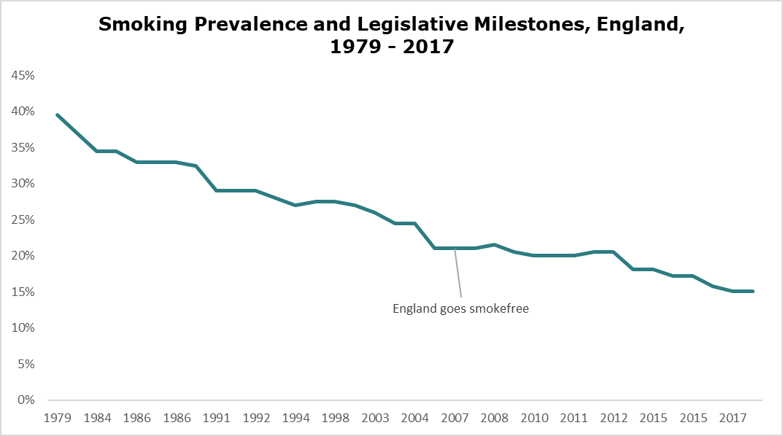

[End]

1. Royal College of Physicians, Hiding in Plain Sight, 2010 <https://www.rcplondon.ac.uk/projects/outputs/hiding-plain-sight-treating-tobacco-dependency-nhs>
2. ASH, Health Inequalities, and smoking, 2019, <https://ash.org.uk/resources/view/health-inequalities-and-smoking>
3. Office of Health Improvement and Disparities, Local Tobacco Control Profiles, <https://fingertips.phe.org.uk/profile/tobacco-control/data#page/1/ati/402/are/E10000016>
4. Action on Smoking and Health ready reckoner, <https://ash.org.uk/resources/view/ash-ready-reckoner>
5. Department of Health and Social Care, Smoke-free generation: tobacco control plan for England, 2017 [Smoke-free generation: tobacco control plan for England - GOV.UK (www.gov.uk)](https://www.gov.uk/government/publications/towards-a-smoke-free-generation-tobacco-control-plan-for-england)
6. Parliamentary Under Secretary of State for Public Health and Primary Care, Advancing Our Health: Prevention in the 2020s (2020) [Advancing our health: prevention in the 2020s – consultation document - GOV.UK](https://www.gov.uk/government/consultations/advancing-our-health-prevention-in-the-2020s/advancing-our-health-prevention-in-the-2020s-consultation-document).
7. Khan, Javed The Khan Review: making smoking obsolete (2022) <https://assets.publishing.service.gov.uk/government/uploads/system/uploads/attachment_data/file/1081366/khan-review-making-smoking-obsolete.pdf>
8. [Stopping the start: our new plan to create a smokefree generation - GOV.UK (www.gov.uk)](https://www.gov.uk/government/publications/stopping-the-start-our-new-plan-to-create-a-smokefree-generation) October 2023
9. Department of Health and Social Care, Stopping the start: our new plan to create a smokefree generation, October 2023 [Stopping the start: our new plan to create a smokefree generation - GOV.UK (www.gov.uk)](https://www.gov.uk/government/publications/stopping-the-start-our-new-plan-to-create-a-smokefree-generation/stopping-the-start-our-new-plan-to-create-a-smokefree-generation#action-already-underway)
10. Royal College of Physicians, Hiding in Plain Sight (2010) <https://www.rcplondon.ac.uk/projects/outputs/hiding-plain-sight-treating-tobacco-dependency-nhs>
11. Smoking prevalence is calculated using weighted estimates from the Annual Population Survey (APS) undertaken annually by the Office of National Statistics (ONS).
12. *Note: there are wider confidence intervals in data at a district level, giving less confidence in degrees of accuracy.*
13. Chief Medical Officer’s Annual Report 2021 Health in Coastal Communities <https://assets.publishing.service.gov.uk/government/uploads/system/uploads/attachment_data/file/1005216/cmo-annual_report-2021-health-in-coastal-communities-accessible.pdf>
14. Office of Health Improvement and Disparities, Local Tobacco Profiles Smoking Prevalence in Adults in Routine and Manual Workers, 2020, https://fingertips.phe.org.uk/profile/tobacco-control/data#page/4/gid/1938132885/pat/6/par/E12000008/ati/402/are/E10000016/iid/92445/age/183/sex/4/cat/-1/ctp/-1/yrr/1/cid/4/tbm/1
15. Action on Smoking and Health, A third of smoking households in England are living in poverty, 9th February 2022, <https://ash.org.uk/media-centre/news/press-releases/a-third-of-smoking-households-in-england-are-living-in-poverty-with-rates-highest-in-the-north#:~:text=Press%20Release-,A%20third%20of%20smoking%20households%20in%20England%20are%20living%20in,rates%20highest%20in%20the%20North&text=New%20analysis%20of%20national%20data,in%20the%20north%20and%20midlands>.
16. Action on Smoking and Health, Smoking in the Home, 2018, <https://ash.org.uk/uploads/FINAL-2018-Smokefree-Housing-report-web.pdf?v=1648034818>
17.
18.
19.
20. Action on Smoking and Health, Illicit Trade in Tobacco, 2022, <https://ash.org.uk/uploads/FINAL-2018-Smokefree-Housing-report-web.pdf?v=1648034818>
21. NHS South, Central and West Commissioning Support Unit, Illicit Tobacco research results: South East England 2018
22. Office of National Statistics, Smoking (General Lifestyle Survey Overview - a report on the 2011 General Lifestyle Survey) 2011 <https://www.ons.gov.uk/peoplepopulationandcommunity/personalandhouseholdfinances/incomeandwealth/compendium/generallifestylesurvey/2013-03-07/chapter1smokinggenerallifestylesurveyoverviewareportonthe2011generallifestylesurvey#:~:text=In%20all%20age%20groups%20in,3%25%20respectively%20were%20heavy%20smokers>.
23. Action on Smoking and Health, Young People and Smoking, September 2019 <https://ash.org.uk/uploads/190913-ASH-Factsheet_Youth-Smoking.pdf>
24. The Lancet, A Time to Act, Vol 10 September 2022, Published Online August 16, 2022 https://doi.org/10.1016/ S2213-2600(22)00303-4
25. # Department of Health and Social Care, Smoke-free generation: tobacco control plan for England, 2017 <https://www.gov.uk/government/publications/towards-a-smoke-free-generation-tobacco-control-plan-for-england>

   
26. NHS Digital, Smoking, Drinking and Drug Use Among Young People in England - 2021 <https://digital.nhs.uk/data-and-information/publications/statistical/smoking-drinking-and-drug-use-among-young-people-in-england>
27. Office for Health Improvement and Disparities, The Khan Review: Making Smoking Obsolete, 2022 <https://www.gov.uk/government/publications/the-khan-review-making-smoking-obsolete>
28. National Institute for Health and Care Guidance and Excellence, Tobacco: preventing uptake, promoting quitting, and treating dependence NG209, 2022 <https://www.nice.org.uk/guidance/ng209>
29. https://vapingfacts.health.nz/
30. E-cigarette or Vaping Associated Lung Injury
31. UK Parliament, House of Lords Library, Vaping Among Teens: A Growing Trend 2022, <https://lordslibrary.parliament.uk/vaping-among-teens-a-growing-trend/#:~:text=The%20proportion%20of%2018%2Dyear,than%20smokers%20trying%20to%20quit>.
32. Lancet, It’s a time to Act, Vol 10 September 2022, Published Online August 16, 2022 https://doi.org/10.1016/ S2213-2600(22)00303-4
33. . NHS Digital, Smoking, Drinking and Drug Use Among Young People in England 2022, <https://digital.nhs.uk/data-and-information/areas-of-interest/public-health/smoking-drinking-and-drug-use-among-young-people-in-england>
34. Action on Smoking and Health, Use of e-cigarettes (vapes) among young people in Great Britain, 2022 <https://ash.org.uk/uploads/Use-of-e-cigarettes-among-young-people-in-Great-Britain-2021.pdf>
35. Birch et al, Rapid growth in disposable e-cigarette vaping among young adults in Great Britain from 2021 to 2022: a repeat crosssectional survey, National Library of Medicine , 2022 <https://pubmed.ncbi.nlm.nih.gov/36065820/>
36. Action on Smoking and Health, Use of e-cigarettes (vapes) among young people in Great Britain, 2022 <https://ash.org.uk/uploads/Use-of-e-cigarettes-among-young-people-in-Great-Britain-2021.pdf>
37. NHS Digital, Smoking, Drinking and Drug Use Among Young People in England 2022, <https://digital.nhs.uk/data-and-information/areas-of-interest/public-health/smoking-drinking-and-drug-use-among-young-people-in-england>
38. Action on Smoking and Health, Use of e-cigarettes (vapes) among young people in Great Britain, 2022 <https://ash.org.uk/uploads/Use-of-e-cigarettes-among-young-people-in-Great-Britain-2021.pdf>
39. Ibid
40. https://www.legislation.gov.uk/ukpga/Geo5/23-24/12/section/7
41. https://www.legislation.gov.uk/ukpga/2014/6/part/5/crossheading/tobacco-nicotine-products-and-smoking/enacted
42. https://www.legislation.gov.uk/ukpga/1991/23/section/5
43. https://www.gov.uk/government/publications/the-khan-review-making-smoking-obsolete/making-smoking-obsolete-summary
44. https://pubmed.ncbi.nlm.nih.gov/6705448/
45. Source IBVTA AGM 15th December 2022
46. https://ash.org.uk/uploads/Use-of-e-cigarettes-among-young-people-in-Great-Britain-2022.pdf
47. https://digital.nhs.uk/news/2022/decrease-in-smoking-and-drug-use-among-school-children-but-increase-in-vaping-new-report-shows
48. Action on Smoking and Health, Smoking: Pregnancy, 2018 <https://ash.org.uk/uploads/HIRP-Pregnancy-1.pdf>
49. *Note: From 2020, Reporting only available at Integrated Care Board level (i.e.. Kent and Medway)*
50. NHS Digital, Smoking at time of delivery <https://digital.nhs.uk/data-and-information/publications/statistical/statistics-on-women-s-smoking-status-at-time-of-delivery-england/statistics-on-womens-smoking-status-at-time-of-delivery-england---quarter-4-october-2017-to-december-2017>
51. Royal college of midwifery https://www.rcm.org.uk/media/3394/support-to-quit-smoking-in-pregnancy.pdf

   
52. Royal College of Midwives, Position Statement: Support to quit smoking in pregnancy, 2022, <https://www.rcm.org.uk/media/3394/support-to-quit-smoking-in-pregnancy.pdf>
53. Ibid
54. Pilot study currently being undertaken. Final results not yet available.
55. National Institute for Health and Social Care Excellence, Tobacco: preventing uptake, promoting quitting, and treating dependence, Aug 2022, <https://www.nice.org.uk/guidance/ng209>
56. Tappin, D. et al. [Effect of financial voucher incentives provided with UK stop smoking services on the cessation of smoking in pregnant women (CPIT III): pragmatic, multicentre, single blinded, phase 3, randomised controlled trial](https://eur01.safelinks.protection.outlook.com/?url=https%3A%2F%2Fash.us14.list-manage.com%2Ftrack%2Fclick%3Fu%3D3d5578d8735672472bede942b%26id%3D4322c618bd%26e%3Dc213c27a31&data=05%7C01%7CDeborah.Smith%40kent.gov.uk%7Cd0a954e7d1344bd29ff208dab5d6af0f%7C3253a20dc7354bfea8b73e6ab37f5f90%7C0%7C0%7C638022230914014629%7CUnknown%7CTWFpbGZsb3d8eyJWIjoiMC4wLjAwMDAiLCJQIjoiV2luMzIiLCJBTiI6Ik1haWwiLCJXVCI6Mn0%3D%7C3000%7C%7C%7C&sdata=O2JduSHJKc6SgXVC%2FSl%2FJ63loTuwv10DyZsiRn%2B9ULA%3D&reserved=0). BMJ (2022).
57. Office for Health Improvement and Disparities, Local Tobacco Control Profiles, <https://fingertips.phe.org.uk/profile/tobacco-control/data#page/6/gid/1938132900/pat/6/par/E12000008/ati/402/are/E10000016/iid/92536/age/168/sex/4/cat/-1/ctp/-1/yrr/1/cid/4/tbm/1>
58. Ibid
59. Prochaska JJ. [Smoking and Mental Illness: Breaking the Link](https://www.nejm.org/doi/full/10.1056/NEJMp1105248). NEJM 2011; 365:196-8 in Action on Smoking and Health, Smoking and Mental Health, 2019**,** [**https://ash.org.uk/resources/view/smoking-and-mental-health**](https://ash.org.uk/resources/view/smoking-and-mental-health)
60. Taylor G et al. [Change in mental health after smoking cessation: systematic review and meta-analysis](https://www.bmj.com/content/348/bmj.g1151). BMJ 2014; 348: g1151 [Change in mental health after smoking cessation: systematic review and meta-analysis | The BMJ](https://www.bmj.com/content/348/bmj.g1151)
61. **Langley K, et al**. [Maternal and paternal smoking during pregnancy and risk of ADHD symptoms in offspring: testing for intrauterine effects](https://academic.oup.com/aje/article/176/3/261/98820). Am.J. Epidemiol. 2012; 176 (3): 261-68 in Action on Smoking and Health, Smoking and Mental Health, 2019**,** [**https://ash.org.uk/resources/view/smoking-and-mental-health**](https://ash.org.uk/resources/view/smoking-and-mental-health)
62. Sibley M. [The role of early childhood ADHD and subsequent CD in the initiation and escalation of adolescent cigarette, alcohol, and marijuana use](https://www.ncbi.nlm.nih.gov/pubmed/24886010). J Abnorm Psychol. 2014 May; 123(2): 362-74 in 68 in Action on Smoking and Health, Smoking and Mental Health, 2019,[**https://ash.org.uk/resources/view/smoking-and-mental-health**](https://ash.org.uk/resources/view/smoking-and-mental-health)
63. Biederman J, et al. [Cigarette smoking as a risk factor for other substance misuse: 10 year study of individuals with and without attention-deficit hyperactivity disorder](https://www.cambridge.org/core/journals/the-british-journal-of-psychiatry/article/cigarette-smoking-as-a-risk-factor-for-other-substance-misuse-10year-study-of-individuals-with-and-without-attentiondeficit-hyperactivity-disorder/401C269572F8ECD5EADE928D15687ADA). British Journal of Psychiatry 2012; 201(3): 207-214 in Action on Smoking and Health, Smoking and Mental Health, 2019**,** [**https://ash.org.uk/resources/view/smoking-and-mental-health**](https://ash.org.uk/resources/view/smoking-and-mental-health)
64. University of York, Smoking Cessation Intervention for People with Severe Mental Ill Health: SCIMITAR+ Trial, 2015 https://www.ncsct.co.uk/usr/pub/SCIMITAR+.pdf
65. Action on Smoking and Health, Evidence into Practice: Smokeless tobacco products, March 2020, <https://ash.org.uk/resources/view/evidence-into-practice-smokeless-tobacco-products>
66. Opinions and Lifestyle Survey 2022, Office of National Statistics 2022 <https://www.ons.gov.uk/peoplepopulationandcommunity/healthandsocialcare/healthandlifeexpectancies/datasets/adultsmokinghabitsinengland>
67. Ibid
68. Action on Smoking and Health, 2019, The End of Smoking [The End of Smoking - ASH](https://ash.org.uk/resources/view/the-end-of-smoking)

   
69. Jackson, Sarah E et al, Smoking and quitting behaviour by sexual orientation: a cross-sectional survey of adults in England, Nicotine & Tobacco Research (2020) in Action on Smoking and Health, LGBT Evidence into Practice Briefing
70. Dentato, MP, The minority stress perspective (2012) in Action on Smoking and Health, LGBT Evidence into Practice Briefing
71. Homeless Link 2014 in Action on Smoking and Health, Smoking: People experiencing homelessness, 2016 <https://ash.org.uk/uploads/HIRP-People-experiencing-homelessness-1.pdf>
72. Crisis 2012 in Action on Smoking and Health, Smoking: People experiencing homelessness, 2016 <https://ash.org.uk/uploads/HIRP-People-experiencing-homelessness-1.pdf>
73. Groundswell, Room to Breathe, 2016, <https://groundswell.org.uk/our-approach-to-research/peer-research/room-to-breathe/>
74. Pratt et al, It’s a hard thing to manage when you’re homeless, BMC Public Health, published 24th May 2019 https://bmcpublichealth.biomedcentral.com/articles/10.1186/s12889-019-6987-7
75. Public Health England, Reducing Smoking in Prisons Management of tobacco use and nicotine withdrawal, 2015, [PHE standard publication template (publishing.service.gov.uk)](https://assets.publishing.service.gov.uk/government/uploads/system/uploads/attachment_data/file/412567/Reducing_smoking_in_prisons.pdf)
76. 1 Ibid
77. OHID, Local Tobacco Profiles, <https://fingertips.phe.org.uk/profile/tobacco-control/data#page/7/gid/1938132885/pat/159/par/K02000001/ati/15/are/E92000001/iid/92443/age/168/sex/4/cat/-1/ctp/-1/yrr/1/cid/4/tbm/1/page-options/ine-yo-1:2021:-1:-1_ine-ct-4_ine-pt-2> Accessed 23/3/23
78. 2 ibid
79. HM Prison and Probation Service, Public Health England, NHS England, Minimum Offer for Stop Smoking Services and Support in Custody, [Minimum Offer for Stop Smoking Services and Support in Custody (england.nhs.uk)](https://www.england.nhs.uk/wp-content/uploads/2017/08/smoke-free-mso-national.pdf)
80. NHS Digital, Statistics on NHS Stop Smoking Services: England 2021-22, <https://digital.nhs.uk/data-and-information/publications/statistical/statistics-on-nhs-stop-smoking-services-in-england/april-2021-to-march-2022/datasets>
81. Office of National Statistics, Drug misuse in England and Wales: year ending March 2020, Article 09/12/2020, <file:///C:/Users/Smithd98/Downloads/Drug%20misuse%20in%20England%20and%20Wales%20year%20ending%20March%202020.pdf>
82. # Hindocha et al, *No Smoke without Tobacco: A Global Overview of Cannabis and Tobacco Routes of Administration and Their Association with Intention to Quit, 2016, National Library of Medicine,*

    [No Smoke without Tobacco: A Global Overview of Cannabis and Tobacco Routes of Administration and Their Association with Intention to Quit - PMC (nih.gov)](https://www.ncbi.nlm.nih.gov/pmc/articles/PMC4933835/)
83. # ASH, 380,000 ‘non-smokers’ regularly smoke cannabis, putting their health at risk, Press Release 19/12/2020, <https://ash.org.uk/media-centre/news/press-releases/380000-non-smokers-regularly-smoke-cannabis-putting-their-health-at-risk>

   
84. Mookherjee, J et al, Drug Needs Assessment, 2022, Kent County Council, <https://www.kpho.org.uk/__data/assets/pdf_file/0004/138109/Drug-needs-assessment.pdf>
85. ibid
86. US Surgeon General Report 2014 in Royal College of Physicians, Hiding in Plain Sight, 2010, <https://www.rcplondon.ac.uk/projects/outputs/hiding-plain-sight-treating-tobacco-dependency-nhs>
87. OHID, Local Tobacco Profiles
88. ASH Ready Reckoner
89. ASH Ready Reckoner
90. Royal college of Physicians, Hiding in Plain Sight, 2010, <https://www.rcplondon.ac.uk/projects/outputs/hiding-plain-sight-treating-tobacco-dependency-nhs>
91. OHID, Local Tobacco Profiles
92. Global Burden of Disease study 2019, <http://vizhub.healthdata.org/gbd-compare/>
93. Kent and Medway Cancer Alliance
94. 47 Kent and Medway Cancer Alliance
95. Royal College of Physicians, Hiding in Plain Sight, 2010, <https://www.rcplondon.ac.uk/projects/outputs/hiding-plain-sight-treating-tobacco-dependency-nhs>
96. Office for Health Improvement and Disparities, Local Tobacco Control Profiles, <https://fingertips.phe.org.uk/profile/tobacco-control/data#page/1/gid/1938132888/pat/6/par/E12000008/ati/402/are/E10000016/yrr/3/cid/4/tbm/1>
97. Action on Smoking and Health, Smoking Statistics, 2021, <https://ash.org.uk/resources/view/smoking-statistics>
98. Office of National Statistics, Adults Smoking Habits in the UK 2021,

    https://www.ons.gov.uk/peoplepopulationandcommunity/healthandsocialcare/healthandlifeexpectancies/bulletins/adultsmokinghabitsingreatbritain/2021#characteristics-of-current-cigarette-smokers-in-the-uk
99. *Action on Smoking and Health,* Evidence into Practice: Motivating quitting through behaviour change communications, 2021, <https://ash.org.uk/uploads/Communications-Evidence-Into-Practice_2022-03-23-095046_rfql.pdf?v=1648029046>
100. Action on Smoking and Health, The End of Smoking, <https://ash.org.uk/uploads/The-End-of-Smoking_final.pdf?v=1655330030>
101. Office for Health Improvement and Disparities, Local Tobacco Profiles, Cost per Quitter, 2020, <https://fingertips.phe.org.uk/profile/tobacco-control/data#page/4/gid/1938132890/pat/6/par/E12000008/ati/402/are/E10000016/iid/91546/age/164/sex/4/cat/-1/ctp/-1/yrr/1/cid/4/tbm/1>
102. University College of London, Smoking in England, <https://smokinginengland.info/graphs/top-line-findings>
103. Office for Health Improvement and Disparities, Nicotine Vaping in England 2022, <https://www.gov.uk/government/publications/nicotine-vaping-in-england-2022-evidence-update/nicotine-vaping-in-england-2022-evidence-update-main-findings#contents>
104. University College London, Smoking in England, <https://smokinginengland.info/graphs/top-line-findings>
105. Independent British Vape Trade Association, <https://www.ibvta.org.uk/>
106. # National Institute for Clinical Excellence, Tobacco: preventing uptake, promoting quitting and treating dependence, 2022 <https://www.nice.org.uk/guidance/ng209/chapter/Terms-used-in-this-guideline#e-cigarettes>

    
107. National Centre for Smoking Cessation and Training, Advice for Services on making e-cigarettes available <https://www.ncsct.co.uk/publication_Service_advice_e-cigarettes.php>
108. Action on Smoking and Health, Bluegrass Insights <https://ash.org.uk/search>
109. Action on Smoking and Health, Evidence into Practice: Motivating quitting through behaviour change communications, 2021, <https://ash.org.uk/uploads/Communications-Evidence-Into-Practice.pdf>
110. Kahn, J, Making Smoking Obsolete, 2022, <https://assets.publishing.service.gov.uk/government/uploads/system/uploads/attachment_data/file/1081366/khan-review-making-smoking-obsolete.pdf>
111. Department of Health and Social Care, Stopping the start: our new plan to create a smokefree generation, October 2023 [Stopping the start: our new plan to create a smokefree generation - GOV.UK (www.gov.uk)](https://www.gov.uk/government/publications/stopping-the-start-our-new-plan-to-create-a-smokefree-generation/stopping-the-start-our-new-plan-to-create-a-smokefree-generation#action-already-underway)
112. Action on Smoking and Health, Key Dates in Tobacco Regulation, 2020, <https://ash.org.uk/uploads/Key-Dates_2022-04-21-101255_ajre.pdf?v=1650535975>